**TRIGONOMETRY**

**1. UNIT CIRCLE:** A **unit circle** is a circle of radius 1 unit. It is usually drawn on the Cartesian plane with its centre at the **origin (0,0)**. i.e.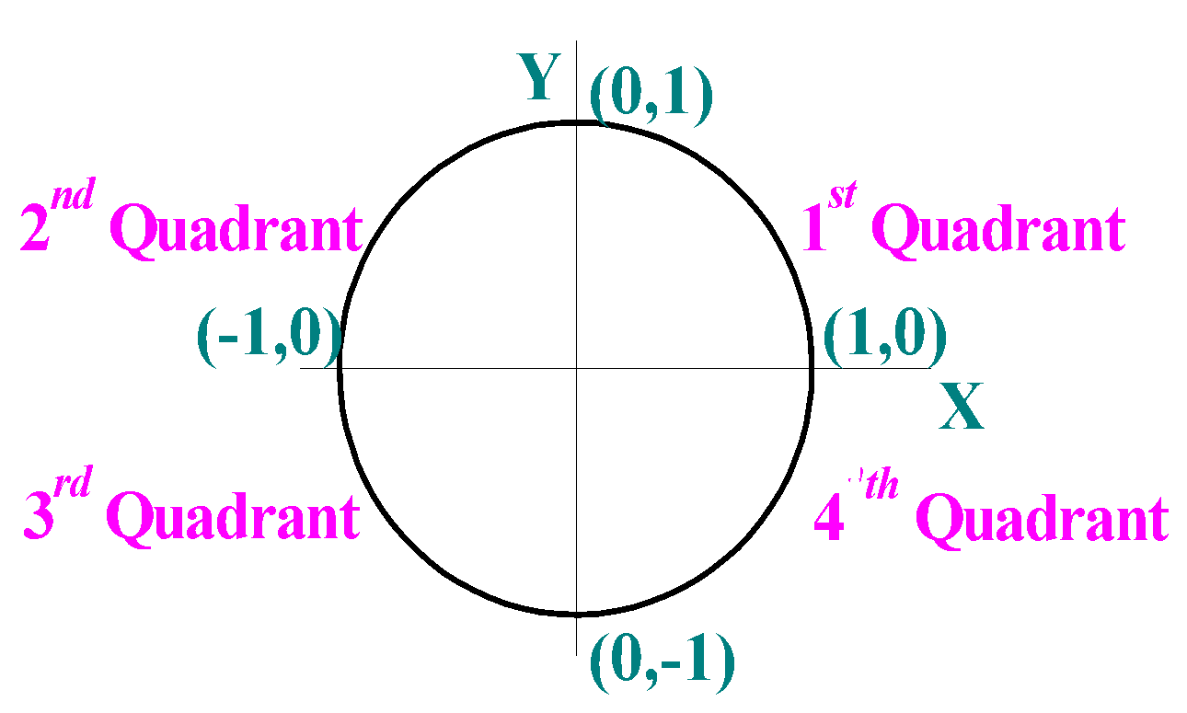

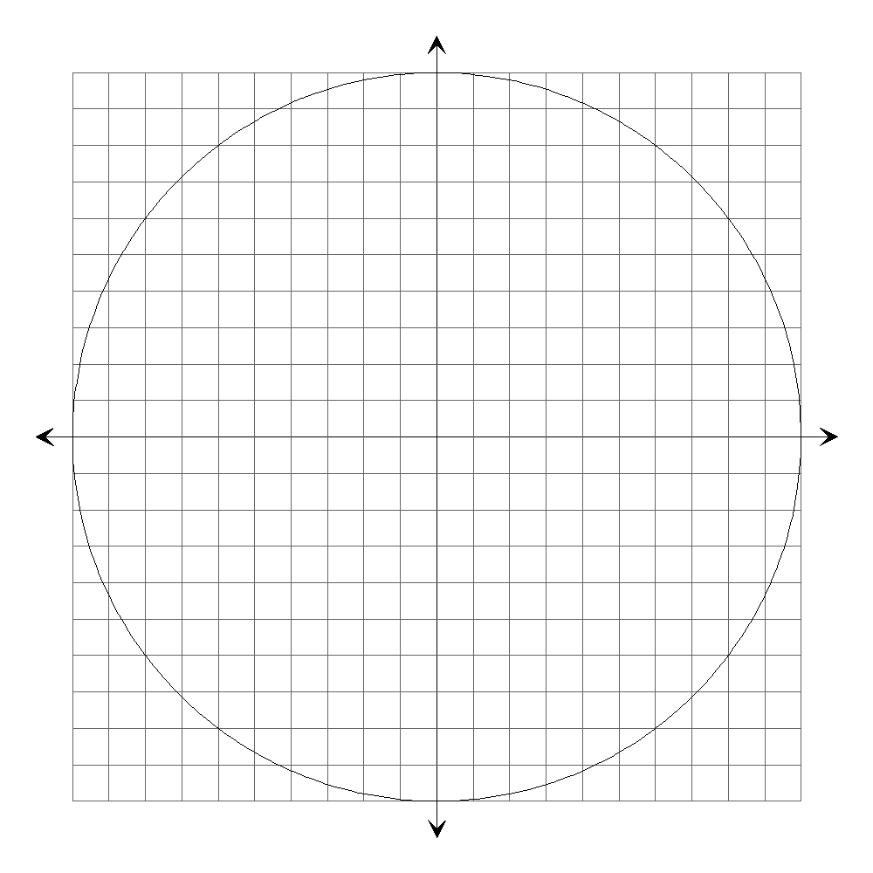

More usually, the unit circle is drawn on a grid, e.g.

An angle in **standard position** has one ray on the positive X-axis (the **initial ray**) and the other (the **terminal ray**) in any of the quadrants depending on the **size** and **direction** of the angle, e.g.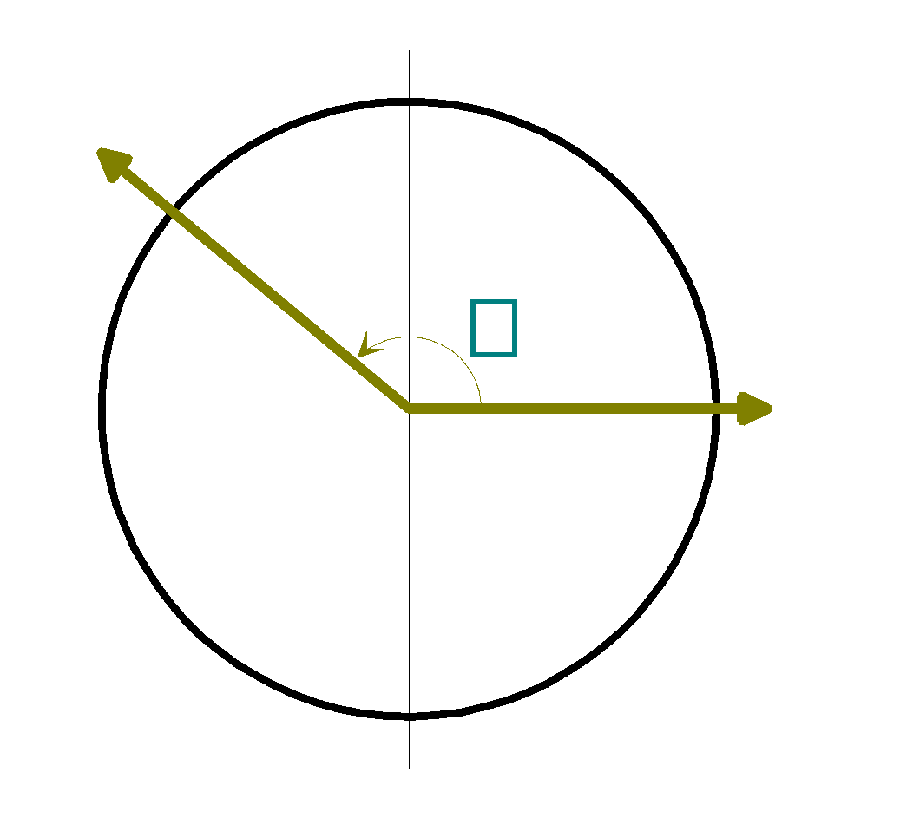

**NOTE:** Anti-clockwise angles ↔ positive and clockwise angles ↔ negative.

To determine the co-ordinates of any point P, for any angle **θ** in standard position – use a right-angled triangle.

Remember: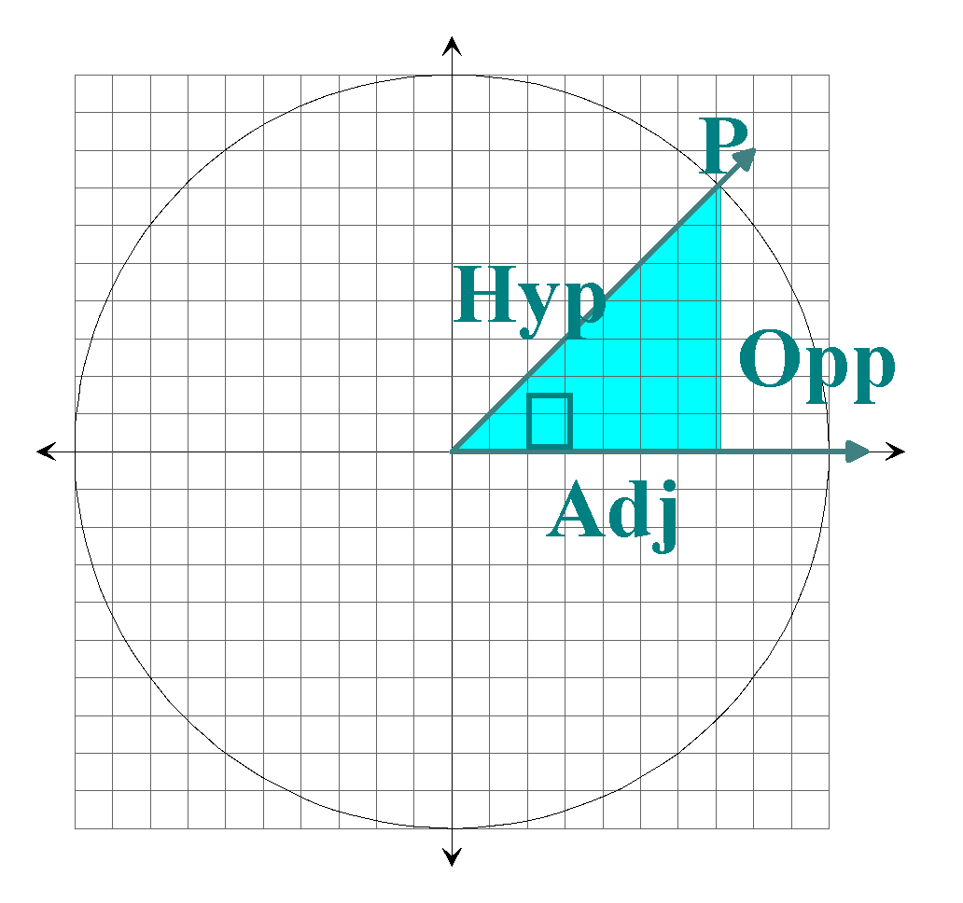

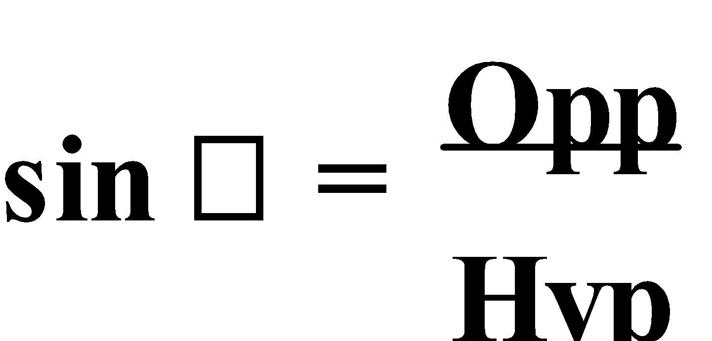 ,

but **Hyp = 1**,

∴ **sin θ = Opp**

⇒ **y-co-ordinate**

Similarly:

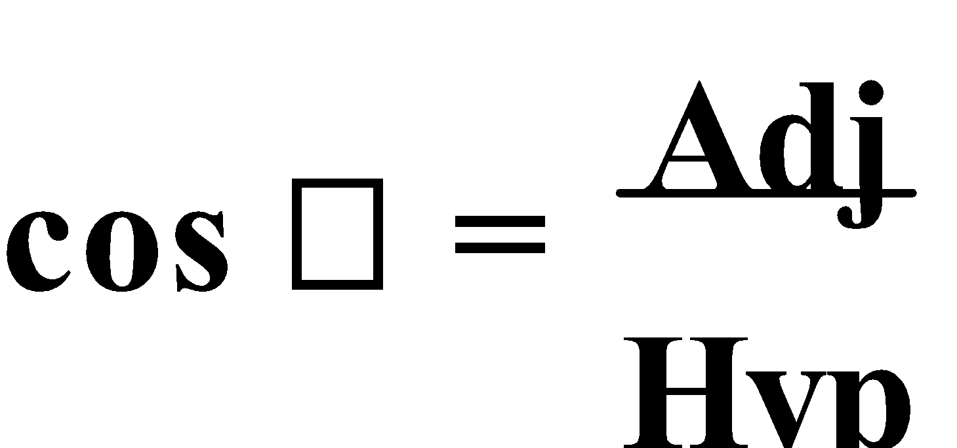 ,

∴ **cos θ = Adj**

⇒ **x-co-ordinate**

Thus, the co-ordinates of P are **(cos θ, sin θ)**.

Hence, the **trigonometric functions** can be **redefined** as **cosine** is the **x-co-ordinate** of the point of intersection of the terminal and the unit circle of an angle in standard position, and **sine** is the **y-co-ordinate** of the point of intersection of the terminal and the unit circle of an angle in standard position. The **unit circle** can then be used to determine the **sine** and/or **cosine** of an **obtuse angle**.

If **β** is an **obtuse** angle, then **sin β = sin (180° – β)**, and **cos β = -cos (180° – β)**.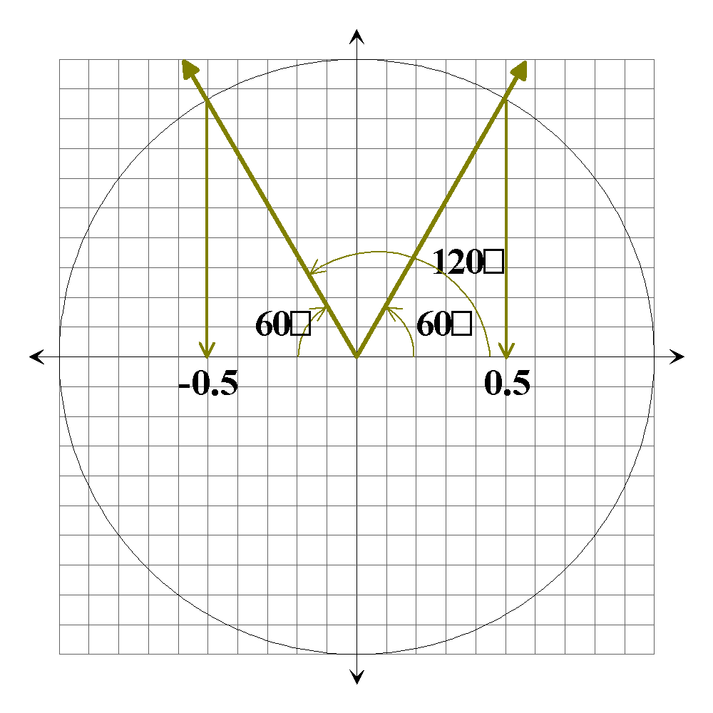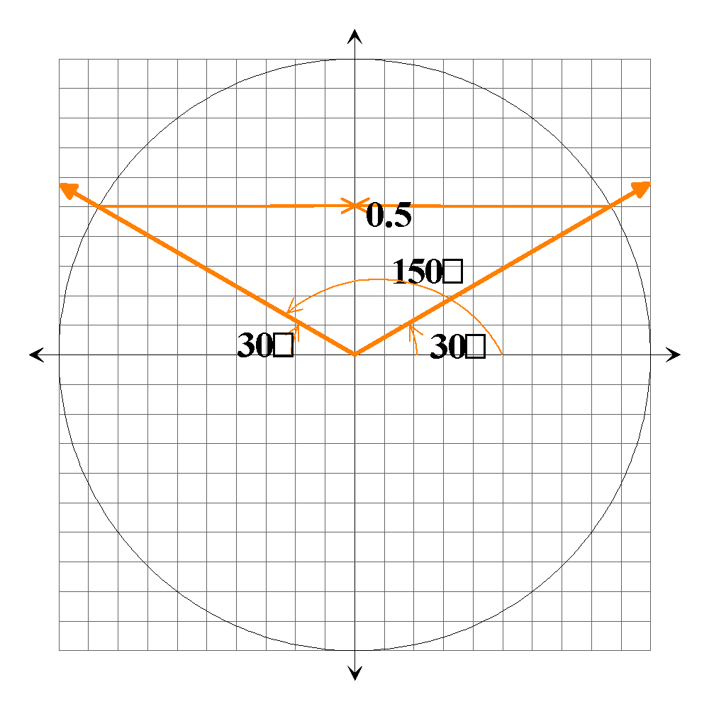

E.g.1. Find the appropriate value for the supplement of:

a) sin 95°

b) cos 130°

c) sin 160°

a) sin 95° = sin (180° – 95°)

= sin 85°

b) cos 130° = -cos (180° – 130°)

= -cos 50°

c) sin 160° = sin (180° – 160°)

= sin 20°

Ref: Ex.1A Q.1-18 (even)

**2. AREA OF A TRIANGLE:** Consider this triangle. Suppose we know the lengths of **a** and **c** and the size of **∠B**, the **area** can be found **without** knowing the height.

Draw AD ⊥ BC.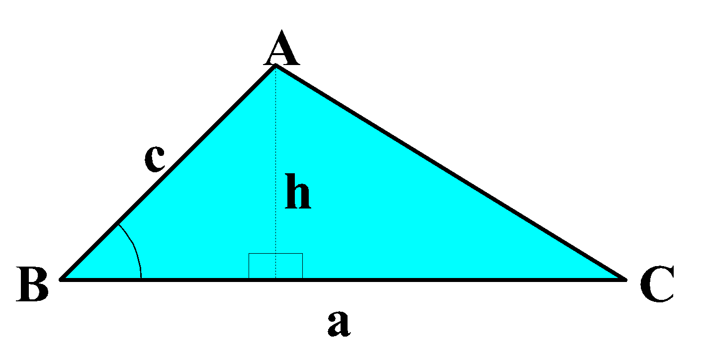

So, in ΔADB

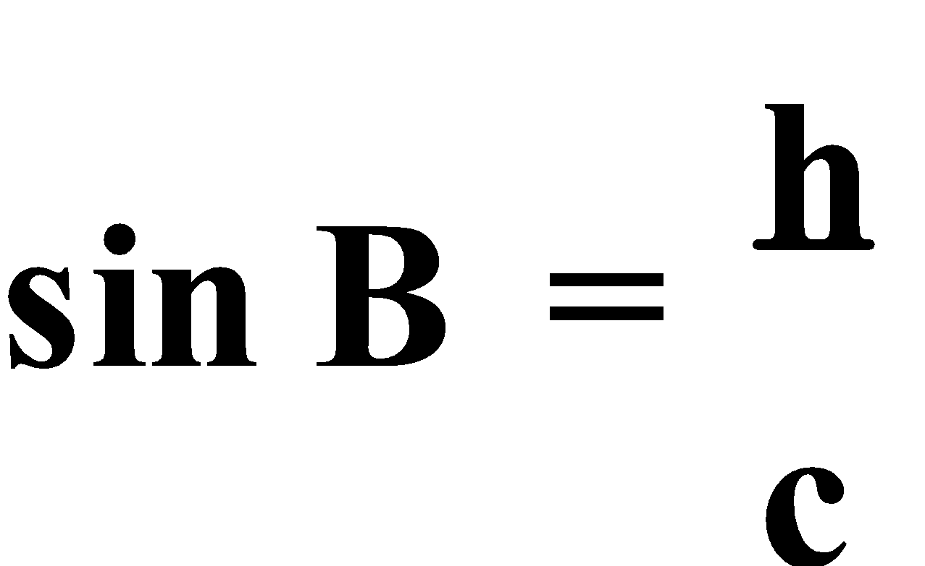 ⇒ h = c × sin B

But the area of a triangle is **A(Δ) = ½ × base × height**

By substituting **h = c × sin B**

So, **A(Δ) = ½ × a × (c × sin B)**

⇒ **A(Δ) = ½ × ac × sin B**

Likewise **A(Δ) = ½ × ab × sin C** or **A(Δ) = ½ × bc × sin A**.

E.g.2. Determine the area of ΔXYZ.

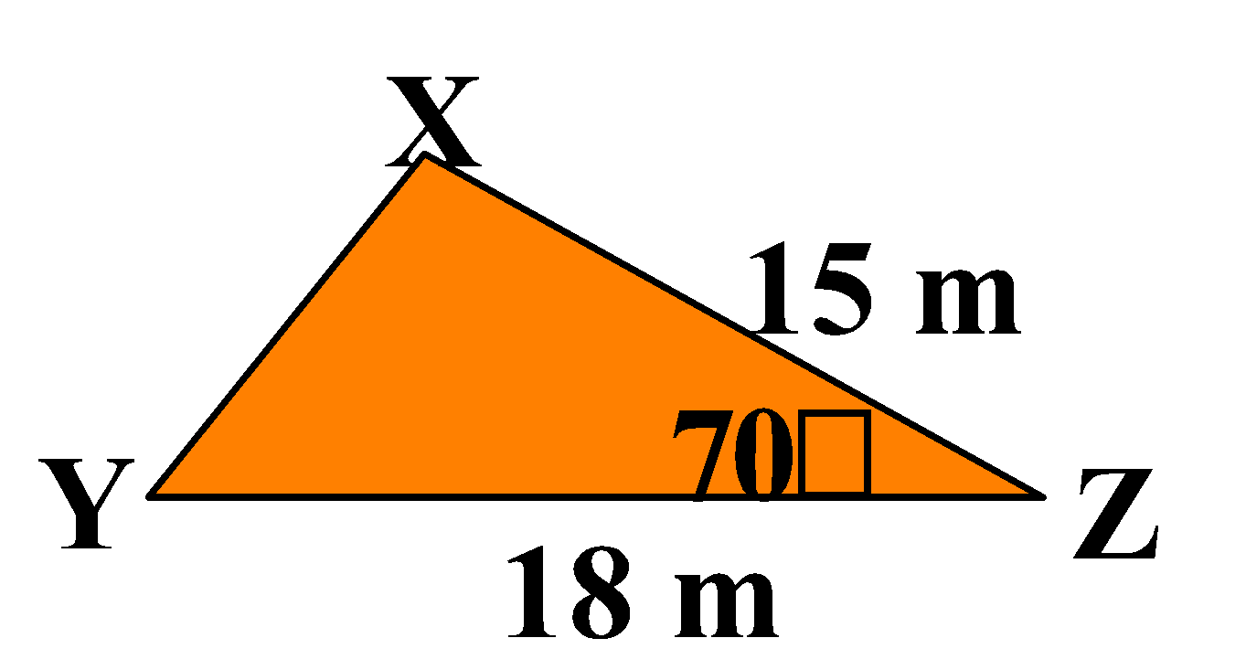

Area = ½ xy sin Z

= ½ × 18 × 15 × sin 70°

≈ 126.9 m²

E.g.3. Determine the value of the variable in each of these triangles given:

a) the area is 15 cm2,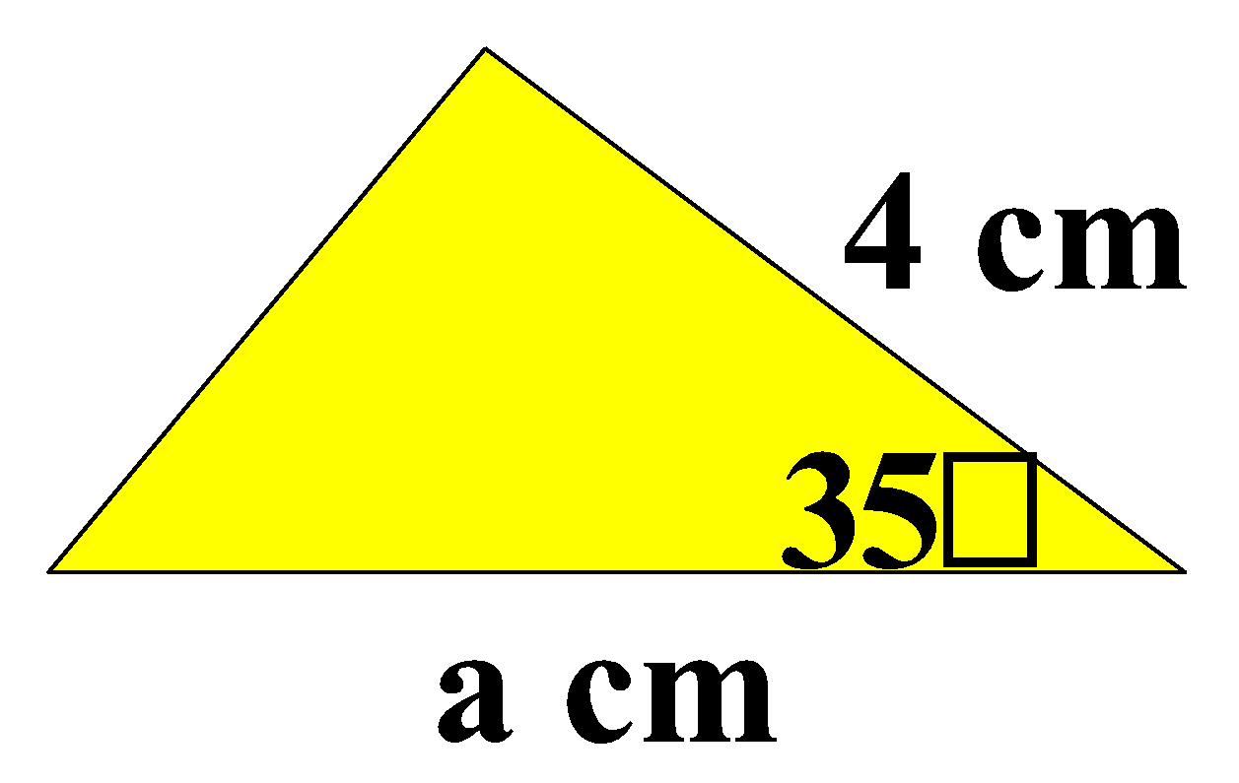

b) the area is 7 m2.

1. ½ × a × 4 × sin 35° = 15

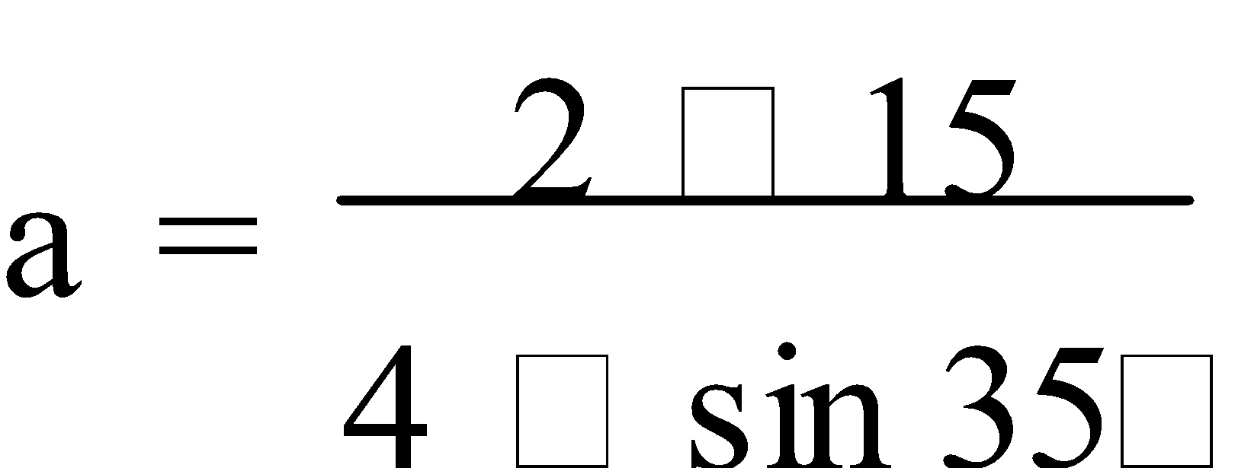

a ≈ 13.1 cm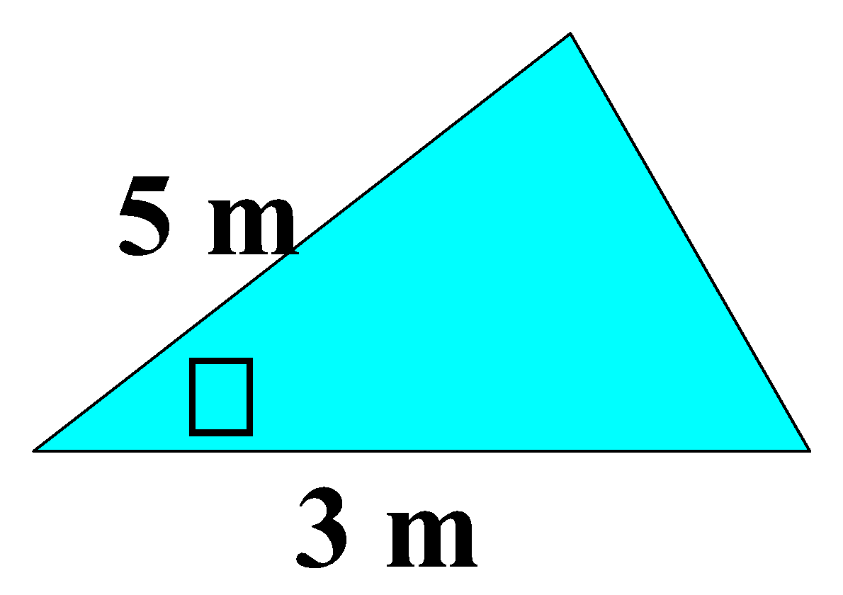

1. ½ × 3 × 5 × sin β = 7

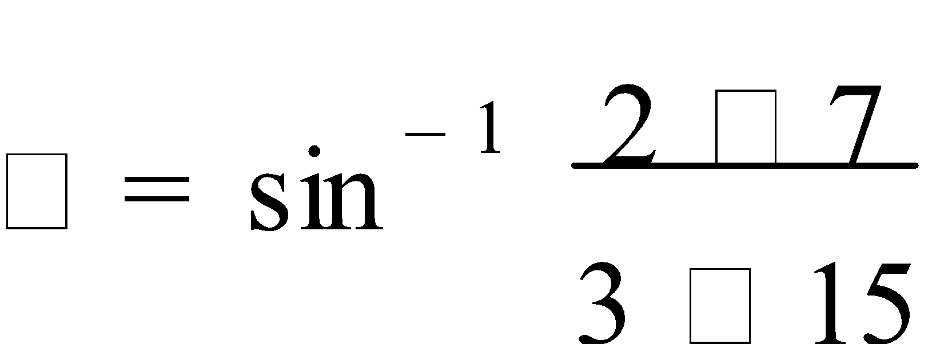 

β ≈ 69°

**NOTE:** When using **sin-1** there is always the possibility of a **double solution**.

However, if **all three side** lengths are **known** but no included angle is known, then

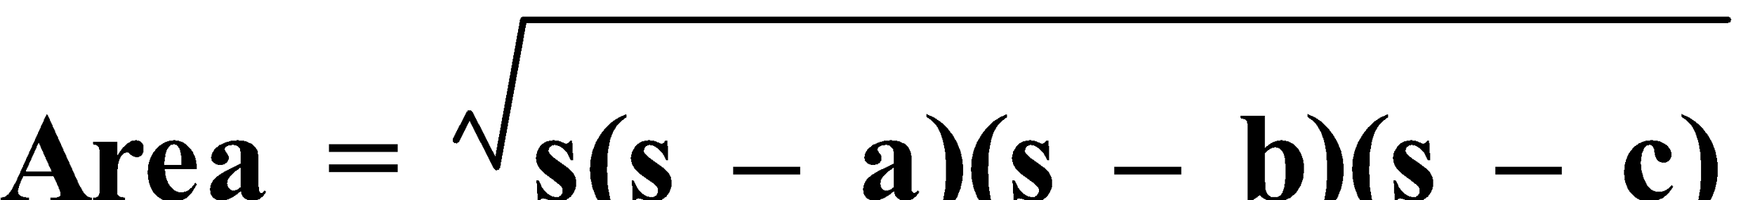, where 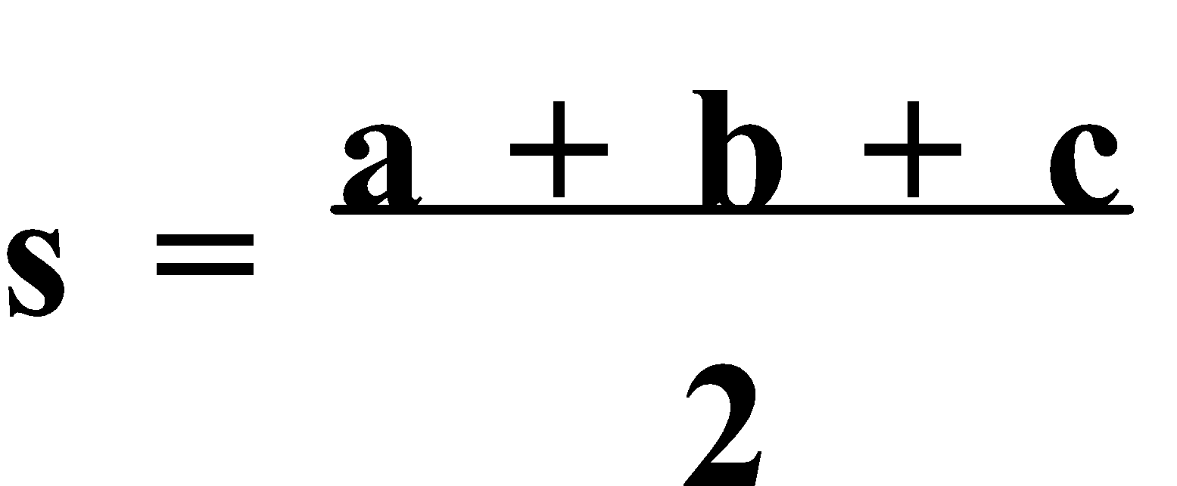. This is known as **Heron’s** (or **Hero’s**) **formula**.

Ref: Ex.1B Q.1-15 (odd)

**3. SINE RULE:** Not all triangles are right-angled, so, we need a method to determine the **length** of an unknown side or the size of an unknown **angle** that works with **non-right-angled triangles**. One method is the **Sine Rule**.

The **Sine Rule** determines the **length** of an **unknown side** given two angles and a corresponding side length, or the **size** of an **unknown angle** given the length of two sides and a corresponding angle.

Consider this triangle.

Suppose we know s∠A, s∠C and a,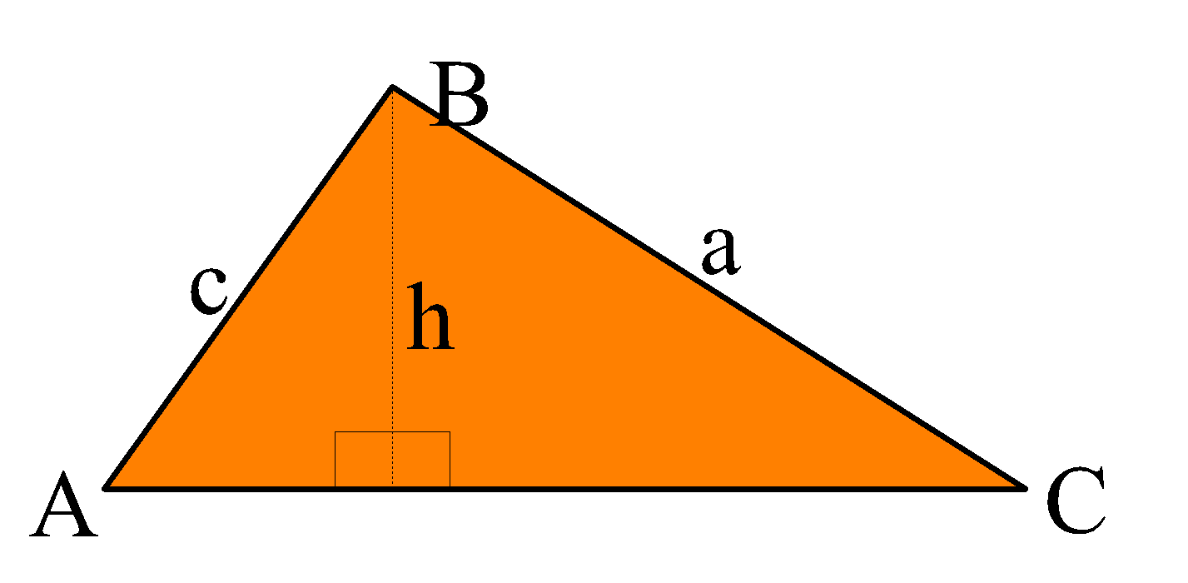

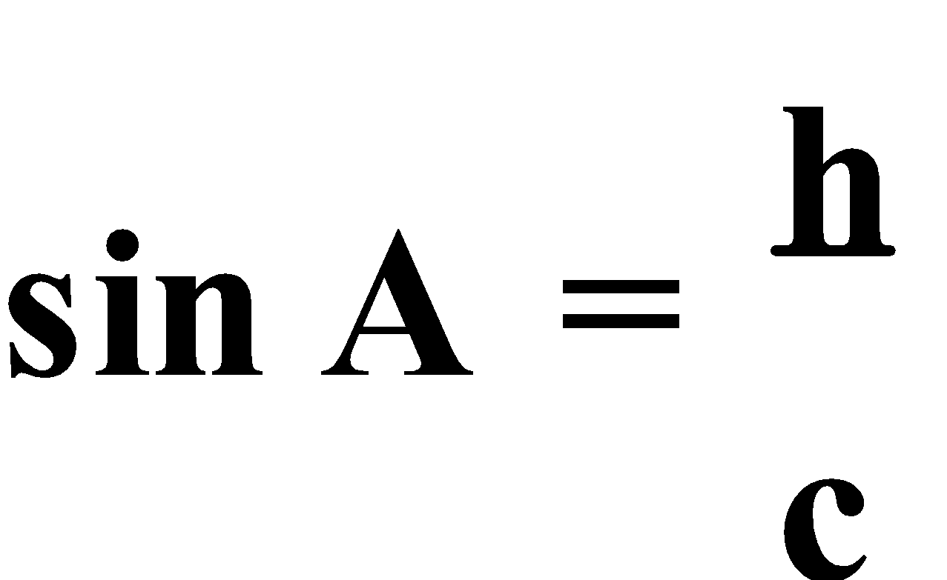

⇒ h = c.sin A

& 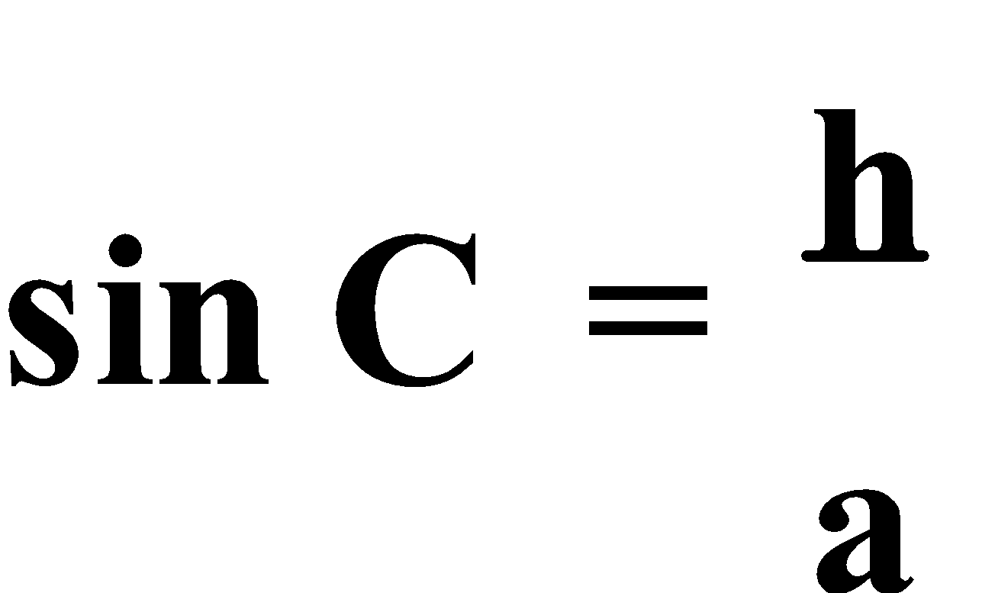

⇒ h = a.sin C

∴ c.sin A = a.sin C

⇒ 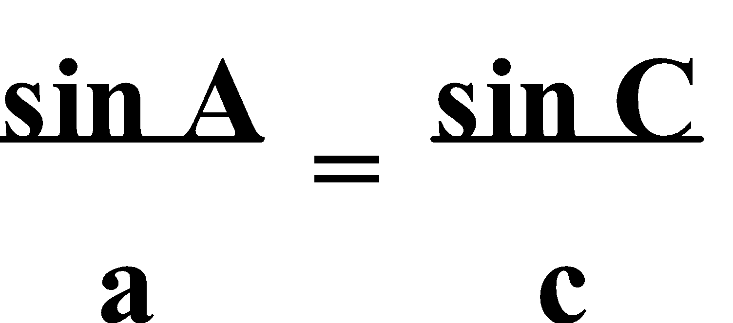 or 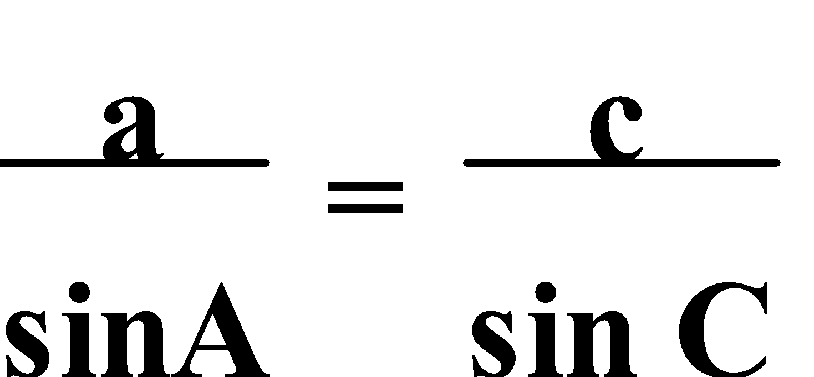

Thus the **Sine Rule** states that for any nonright triangle ABC, 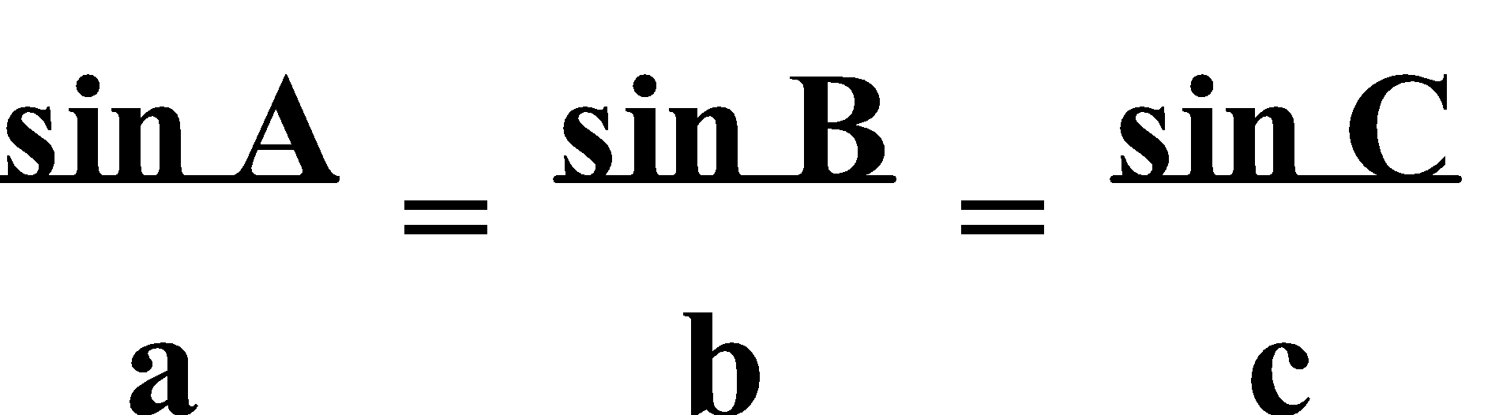 or 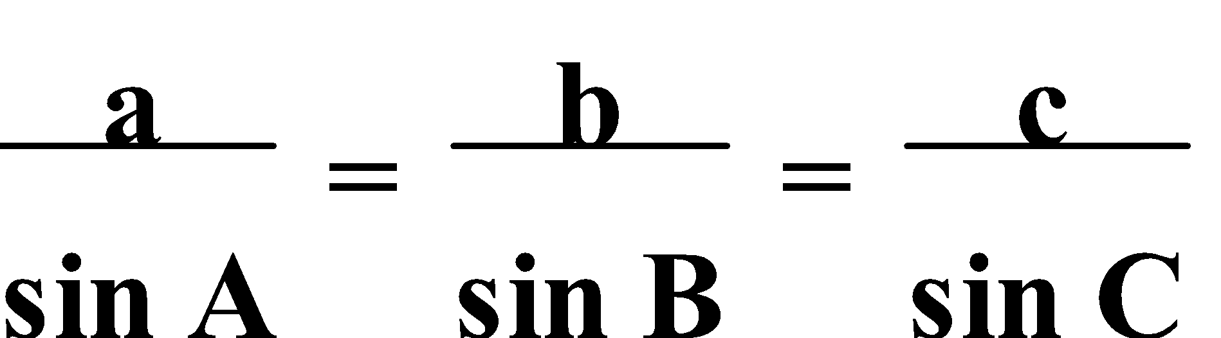.

**Always** check for **two solutions** when finding an angle size using the Sine Rule.

E.g.4. Solve for ∠N, in ΔKMN, if n = 5 cm, m = 4 cm, s∠M = 30°.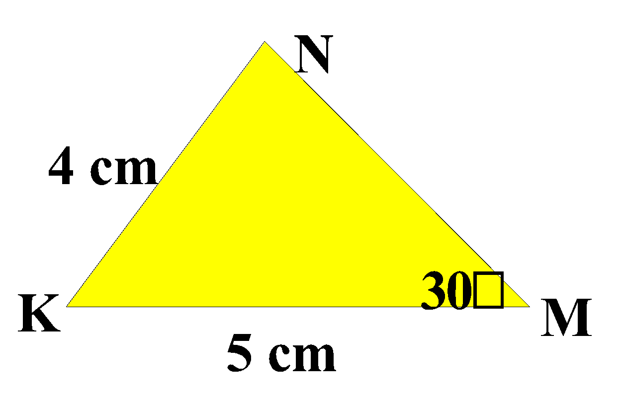

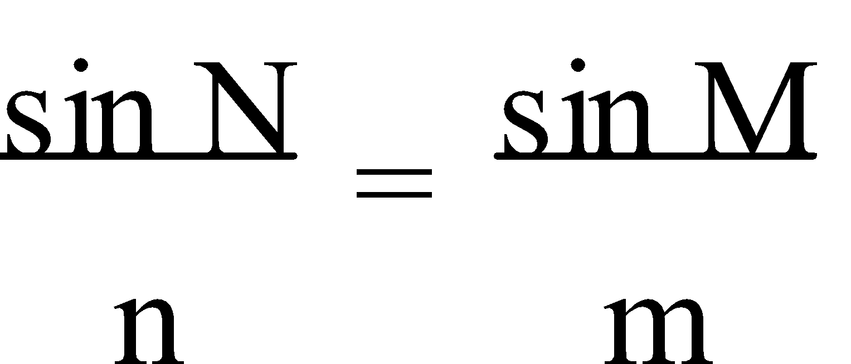

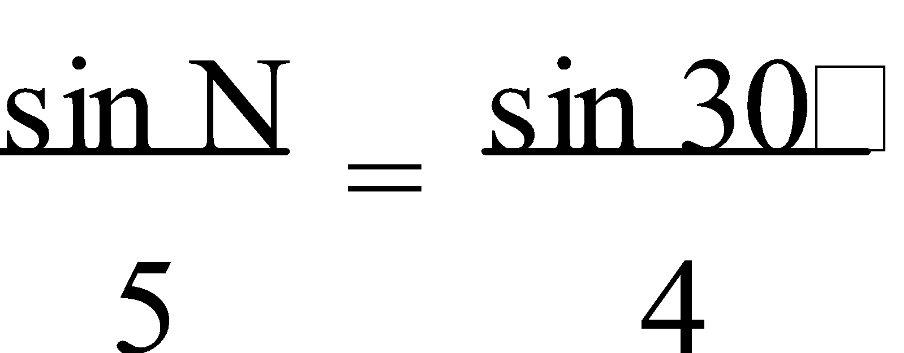

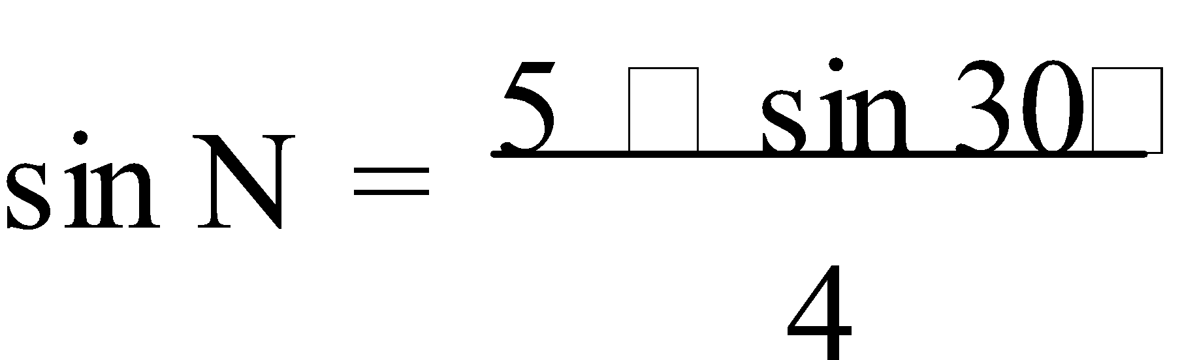

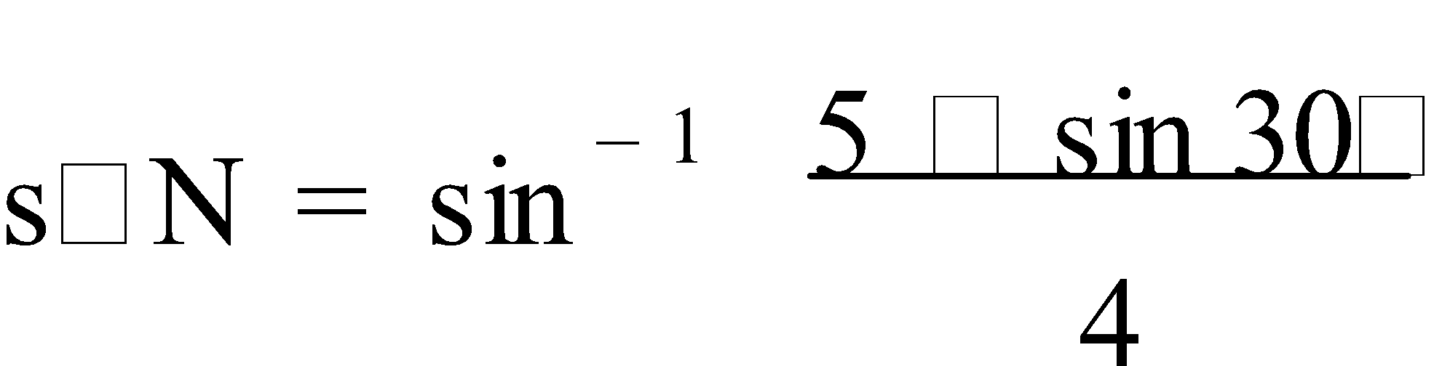 

s∠N ≈ 38.7° or 141.3°

In the previous example, there were two possible sizes for angle Y as two triangles can be drawn that satisfy the given conditions.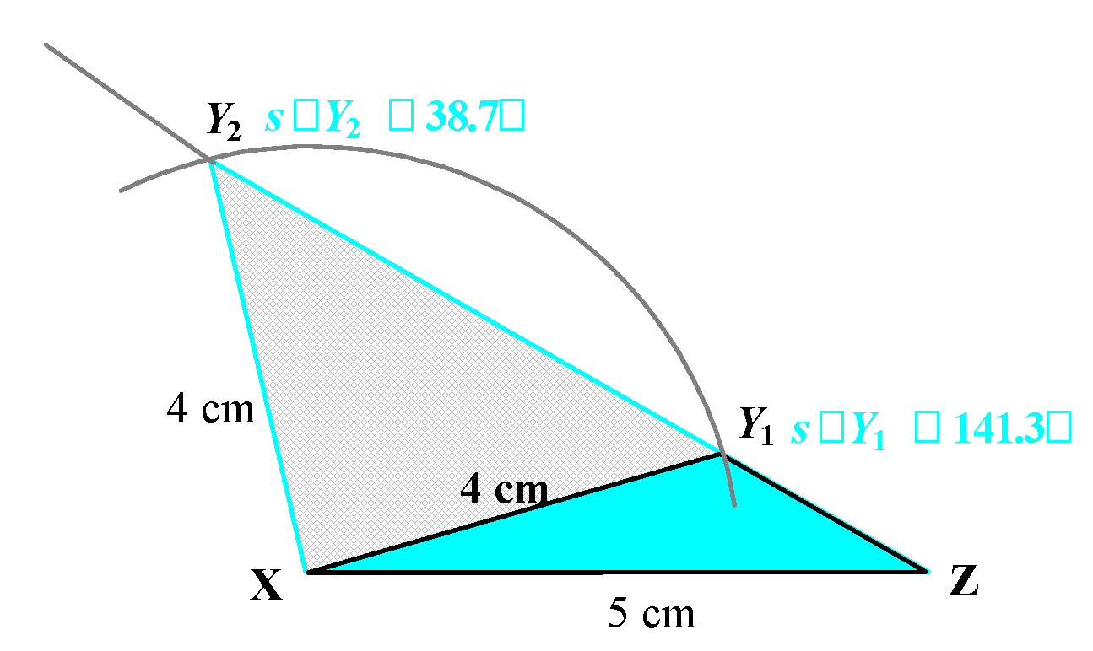

**4. COSINE RULE:** Another method that works with **non-right-angled triangles** is the **Cosine Rule**. The **Cosine Rule** determines the **length** of the third side given the lengths of the other two sides and the included angle, or the size of an **angle** given the lengths of the three sides.

Consider this triangle.

Given s∠C, a and b,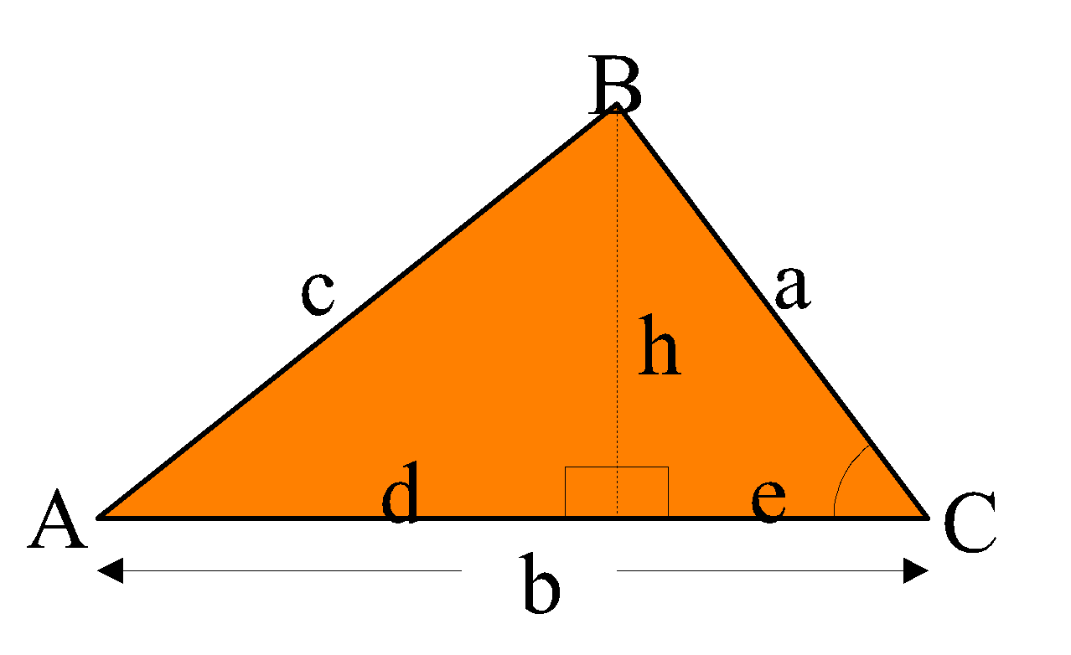

c2 = h2 + d2 & d = b – e

⇒ d2 = (b – e)2

= b2 – 2be + e2

e2 = a2 – h2

& 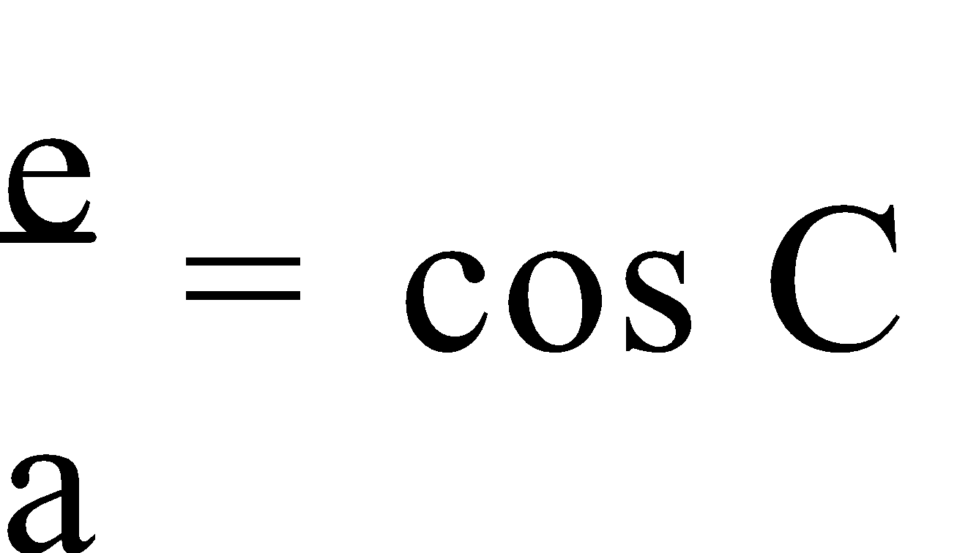

⇒ e = a.cos C

∴ c2 = h2 + [b2 – 2ba.cos C + a2 – h2]

= h2 + b2 – 2ab.cos C + a2 – h2

∴ **c2 = a2 + b2 – 2ab cos C**

Thus, the **Cosine Rule** states that for any nonright triangle ABC, **c2 = a2 + b2 – 2ab cos C**, or 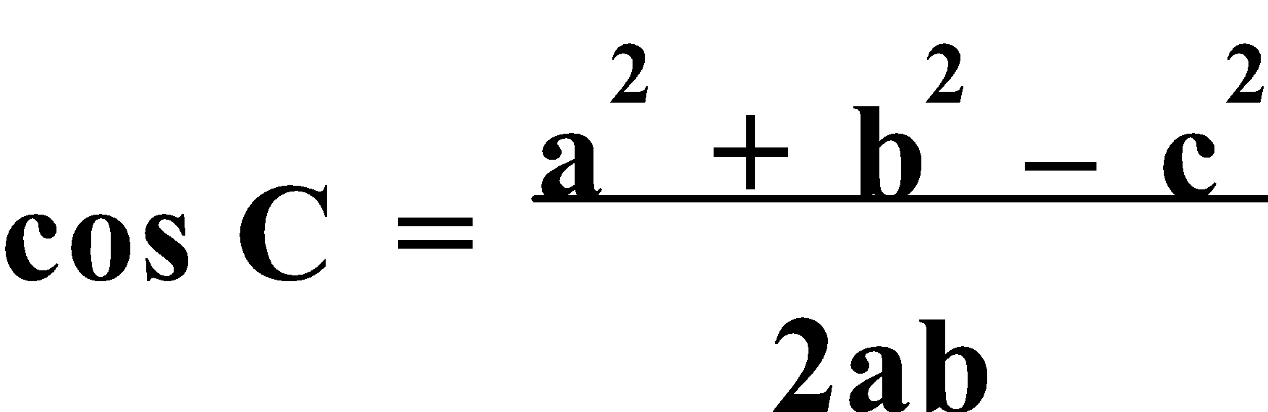.

**NOTE:** With **Cosine Rule** there is only **one solution** for an angle.

E.g.5. Given x = 14, y = 11, z = 20, find the size of the smallest angle of ΔXYZ.

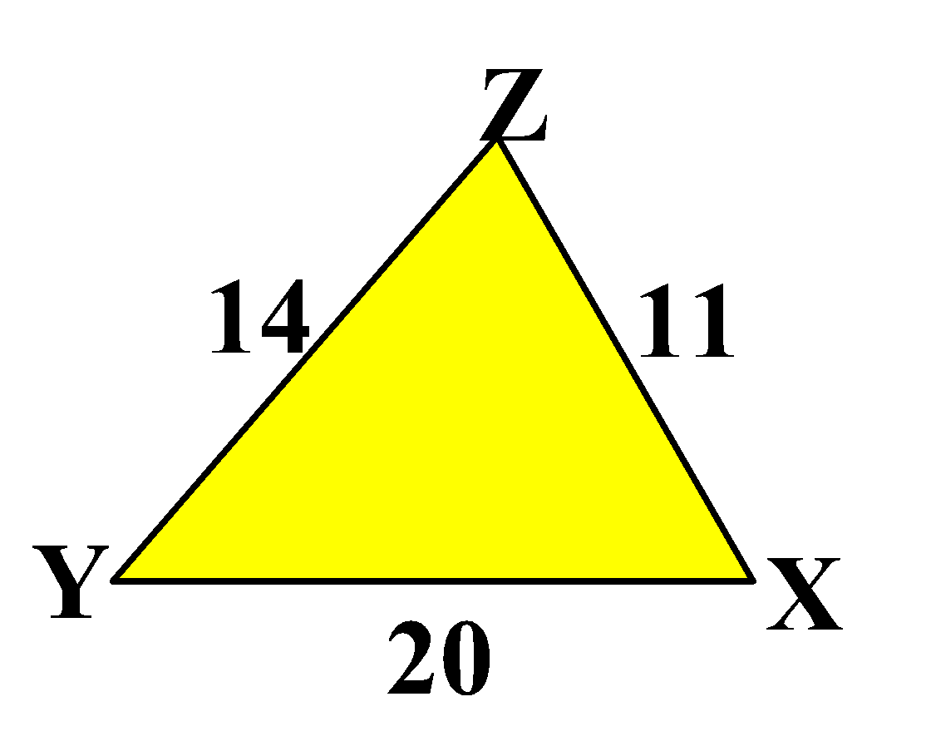

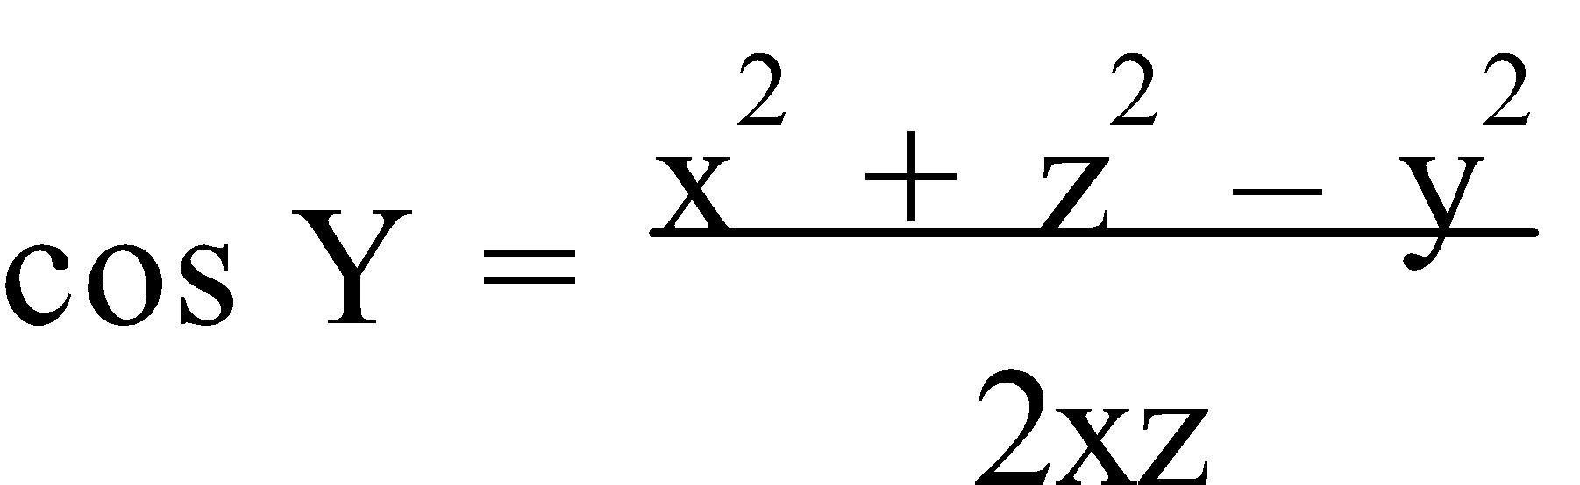

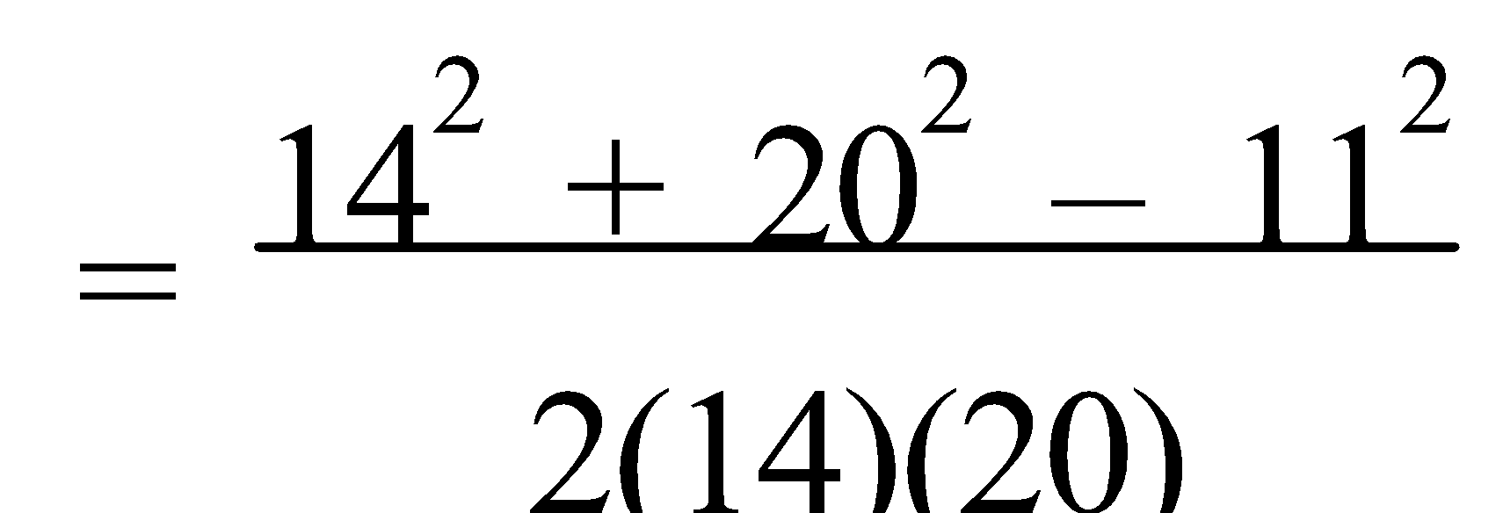

≈ 0.8482

s∠Y ≈ 31.98°

Ref: Ex.1C Q.1-42 (even)

**INDICES**

**1. INDIEX LAWS:** For am, m is called the **index, exponent or power**, and a is the **base**. The **Index Laws/Rules**, for **a ≠ 0**, are –

* **am × an = am+n**
* **am ÷ an = am-n**
* **a0 = 1**
* **(am)n = amn**
* **(ab)n = anbn**
* 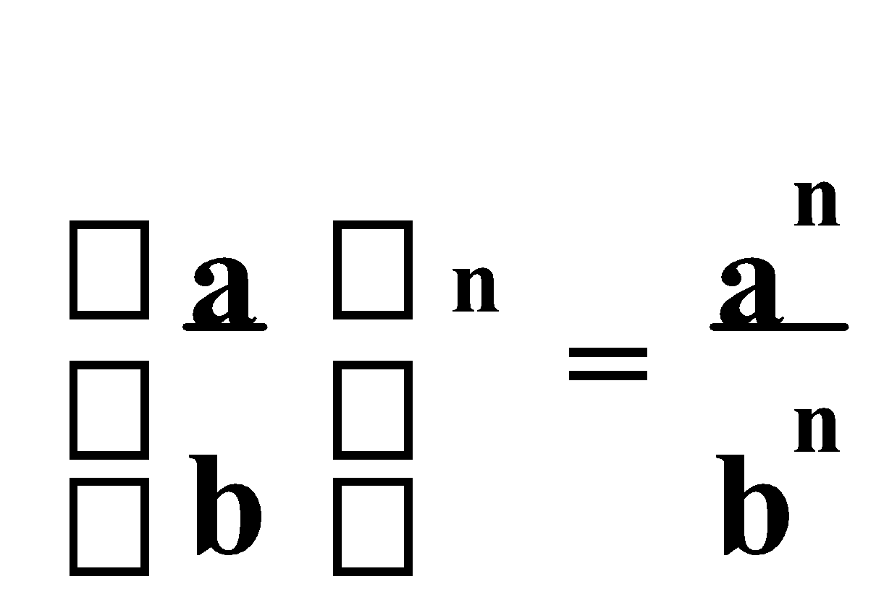

* 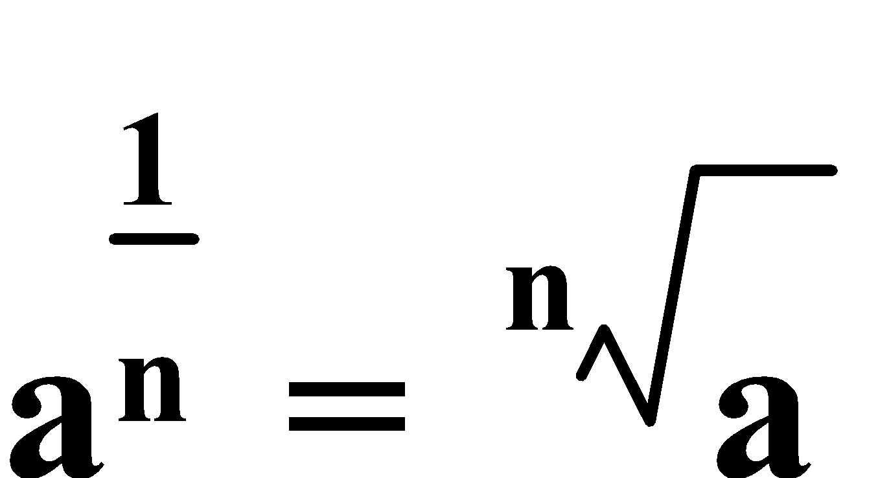
* 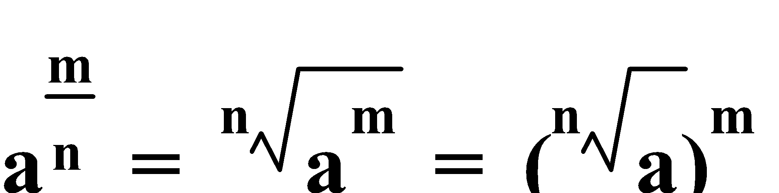
* 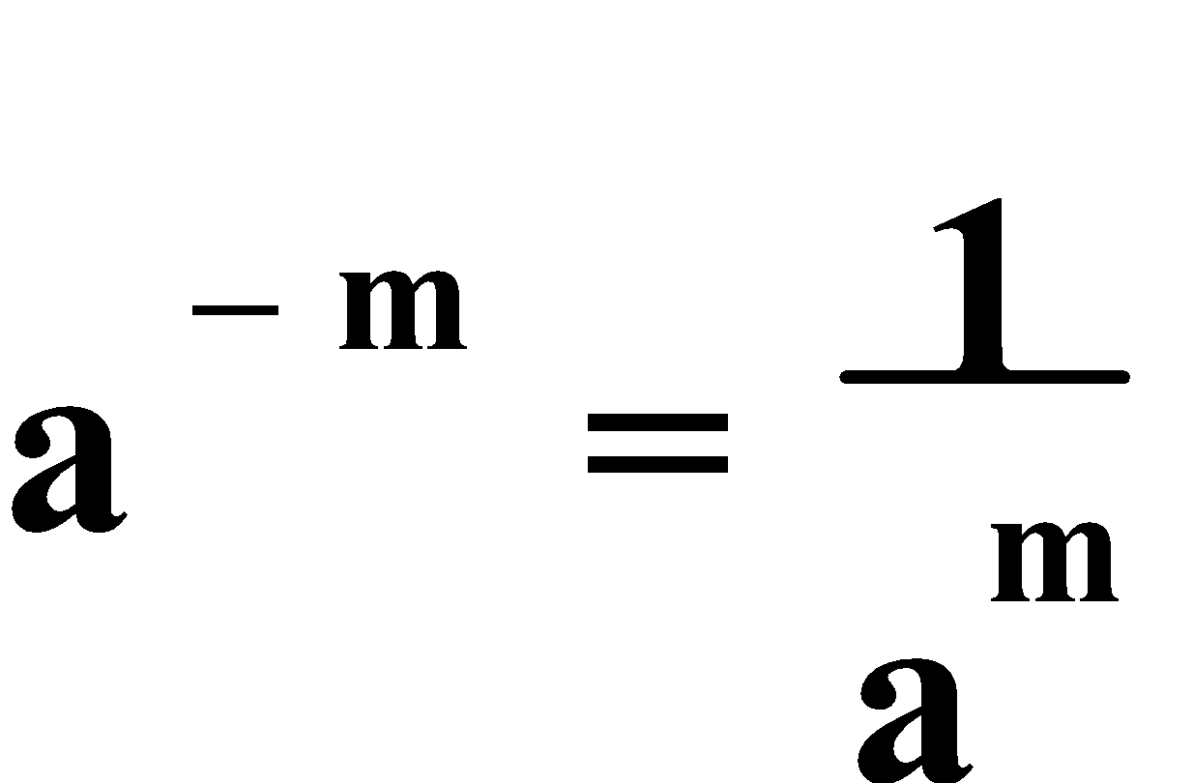
* 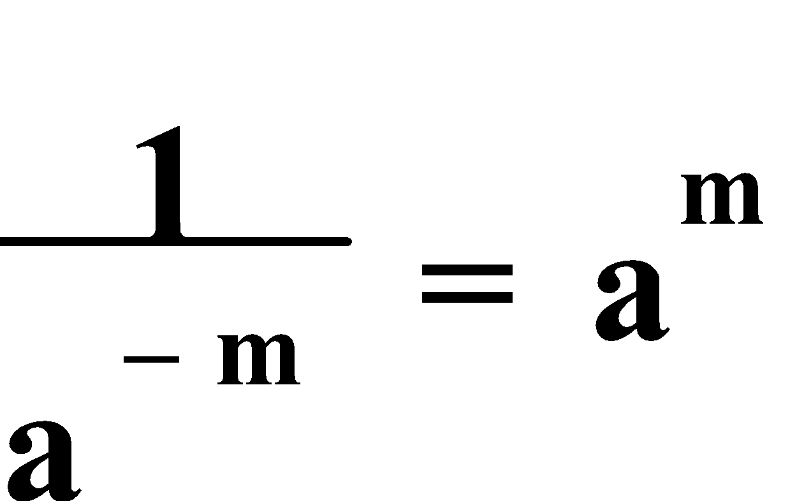

E.g.1. Without a calculator, evaluate:

a) 810.25

b) 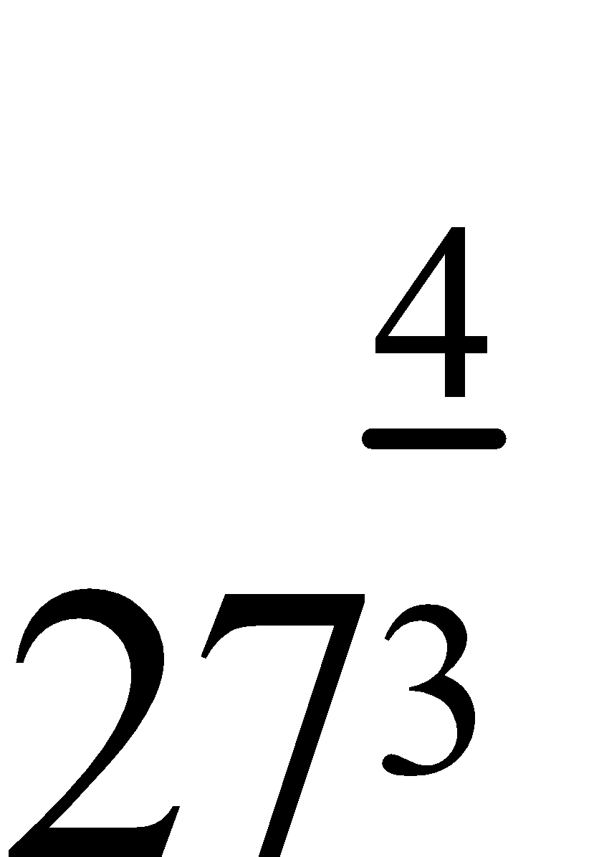

c) (58 ÷ 55)⅓

d) 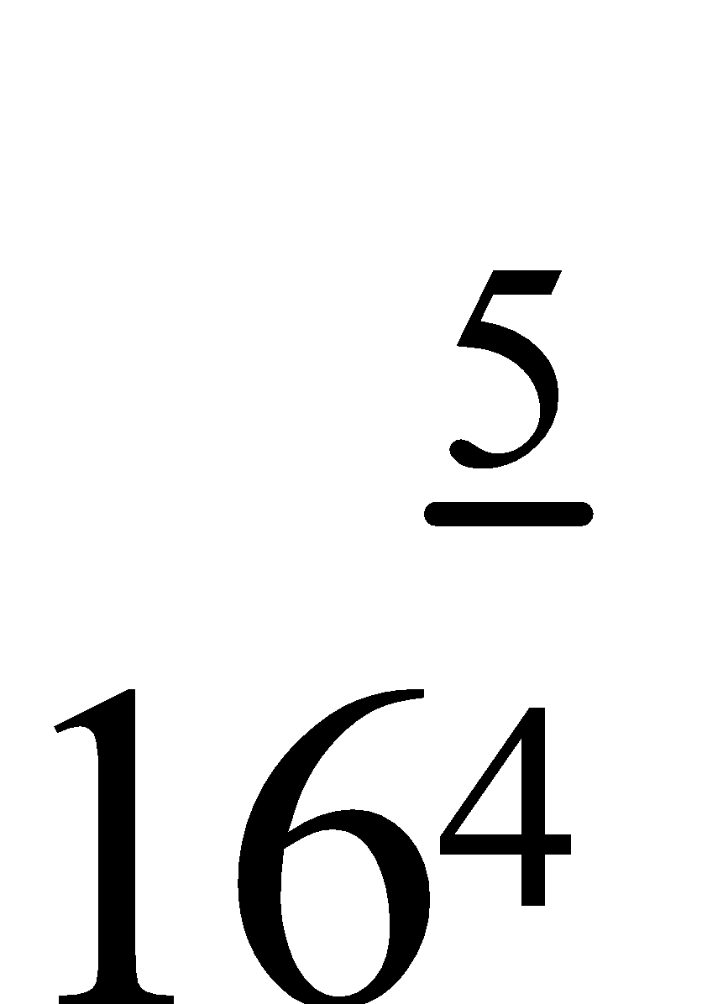

a) 810.25 = 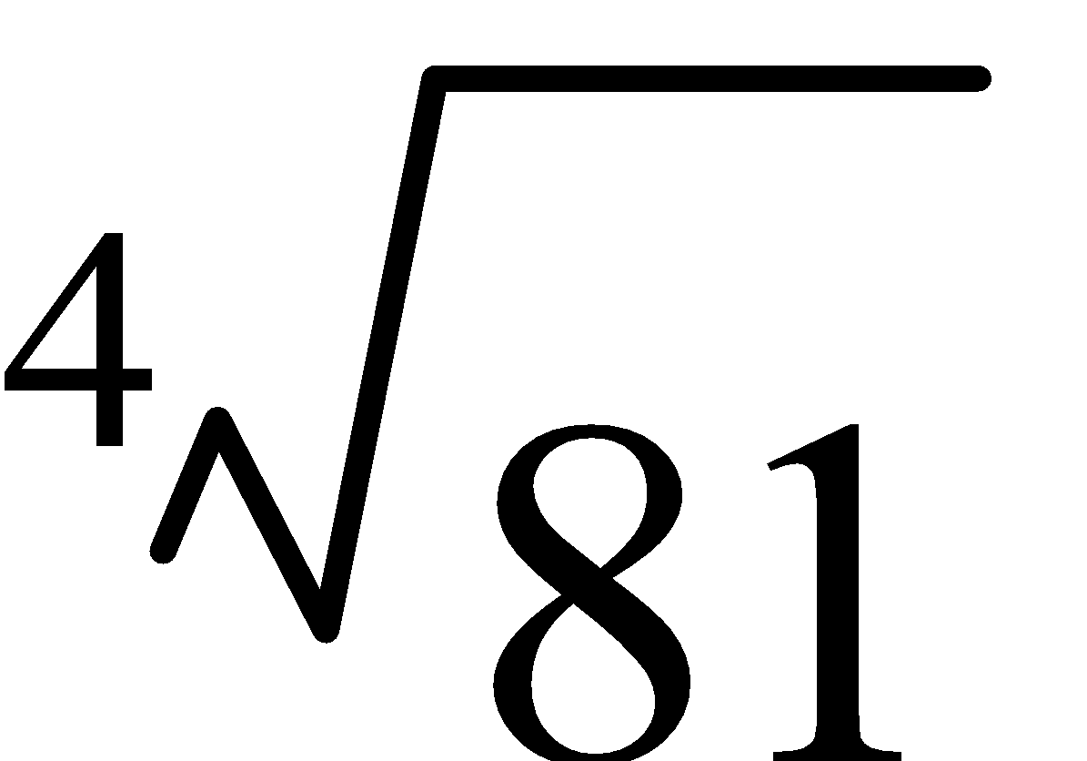

= ± 3

b)  = 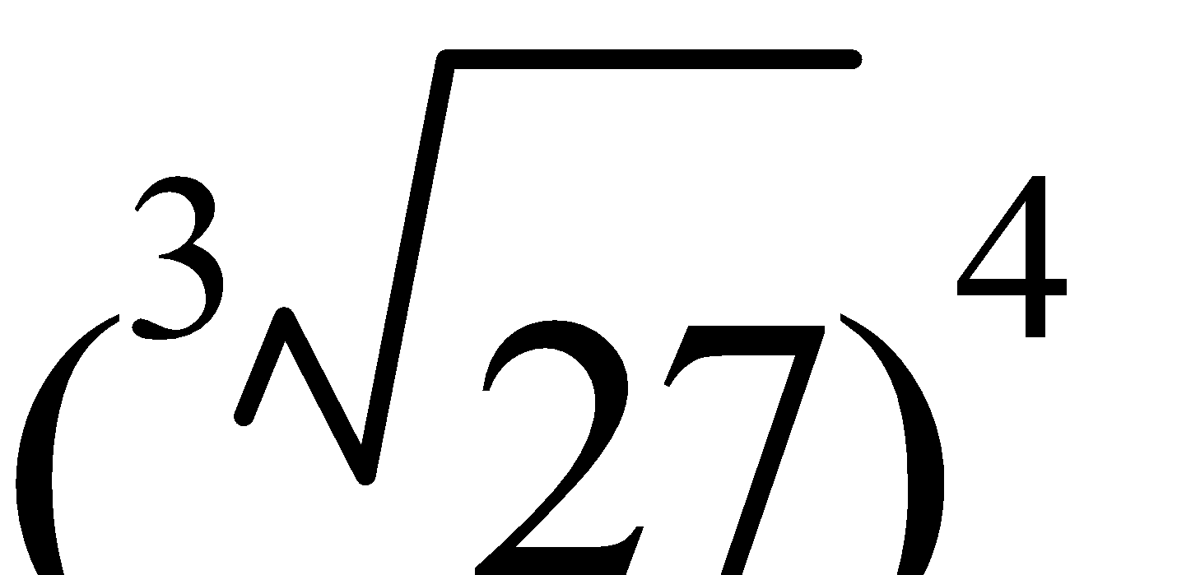

= 34

= 81

c) (58 ÷ 55)⅓ = (53)⅓

= 5

d)  = 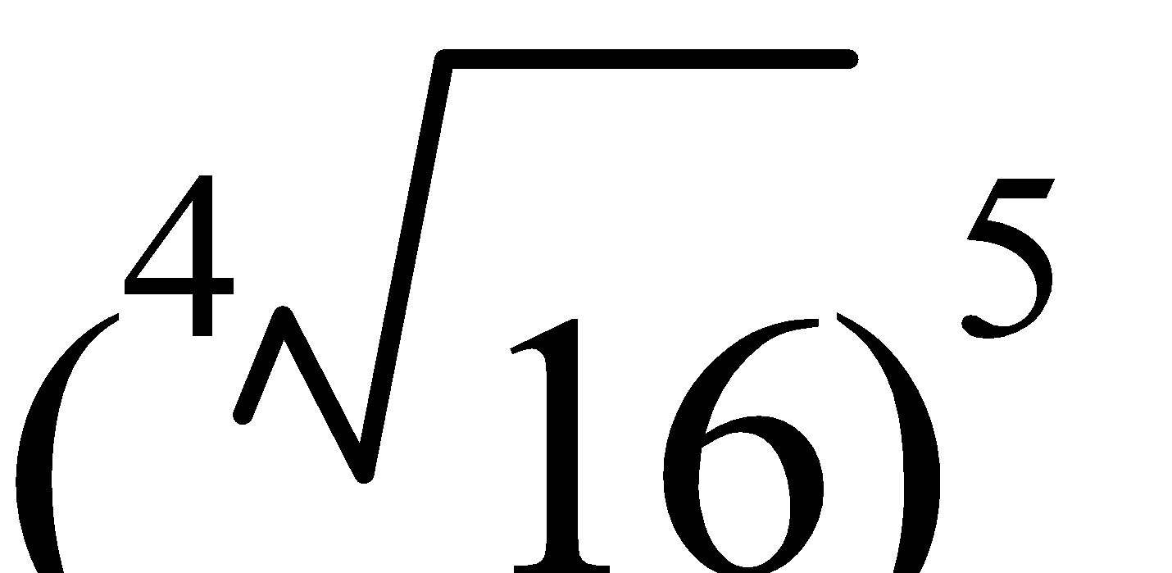

= ± 25

= ± 32

E.g.2. Simplify, expressing your answers in terms of positive indices:

a) c-3d4 × c7d-8

b) 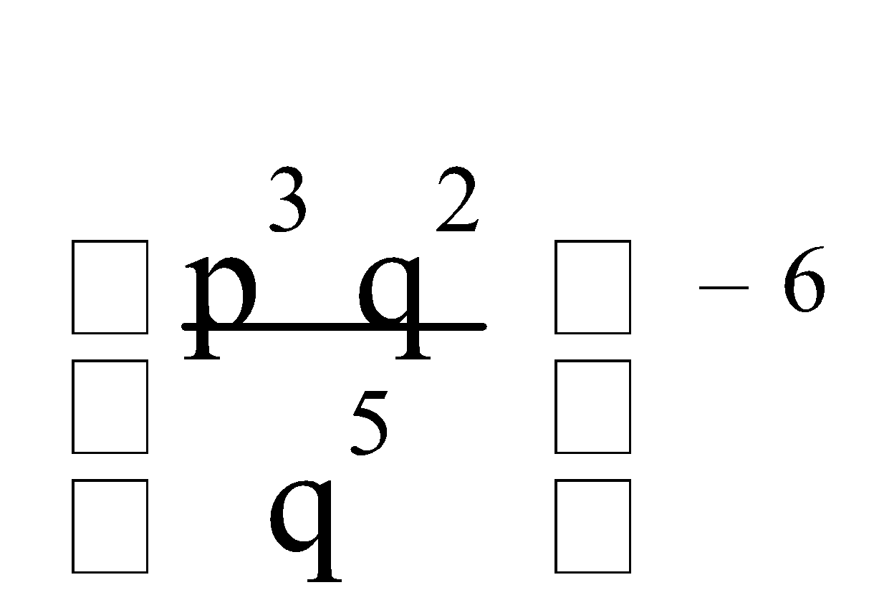

c) (27m-6n12)⅓

d) 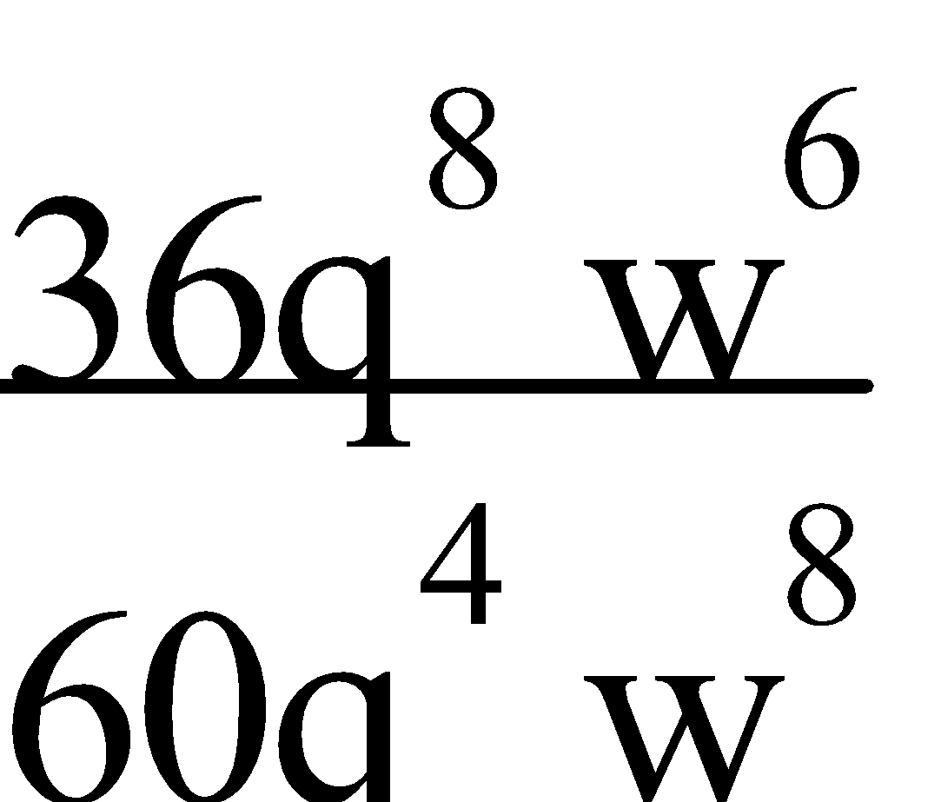

a) c-3d4 × c7d-8 = c4d-4

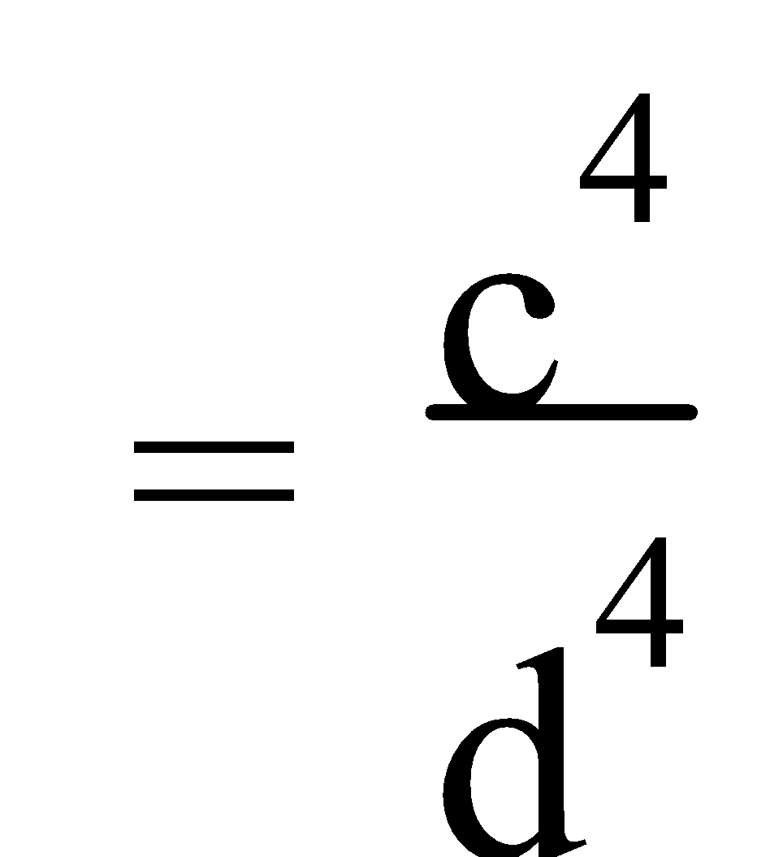

b)  = (p3q-3)-6

= p-18q18

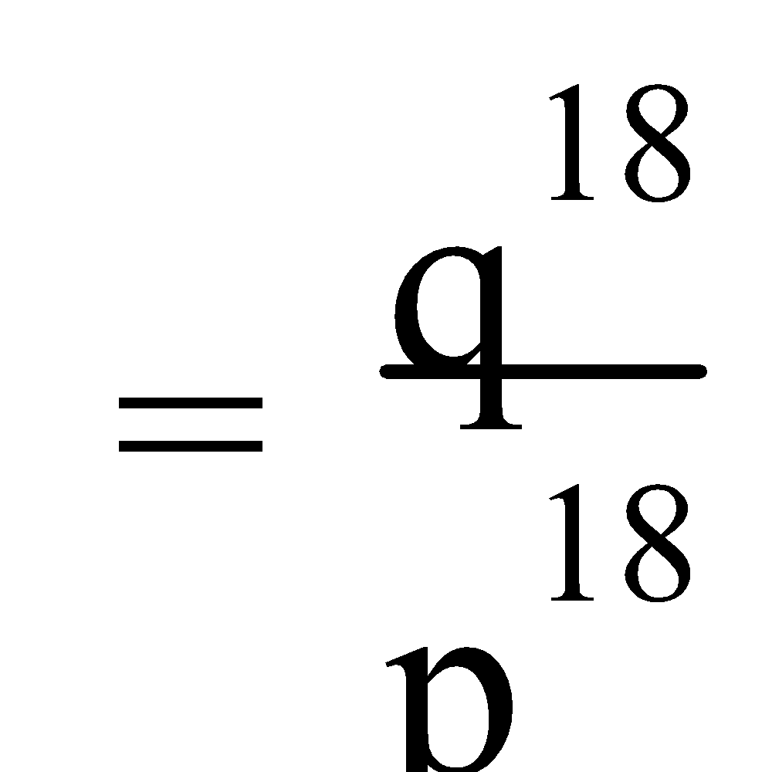

c) (27m-6n12)⅓ = 3m-2n4

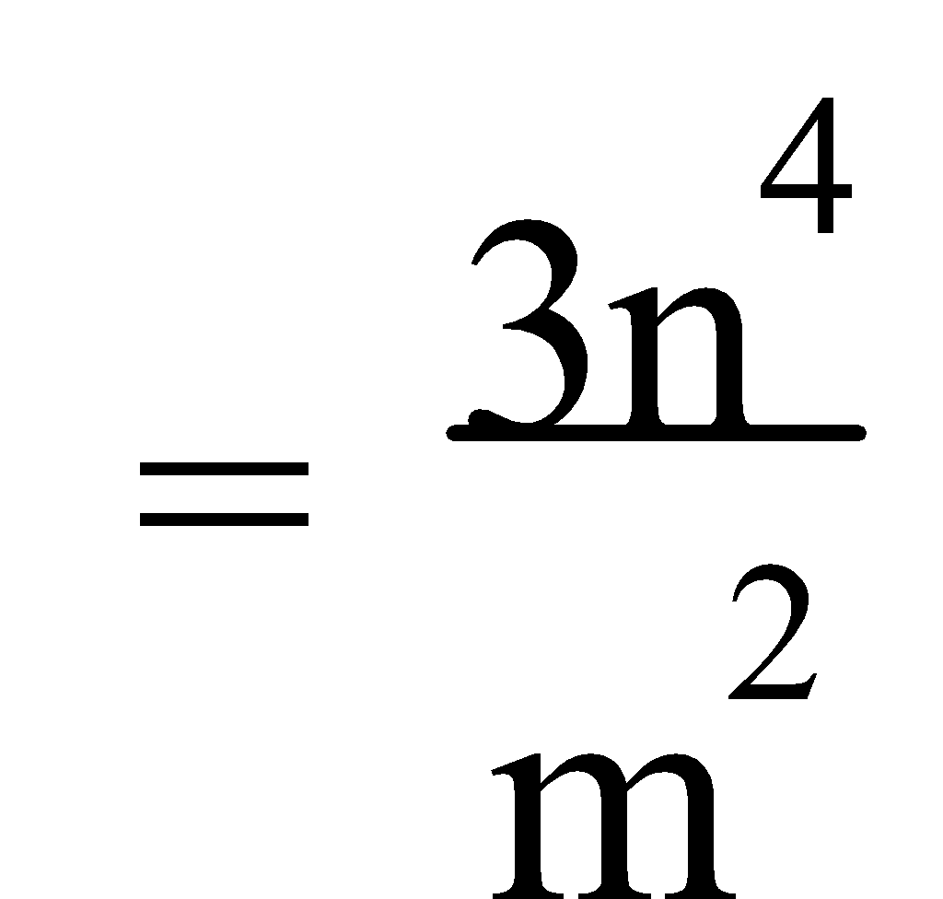

d)  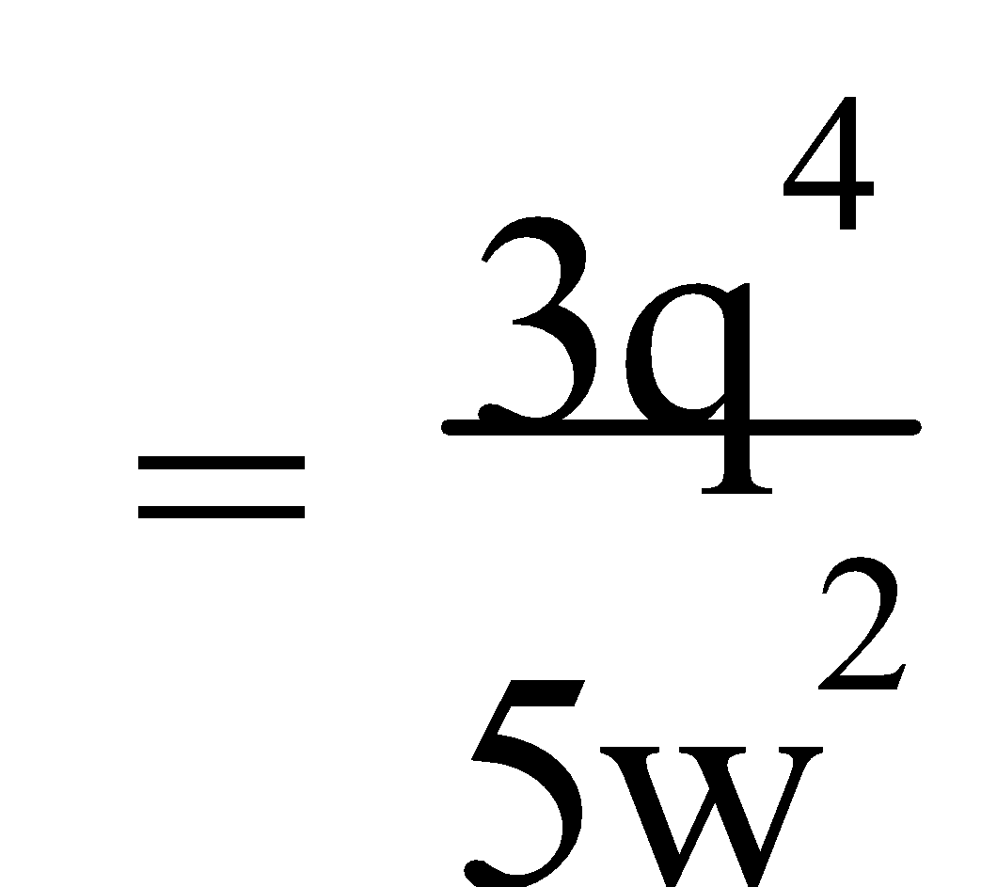

Ref: Ex.2A Q.1-124 (R.H.S.); 125-133

**2. SOLVING EQUATIONS INVOLVING INDICES:** Equations involving indices could have the unknown as the index or as the base. They can be solved by expressing both sides of the equation as powers of the same base; by reducing the power to 1 for the unknown; or by refining the solution by a “trial and adjustment” method.

E.g.3. Solve:

a) 8x-1 = 163x

b) a¾ = 27

c) 5x = 100

d) 32x – 7 = 74

e) 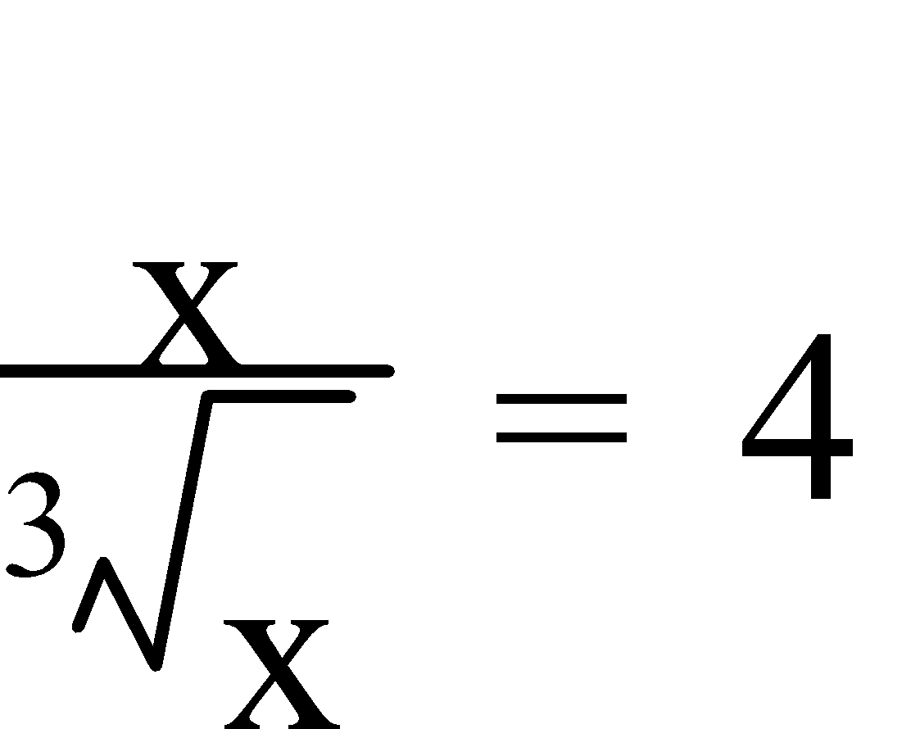

a) 8x-1 = 163x

(2³)x-1 = (24)3x

23x-3 = 212x

3x – 3 = 12x

9x = -3

x = -⅓

b) a¾ = 27 

(a¾) = (27)

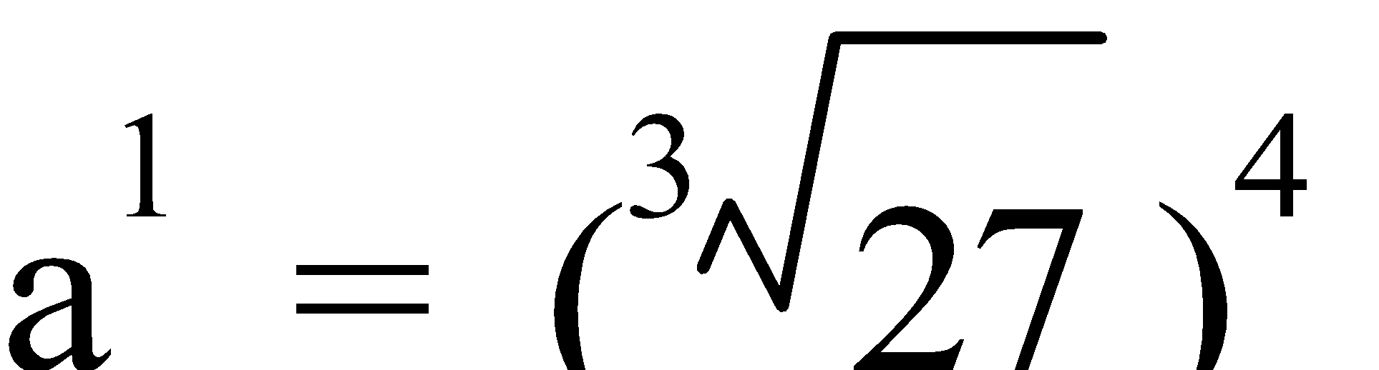

a = 34

a = 81

c) 5x = 100

But 52 = 25 and 53 = 125

Hence, x must be estimated.

Try: x = 2.5, 52.5 ≈ 56

x = 2.8, 52.8 ≈ 91

x = 2.9, 52.9 ≈ 106

∴ x must be between 2.8 and 2.9, so try:

x = 2.85, 52.85 ≈ 98

x = 2.86, 52.86 ≈ 100

∴ x ≈ 2.86

d) 32x – 7 = 74

32x = 81

32x = 34

2x = 4

x = 2

e) 

x⅔ = 4

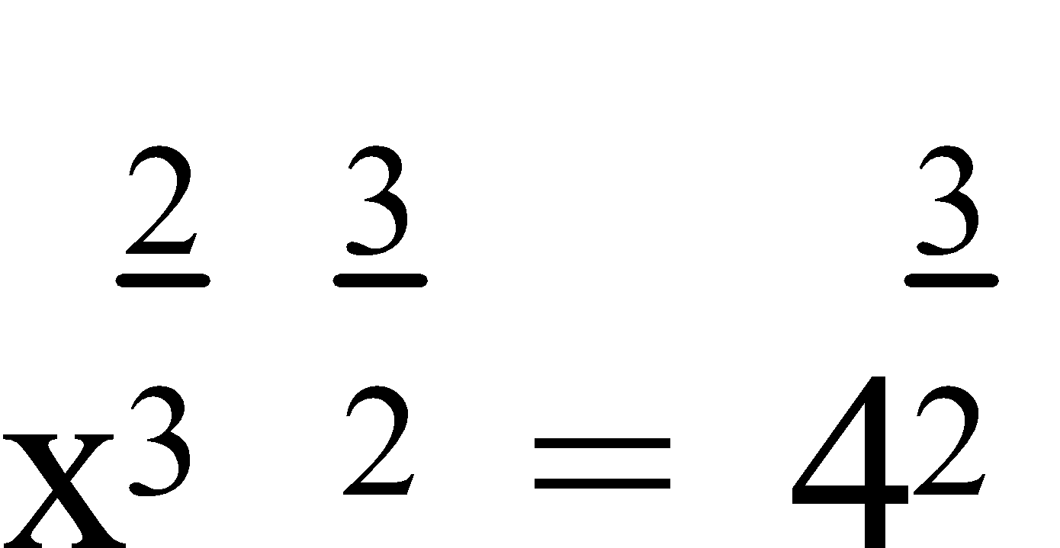 

x = 23

x = 8

Ref: Ex.2B Q.1-54 (R.H.S.); 55

**SETS, PROBABILITY AND TREE DIAGRAMS**

**1. DEFINITIONS AND NOTATION FOR SETS:** A **set** is a group of things that have a relationship between them. Sets are usually contained between **curly brackets { }** and are **named** using a **capital letter**. Sets may be represented by **listing the elements** between curly brackets, in **words**, **graphically/diagrammatically** or by using **set builder notation**, e.g. P = {x: x > 2}. A letter with a subscript, e.g. **x3**, often denotes an **element of a set**.

Some **symbols** associated with sets are –

**∈** is an element of

**∉** is not an element of

**⊂** is a subset of

**⊆** is a **proper** subset of

**⊄** is not a (proper) subset of

**U** the **universal set**, i.e. the set of all things under discussion

**…** and so on

**n(A)** or **| A |** the number of elements in the set A

**A'** or**A** the complement of the set A

**{ }** or **φ** the empty set

**A = B** the set A is **equal** to the set B, i.e. the sets contain the same elements

**NOTE:** Any set which ends with …, e.g. {1, 2, 3,…} is called an **infinite set**.

A **Venn Diagram** is a diagrammatic representation of sets. 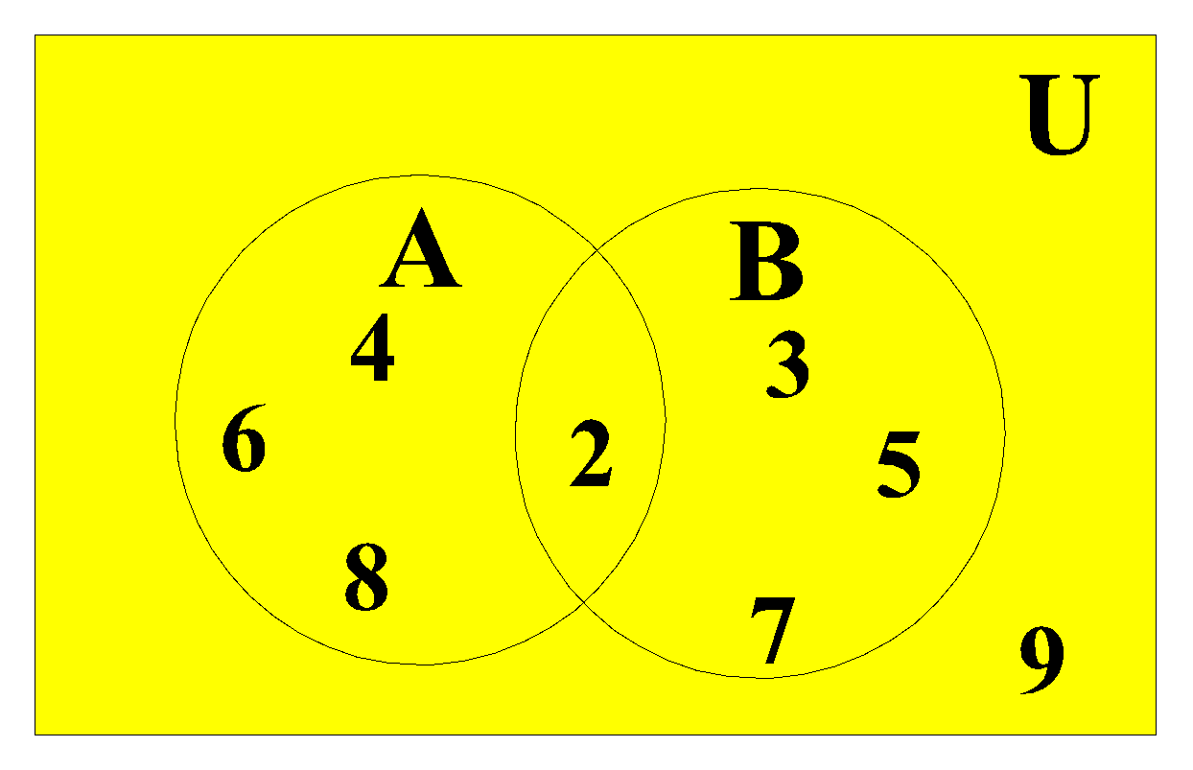

This diagram shows two sets –

A the even integers from U and

B the prime numbers in U

where U = {2, 3, 4, 5, 6, 7, 8, 9}.

Venn diagrams can be used to illustrate **operations between sets** – 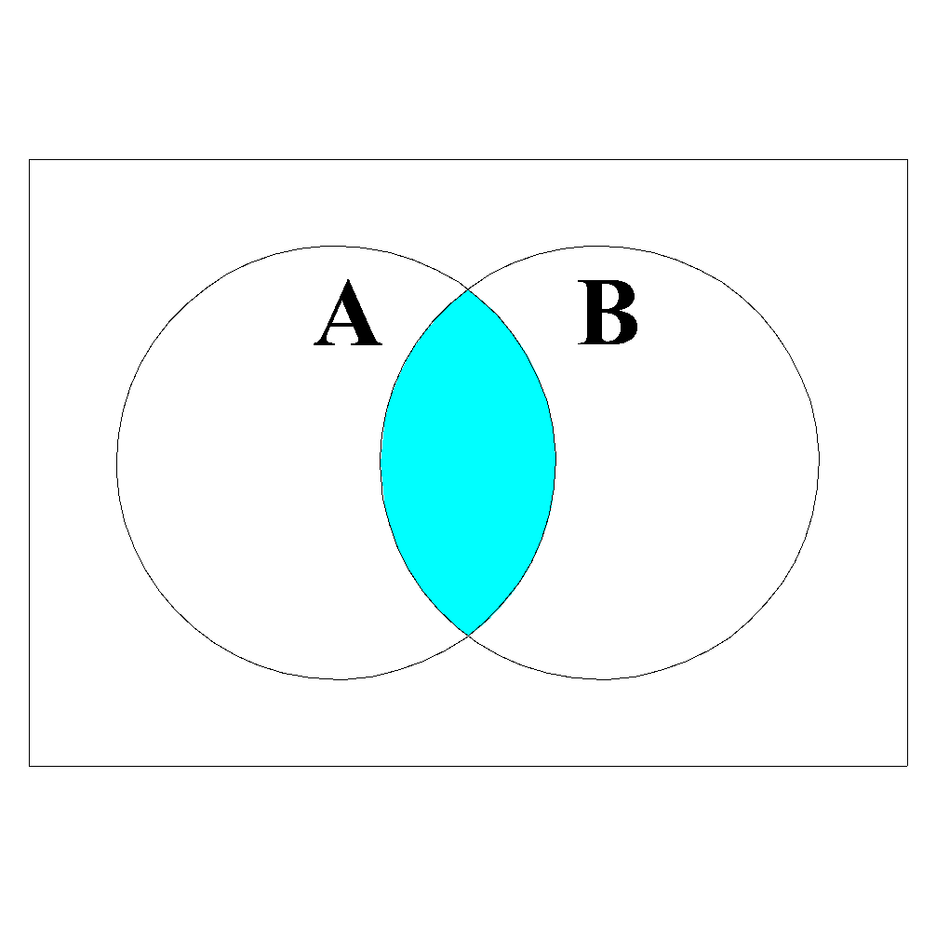

**A ∩ B**

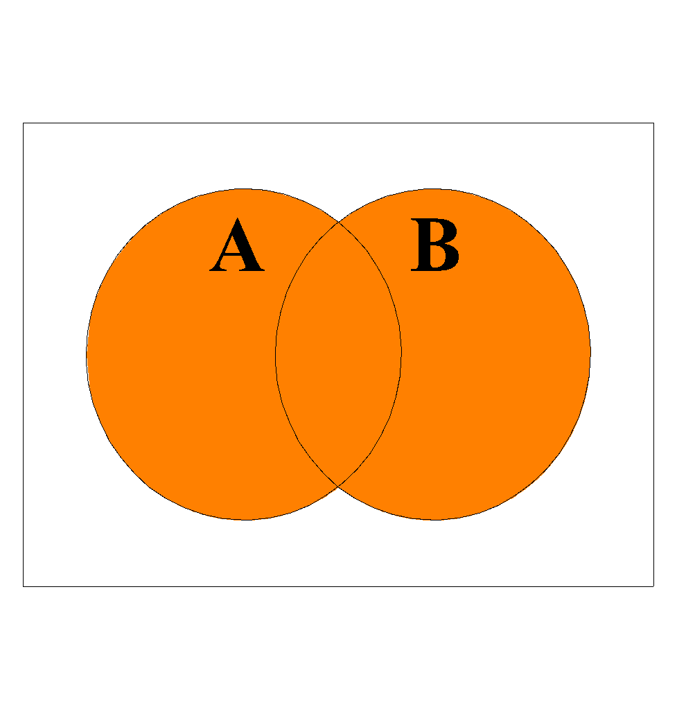

**A ∪ B**

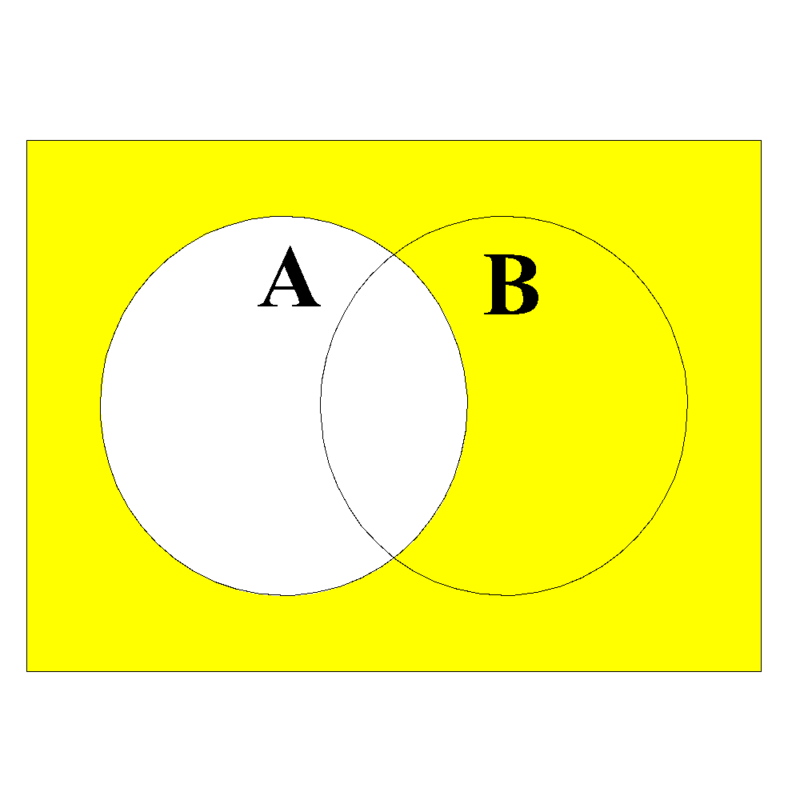

**A'** or**A**

Ref: Ex.3A Q.1; 2-16 (even)

**2. VENN DIAGRAMS:** **Venn diagrams** are generally used to solve problems when there is **no** particular **interest** in **specific elements**, just the **number** of elements, or the **probabilities** for each section of the diagram is important.

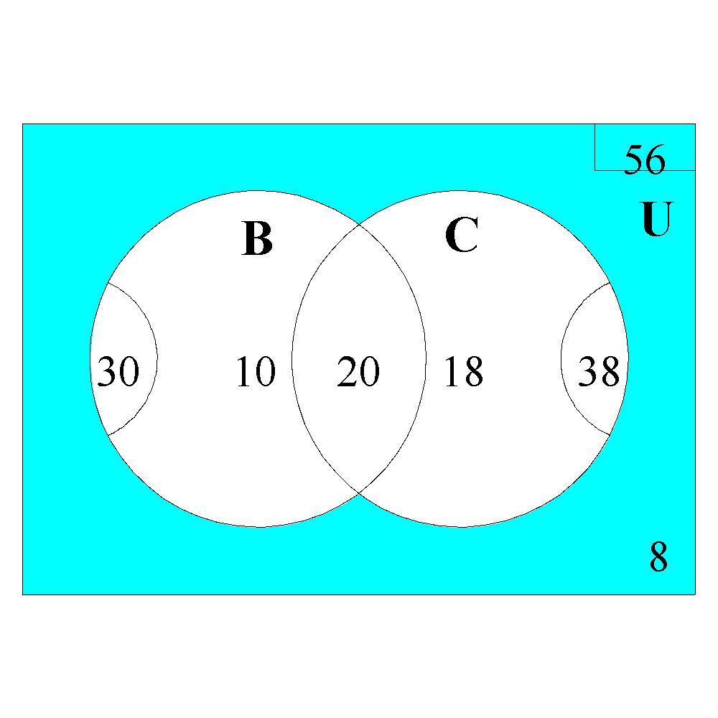

E.g.1. This diagram shows the methods of transportation to work of 56 people interviewed. How many of those interviewed had:

a) only used one method of transport?

b) taken the bus but not used a car?

c) used none of these methods of transport?

1. n(one method) = 10 + 18 = 28
2. n(bus but not car) = 10
3. n(no method) = 8

E.g.2. 100 people were surveyed about which brand of chocolate milk they prefer. The probabilities are given in this Venn diagram. What is the probability of a person: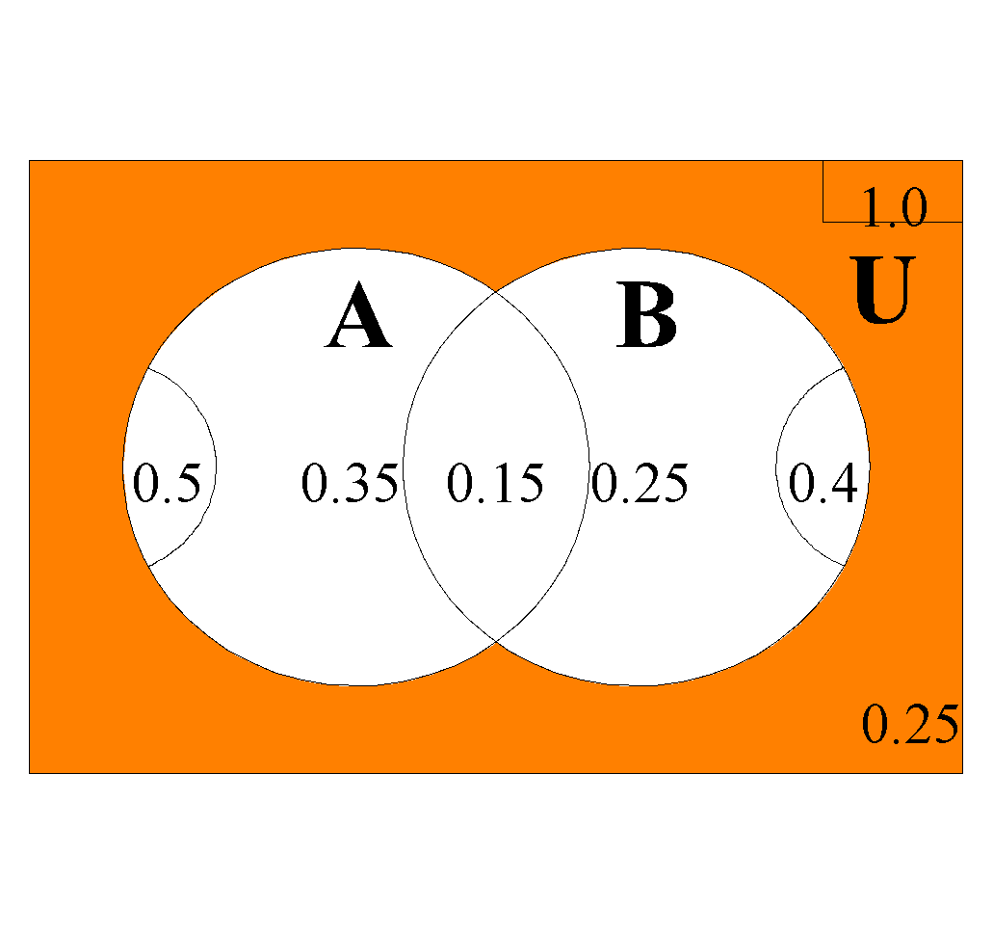

a) preferring Brand A?

b) liking neither?

c) liking both equally?

1. P(Brand A) = 0.5
2. P(neither) = 0.25
3. P(both) = 0.15

Ref: Ex.3B Q.1-12 (even)

**3. TREE DIAGRAMS:** **Tree diagrams** can **show** the **probabilities** associated with the given sets, or be used to **determine probabilities** or have the **probabilities listed** rather than the numbers of each section.

E.g.3. A bowl contains 6 pink and 7 orange balls. Two balls are selected at random from the bowl. Determine the probability of obtaining: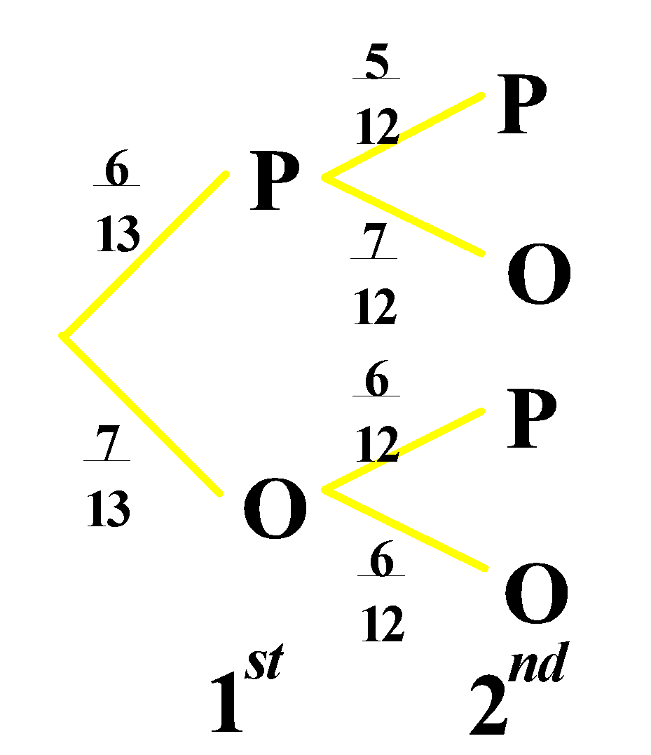

a) two pinks?

b) a pink then an orange?

c) a pink given the first was an orange?

1. P(two pinks) = 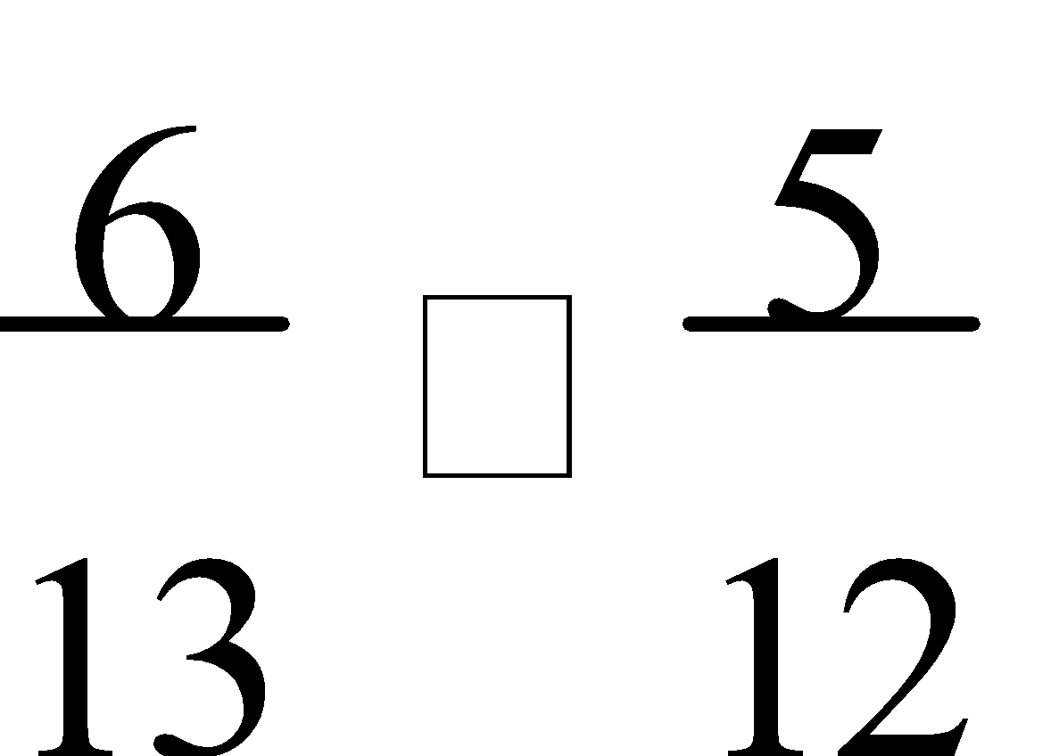

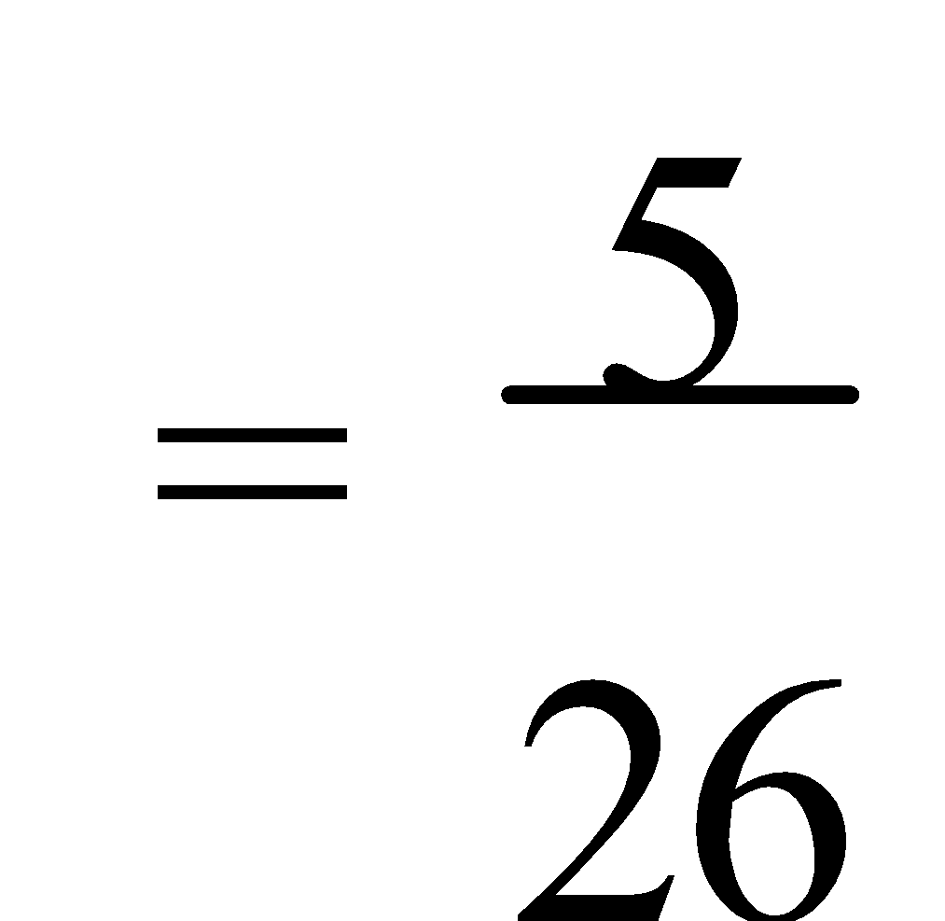

1. P(pink then orange) = 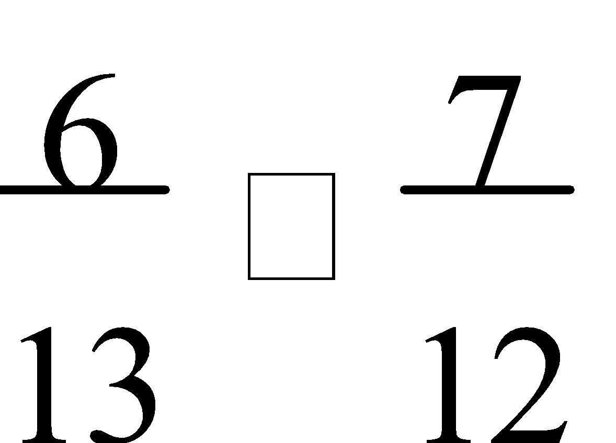

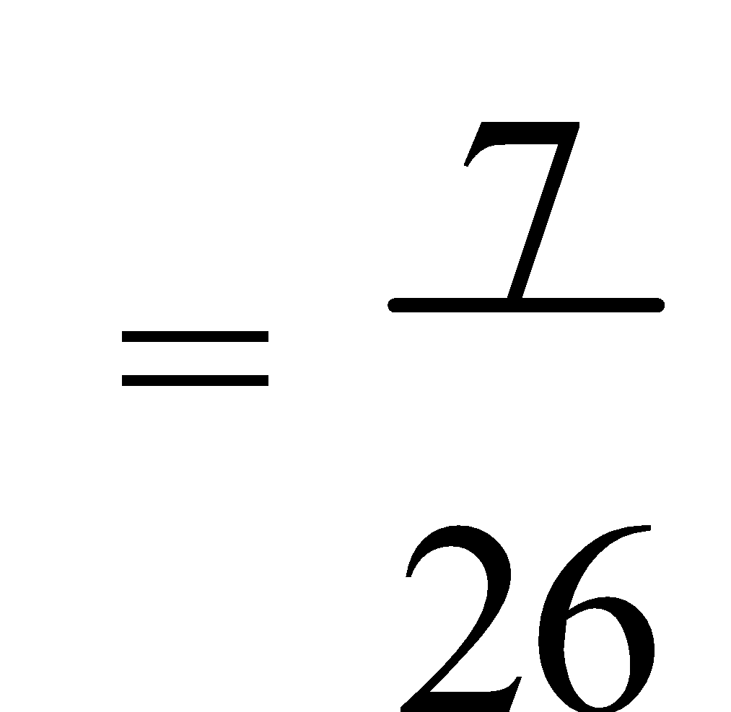

1. P(pink| orange 1st) = 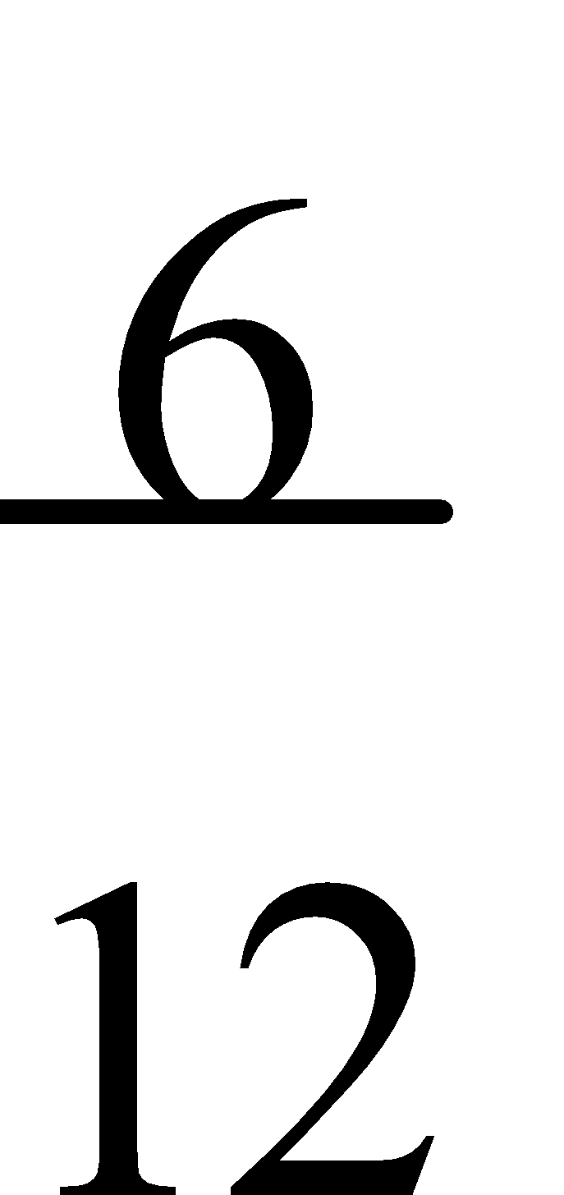

= ½

Ref: Ex.3C Q.1-6 (even)

**4. COMPOUND EVENTS:** When two events are combined, the result is known as a **compound event**. The key words are **AND** and **OR**. A **and** B – **both events** are satisfied, A **or** B – **one or both** events are satisfied. Thus, **and** is the **intersection** of the two sets, and **or** is the **union** of the two sets.

E.g.4. When a red and blue dice are rolled simultaneously, what is the probability of:

a) a 4 on the blue die and a 2 on the red die?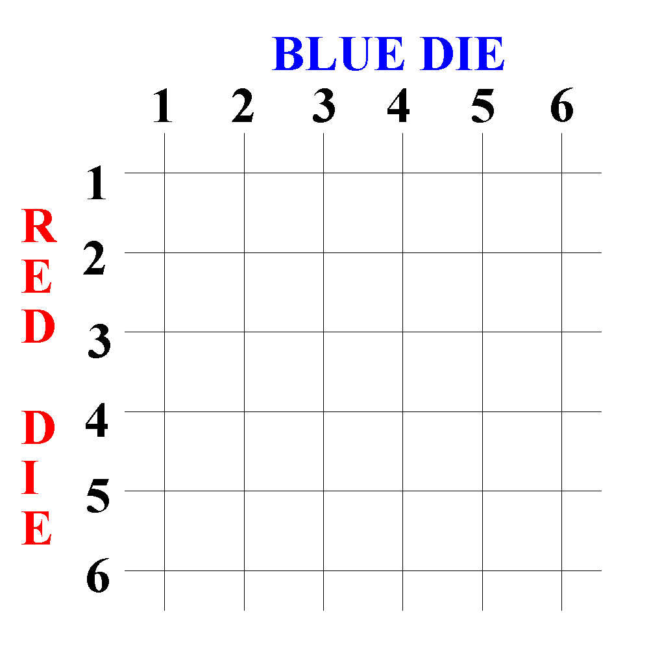

b) a 2 on the red die or a sum of 4?

1. P(B4 and R2) = 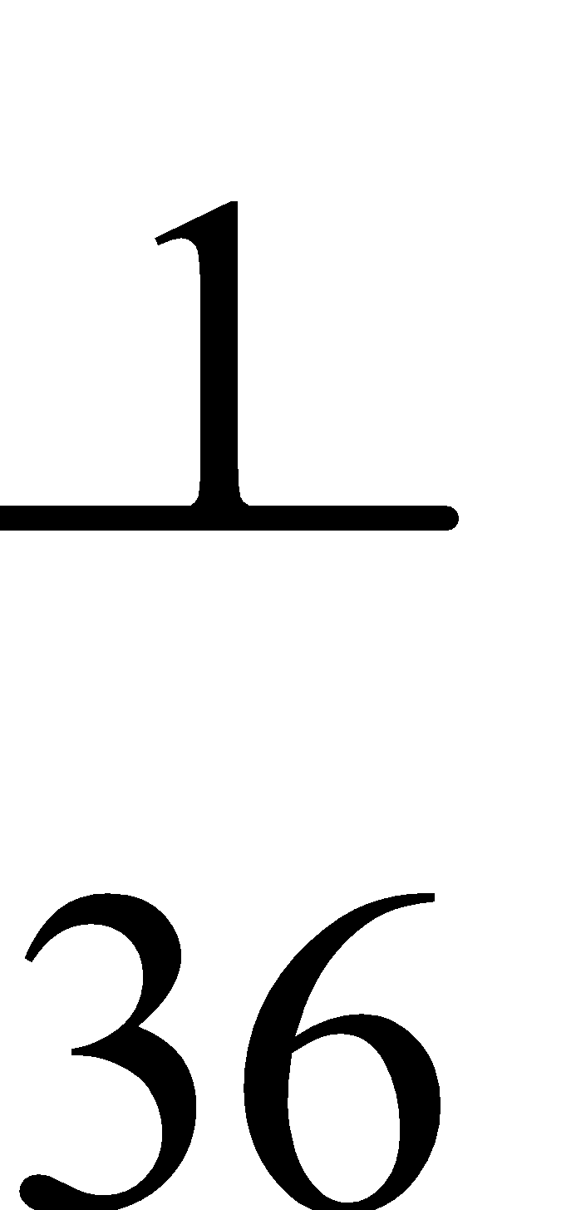
2. P(R2 or sum of 4) = 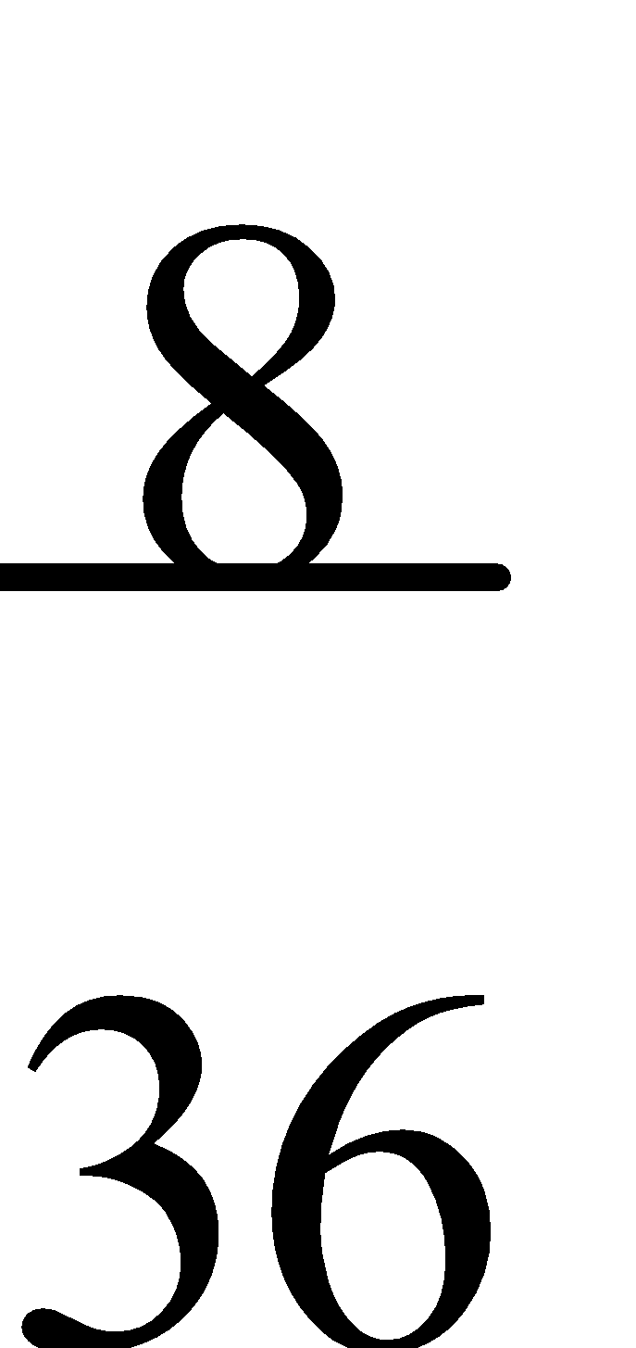

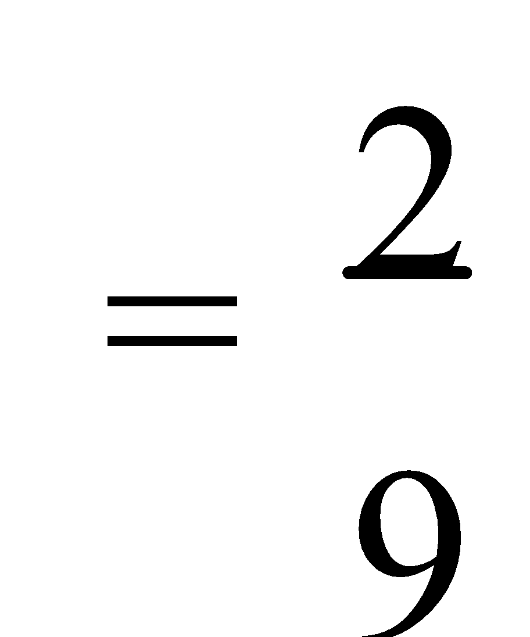

Ref: Ex.3D Q.1-6 (even)

ACTIVITIES p.71

**COUNTING**

**1. ARRANGEMENTS:** **Counting techniques** are used to examine the different outcomes of choice problems. The **multiplication principle** determines the number of different ways (**arrangements**) of performing one operation followed by another operation. If two successive events can be performed in “**a**” ways and in “**b**” ways respectively, then there are **a × b ways** of performing the **events in succession**.

E.g.1. A librarian has 6 different books to **arrange** on a shelf. How many different arrangements are possible?

| 6 | 5 | 4 | 3 | 2 | 1 |
| --- | --- | --- | --- | --- | --- |

∴ n(arrangements) = 6 × 5 × 4 × 3 × 2 × 1 = 720

E.g.2. Using the digits 1, 2, 3, 4, 5 and 6 and the letters A, B, C, D and E, how many six-digit number plates can be made using 3 letters followed by 3 digits?

| 5 | 5 | 5 | 6 | 6 | 6 |
| --- | --- | --- | --- | --- | --- |

∴ n(arrangements) = 53 × 63 = 27 000

Ref: Ex.4A Q.1-15 (odd)

**2. ADDITION PRINCIPLE:** If either of two separate (**mutually exclusive**) events can be performed in “**a**” ways and “**b**” ways respectively, then there are **a + b ways** of performing **either event**, i.e. of performing one event **or** the other event, provided events A and B are **mutually exclusive**. **Mutually exclusive** events cannot occur together.

E.g.3. Using the digits 0-7 and the letters A-J, how many six-digit number plates can be made using 6 letters or 6 digits if no letter or digit can be used more than once?

| Letters: | 10 | 9 | 8 | 7 | 6 | 5 |
| --- | --- | --- | --- | --- | --- | --- |

| Digits: | 8 | 7 | 6 | 5 | 4 | 3 |
| --- | --- | --- | --- | --- | --- | --- |

∴ n(arrangements) = 10 × 9 × 8 × 7 × 6 × 5 + 8 × 7 × 6 × 5 × 4 × 3 = 171 360

Ref: Ex.4B Q.1-13 (odd); 14, 15

E.g.4. How many arrangements of the letters in the word MATHS are possible if:

a) all letters are used?

b) all letters are used but the last must be S?

c) three letters are used?

d) five letters are used but the first must be M and the last must be S?

e) three letters are used but S is excluded?

f) all letters are used but M and S must be together?

a) 5 × 4 × 3 × 2 × 1 = 120

b) 4 × 3 × 2 × 1 = 24

c) 5 × 4 × 3 = 60

1. 1 × 3 × 2 × 1 × 1 = 6

e) 4 × 3 × 2 = 24

f) M and S are treated as one letter and there are two ways of ordering them – MS or SM.

∴ (4 × 3 × 2 × 1) × 2 = 48

Ref: Ex.4C Q.1-11 (odd)

E.g.5. Using the digits 1, 2, 3, 4, 5 and 6:

a) How many six-digit even numbers can be made?

b) How many of the numbers from a) are bigger than 400 000?

a) For an even number the last digit must be a 2, 4 or 6.

| ? | ? | ? | ? | ? | 3 |
| --- | --- | --- | --- | --- | --- |

This leaves 5 digits to choose from for the first, 4 for the second, …

| 5 | 4 | 3 | 2 | 1 | 3 |
| --- | --- | --- | --- | --- | --- |

Thus the number of six-digit even numbers = 5 × 4 × 3 × 2 × 1 × 3

= 360

| 3 | 4 | 3 | 2 | 1 | 1 |
| --- | --- | --- | --- | --- | --- |

b) For numbers to be greater than 400 000, the first digit must be a 4, 5 or 6.

Numbers > 400 000 and ending in a 2:

| 2 | 4 | 3 | 2 | 1 | 1 |
| --- | --- | --- | --- | --- | --- |

Numbers > 400 000 and ending in a 4:

| 2 | 4 | 3 | 2 | 1 | 1 |
| --- | --- | --- | --- | --- | --- |

Numbers > 400 000 and ending in a 6:

∴ The total number of even numbers > 400 000 = 72 + 48 + 48

= 168

Ref: Ex.4D Q.1-10 (even)

**3. PROBABILITY:** **Counting techniques** are sometimes useful in **probability problems**.

E.g.6. If two letters are picked from the alphabet, what is the probability that the two letters are A and T?

Total number of 2 letter picks = (26 × 25) ÷ 2

= 325

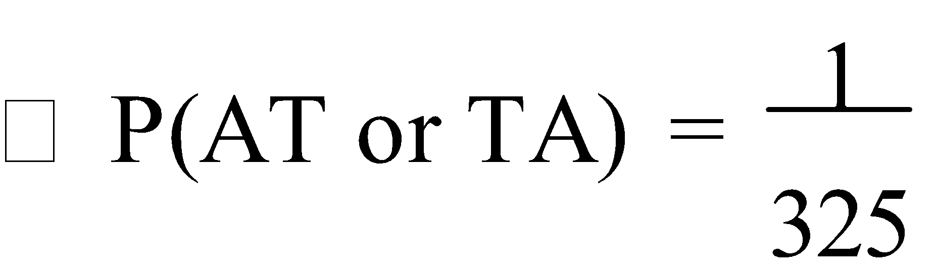

E.g.7. If all the letters of the word **MATHS** are arranged in random order, what is the probability that:

a) the M will be the first letter?

b) the T and H will be next to one another?

c) the A will be first **or** last?

d) the S will be last given the M was first?

Total number of arrangements = 5 × 4 × 3 × 2 × 1

= 120

1. P(M1) = 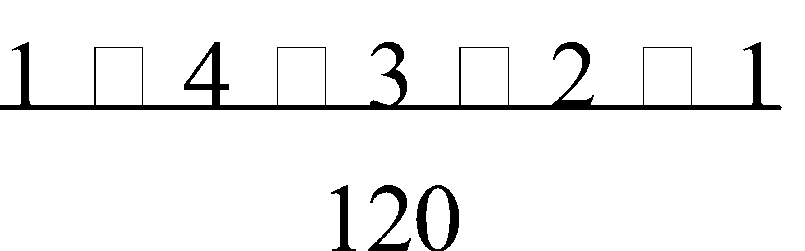

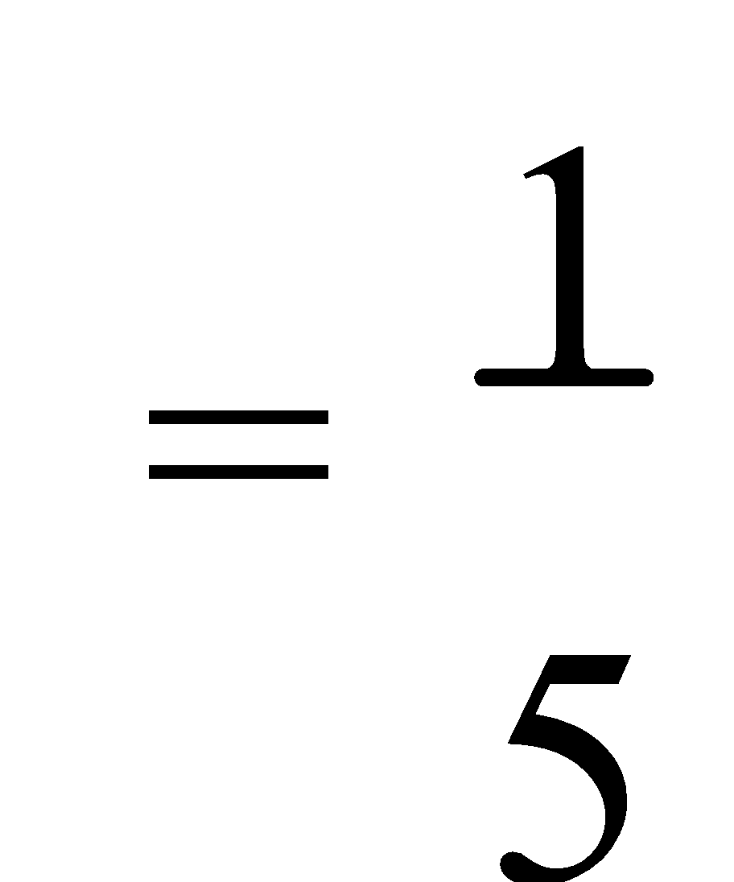

1. P(TH or HT) = 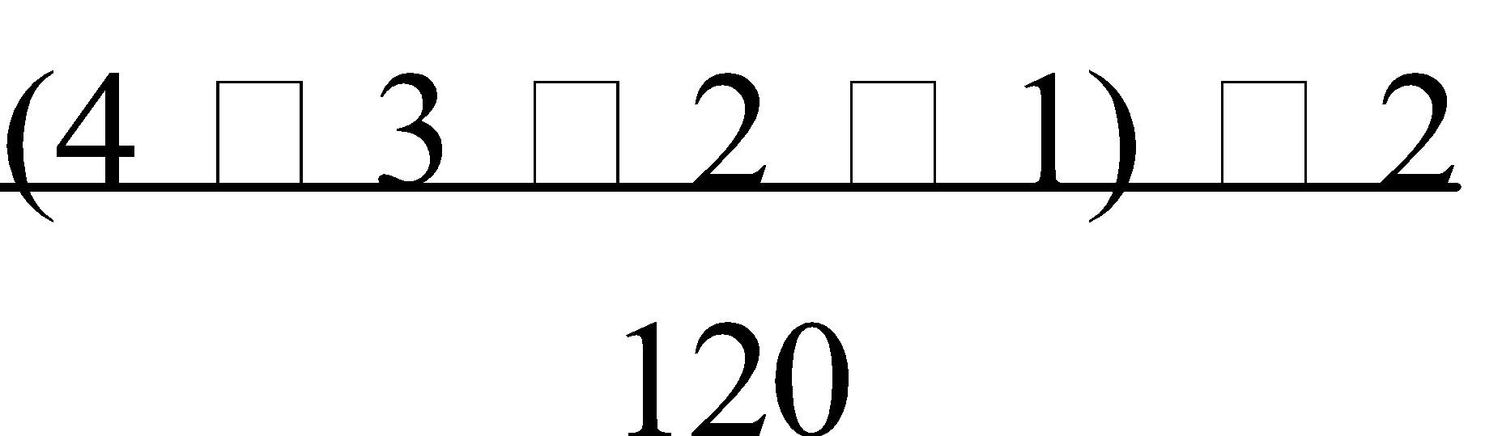

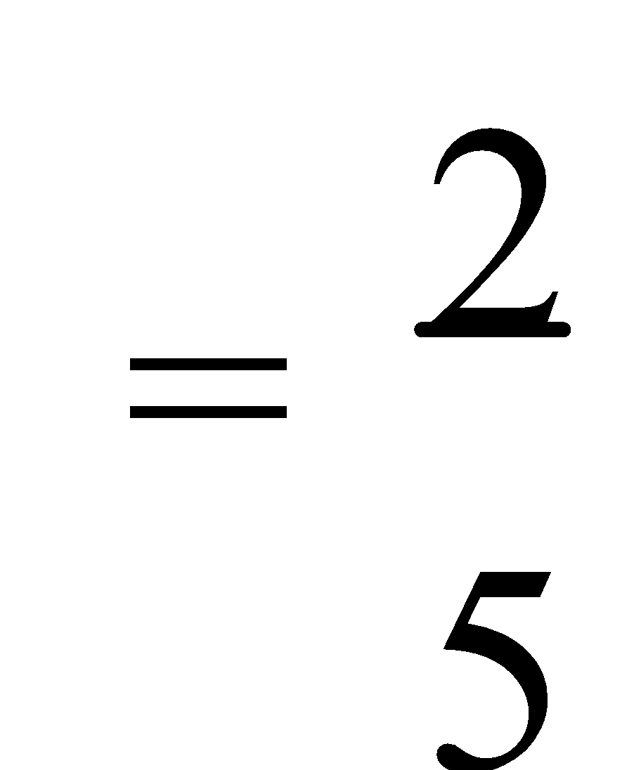

1. P(A1 or A5) = 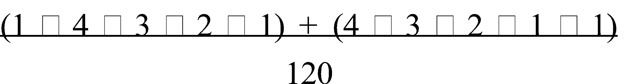



1. P(S5 | M1) = 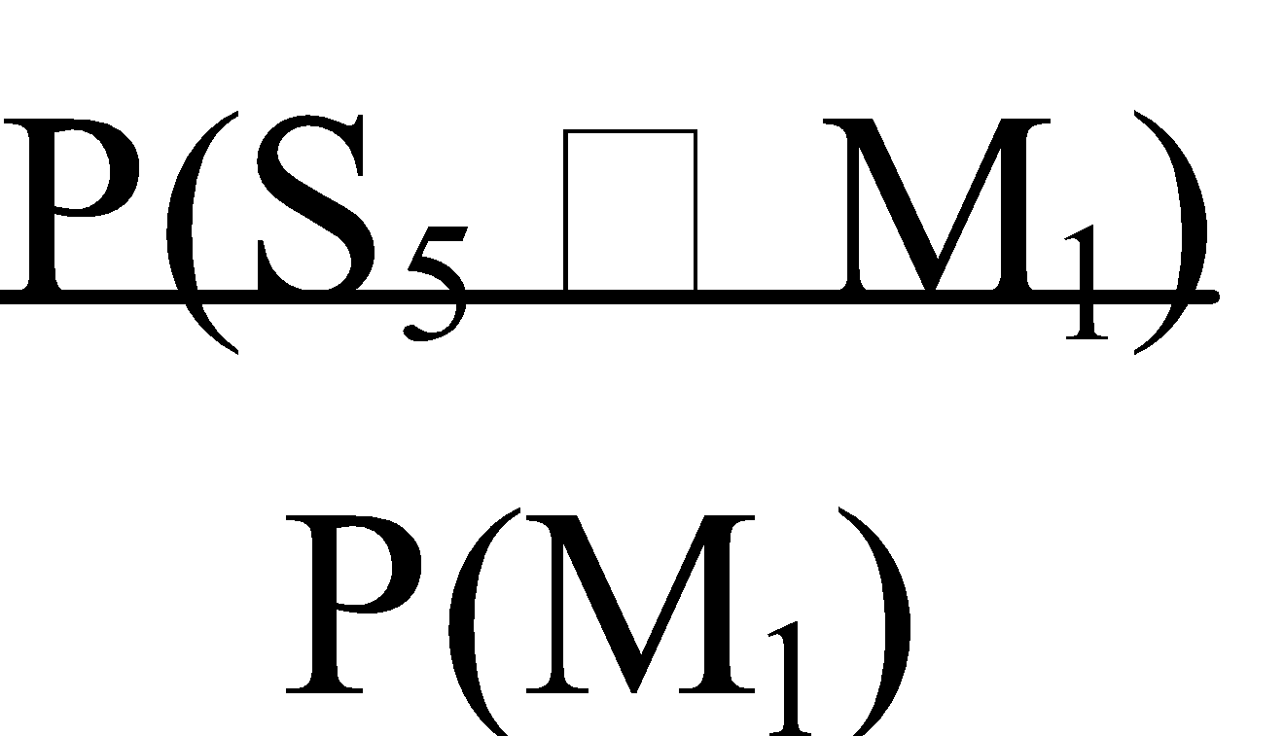

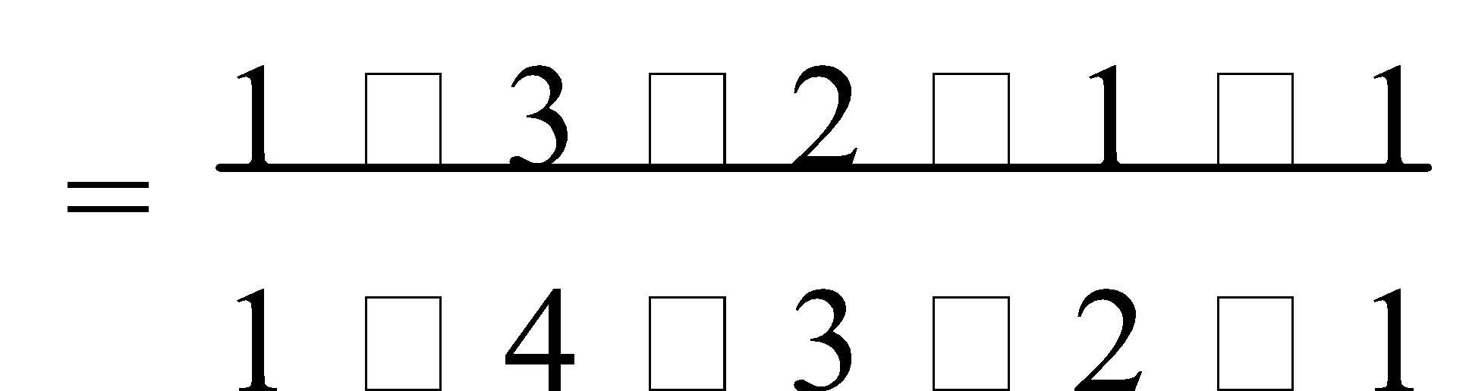

= ¼

Ref: Ex.4E Q.1-13 (odd)

**FUNCTION**

**1. SKETCHING PARABOLAS:** The graph of a quadratic function is a **parabola**. The two most important features of a parabola are its **axis (line) of symmetry** and its **turning point** (maximum or minimum) which lies on the axis of symmetry. A “**standard**” quadratic equation is **y = x2**, where the **turning point** is **(0,0)**, and it has a **minimum** turning point.

For an equation in the form of **y = a[b(x – c)2] + d** –

**+a dilates** a “standard” graph **parallel** to the **Y-axis**,

**-a reflects** a “standard” graph in the **X-axis**,

**b dilates** a “standard” graph parallel to the X-axis with a **scale factor** of ,

**c translates** a “standard” graph **horizontally** **c units** to the **left** for **+c** and the **right** for **-c**,

**d translates** a “standard” graph **vertically d units up** for **+d** and **down** for **-d**.

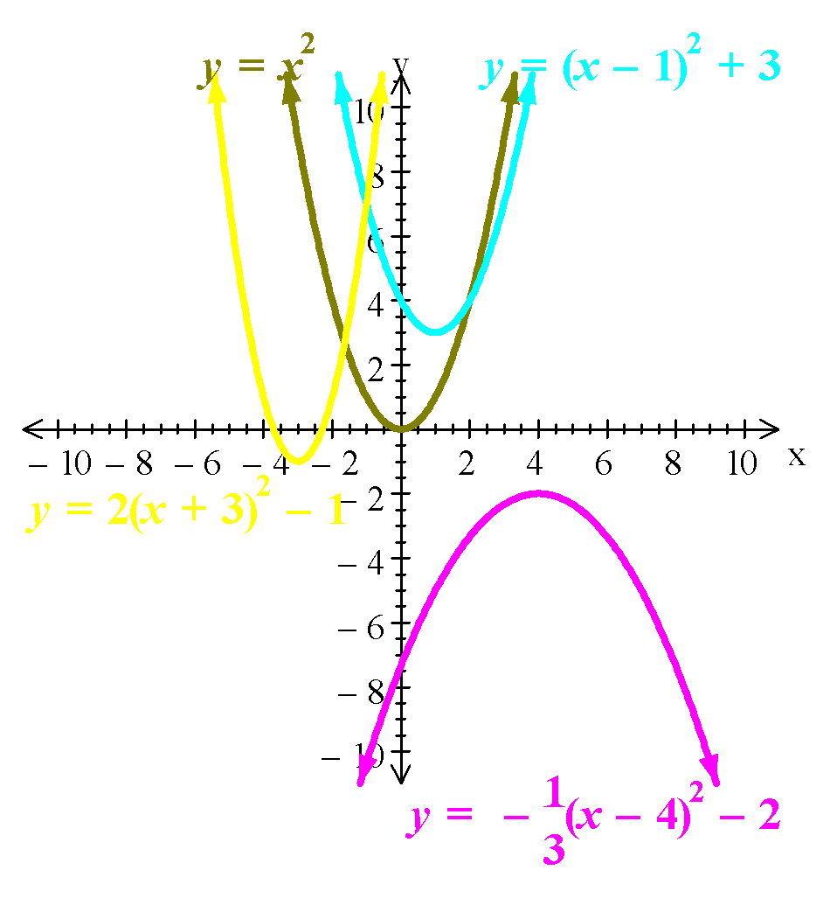

E.g.1. Sketch the graph of:

a) y = (x – 1)2 + 3

b) y = 2(x + 3)2 – 1

c) y = -⅓(x – 4)2 – 2

a) y = (x – 1)2 + 3

Translate graph right 1 unit and up 3 units.

b) y = 2(x + 3)2 – 1

Dilate graph parallel to the Y-axis, and translate graph left 3 units and down 1 unit.

c) y = -⅓(x – 4)2 – 2

Dilate graph parallel to the Y-axis, reflect graph in the X-axis and translate graph right 4 units and down 2 units.

Ref: Ex.5A Q.1-7

**2. OTHER FUNCTIONS:** The general form of a **cubic function** is given by **ax3 + bx2 + cx + d** where **a**, **b**, **c** and **d** are constants and **a ≠ 0**. The graph of a cubic polynomial is always a continuous curve and may cut the X-axis **once**, **twice** or **three** times. For **+a** the graph is in the **1st** and **3rd quadrants**, and for **–a** the graph is in the **2nd** and **4th quadrants**.

**NOTE:** If a function is given in factorized form then the roots of the function are determined by equating each term to zero.

The general form of a **root function** is given by 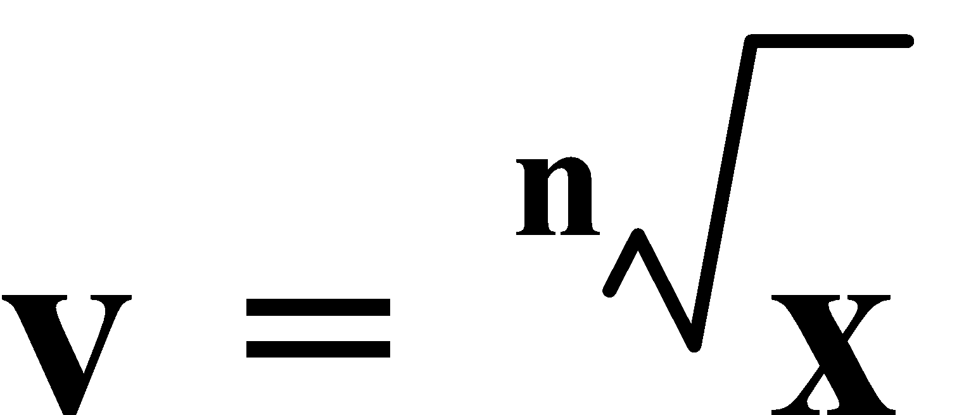 where if **n** is **even**, then the graph is in the **1st quadrant**, but to get a “**complete**” graph then graph 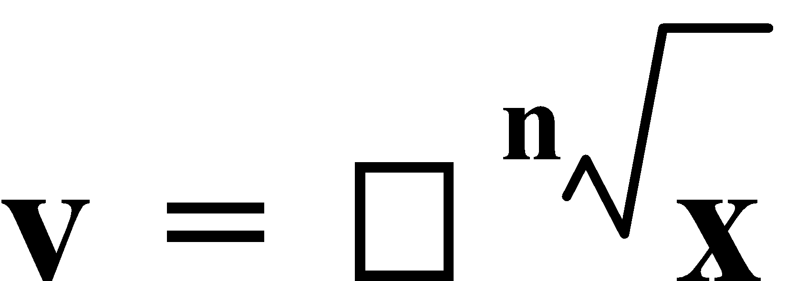, which is equivalent to a “**parabola**” in the **X-axis**, and if **n** is **odd**, then the graph is in the **1st** and **3rd quadrant**, which is equivalent to a “**cubic**” in the **X-axis**.

The general form of a **reciprocal function** is given by 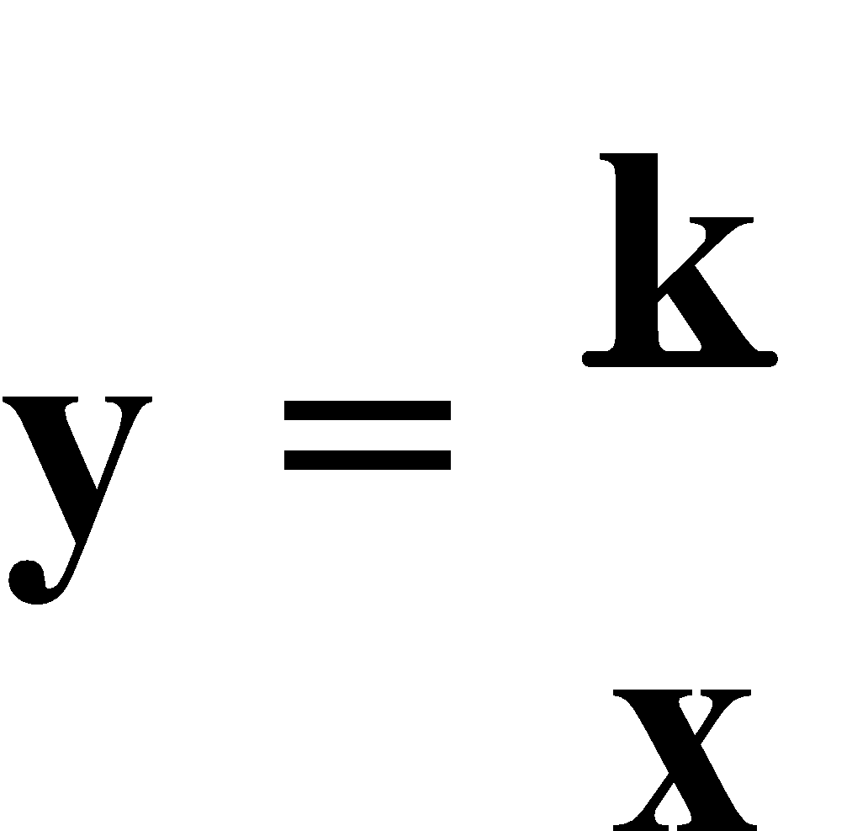or **xy = k**. For **+k** the graph is in the **1st** and **3rd quadrants**, and for **–k** the graph is in the **2nd** and **4th quadrants**. The graph is **asymptotic** to both the **X-** and **Y-axes**.

The general form of an **exponential function** is given by **y = k.ax** where **k** is the value of the **vertical intercept**. The graph is **asymptotic** to the **X-axis** and is only in the **1st** and **2nd quadrants**, with the graph is ‘high’ in the **1st quadrant** for **+k**, and the graph is ‘high’ in the **2nd quadrant** for **–k**. All of these functions conform with the **transformations** studied for **quadratic functions**.

E.g.2. Sketch the graph of:

a) f(x) = (x + 2)(x – 1)(x – 4)

b) 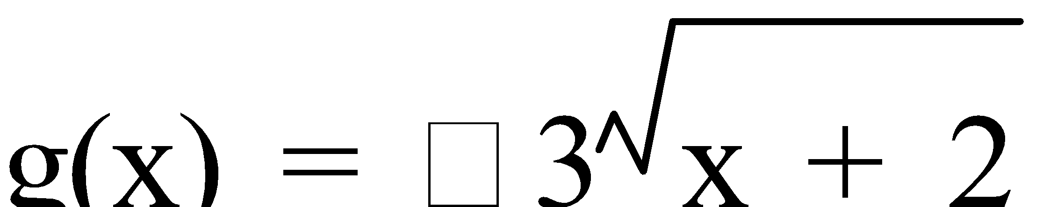

c) 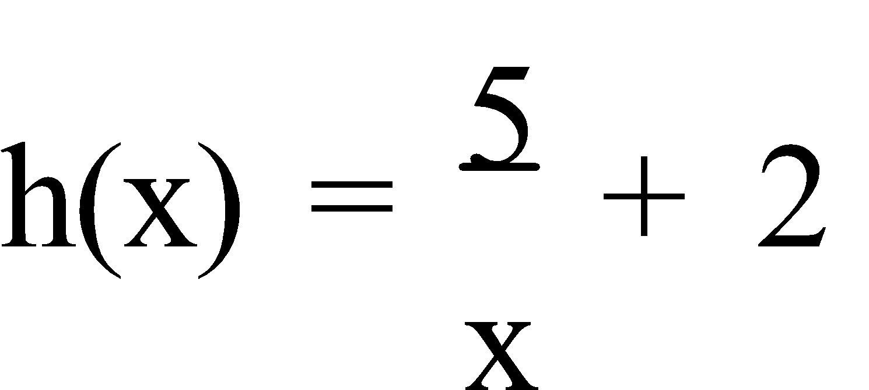

a) f(x) = (x + 2)(x – 1)(x – 4)

b) 

c) 

Ref: INVESTIGATION p.107

Ex.5B Q.1; 2-12 (even)

**3. TRANSFORMATIONS:** Some types of transformations are –

* a **translation** in the **Y direction**, e.g. y = f(x) → **y = f(x) ± c**,
* a **translation** in the **X direction**, e.g. y = f(x) → **y = f(x ± b)**,
* a **reflection** in the **Y-axis**, e.g. y = f(x) → **y = f(-x)**,
* a **reflection** in the **X-axis**, e.g. y = f(x) → **y = -f(x)**,
* a **dilation** in the **Y direction**, e.g. y = f(x) → **y = a.f(x)**, and
* a **dilation** in the **X direction**, e.g. y = f(x) →

Graphs are often a combination of more than one transformation.

E.g.1. The graph on the right shows **y = f(x)**. Draw the graph of:

a) y = -f(x) – 1

b) y = 2f(-x)

c) y = f(x + 3)

d) y = f(2x + 2)

e) y = f(1 – x)

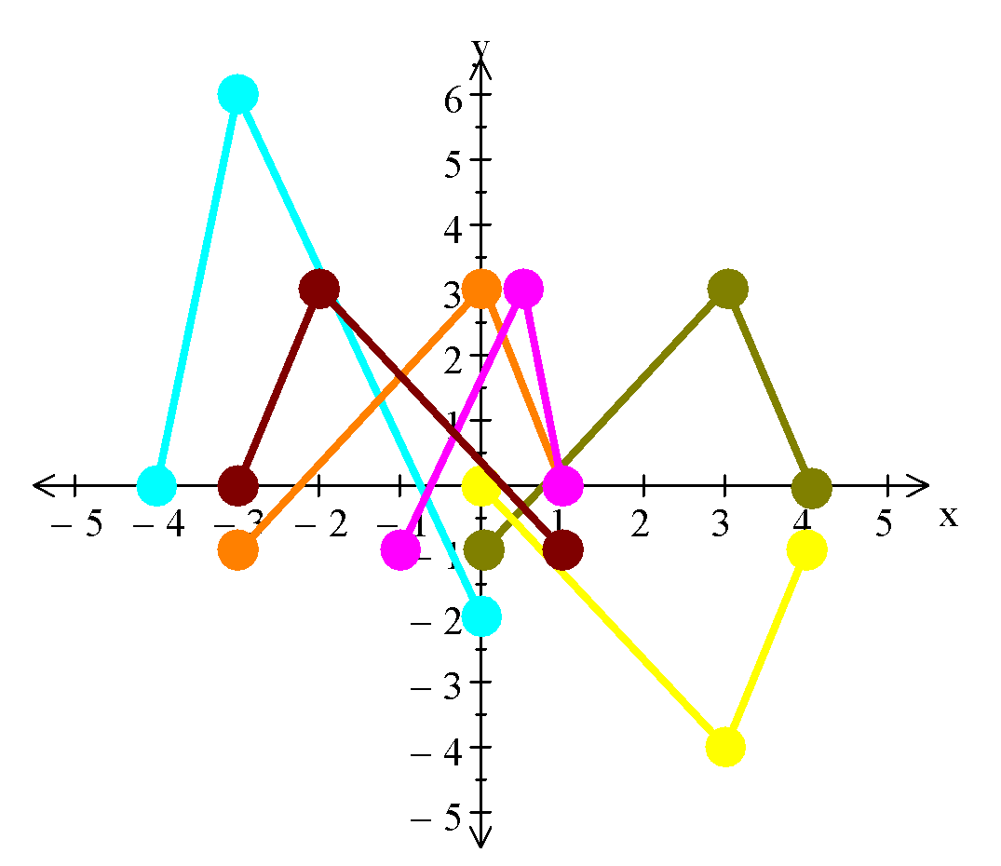

a) **y = -f(x) – 1**

b) **y = 2f(-x)**

c) **y = f(x + 3)**

d) **y = f(2x + 2)**

i.e. 2x + 2 = 4 ⇒ x = 1

2x + 2 = 3 ⇒ x =  

2x + 2 = 0 ⇒ x = -1

e) **y = f(1 – x)**

1 – x = 4 ⇒ x = -3

1 – x = 3 ⇒ x = -2

1 – x = 0 ⇒ x = 1

Ref: TRANSFORMATION GRAPHS

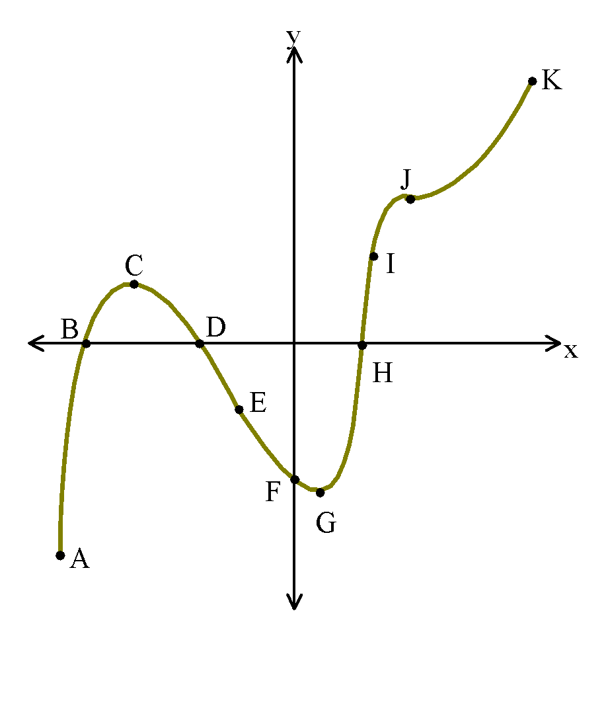

**4. NOTEWORTHY FEATURES:** Consider this graph:

Point A is the **global minimum**. Points B, D and H are **roots**.

Point C is a **(local) maximum point**. Points E and I are **points of inflection**. Point F is the **y-intercept**. Point G is a **(local) minimum point**. Point J is a **point of horizontal inflection**. Point K is the **global maximum**.

The terms **concave down** and **concave up** are often used to describe the shape of a graph near a maxima or a minima. Points on the curve where it changes from being concave down to concave up, or vice versa, are called **points of inflection**.

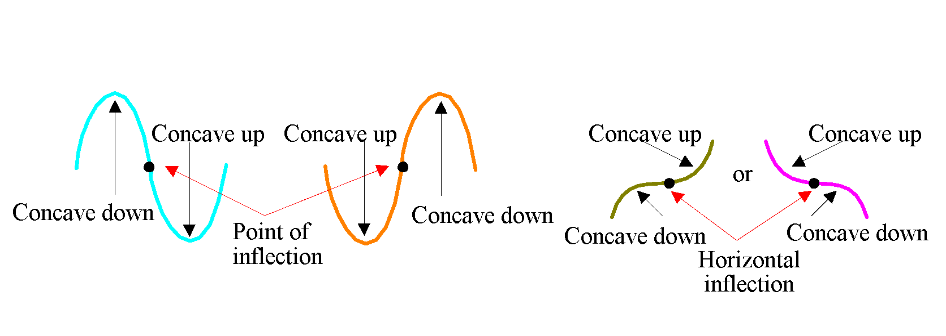

The **domain** is the set of **x-numbers** that a function can use, and the **range** is the set of **y-numbers** that result from the domain. If no specific domain is given, then assume it to be all of the **Real numbers**. For a variety of reasons, a **restricted domain** is sometimes given for a particular function.

E.g.4. a) Find the range of the function f(x) = 2x2 – 5 given the domain is {-1, 0, 1, 2}.

b) State the domain of the function g(x) = 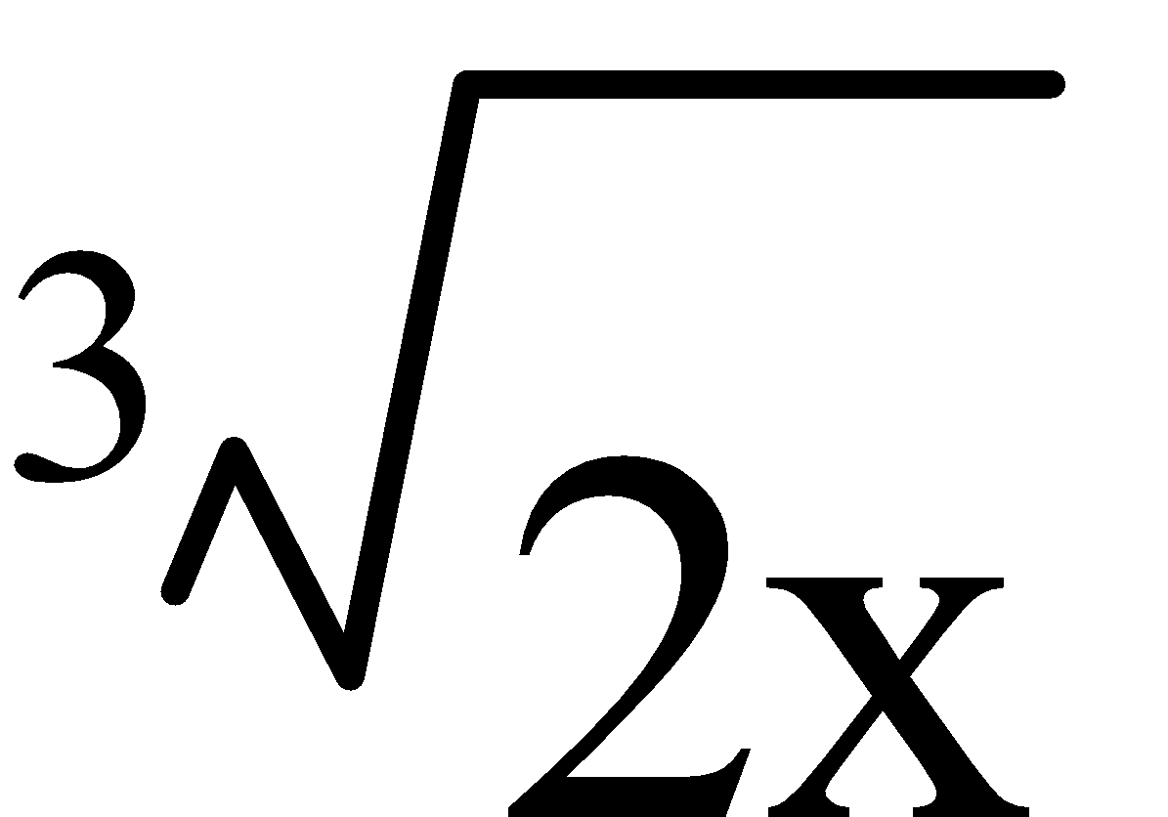 given the range is {-1, 0, 1, 2}.

a) f(x) = 2x2 – 5 ⇒ Domain = {-1, 0, 1, 2}

f(-1) = -3 f(0) = -5 f(1) = -3 f(2) = 3

∴ Range = {-3, -5, 3}

b) g(x) =  ⇒ Range = {-1, 0, 1, 2}

 = -1 ⇒ x = -½  = 0 ⇒ x = 0  = 1 ⇒ x = ½  = 2 ⇒ x = 4

∴ Domain = {-½, 0, ½, 4}

Ref: Ex.5C Q.1-5; 6-10 (even)

**5. SOLVING EQUATIONS:** **Equations** can be solved by ‘**guess and check**’, **algebraically**, using any of the **solver programs** on a calculator or **graphically**.

To **solve graphically** – **graph** all of the equations, and read the appropriate **point(s) of intersection** from the graph.

E.g.5. Solve graphically:

a) 2x2 – 6x + 1 = 3x – 4

b) 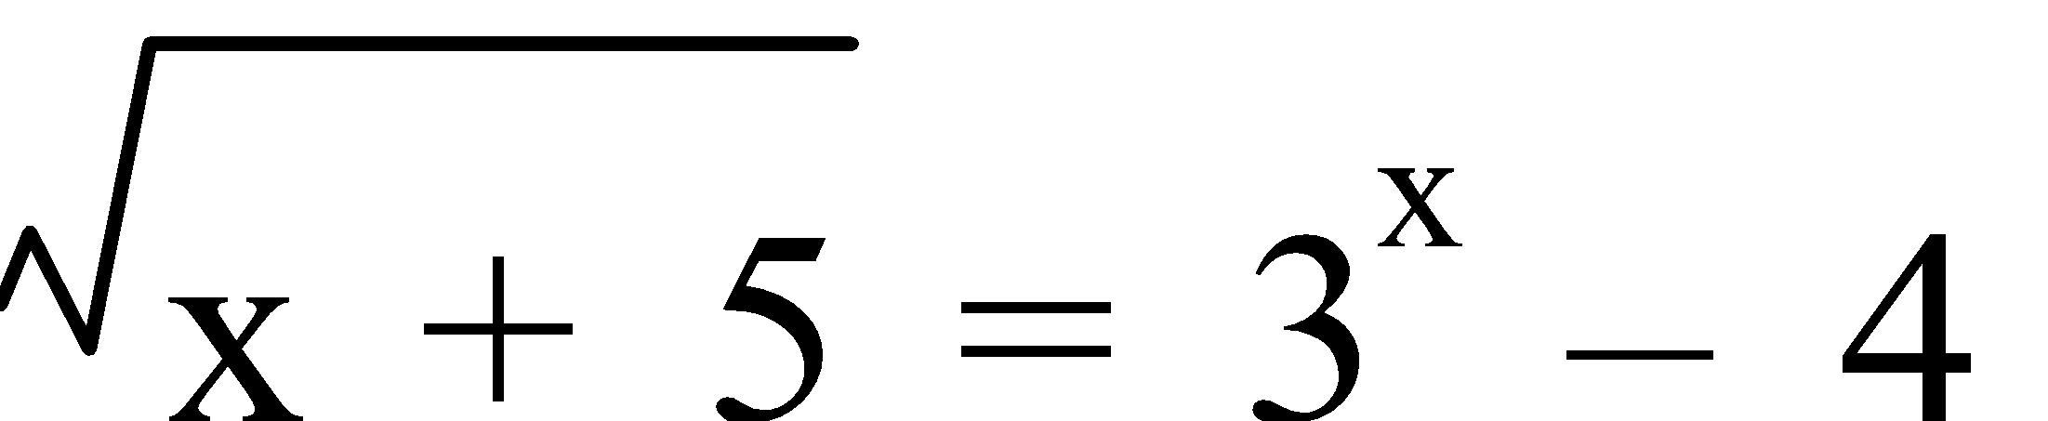

c) 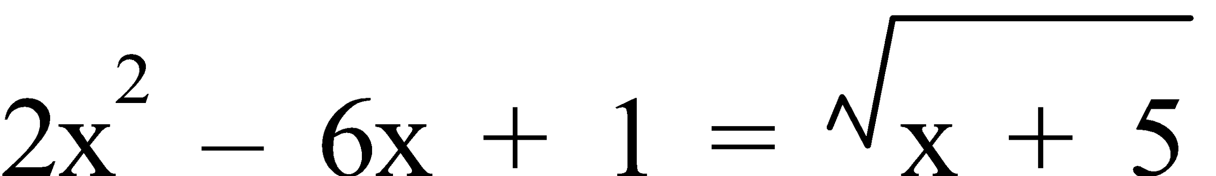

a) 2x2 – 6x + 1 = 3x – 4

From the graph (CAS calc.),

x ≈ 0.63

b) 

From the graph (CAS calc.),

x ≈ 1.72

c) 

From the graph (CAS calc.),

x ≈ -0.19 or x ≈ 3.29

Ref: Ex.5D Q.1-4

**6. PROPORTION:** Two quantities, a and b, are **directly proportional** if one quantity increases as the other increases and vice versa. This is written as **a ∝ b** or **a = kb**, where **k** is the **constant of variation**. The **graph** of a **direct proportion** relationship is a **line** passing through the **origin (0,0)**, provided **c = 0** with a **gradient** of **k**. When graphing **a versus b** or **a against b** – **b** is on the horizontal axis, and **a** is on the vertical axis. Likewise, in a **table of values** – **b** is in the **top** row or **left** column, and **a** is in the **bottom** row or **right** column, with a **constant first difference pattern**.

Two quantities are **inversely proportional** if one quantity increases as the other decreases. This is written as **a ∝**  or **a =** , where **k** is the **constant of variation**. The **graph** of an **inversely proportion** relationship is a **curve** that is **asymptotic** to both the **X-** and **Y-axes**, passing through the points **(1,k)** and **(k,1)**. In a **table of values** – there is a **constant product**, with **a × b = k**. **Inverse proportion** is sometimes known as the “**sharing**” function. **Other relationships** are neither direct nor inverse.

E.g.6. “River Extra Energy”, a company which provides mineral water, charges a fixed delivery fee of $30 plus $1.30 per litre for its product.

a) Write an equation relating **C**, the charge in dollars, with **n**, the number of litres of mineral water delivered.

Another mineral water company, “El Dale” delivers water but without any delivery charge. The equation which they use to calculate the cost, **F** dollars, for **n**, the number of litres of mineral water delivered, is **F = 2n**.

b) For what values of **n** is it better to buy from “El Dale” than from “River Extra Energy”?

a) C = $(1.3n + 30)

b) From the graph,

It is better to buy from “El Dale” for n ≤ 42 L.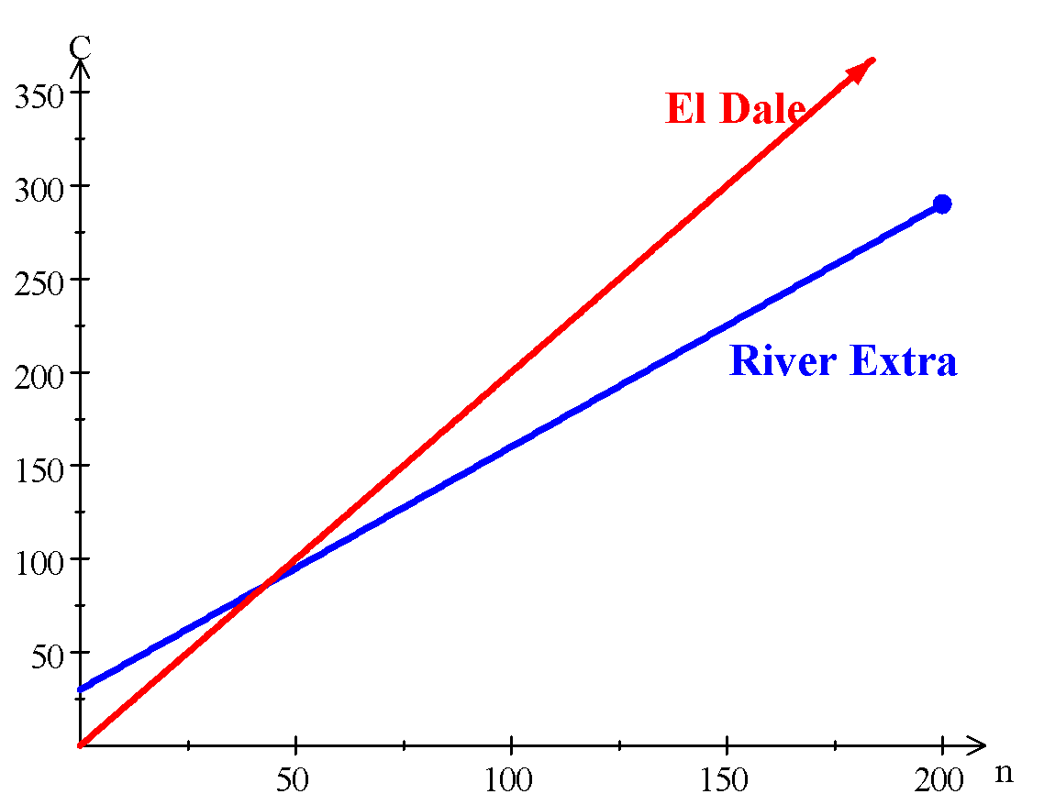

Ref: Ex.5E Q.1-9 (odd)

**RATES AND VARIATION**

**1. RATES:** A **rate** is the amount one quantity varies in relation to another. The two quantities are different and have **different units**. Each unit **cannot** be changed to the other.

E.g.1. A marathon runner covers the 42 km distance at an average speed of 12 km/h.

a) How long should it take her to finish the race?

What is her speed in:

b) metres per hour?

c) metres per minute? and

d) metres per second?

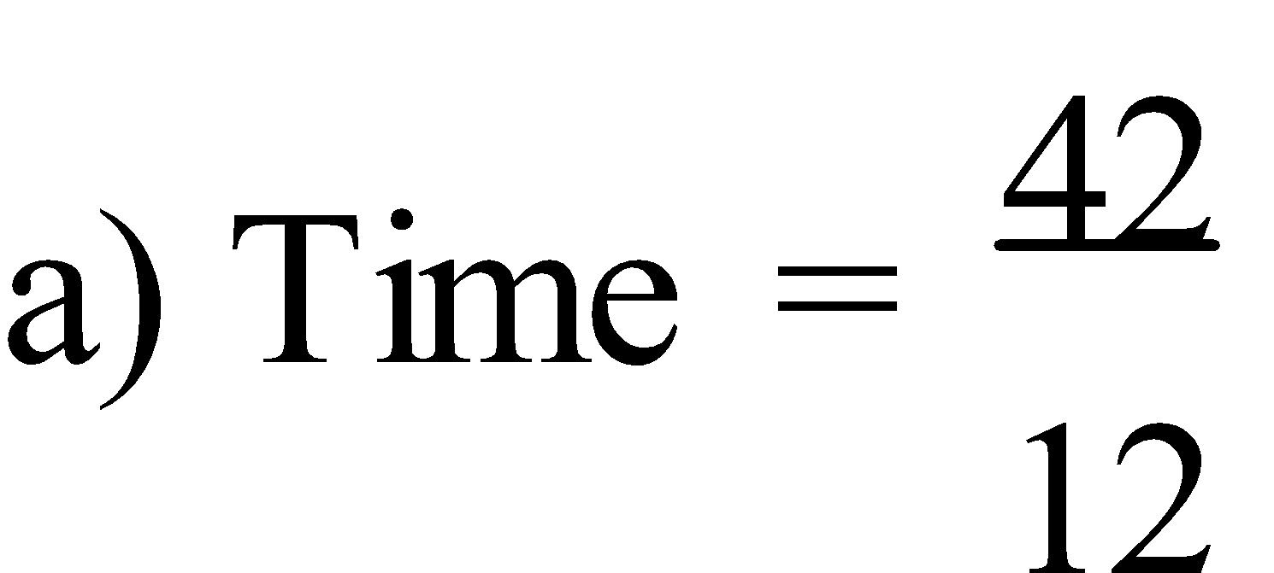

= 3½ h

∴ It should take the runner 3½ hours to finish the race.

b) 12 km/h = 12 000 m/h

c) 12 000 m/h = 200 m/min

d) 200 m/min = 3⅓ m/s

Ref: RATES Q.1-22 (even)

**2. PROPORTION:** A **proportion** is a comparison between two different quantities. A **proportion** exists when two ratios are equal. Two quantities are **directly proportional** if one quantity increases as the other increases and vice versa. Two quantities are **inversely proportional** if one quantity increases as the other decreases.

The **unitary method** is one method used to solve proportional problems. The method involves calculating the value of **one unit** measure of the ‘known’ quantity, and then calculating the **proportional value** of the other quantity.

E.g.2. a) If 10 litres of petrol cost $14.20. What would 6½ litres cost?

b) If 6 painters can paint an office building in 8 days. How long would it take 9 painters working at the same rate?

a) 10 litres of petrol cost $14.20

1 litre of petrol cost $1.42

6½ litres of petrol cost $9.23

b) 6 painters take 8 days

1 painter takes 48 days

9 painters take 5⅓ days

Ref: UNITARY METHOD Q.1-30 (even)

**3. DIRECT VARIATION:** If two quantities are directly proportional we write **y ∝ x** which is read as “**y is directly proportional to x**”. So, if y ∝ x, then **y = kx** where **k** is a constant called the **constant of proportionality**.

When **two directly proportional quantities** are **graphed**, the result is a **line** with a **slope of k** and which passes through the origin, **(0,0)**, i.e. the **y-intercept is zero**. As **one** variable **increases**, the **other** variable **increases**, and as **one** variable **decreases**, the **other** variable **decreases**.

E.g.3. Fruit buns cost 60 cents each.

a) Complete this table.

| **NUMBER BOUGHT (x)** | **0** | **1** | **2** | **3** | **4** | **5** |
| --- | --- | --- | --- | --- | --- | --- |
| **PRICE PAID (y)** |  |  |  |  |  |  |

b) Graph this information.

c) Determine the law connecting x and y.

d) State the value of k.

e) Confirm that the quantities are directly proportional.

a)

| **x** | 0 | 1 | 2 | 3 | 4 | 5 |
| --- | --- | --- | --- | --- | --- | --- |
| **y** | **0.00** | **0.60** | **1.20** | **1.80** | **2.40** | **3.00** |

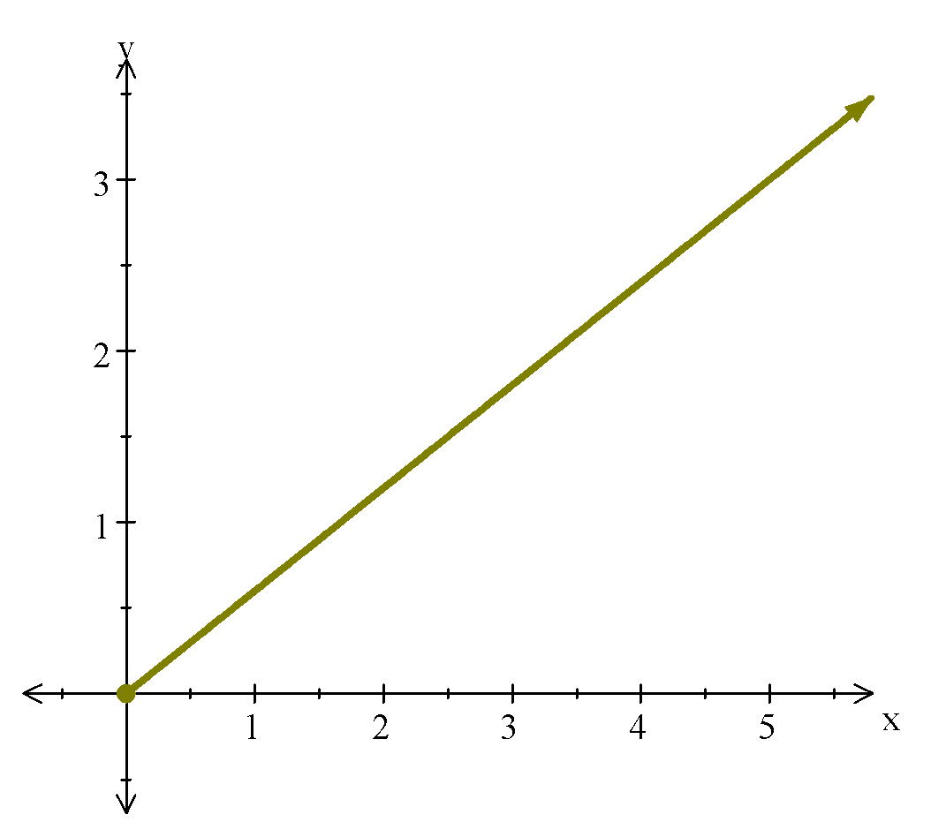

b)

c) y = 0.6x

d) k = 0.6

e) 1 fruit bun costs $0.60

2 fruit buns cost $1.20

i.e. Double the number of buns doubles the cost.

∴ the quantities are directly proportional.

Ref: DIRECT PROPORTION

**4. CONSTANT OF VARIATION:** For any point in a relationship that is **directly proportion**, the ratio 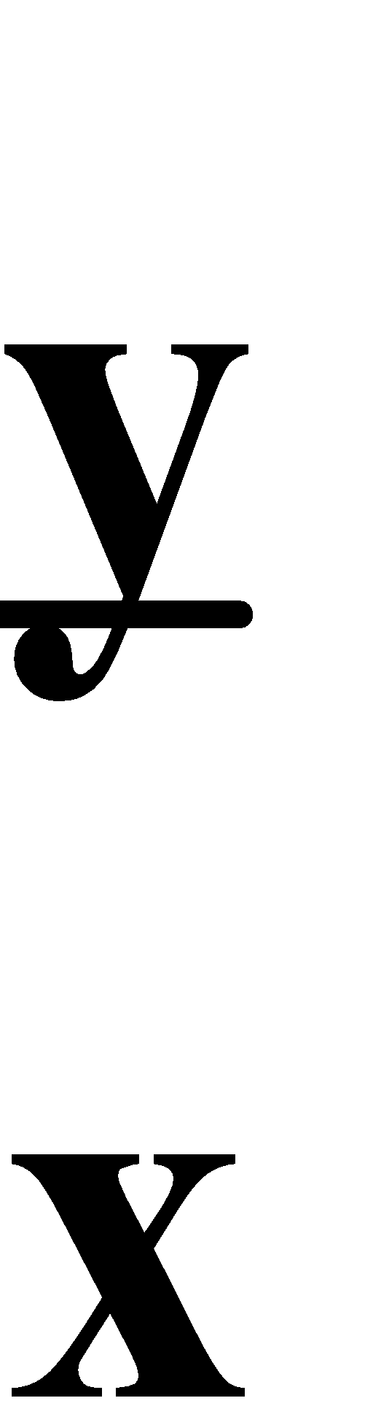 is the **constant of proportionality** or **variation**.

E.g.4. If x and y are directly proportional and y = 24 when x = 3, find:

a) the constant of proportion, and

b) the value of x when y = 16.

a) k = 8 ⇒ y = 8x

b) When y = 16, x = 2

Ref: CONSTANT OF PROPORTIONALITY

**5. PARTIAL VARIATION:** For **x** and **y**, if **y** varies **partly** as **x** and **partly** as a **constant**, then **y = kx + c** is called the **partial proportion** or **variation**. **k** is still called the **constant** of **proportionality** or **variation**. **Two points** are required to find the values of **k** and **c**.

E.g.5. Marina discovers water leaking from a pipe in her kitchen. The plumber’s charge varies partly with the time (t) it takes him to fix the problem and a call-out fee of $30. If a 45 minute job costs $90, find:

a) the rule relating cost with time,

b) the cost of a 1 hour and 20 minute job, and

c) how long it took to do a job costing $230?

1. c = $30

Cost = kt + 30

90 = 45k + 30

45k = 60

k = 1⅓

∴ Cost = 1⅓t + 30

1. 1 hour 20 min = 80 minutes

Cost = 1⅓ × 80 + 30

≈ $136.67

c) 230 = 1⅓t + 30

1⅓t = 200

t = 150 min

∴ A $230 job takes 2½ hours.

Ref: PARTIAL PROPORTION

**6. INVERSE VARIATION:** If **one** quantity **increases** as **another** quantity **decreases**, then the two quantities are **inversely proportional**. If two quantities are inversely proportional, then 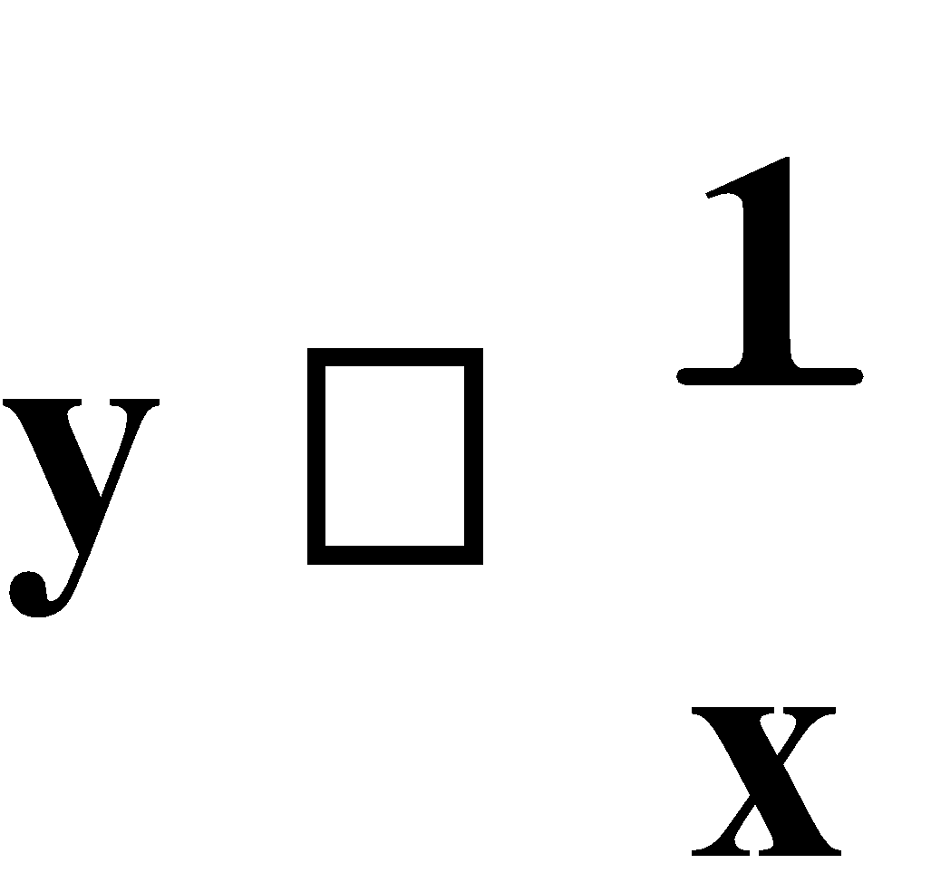 and 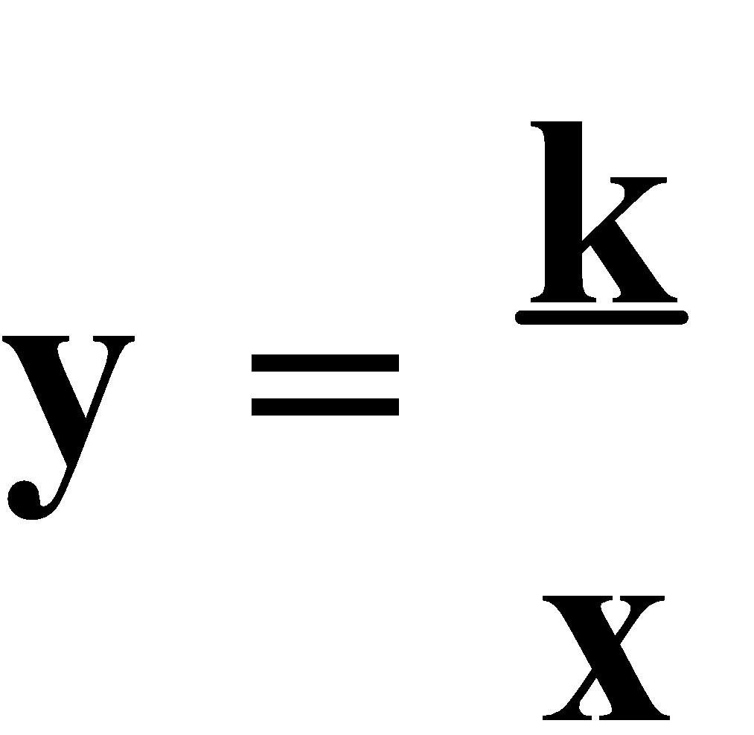 or **xy = k** where **k is the constant of proportionality** or **variation**. The **graph** of an **inverse proportion** is an **hyperbola**, or the ‘positive half’, where **neither** variable is equal to **zero**.

E.g.6. Let x be the number of painters and y the number of days taken to complete a job.

a) Complete the following table:

| **x** | **1** | **2** | **3** | **4** | **5** |
| --- | --- | --- | --- | --- | --- |
| **y** | **24** |  |  |  |  |

b) Draw a graph of these results.

c) Determine the law connecting x and y.

d) State the value of k.

e) How many painters would be required to complete the job in 3 days?

a)

| **x** | 1 | 2 | 3 | 4 | 5 |
| --- | --- | --- | --- | --- | --- |
| **y** | 24 | **12** | **8** | **6** | **4.8** |

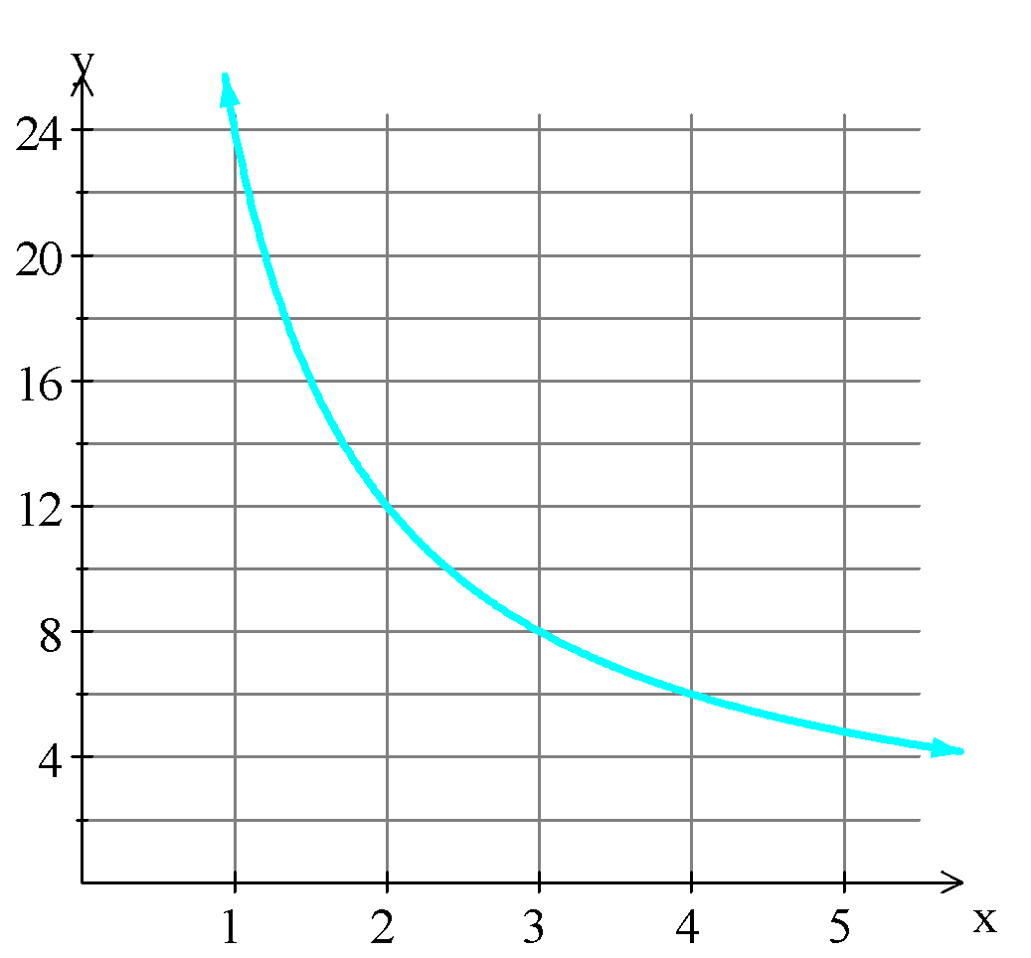

1. xy = 24 or 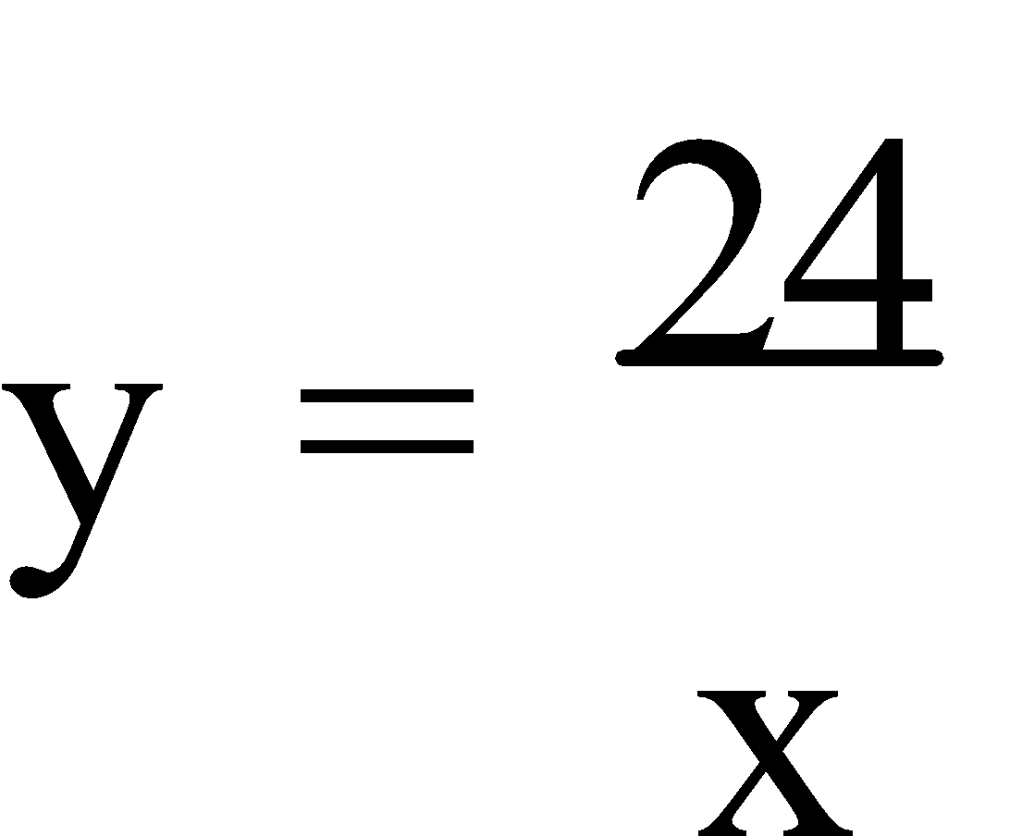
2. ∴ k = 24
3. 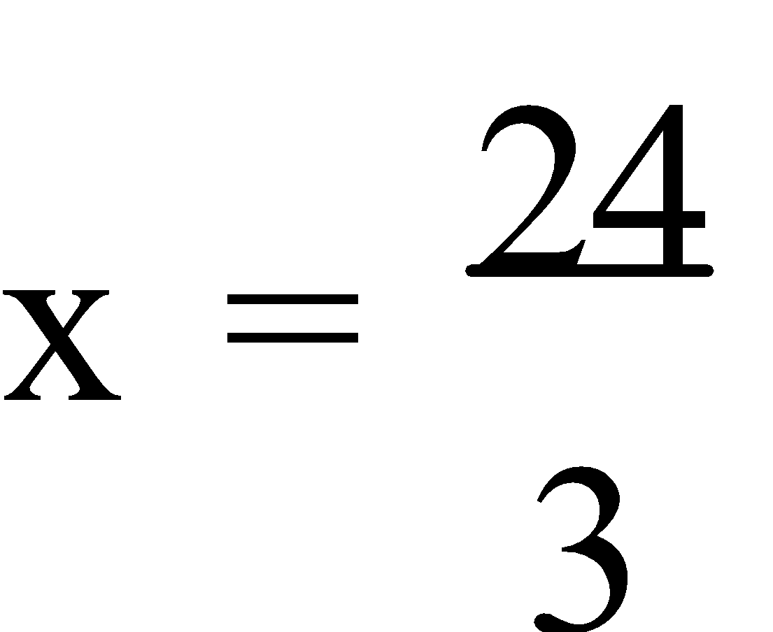

= 8

∴ It takes 8 painters 3 days to complete the job.

Ref: INVERSE PROPORTION

**CENTRAL TENDENCY AND DISPERSION**

**1. MEASURES OF CENTRAL TENDENCY:** **Data** is a set of scores. A **statistic** is a single number used to represent the data, in some manner. The **mean** ( 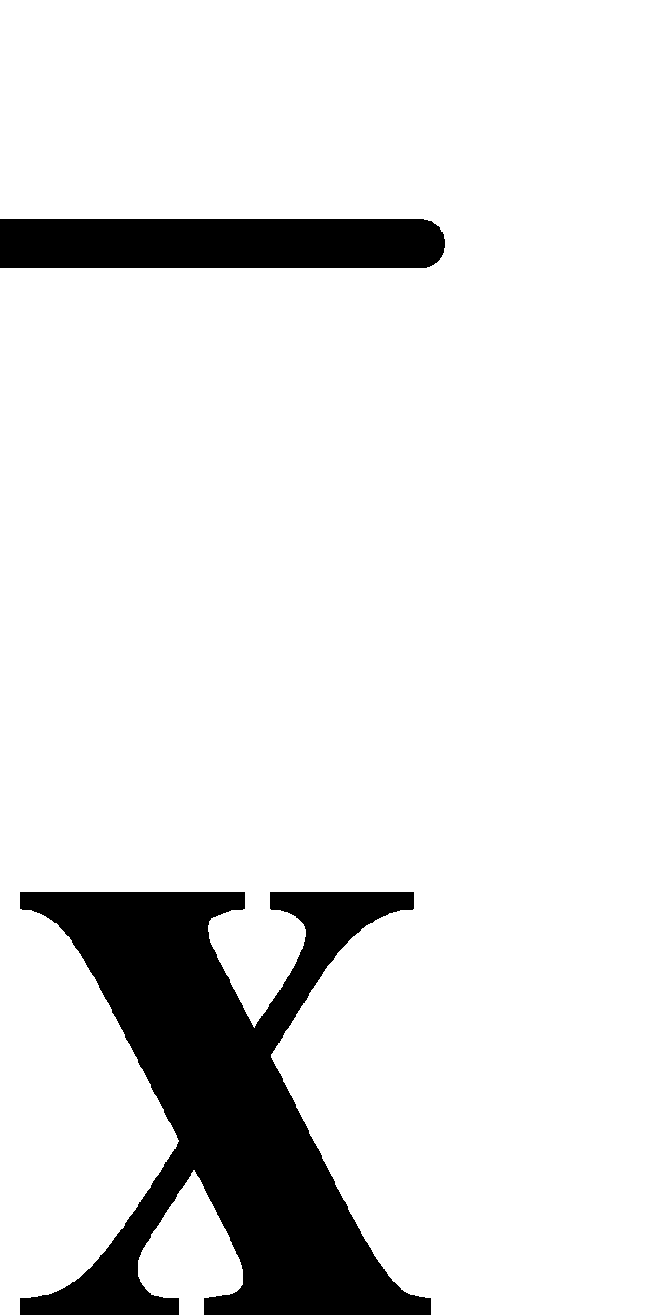 or **μ**) is the sum of the scores divided by the total number of scores. The **median** of a set of scores is the middle score, or the mean of the two middle scores, when the data is **arranged in numerical order**. The **mode** is the **most frequent** score. Not all data have a mode. Some data have two modes – this is called a **bimodal** set of data. The **mean, median** and **mode** are all **measures of central tendency**.

**NOTE:** The modal value on the graphics calculator is unreliable but the CAS calculator is very reliable, showing “no mode” and bimodal solutions.

The measures of central tendency can be calculated from the **raw data**, a **frequency table**, or a variety of graphs such as a **dot frequency diagram** or a **stem and leaf plot**.

E.g.1. Calculate the measures of central tendency for each of the following:

a)

| **SCORE** | **FREQUENCY** |
| --- | --- |
| 3  4  5  6 | 1  2  1  3 |
| **TOTAL** | 7 |

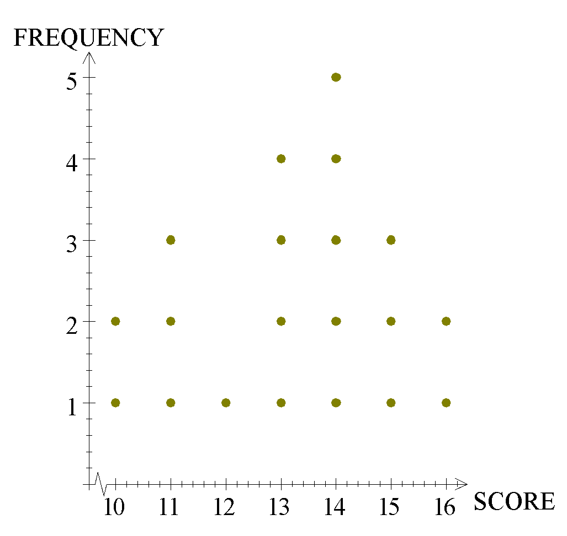

b)

c)

| 21 | 5 |  |  |  |  |  |
| --- | --- | --- | --- | --- | --- | --- |
| 22 | 5 | 3 | 8 |  |  |  |
| 23 | 0 | 1 | 7 | 4 | 2 |  |
| 24 | 4 | 4 | 3 | 5 | 1 | 0 |
| 25 | 8 | 9 | 5 |  |  |  |
| 26 | 6 | 2 |  |  |  |  |

Using the g. calc.

a) Mean ≈ 4.86

Mode = 6

Median = 5

b) Mean = 13.2

Mode = 14

Median =13.5

1. Mean = 240.6

Mode = 244

Median 240.5

Ref: Ex.6A Q.1-17 (odd)

**2. MEASURES OF DISPERSION:** The **range** is the difference between the highest and lowest scores. The **interquartile range** is the difference between the **upper** and **lower quartiles**. Both the range and the interquartile range are some of the **measures of spread** (or **dispersion**).

The **deviation** of any score is the difference between that score and the mean, i.e. 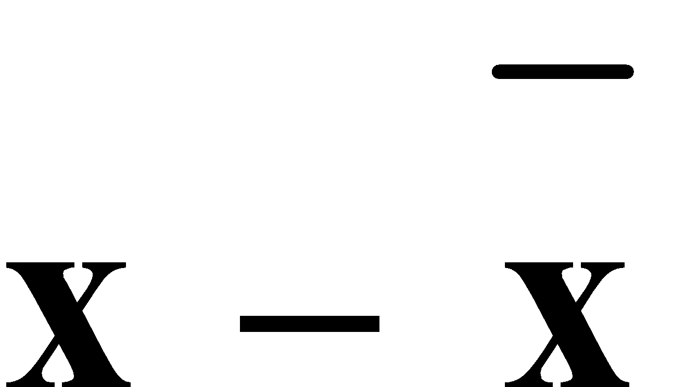. The sum of the deviations is always zero. Thus the **mean**, or more fully the **arithmetic mean**, is that value which gives a zero sum for the deviations.

The **variance** is the **average of the squares** of the deviations. It is denoted by **s2** or **σ2** and is 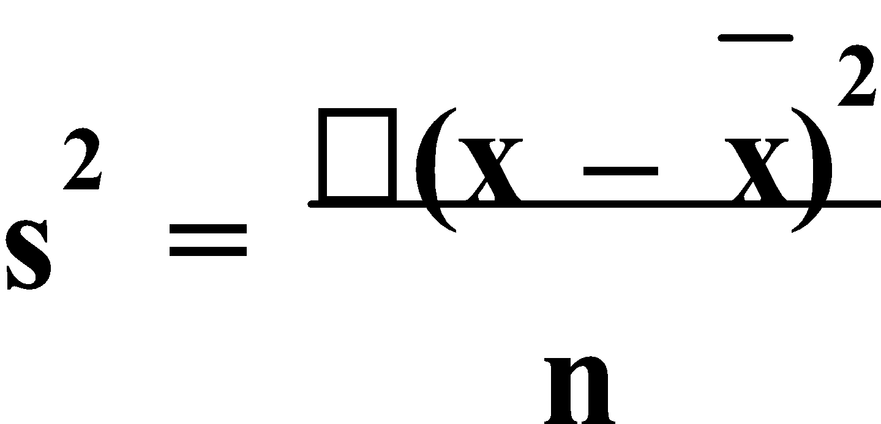 or 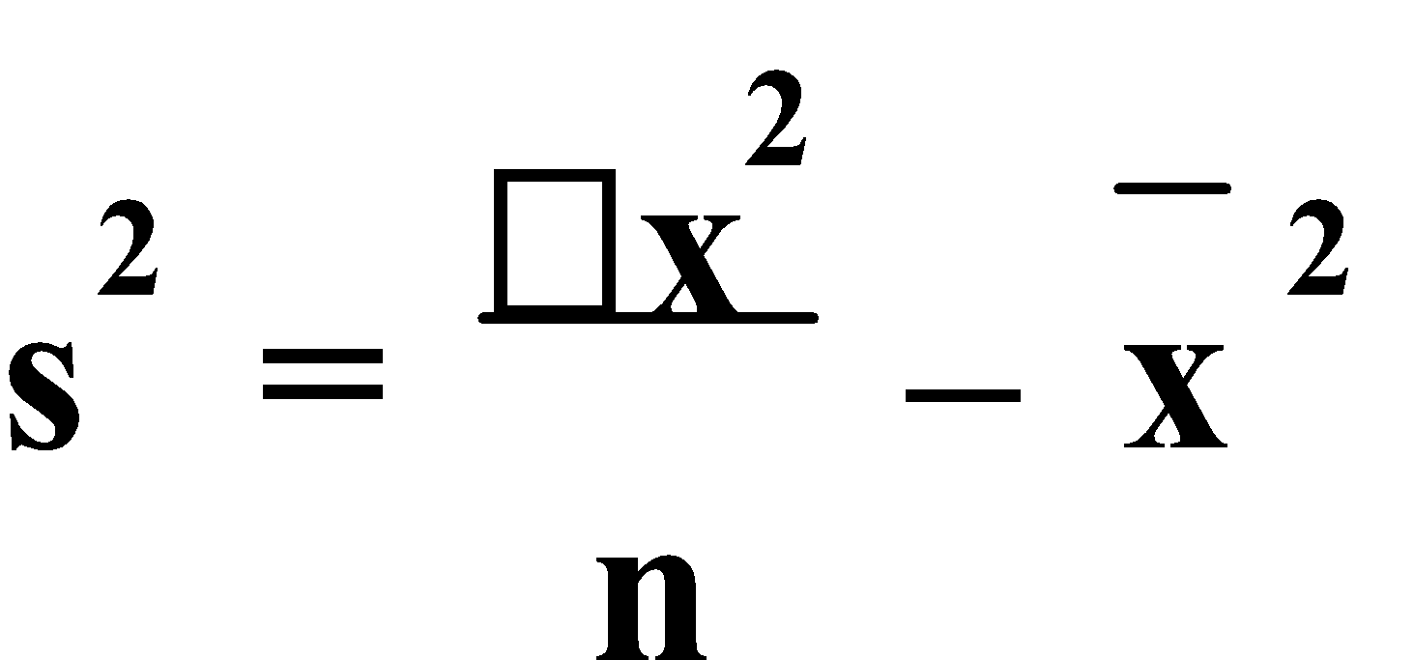. As a measure of dispersion, the variance has an obvious weakness; it produces results in squared units. This disadvantage can be overcome by taking the square root of the variance.

The square root of the variance is called the **standard deviation**. It is the most widely used statistic because of its mathematical reliability and accuracy. The standard deviation (**s** or **σ**) is the square root of the variance and is 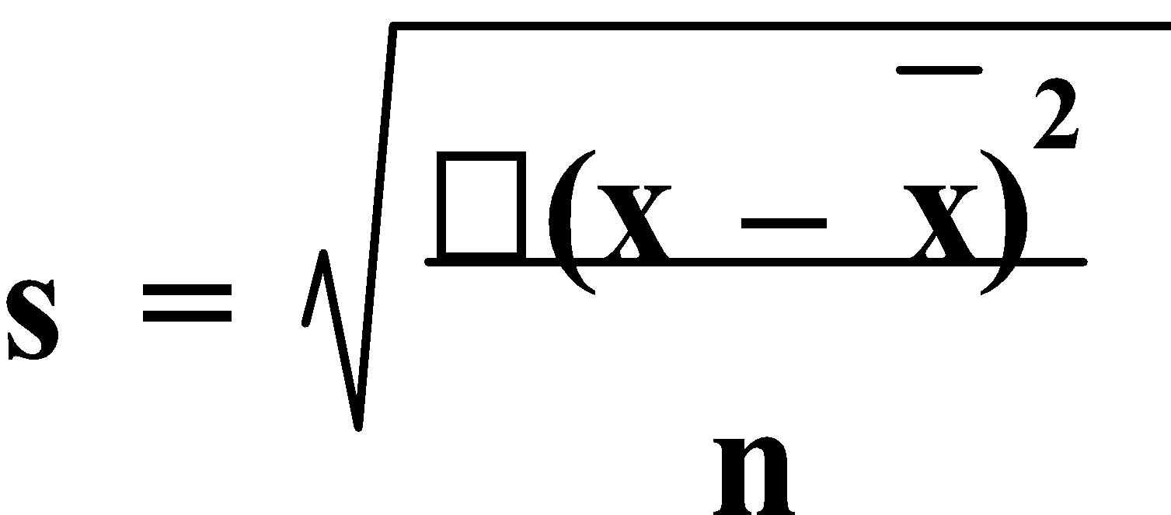 or 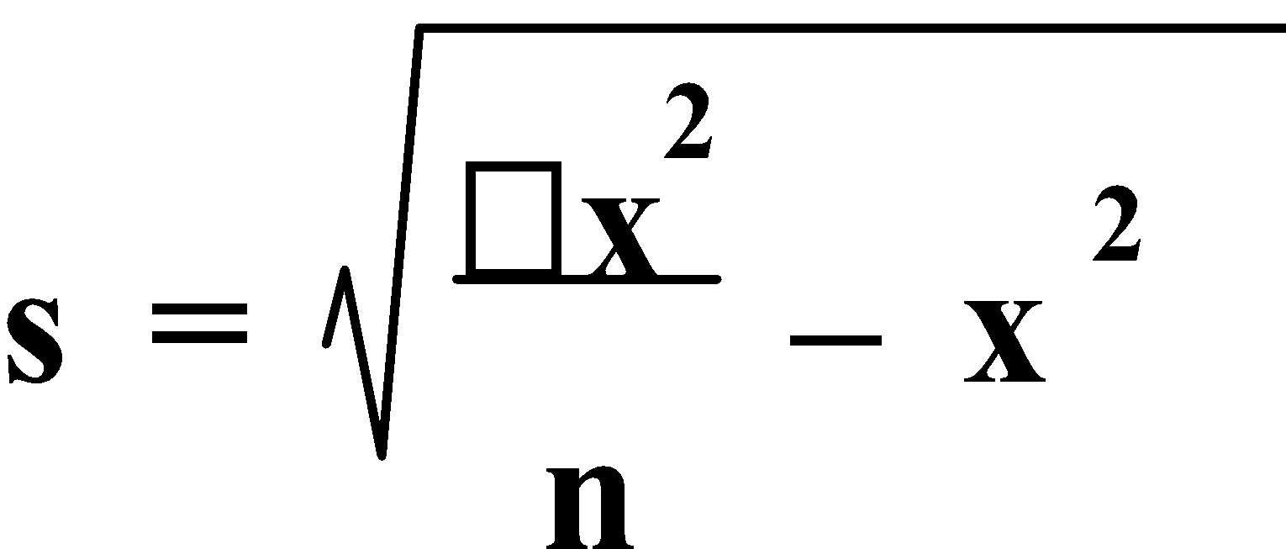 . 

E.g.2. The scores for the test results of a group of ten students were 3, 5, 5, 5, 6, 7, 7, 8, 8, 9. Find the:

a) range,

b) interquartile range,

c) variance and

d) standard deviation.

3 5 5 5 6 7 7 8 8 9

^ ^ ^

L.Q. Med U.Q.

Range = 9 – 3 = 6

Interquartile range = 8 – 5 = 3

| **Score**  **x** | **Frequency**  **f** | **Deviation** | **Deviation²** |  |
| --- | --- | --- | --- | --- |
| 3  5  6  7  8  9 | 1  3  1  2  2  1 | -3.3  -1.3  -0.3  0.7  1.7  2.7 | 10.89  1.69  0.09  0.49  2.89  7.29 | 10.89  5.07  0.09  0.98  5.78  7.29 |
|  |  |  | **Total** | 30.10 |

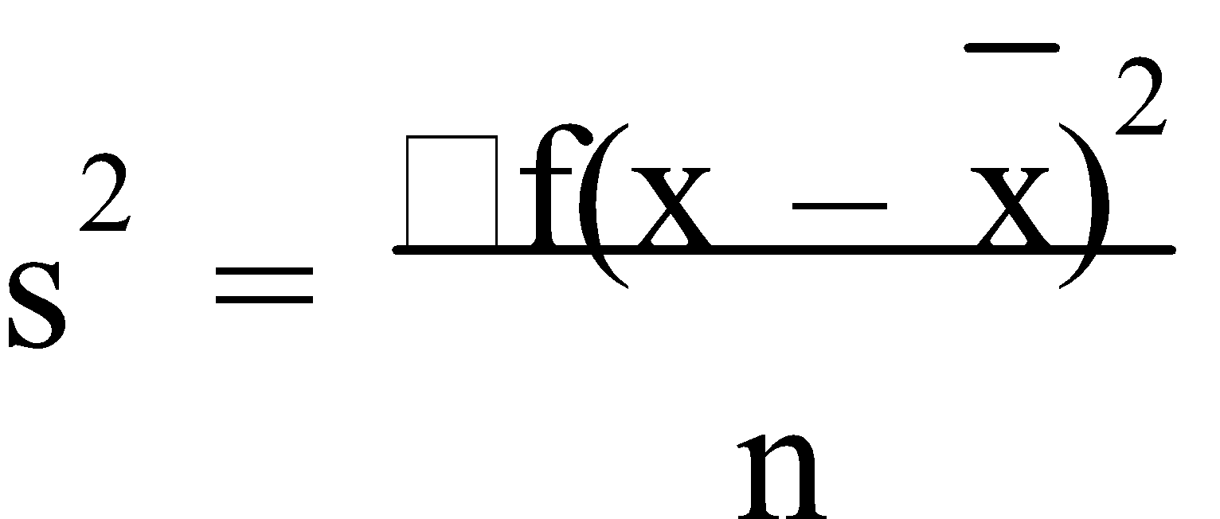

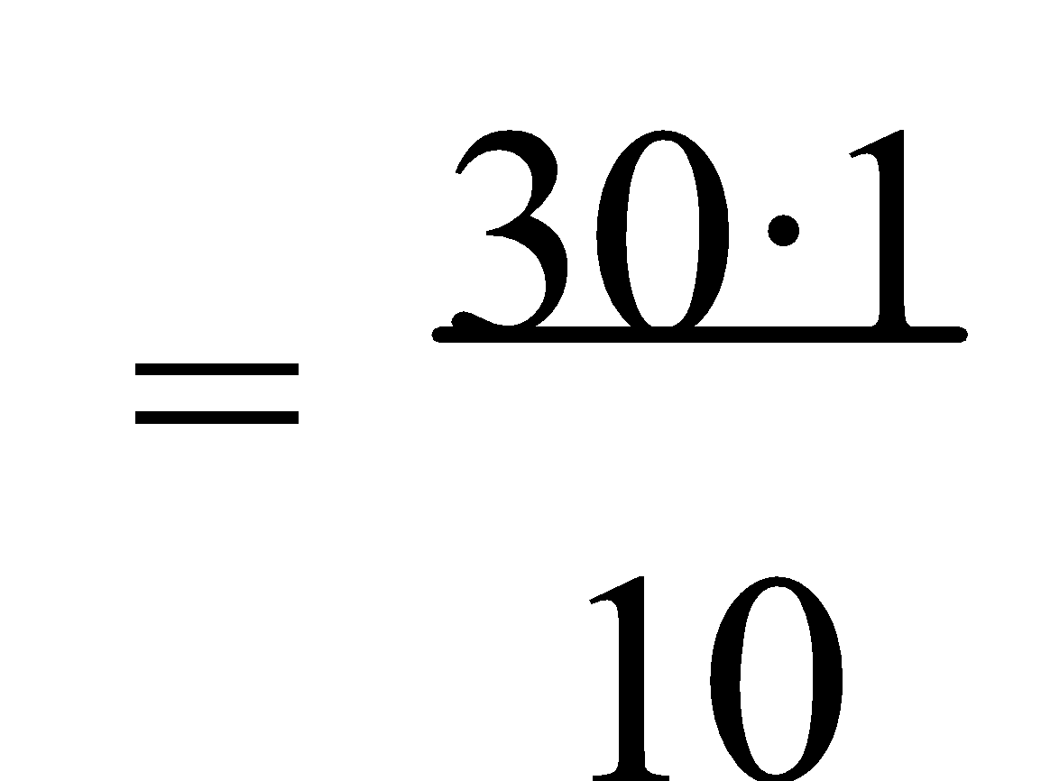

= 3.01

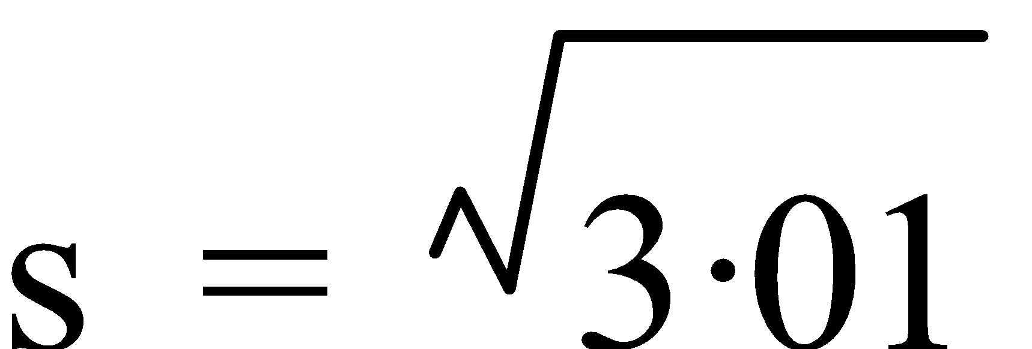

≈ 1.73

Ref: Ex.6B Q.1-12 (even)

**3. DEVIATION INTERVALS:** For most distributions, very few, if any, of the scores are more than three standard deviations from the mean, i.e. the scores lie between 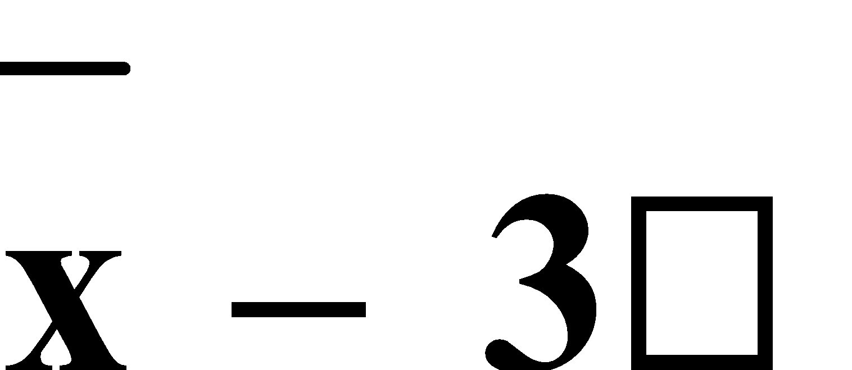 and 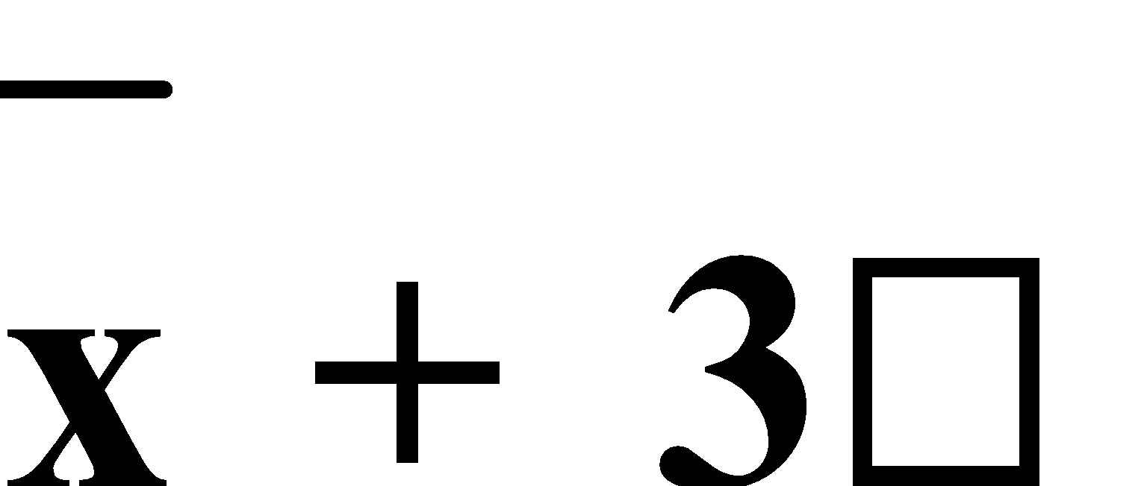.

**NOTE:** Your calculator gives both **σn** and **σn-1**. We use **σn** although **σn-1** gives a better answer as it compensates for there (usually) being less variation in a small sample than there is in a population.

E.g.3. For the data set 22, 45, 35, 55, 50, 67, 70, 17, 40, 45, 51, 50, 54, 65, find:

a) the mean and standard deviation,

b) how many scores lie less than one standard deviation from the mean, and

c) how many scores lie less than two standard deviations from the mean.

1. From the g. calc.:x ≈ 47.57 and σ ≈ 14.93
2. x – σ ≈ 32.64 andx + σ ≈ 62.50

∴ 9 scores are less than one standard deviation from the mean.

c) x – 2σ ≈ 17.71 andx + 2σ ≈ 77.44

∴ 13 scores are less than two standard deviations from the mean.

Ref: Ex.6C Q.1-15 (odd)

**4. GROUPED DATA:** For data with a lot of scores but very few repeated values it is often better to represent the data in **groups** or **class intervals**, although some information is lost. All **statistics**, except mode, are calculated at the **midpoint** of the intervals. The mode is given as the **modal class interval**. **Graphs** are drawn on the **class boundaries**.

Ref: Ex.6D Q.1-11 (odd)

**BOXPLOTS AND HISTOGRAMS**

**1. BOX AND WHISKER DIAGRAMS:** A **box plot** ora **box and whisker diagram** is a summarizing diagram that illustrates both the centre of a distribution (usually the median although sometimes the mean) and it’s dispersion (both the interquartile range and the range). The **interquartile range (I.Q.R.)** takes into account the ranks of all of the scores and is calculated by **I.Q.R. = Q3 – Q1** where **Q3** is the upper quartile and **Q1** is the lower quartile. The **median** is sometimes referred to as **Q2**.

**NOTE:** The whiskers show the first and last scores and the box marks the L.Q., median and the U.Q.

E.g.1. Draw a box plot for the following data: 7, 11, 13, 12, 8, 5, 9, 10, 8, 4, 3, 4, 5, 4, 2.

2, 3, 4, 4, 4, 5, 5, 7, 8, 8, 9, 10, 11, 12, 13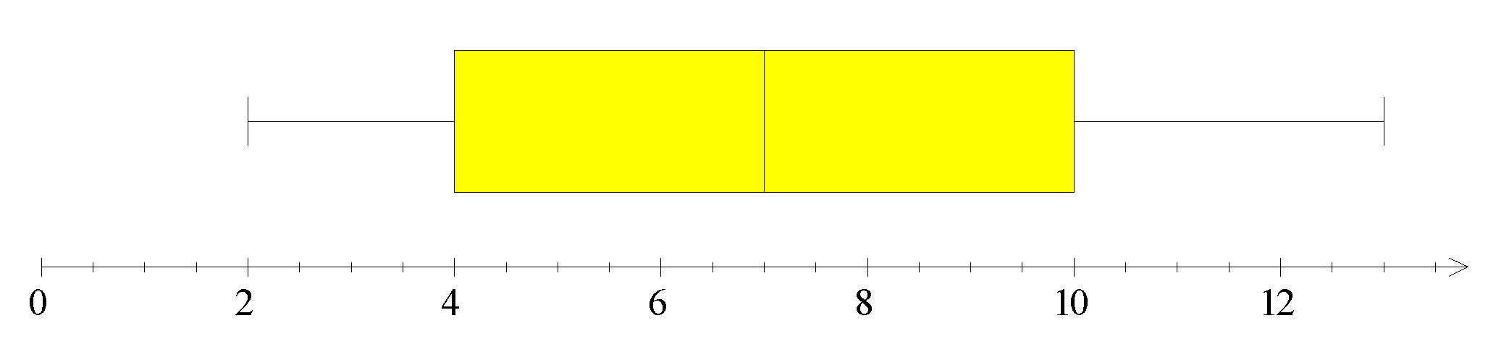

A **boxplot** can also be used to **compare two or more sets** of data. Each plot is graphed **above** the line and have a gap between the box of each plot. When **analysing** or **comparing data sets**,comment on the **location** of the **median** (or **mean**) scores, the **spread** or **range/interquartile range** of the scores, the “**shape**” of the distribution in terms of its **symmetry** or **skewness**, **outliers**, etc.

If the median is in the **middle** of the box, then the data set is **symmetrical**. If the median is towards the **right-hand** end of the box, then the data set is **negatively skewed** as more data is on the left. If the median is towards the **left-hand** end of the box, then the data set is **positively skewed** as more data is on the right.

E.g.2. Compare the data from E.g.1 to the following data:

4, 5, 7, 8, 9, 8, 10, 10, 9, 9, 8, 8, 5, 4, 6.

4, 4, 5, 5, 6, 7, 8, 8, 8, 8, 9, 9, 9, 10, 10

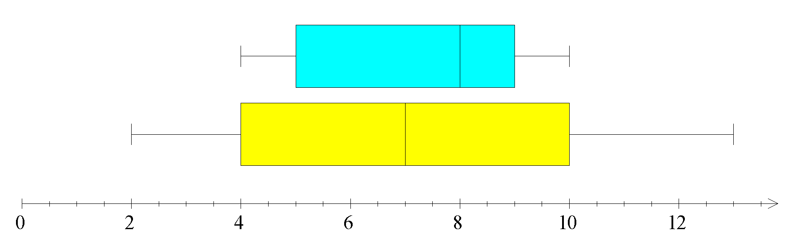

The data in E.g.2 has a smaller dispersion, i.e. a smaller range and interquartile range but it has a higher median than the data in E.g.1.

Ref: Ex.7A Q.1-10 (even); 5

**2. HISTOGRAMS:** A **histogram** is a “column” graph with adjoining columns. It is used for **grouped discrete data** or for **continuous data** but the data may appear to be **discrete**, in nature. If the data appears to be discrete, then the **class intervals** or “**bins**” are from half unit to half unit, e.g. 12.5 → 13.5, 13.5 → 14.5, 14.5 → 15.5, etc., and the “**bin width**” is **1 unit**. The **vertical axis** is the **frequency** and the **horizontal axis** is a **number line**.

The **class intervals** should be of **equal size**, and the frequency can, in some cases, be given as a **relative frequency**, i.e. a fraction of the whole expressed as a decimal, or as a **percentage frequency**, i.e.a percentage of the whole. The **relative frequency** indicates **how significant** a particular score is compared to the total distribution. The **percentage frequency** indicates the percentage of the total scores for a given score.

A **frequency polygon** is a special form of line graph that uses the midpoints of the groups or intervals. It is often **drawn over** a histogram. A **frequency polygon** **starts** at the **midpoint** of the **previous interval** to the start of the histogram, and **ends** at the **midpoint** of the **next interval** to the end of the histogram, so the axis **must** have sufficient space left for this.

E.g.3. Draw a histogram and frequency polygon for this data.

| **HEIGHT** | **BOUNDARIES** | **FREQUENCY** |
| --- | --- | --- |
| 1.45-1.49  1.50-1.54  1.55-1.59  1.60-1.64  1.65-1.69  1.70-1.74  1.75-1.79 | 1.445-1.495  1.495-1.545  1.545-1.595  1.595-1.645  1.645-1.695  1.695-1.745  1.745-1.795 | 3  6  9  11  12  7  2 |
|  | TOTAL | 50 |



Ref: Ex.7B Q.1, 4-6

As for boxplots, **histograms** can also be **skewed**. In general, for a **negatively skewed** data set – **mean < median < mode** and for a **positively skewed** data set – **mode < median < mean**.

Ref: Ex.7C Q.1-10 (even); 7

**SEQUENCES**

**1. SEQUENCES:** A **sequence** is any group or set of numbers, most of which follow some definite pattern. Each member or **term** of the sequence can be labelled as T1, T2, T3,...,Tn. **Tn**  is called the **general term** and is often used to define the sequence.

Other letters, besides T, are sometimes used particularly for well known sequences. **F** is usually used for the **Fibonacci** sequence. **L** is usually used for the **Lucas** sequence.

E.g.1. Find the 7th term of each of the following sequences:

a) Tn = 2n + 5

b) Tn = n² + n – 1

a) Tn = 2n + 5

T7 = 2(7) + 5

= 19

b) Tn = n² + n – 1

T7 = 7² + 7 – 1

= 55

**2. RECURSIVE FORMULAE:** A **recursive formula** “runs back” which simply means that it refers back to previous terms. To determine the sequence – the **value** of at least **one term**, usually the first term, **must be known** and then any others can be determined from this, e.g. **Tn+1 = Tn + 3** with **T1 = 4**.

A recursive formula may be re-written to form a **difference equation (rule)** which indicates the difference between successive terms, e.g. **Tn+1 – Tn = 3** with **T1 = 4**. A formula for Tn can usually be determined using a table of values by calculating the **difference pattern** and hence, the rule (as was previously done).

E.g.2. Write the difference equation for the sequence 4, 7, 10, 13,… and write the rule for the nth term.

4, 7, 10, 13, ... difference = 3

∴ Tn+1 – Tn = 3 and T1 = 4

So, Tn = 3n + 1

**3. ARITHMETIC SEQUENCES:** An **Arithmetic** (**Sequence** or) **Progression (A.P.)** is a sequence of terms where there is a **common difference (d)** between successive terms, i.e. a linear sequence. In general, the **first term** of an A.P. is **a**, so the A.P. is a, a + d, a + 2d, a + 3d, ... Hence, the nth term will be **Tn = a + (n – 1)d**.

E.g.3. Find, for the sequence 21, 18, 15, ...:

a) the common difference,

b) the 7th term, and

c) the nth term.

21, 18, 15,... i.e. a = 21

a) d = 18 – 21 = -3

b) Tn = a + (n – 1)d

T7 = 21 + (7 – 1)(-3) = 3

c) Tn = 21 + (n – 1)(-3)

= 21 – 3n + 3

= 24 – 3n

E.g.4. Find the first 4 terms of the arithmetic sequence in which T5 = 7 and T11 = 22.

T5 = 7 and T11 = 22

⇒ a + 4d = 7 and a + 10d = 22

⇒ a = 7 – 4d a = 22 – 10d

7 – 4d = 22 – 10d

-4d + 10d = 22 – 7

6d = 15

d = 2.5

& a + 4(2.5) = 7

a + 10 = 7

a = -3

∴ The first 4 terms of the sequence are -3, -0.5, 2, 4.5.

**4. GEOMETRIC SEQUENCES:** A **Geometric** (**Sequence** or) **Progression (G.P.)** is a sequence of terms with **common ratio (r)** between successive terms. In general, the **first term** of the G.P. is **a**,so the G.P. is a, ar, ar², ar3... Hence, the nth term will be **Tn = arn – 1**.

E.g.5. a) Find the 12th term of the sequence 50, 60, 72, 86.4, ...

b) Which term of the G.P. 2, 6, 18, 54, ... is 39 366?

c) The fifth and eighth terms of a G.P. are 15 and 1 875 respectively. Find the sequence.

a) 50, 60, 72, 86.4,...

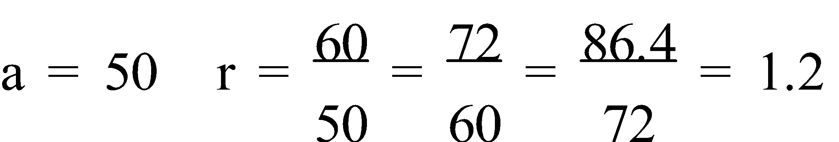

Tn = arn – 1

Tn = 50(1.2)n – 1

T12 = 50(1.2)11

≈ 371.5

b) 2, 6, 18, 54,...

a = 2 r = 3

Tn = arn – 1

39 366 = 2(3)n-1

3n – 1 = 19 683

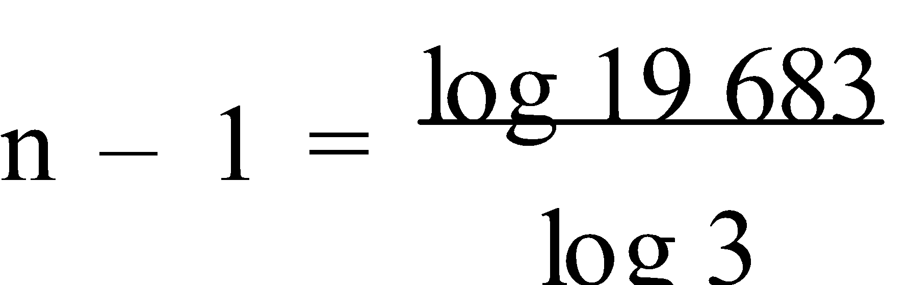

n – 1 = 9

n = 10

∴ 39 366 is the 10th term of the given G.P.

c) T5 = ar4 = 15 and T8 = ar7 = 1 875

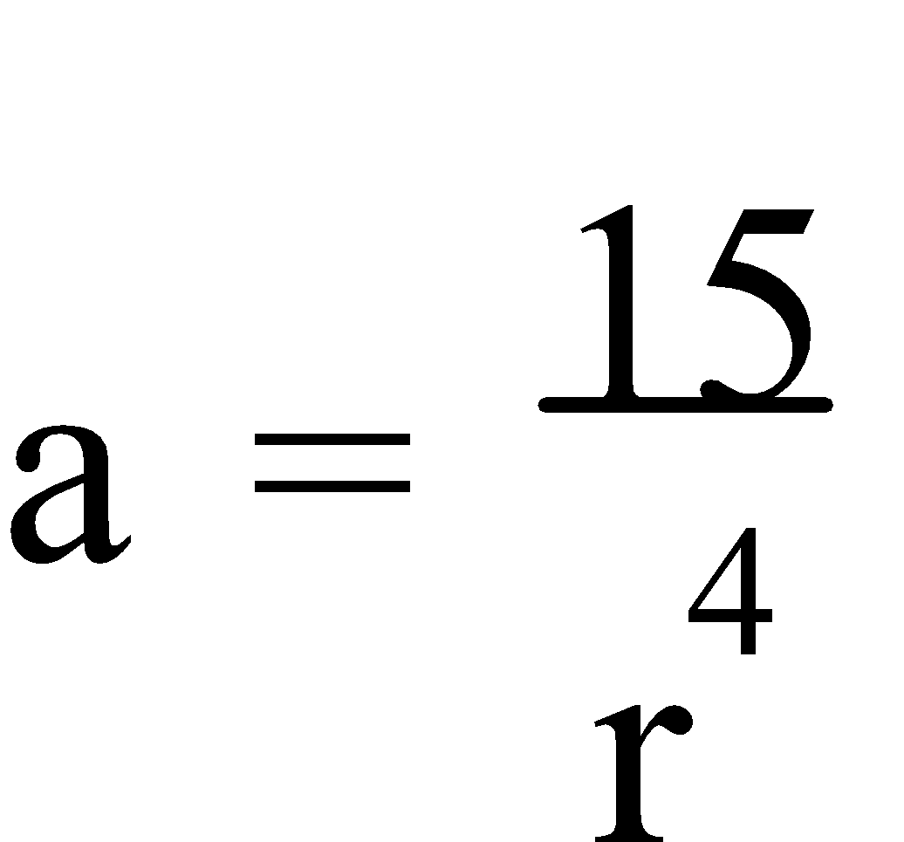 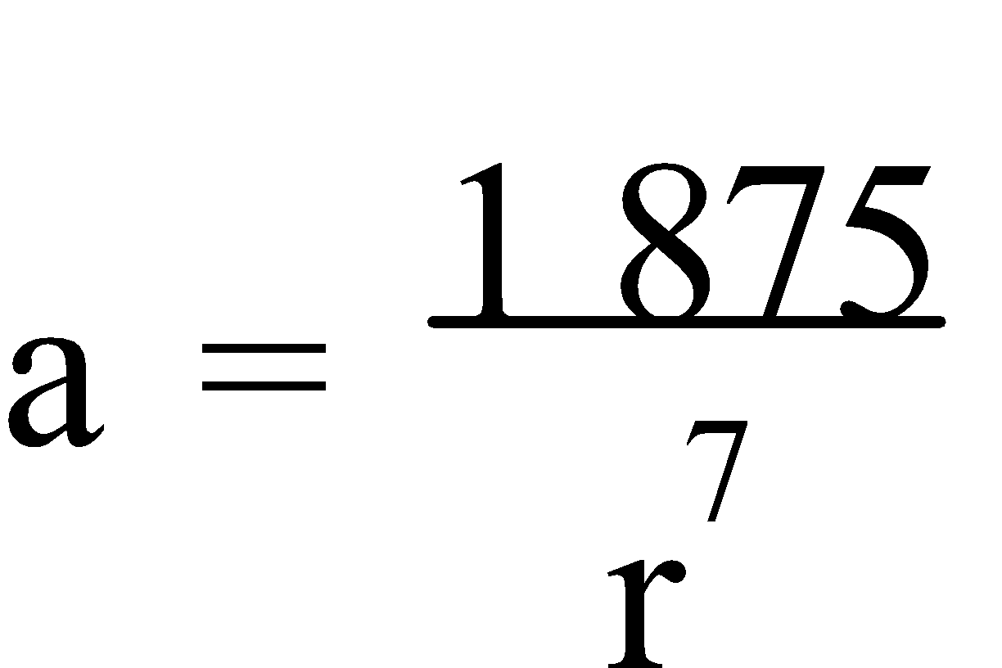

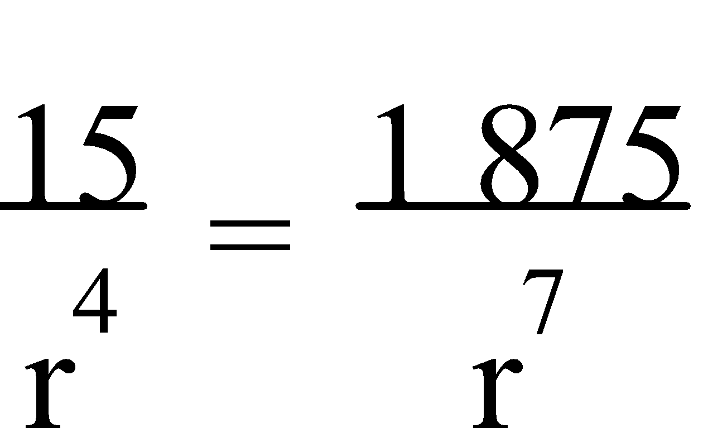

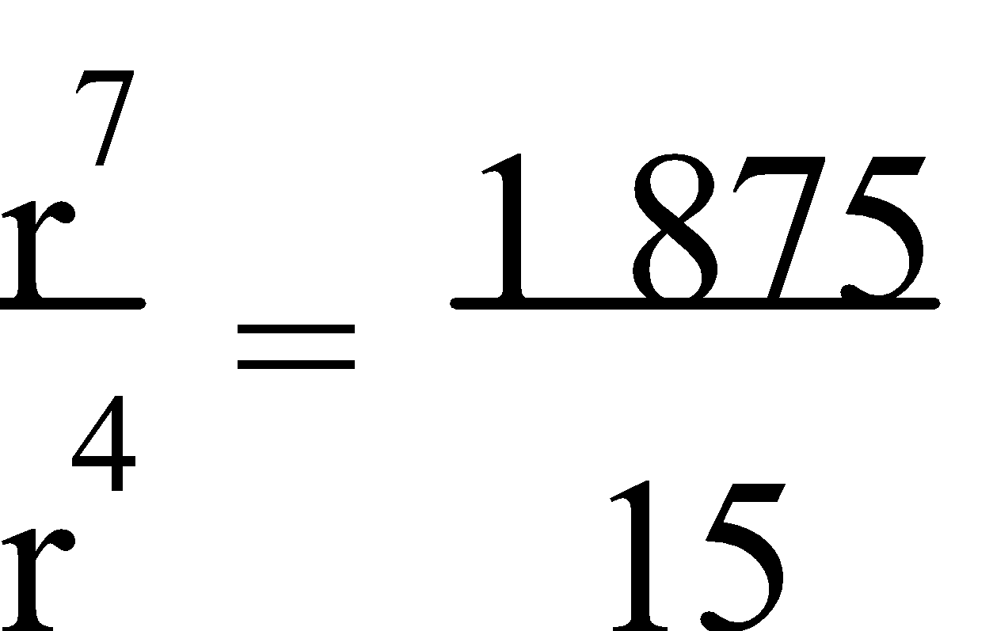

r3 = 125

r = 5

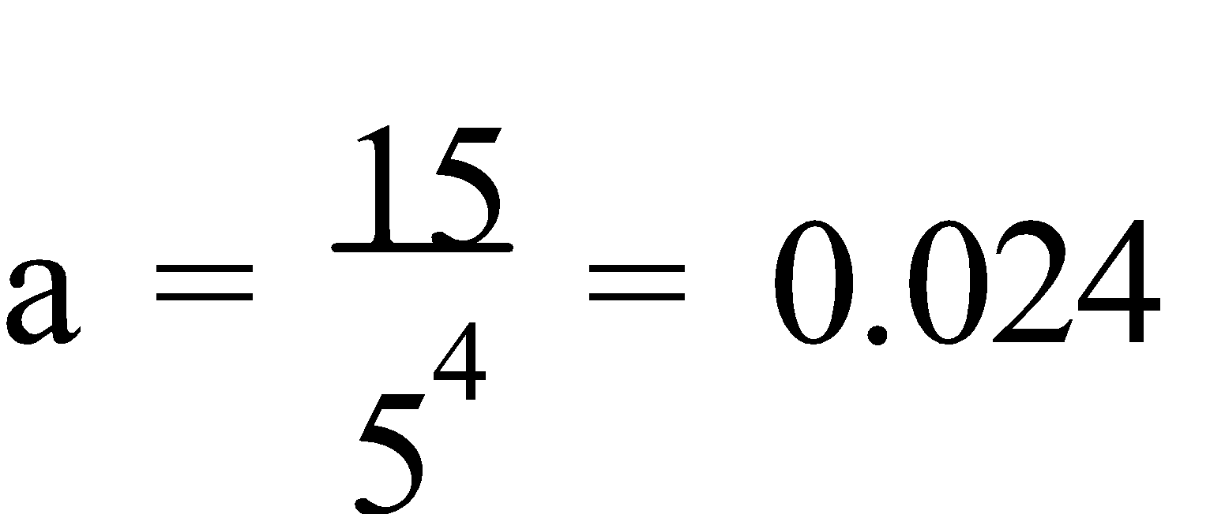

∴ The G.P. is 0.024, 0.12, 0.6,...

**5. GROWTH AND DECAY:** Many number patterns exist in everyday situations and an understanding of sequences can be useful in solving real life problems.

**NOTE:** Many money problems involve **T0** instead of **T1**.

E.g.6. An employee is hired on a quarterly salary of $7 000 with increments of $250 per quarter.

a) What will the employee earn in the tenth quarter of employment?

b) When will the employee be earning $8 500 per quarter?

a)

| **QUARTER** | 1 | 2 | 3 | 4 |
| --- | --- | --- | --- | --- |
| **SALARY** | 7 000 | 7 250 | 7 500 | 7 750 |

d 250 250 250

Rule: s = 7 000 + 250(q – 1)

s(10) = 7 000 + 250(9)

= $9 250

∴ The employee will earn $9 250 per quarter in the tenth quarter of employment.

1. 8 500 = 7 000 + 250(q – 1)

1 500 = 250(q – 1)

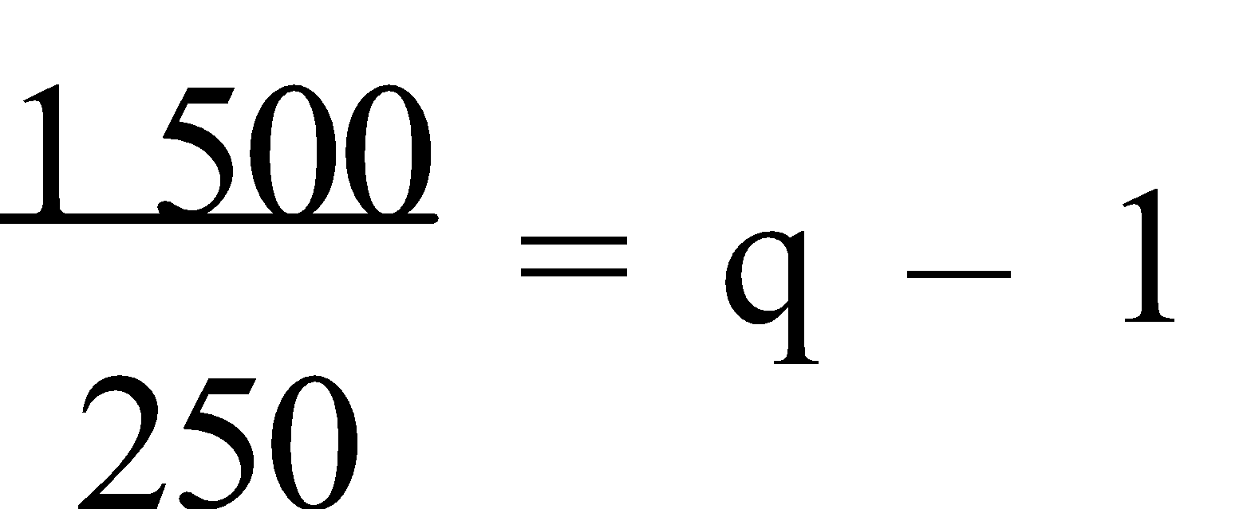

6 = q – 1

q = 7

∴ The employee will be earning $8 500 per quarter in the seventh quarter.

E.g.7. The predicted growth pattern of a town with a current population of 2 000, is for a population of 2 400 at the end of the first year, 2 880 at the end of the second year, 3 456 at the end of the third year and so on. Given that the pattern continues, find:

a) the population at the end of 10 years, and

b) when the population reaches approximately 23 610.

a)

| **YEAR** | 0 | 1 | 2 | 3 |
| --- | --- | --- | --- | --- |
| **POPULATION** | 2 000 | 2 400 | 2 880 | 3 456 |

d 400 480 576

r 1.2 1.2 1.2

Rule: p = 2 000(1.2)y

p(10) = 2 000(1.2)10

≈ 12 383

∴ The population will be approximately 12 383 at the end of 10 years.

b) [Graph p = 2 000(1.2)y; then use G-Solv, X-cal]

From the CAS calc., y ≈ 13.5 when p = 23 610

∴ The population will reach approximately 23 610 in the 14th year.

E.g.8. $1 500 is deposited on 1st January, 1985 to open an account. On each subsequent anniversary of this date a further $1 500 is deposited into the account. If the account earns interest at the rate of 10% per annum compounded annually, how much will be in the account:

a) on 31st December, 1999 immediately after the annual interest calculation, and

b) on 1st January 2000, following the deposit of $1 500?

1. Total account balance (31st December, 1985) = $1 500 × 1.1

= $1 650

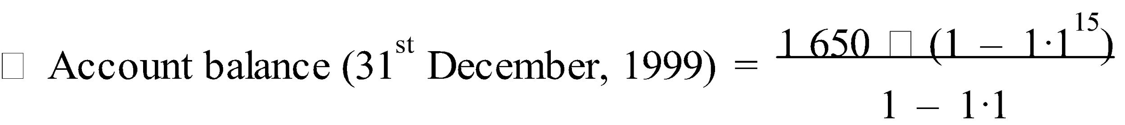

≈ $52 424.59

1. ∴ Account balance (1st January, 2000) ≈ $52 424.59 + $1 500

≈ $53 924.59

Ref: Ex.8A Q.1-22 (even)

**6. PAYMENTS:** Regular **payments** can be made **into** an account, e.g. to pay off a loan, or **from** an account, e.g. an **annuity**. Where regular payments are made to pay off a loan – each payment **reduces** the **amount owing** and hence, the **interest** is reduced. This is called **reducible interest** or **amortization**.

An **annuity** is a regular payment paid from an account in the form of an **allowance** or a **pension**.

**NOTE:** A spreadsheet is an efficient method of setting up a repayment schedule.

E.g.9. At the beginning of April, Lindsay borrowed $5 000 to buy a car. She is considered a medium credit risk and so is required to pay an interest rate of 24% p.a. calculated monthly. She repays $550 per month with payments due on the first of each month. In August she receives her tax refund and decides to pay off the loan (September 1). How much must she pay?

P = $5 000 Interest rate = 2% per month Payments = $550 per month

| **PAYMENT** | **AMOUNT OWING ($)** | **INTEREST PAYABLE ($)** | **MONTHLY PAYMENT ($)** | **BALANCE OWING ($)** |
| --- | --- | --- | --- | --- |
| May 1 | 5 000.00 | 100.00 | 550.00 | 4 550.00 |
| June 1 | 4 550.00 | 91.00 | 550.00 | 4 091.00 |
| July 1 | 4 091.00 | 81.82 | 550.00 | 3 622.82 |
| August 1 | 3 622.82 | 72.46 | 550.00 | 3 145.28 |
| September 1 | 3 145.28 | 62.91 | 3 208.18 | --- |

∴ Lindsay must pay $3 208.18 on September 1 to pay off her loan.

Ref: Ex.8B Q.1-5 (odd)

**SAMPLING METHODS AND CAPTURE-RECAPTURE**

**1. SAMPLING:** Some **population sizes** (**N**) are too large to survey. So, a **small group** or **sample** is selected to represent the population. As a guide, the **sample** size (**n**) is 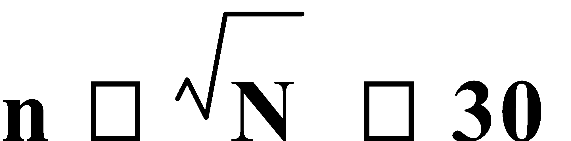. There are a number of different **sampling techniques**. We must ensure that any sample is truly **random**, and that each member of the population has an **equal chance** of being included in the sample. This is known as **simple random sampling**. To choose a true random sample, you could **draw names from a hat**, **roll a die**, use **random digit tables**, or use the **random number generator** on your calculator.

When the target population is known to consist of different classes (**strata**), it is possible that a small sample may not truly represent the entire population. We would then use a **stratified random sample**. The **sample size** of each **stratum** is in the same **proportion** as the stratum to the **population**. The advantage with **stratified random sampling** is that it takes into account the various chosen strata. A **simple random sampling** is conducted on each stratum. It offers a more efficient sampling with the possibility of **smaller sample sizes**.

**Cluster sampling** involves selecting an identifiable group within the population to represent the population. Surveying a school House group is an example of cluster sampling.

**Judgement sampling** involves any sample selected by the surveyor that they believe accurately reflects the opinion of the population, e.g. A class, House group or Form group could be used as a sample for a school survey.

**Quota sampling** involves selecting the required number in the stratified sample by a non-random method, e.g. Pollsters in Hay Street or a shopping mall, asking ‘random’ people to take part in a survey, but only choosing people that ‘fit’ within the required age groups and/or sex.

**Systematic sampling** involves selecting the sample in a predetermined pattern, e.g. Every 10th person on the school roll.

**Convenience sampling** involves selecting a sample in the easiest and/or most cost effective manner, and thus **utilizing** any of the **previous methods**, whichever is most convenient and/or cost effective at the time of the survey.

E.g.1. From a class of 30, use the calculator random digit generator to randomly select 5 students if each student has been allocated a number (1-30).

e.g. From the CAS calc., 3, 2, 25, 22, 30

E.g.2. Students from a high school are to be surveyed and a sample of 40 is to be selected. Complete the following table to determine the size of the sample for each year group.

| **YEAR** | **8** | **9** | **10** | **11** | **12** | **TOTAL** |
| --- | --- | --- | --- | --- | --- | --- |
| **NUMBER** | 270 | 215 | 190 | 120 | 105 | 900 |
| **PROPORTION** | **0.3** | **0.238** | **0.21** | **0.13** | **0.116** | **1** |
| **SAMPLE** | **12** | **10** | **8** | **5** | **5** | **40** |

Ref: Ex.9A Q.1-6 (even)

**2. CAPTURE-RECAPTURE:** **Capture-recapture** is a method that makes it possible to estimate the population of animals, in the wild. The **process** involves **catching** and **tagging** a sample of the population, **releasing** the tagged animals back into the population, and at a later date, **capturing** another sample, noting the number of **tagged** animals **in** the **second sample**. Assuming the **proportion** of **tagged** animals, from the **first capture**, in the population is reflected in the **proportion** of **tagged** animals in the **second capture**, then an **estimate** of the **total population** is 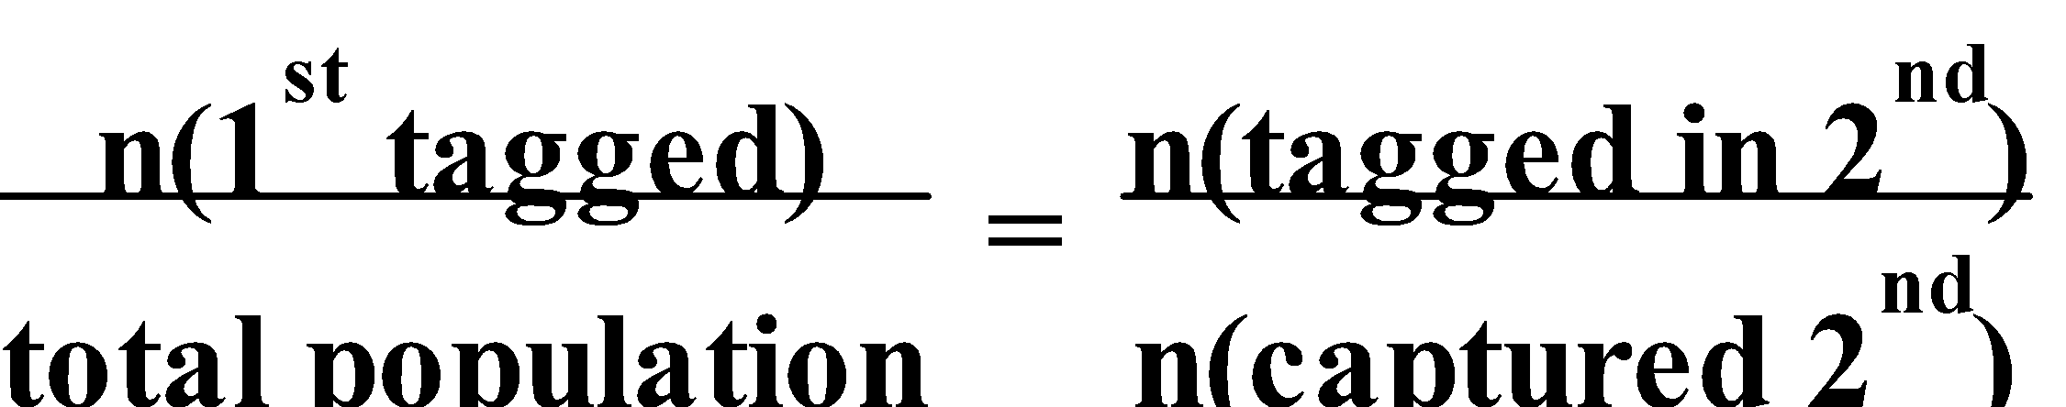.

E.g.3. In an attempt to estimate the size of a recently discovered numbat population –

86 were captured, tagged and released. 1 week later, 73 were captured and 8 were tagged. What is the estimated size of the population?

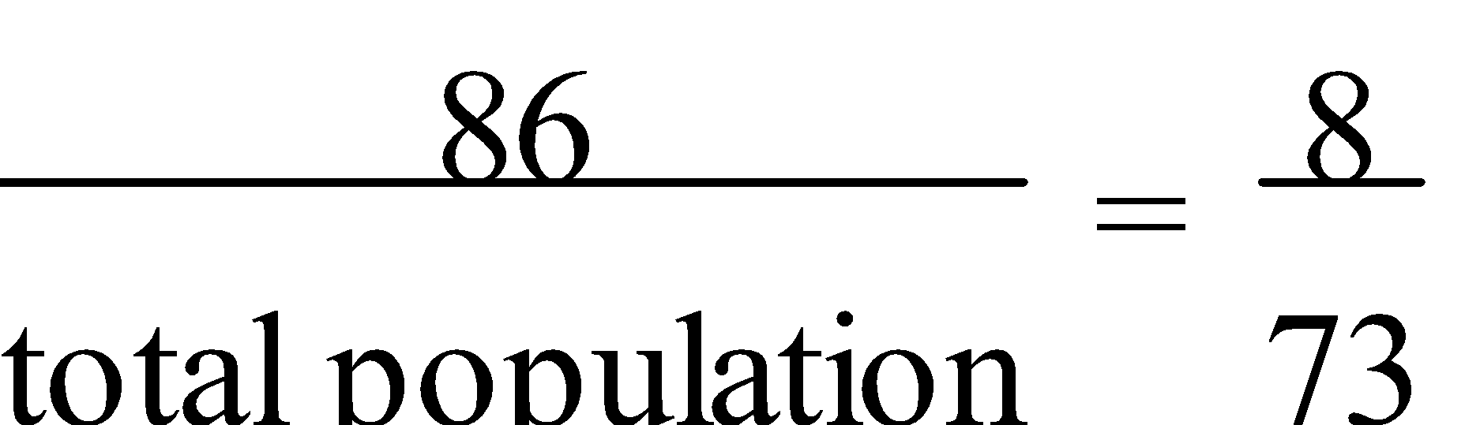

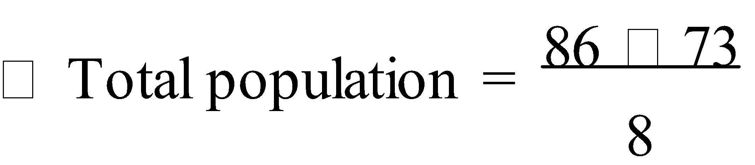

= 784.75

∴ The numbat population is estimated to be 785.

Ref: Ex.9B Q.1-4

It is not ‘possible’ to **capture** and **tag** people. However, a **similar process** can be used to determine **human populations** where 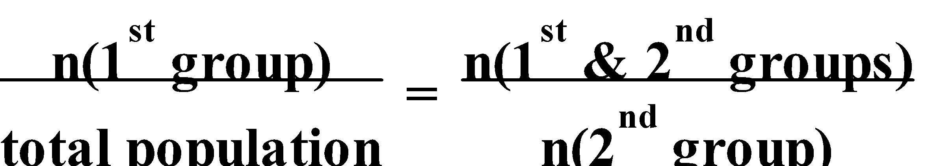.

E.g.4. To estimate the number of people requiring knee reconstructions as the result of sports injuries, a government enquiry compared the number of WAFL/AFL footballers requiring the reconstruction (1 024) to the number of people receiving the treatment from Royal Perth Hospital (53) with 34 of the footballers received their treatment at Royal Perth. Use this information to estimate the total number of reconstructions during that year.

Let k be the total number of knee reconstructions due to sports injuries.

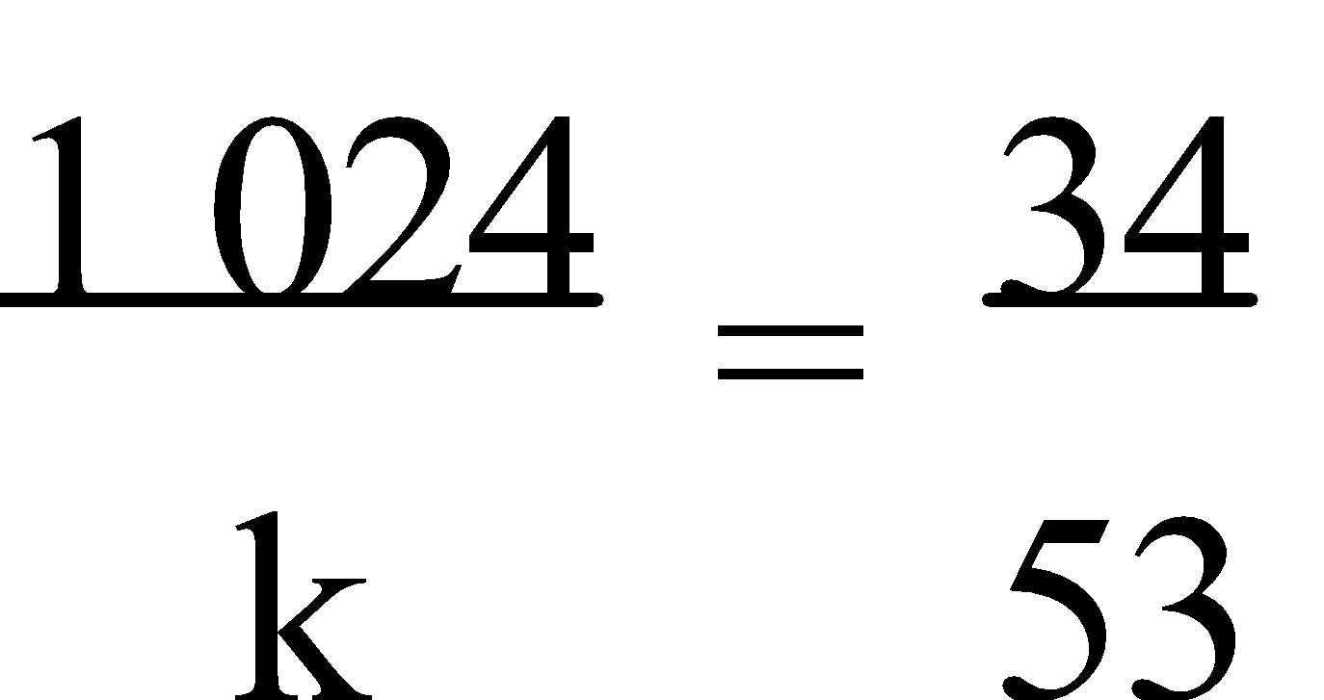

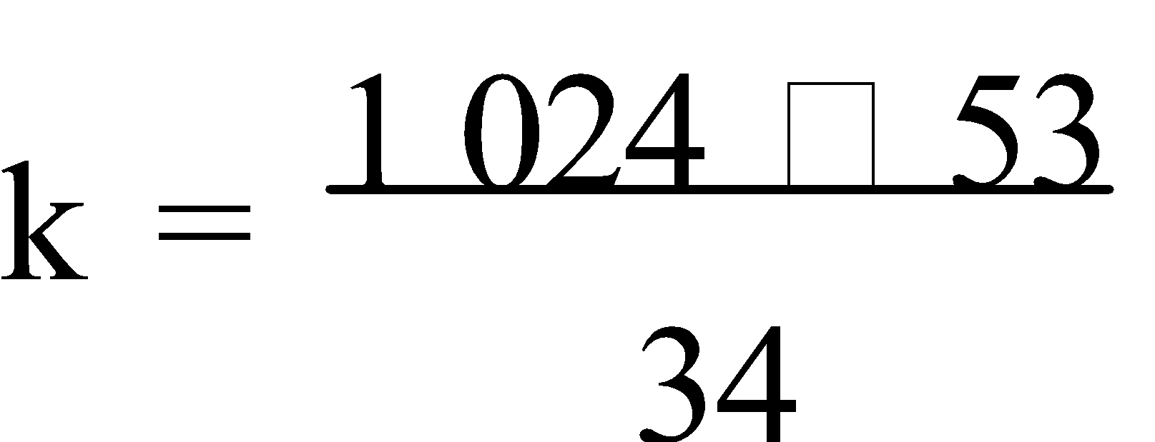

= 1 596

∴ Approximately 1 596 knee reconstructions due to sports injuries were in this year.

Ref: Ex.9C Q.1-4

**NORMAL DISTRIBUTION**

**1. NORMAL DISTRIBUTIONS:** Many naturally occurring variables, e.g. human I.Q.’s, the weights of cats, etc. fit a smooth ‘**bell shaped curve**’ known as a **normal curve**. 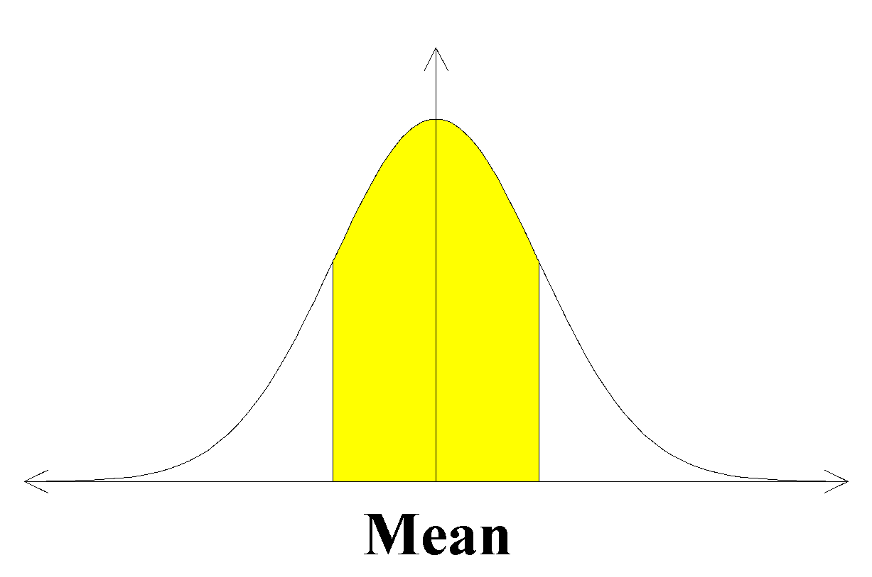

A normal curve with a mean of zero and a standard deviation of one is known as a **standard normal distribution**. 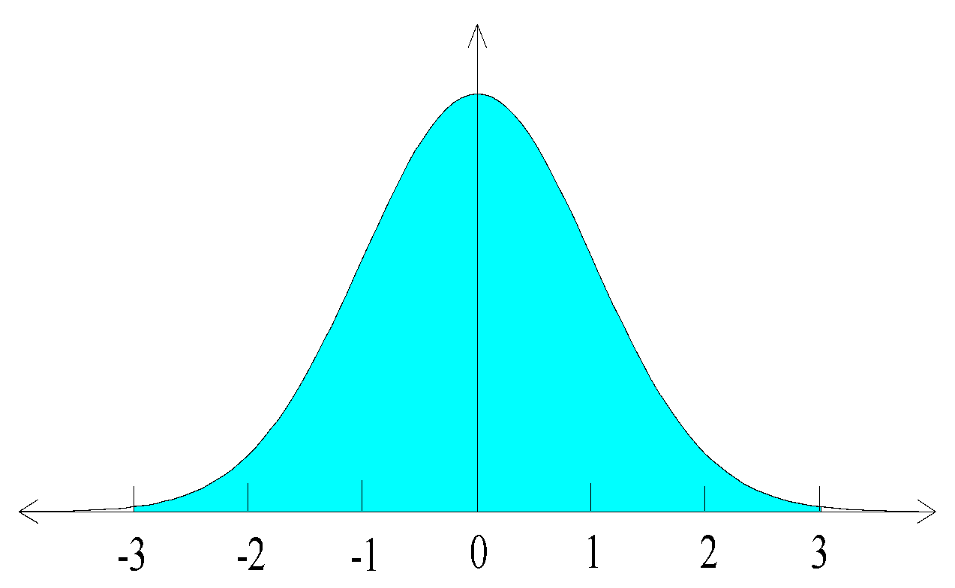

For **standard normal distributions** –

**68.3%** of the distribution **95.4%** of the distribution **99.7%** of the distribution

lies within **one standard** lies within **two standard** lies within **three standard**

**deviation** of the mean. **deviations** of the mean. **deviations** of the mean.

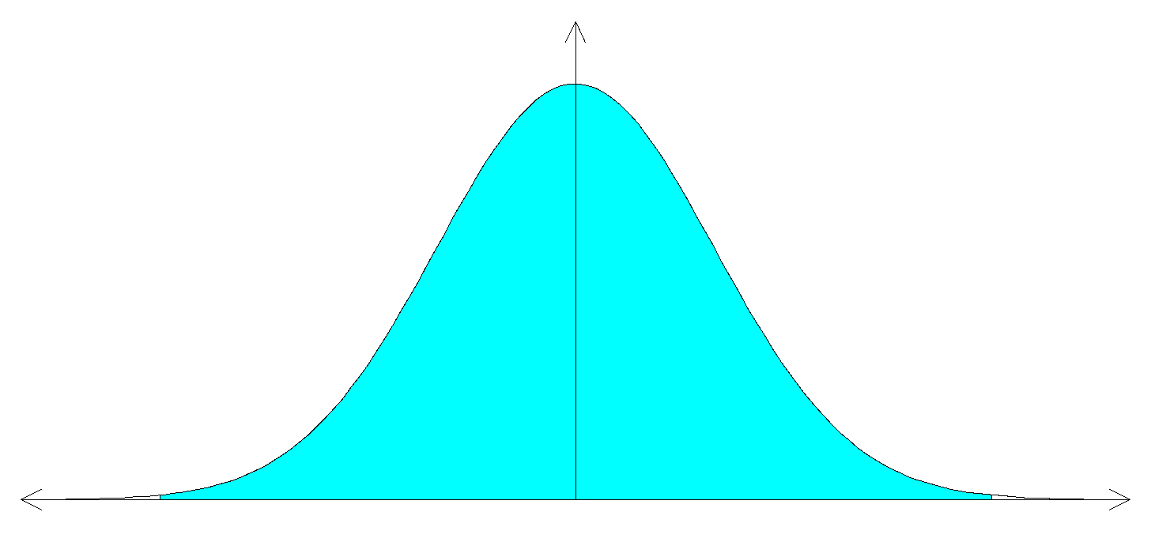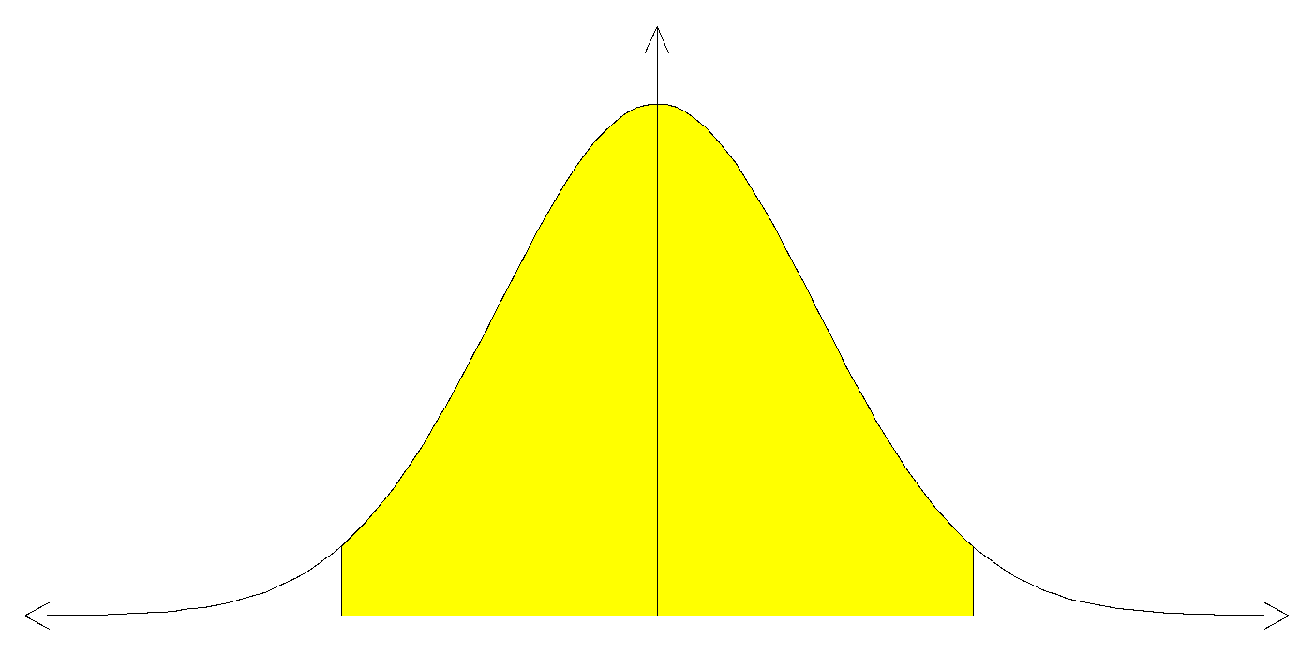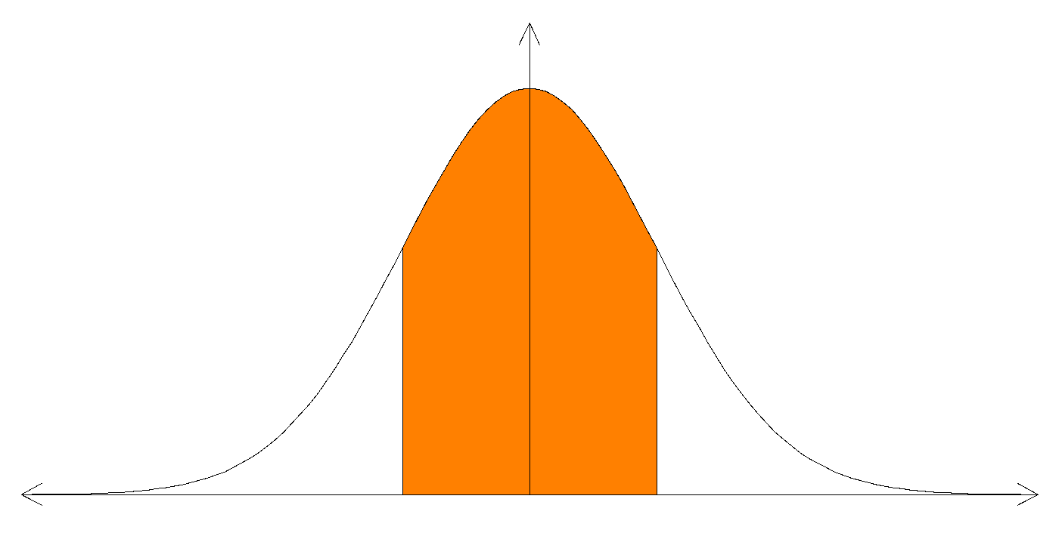

The **normal distribution** is also called the **Gaussian distribution**.

To determine the **probabilities** for normally distributed sets of data, a **book of tables** or an appropriate **calculator programme** may be used. The **entries** in the book of **tables** are **cumulative probabilities** associated with a particular **standardized score z** where 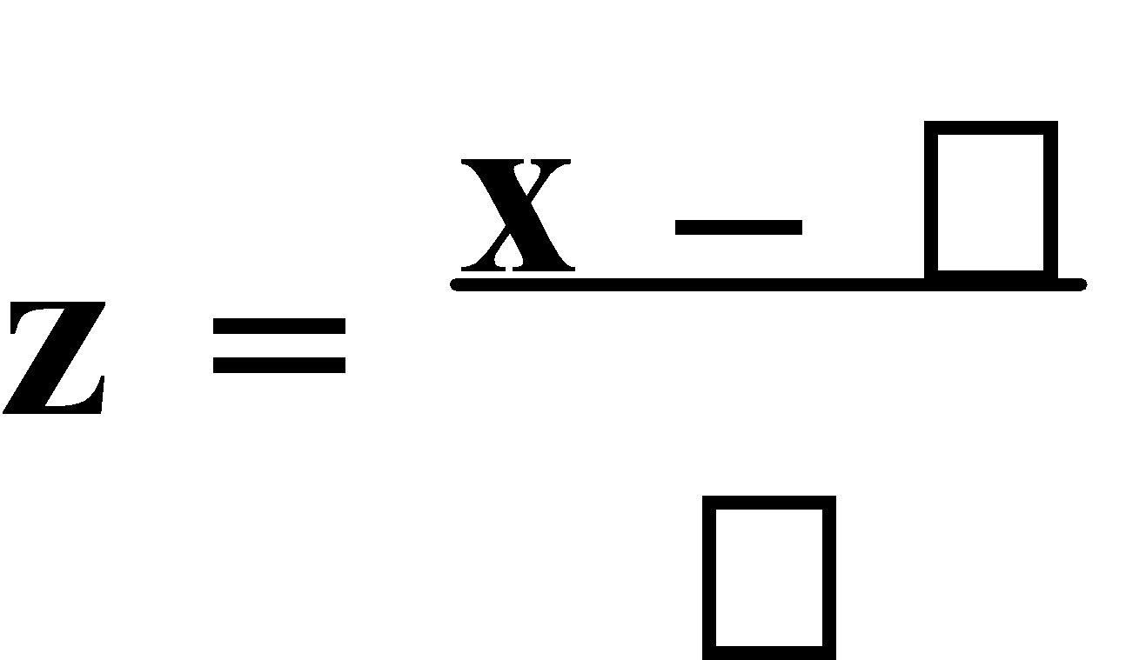. The **shaded area** to the left of z in this diagram represents the **cumulative probability**, where **P(Z ≤ z)**.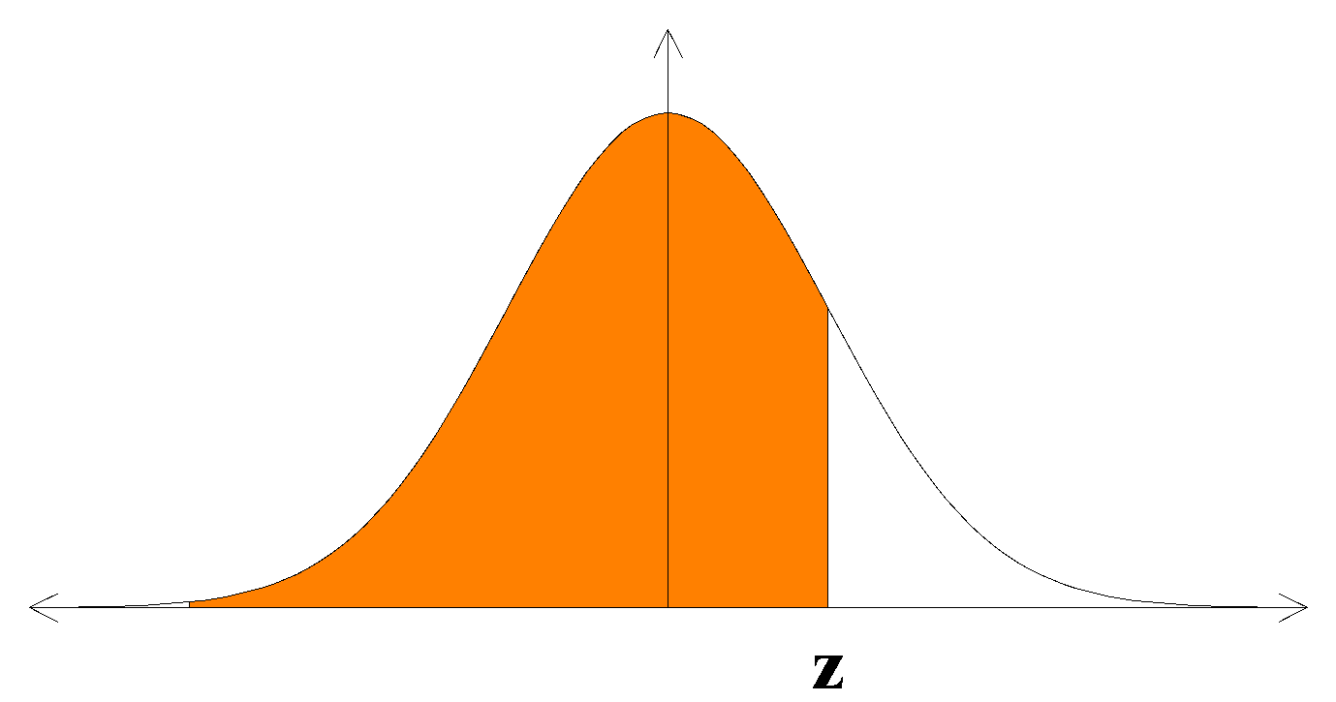

E.g.1. Find:

a) P(Z ≤ 1.74)

b) P(-0.7 ≤ Z ≤ 0.4)

c) P(Z > 0.73)

d) P(Z ≤ k) = 0.9798

e) P(Z > k) = 0.83

f) P(-1.2 ≤ Z ≤ k) = 0.642

g) P(-k ≤ Z ≤ k) = 0.68

a) P(Z ≤ 1.74) = 0.9591 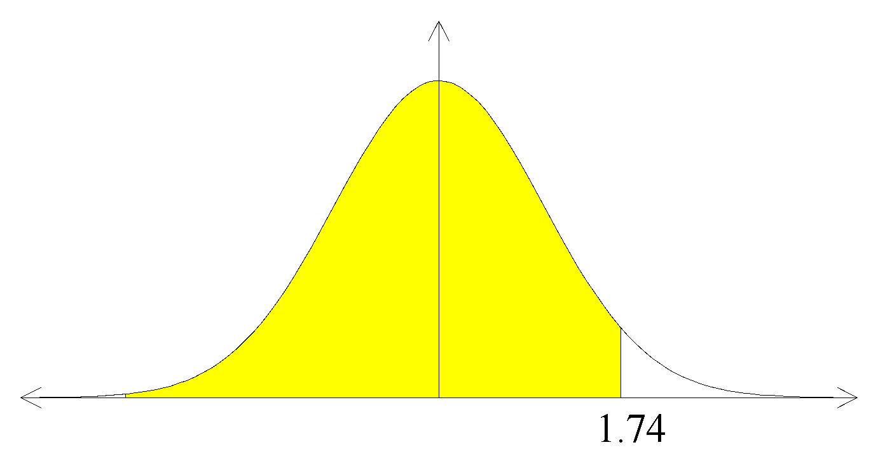

b) P(-0.7 ≤ Z ≤ 0.4) = P(Z ≤ 0.4) – P(Z ≤ -0.7)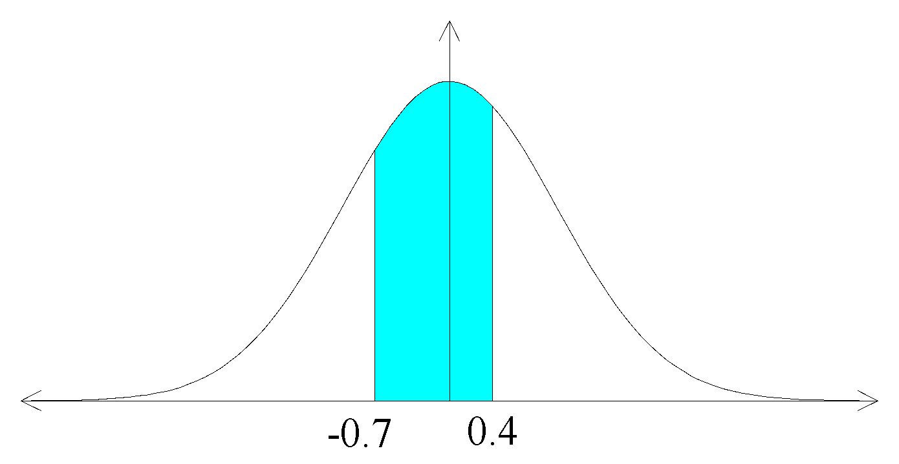

= 0.6554 – 0.2420

= 0.4134

c) P(Z > 0.73) = 1 – P(Z ≤ 0.73)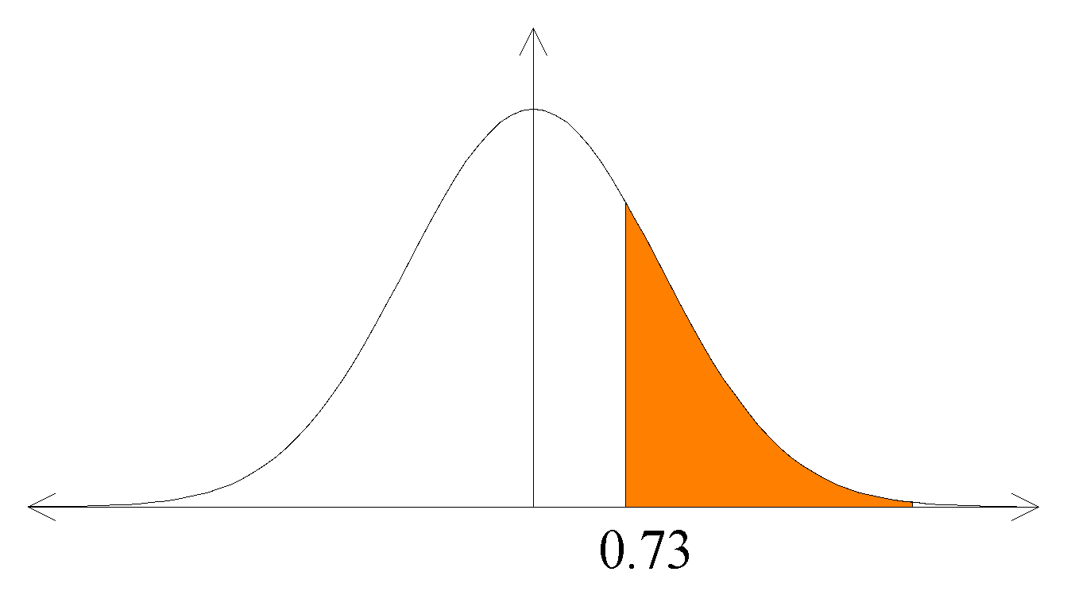

= 1 – 0.7673

= 0.2327

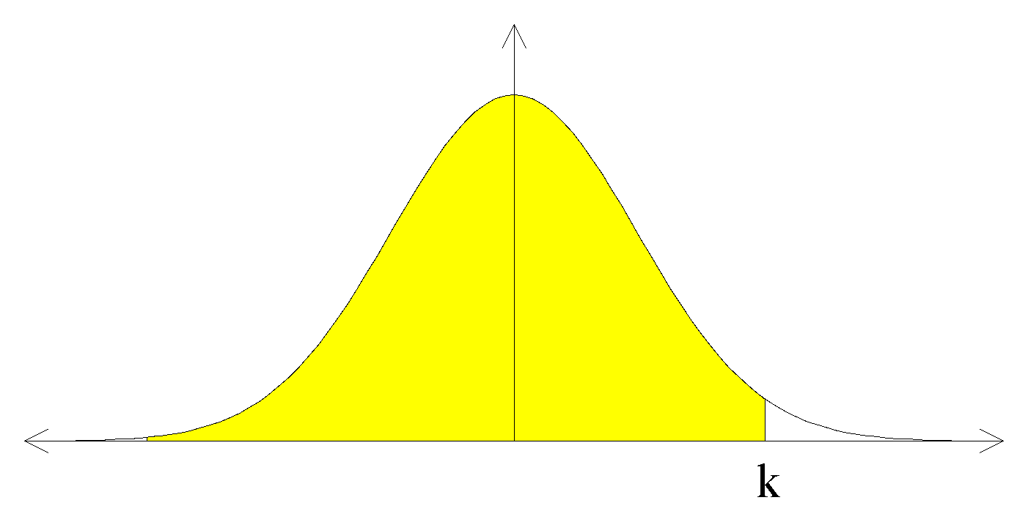

d) P(Z ≤ k) = 0.9798

k = 2.05 (From tables/CAS calc)

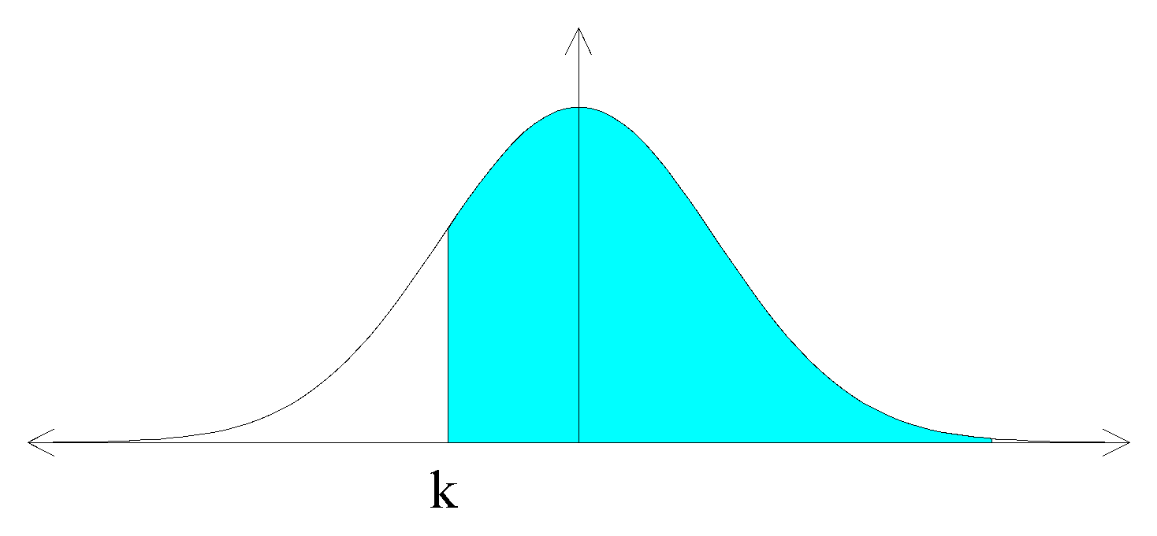

e) P(Z > k) = 0.83

P(Z ≤ k) = 1 – 0.83

= 0.17

∴ k ≈ -0.95

f) P(-1.2 ≤ Z ≤ k) = 0.642

P(Z ≤ k) – P(Z ≤ -1.2) = 0.642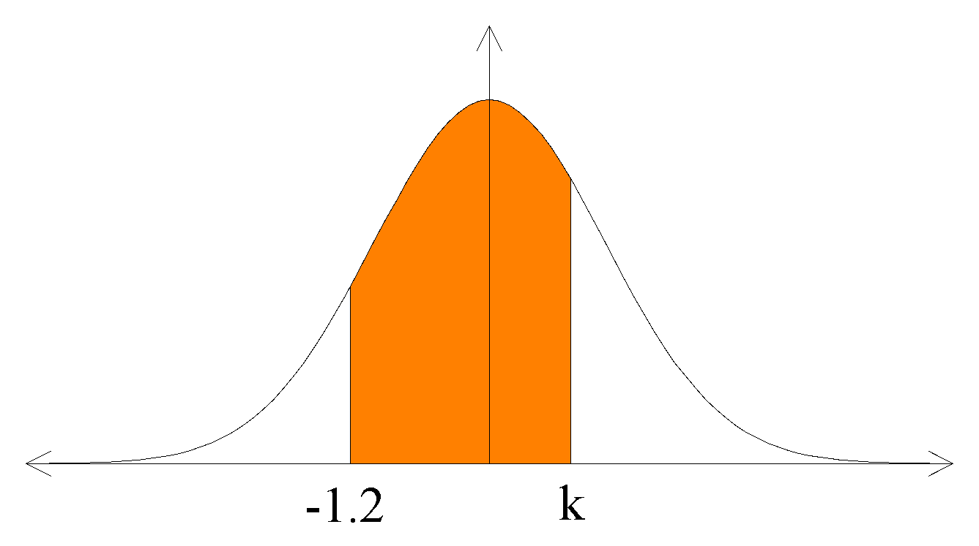

P(Z ≤ k) = 0.642 + P(Z ≤ -1.2)

= 0.642 + 0.1151

= 0.7571

∴ k ≈ 0.70

g) P(-k ≤ Z ≤ k) = 0.68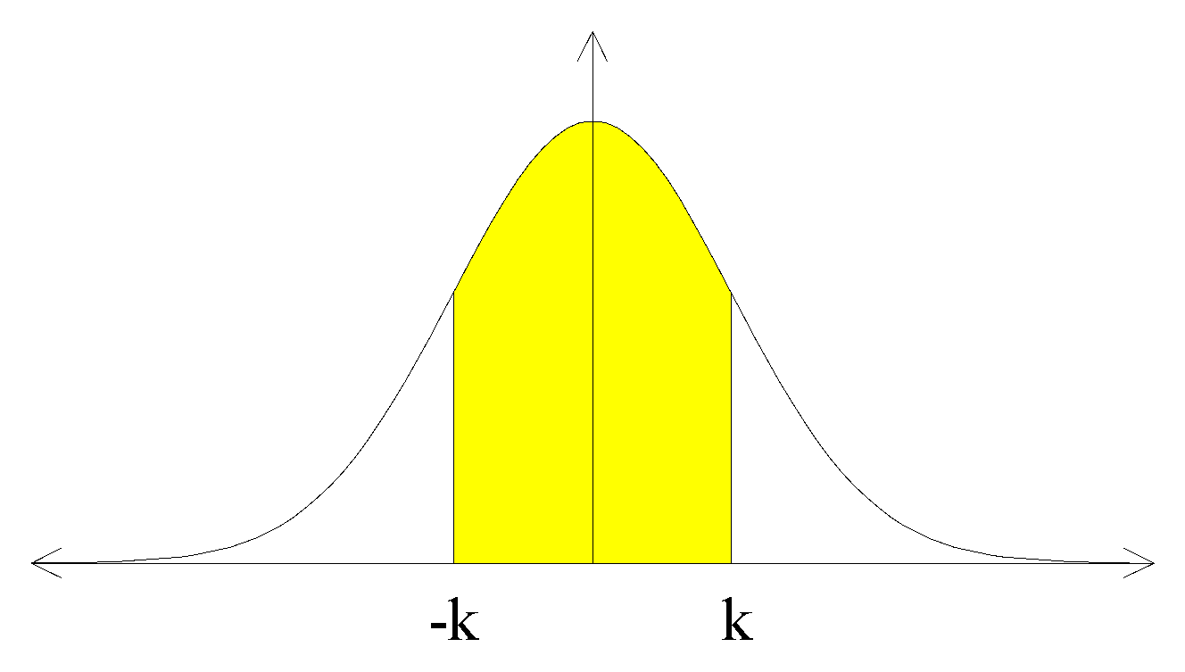

P(0 ≤ Z ≤ k) = 0.34

P(Z ≤ k) = 0.34 + P(Z ≤ 0)

= 0.34 + 0.5

= 0.84

∴k ≈ 0.99

Ref: Ex.10A Q.1-17 (odd)

If the continuous random variable X is **normally distributed** with a **mean** **μ** and **standard deviation** **σ** and hence **variance** **σ**2, then it is written as **X~N(μ,σ2)**, where

**μ** and **σ2** are the **parameters**. As it is unlikely that a distribution will have **μ = 0** and **σ = 1**, i.e. be a **standard normal distribution**, then it would be necessary to **standardize the scores**. For X, a normally distributed variable, the **proportion** of the distribution that falls below a value of **k** may be referred to as a **percentile** or **quantile**, e.g. P(Z < k) = 0.7, k is the 70th percentile or 0.7 quantile.

E.g.2. The pulse rates of 17 year old boys is recorded at rest and it is found that the results are normally distributed with a mean of 76 beats per minute (b.p.m.) and a standard deviation of 5 b.p.m.

a) Find the probability that a boy’s pulse rate is less than 80 b.p.m.

b) What proportion of boys have a pulse rate between 70 b.p.m. and 80 b.p.m.?

c) What pulse rates do the boys with the lowest 10% of pulse rates have?

d) In a group of boys with pulse rates under 80 b.p.m., what percentage will have pulse rates greater than the mean?

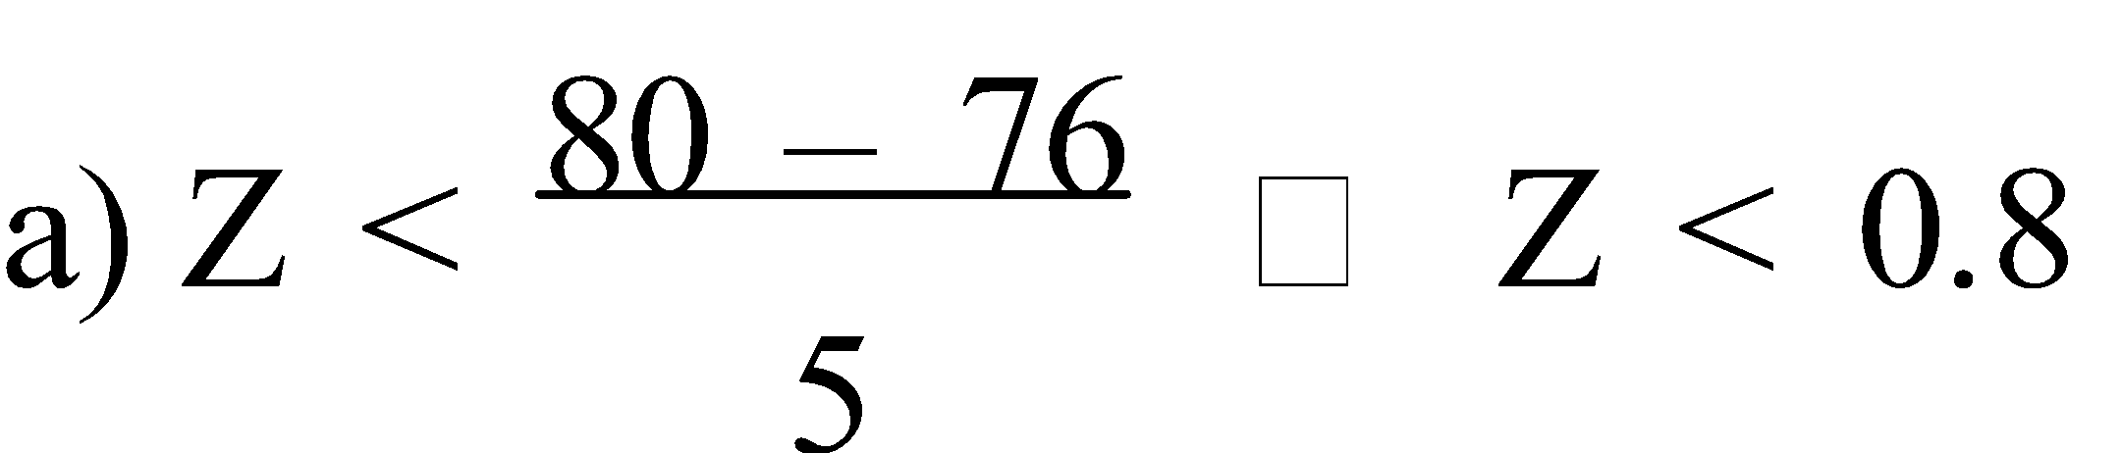

∴P(X < 80) = P(Z < 0.8)

= 0.7881

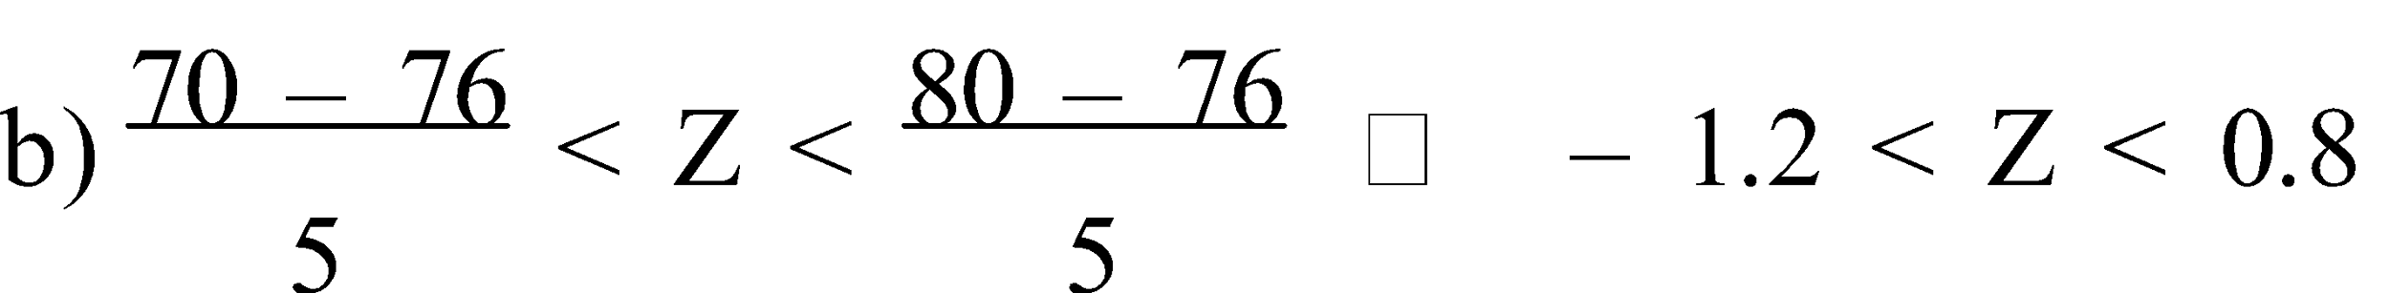

∴P(70 < X < 80) = P(-1.2 < Z < 0.8)

= 0.7881 – 0.1151

= 0.673

c) P(X < c) = 0.1

i.e. P(Z < k) = 0.1

k ≈ -1.28

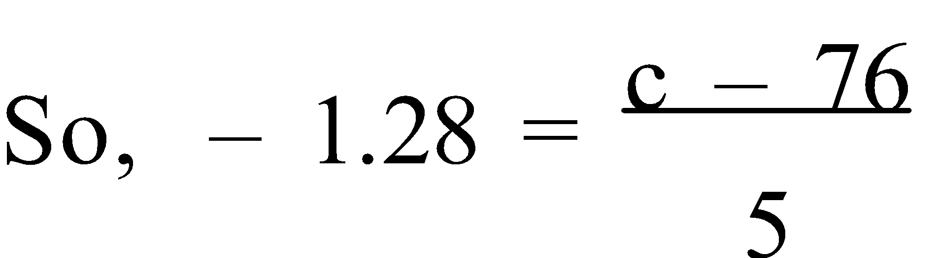

c = 69.6

∴The boys with the lowest 10% of pulse rates have 69.6 b.p.m.

d) P(76 < X <80 | X < 80) = P(0 < Z < 0.8 | Z < 0.8)

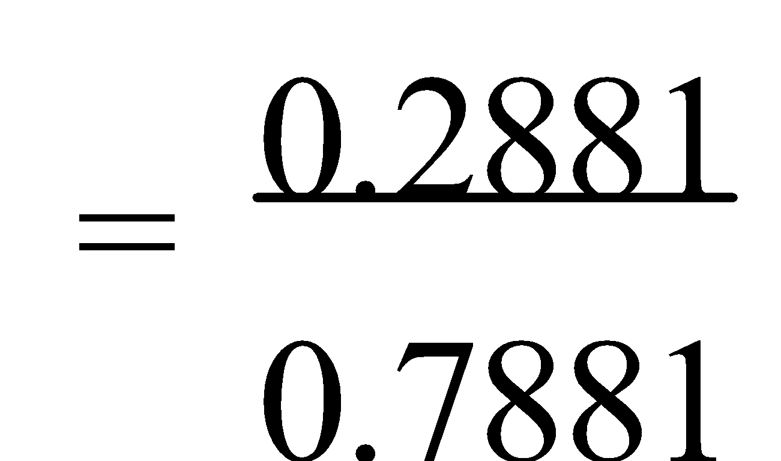

≈ 0.3656

∴ About 37% of boys with a pulse rate under 80 b.p.m. will have pulse rates greater than the mean.

Ref: Ex.10B Q.1-20 (even)

**FUNCTIONS AND GRAPHS**

**1. OPTIMUM VALUE:** An **optimum value** is the best value in a particular situation – **best** usually means **largest** or **smallest**. **Optimisation** is the process of finding minimum and/or maximum values. A **table of values** is often very useful when trying to find the optimum value to a particular situation.

E.g.1. Rowan, who owns a goat, is planning to grow vegetables but these must be fenced off. He has 16 metres of suitable fencing wire. What is the maximum rectangular area he can enclose given that an existing fence can be used as one side of the rectangle? Would a semicircle enclose a bigger area? and if, so what is the difference in area?

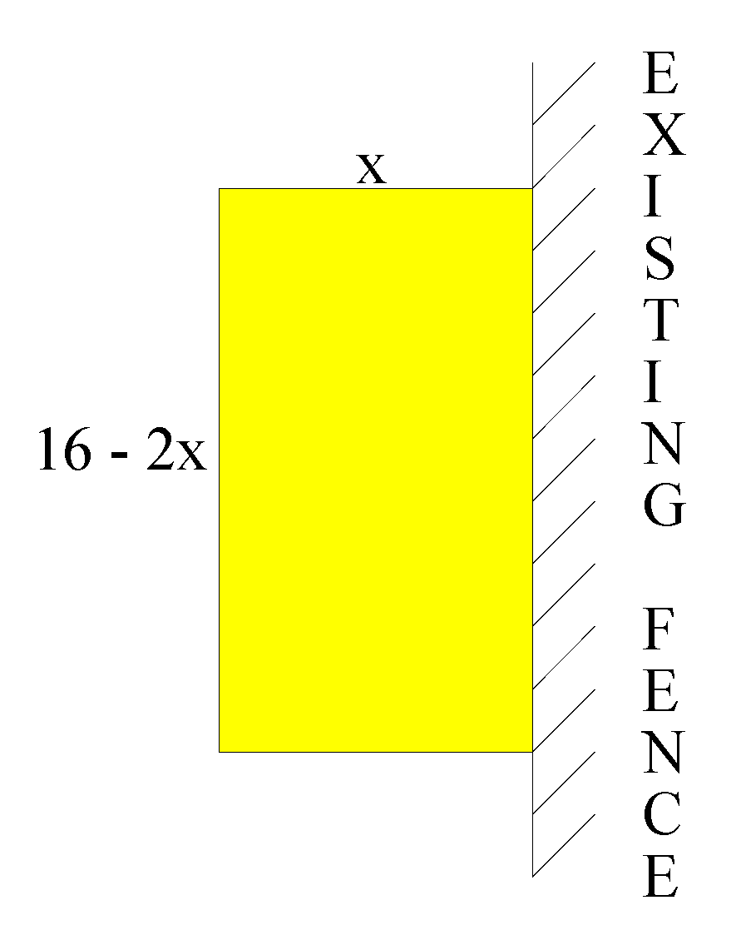

| **x (m)** | **16 – 2x (m)** | **AREA (m2)** |
| --- | --- | --- |
| 1  2  3  4  5 | 14  12  10  8  6 | 14  24  30  32  30 |
| 3.9  4.1 | 8.2  7.8 | 31.98  31.98 |

∴ Maximum rectangular area is 32 m².

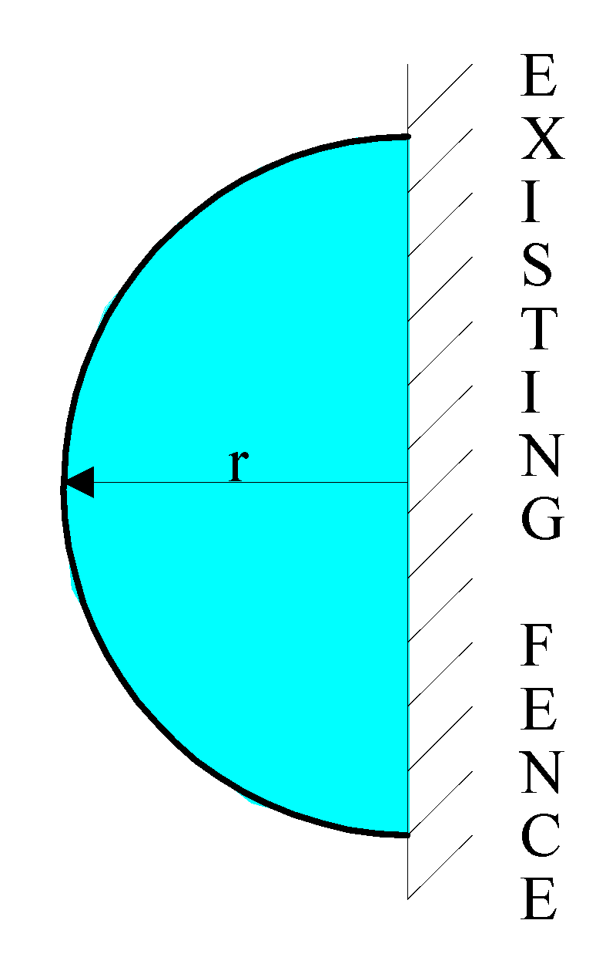

½C = 16

C = 32 m

C = 2πr

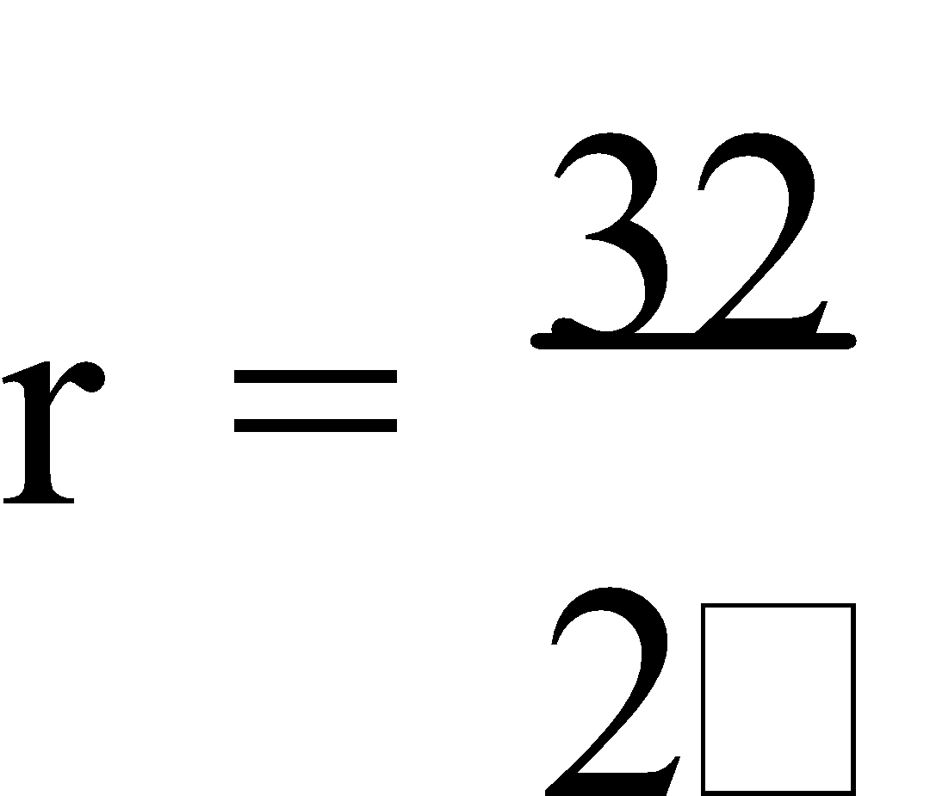

≈ 5.09 m

A = ½πr²

≈ 40.74 m²

∴ Yes, a semi-circular area would be bigger by approximately 8.74 m2.

An alternative to “**zooming in**” on the optimum value using a table values is to **graph** the points or rule, then use the graph to determine where the **optimum solution** occurs.

E.g.2. The average cost of constructing an apartment block of x storeys is given by 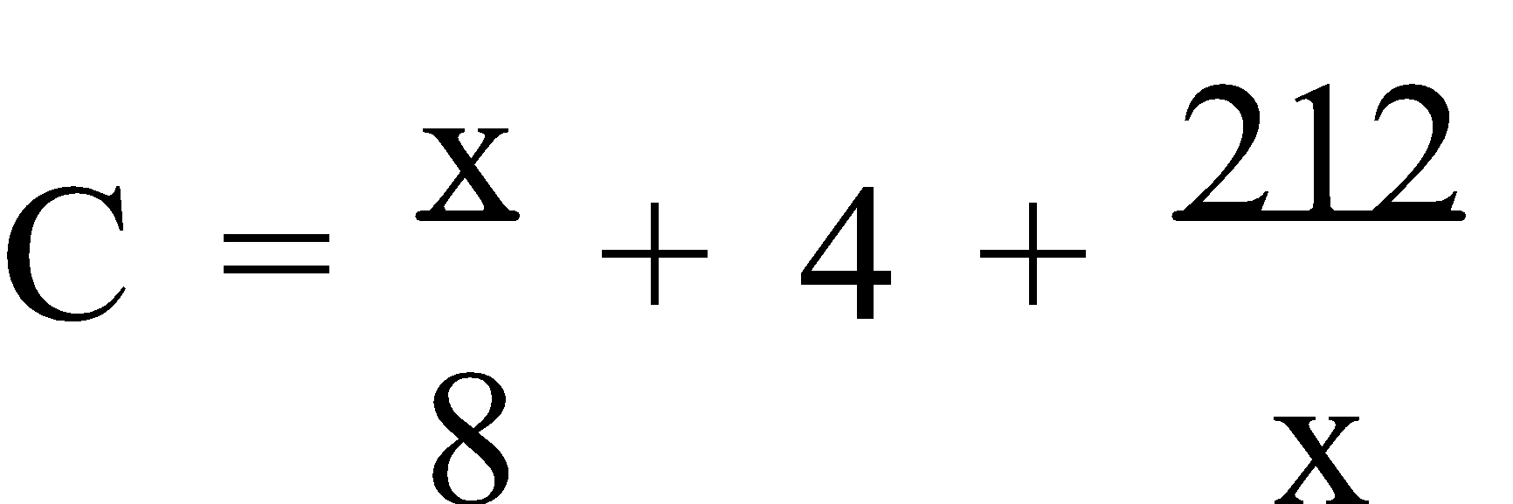 where C is in millions of dollars. Determine the optimum number of storeys to build to minimize the cost.

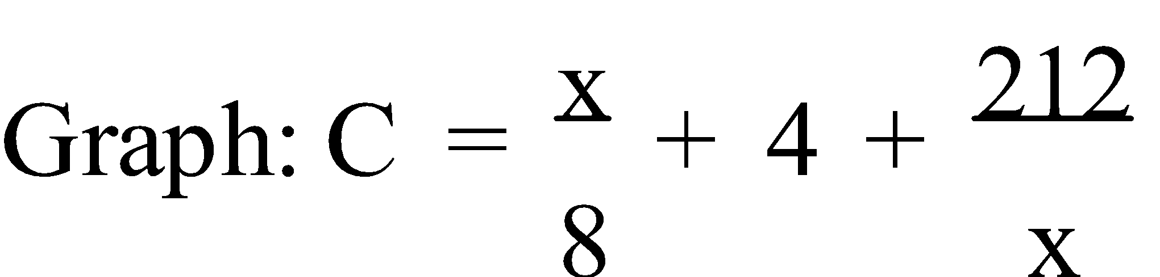

From the CAS calc., the minimum is at (41.18,14.30).

∴ The optimum number of storeys to build is 41 for a cost of $14.3 million.

Ref: *Ex.1A Q.1-17 (odd)*

**2. GRADIENT OF A CURVE:** Consider this graph – 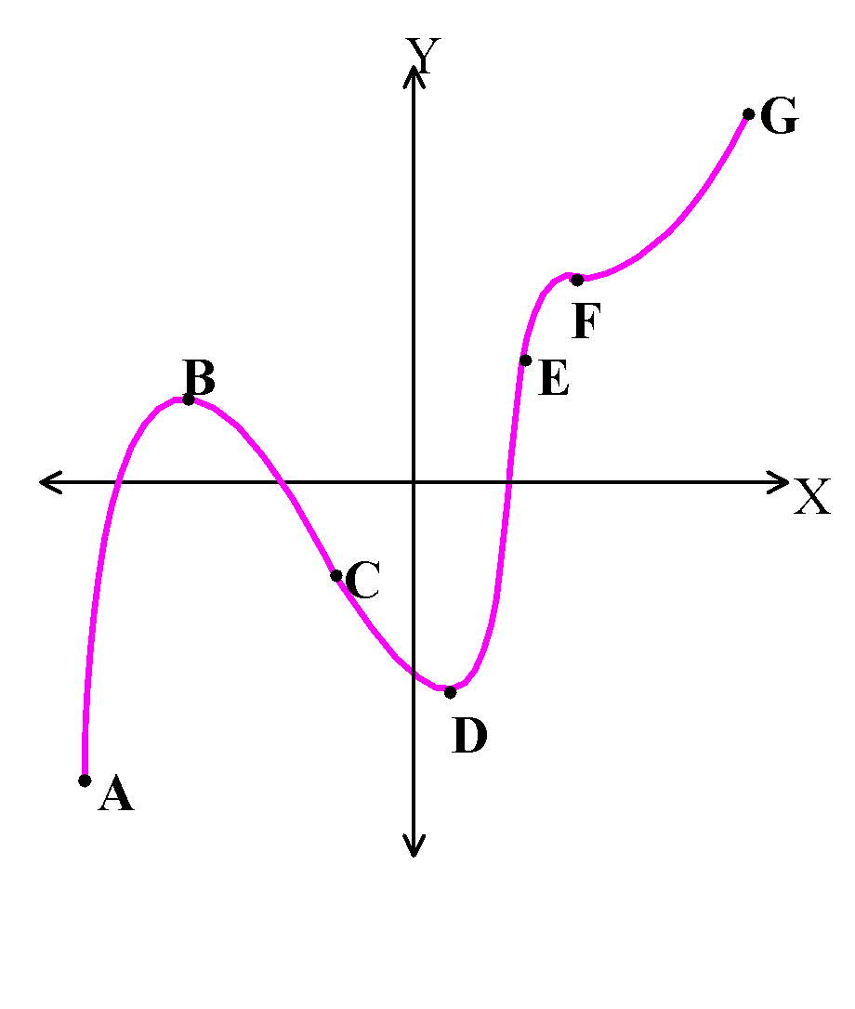

Point A is the **global minimum point**.

Point B is a **local maximum point**.

Point D is a **local minimum point**.

Point G is the **global maximum point**.

From A to B the **gradient** is **positive** and hence we say that

the function is **increasing** over this interval.

The function is **decreasing** from B to D (**negative gradient**)

and then **increases** again from D to G. If the graph continued,

then as **x → ∞**, **y → ∞** and as **x → -∞**, **y → -∞**.

Points C and E are **points of inflection** and

Point F is a **point of horizontal inflection**.

The terms **concave down** and **concave up** are often used to describe the shape of a graph near maxima or minima. Points on the curve where it changes from being concave down to concave up, or vice versa, are called **points of inflection**. If a graph is **momentarily horizontal** at a point of inflection, then the point is a **point of** **horizontal inflection**.

Local maxima and minima are sometimes referred to as **turning points**. Turning points and points of horizontal inflection can also be referred to as **stationary points**.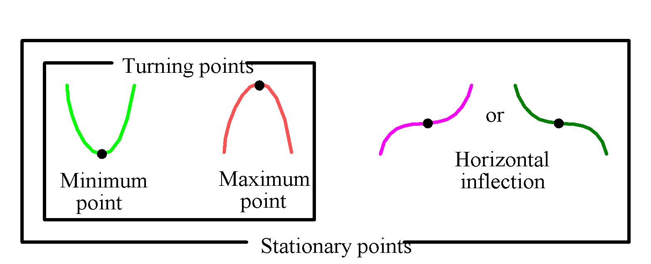

As we pass through a **maximum point** the gradient changes from **positive to negative**. Likewise as we pass through a **minimum point** the gradient changes from **negative to positive**. Hence the **gradient** is **zero** at both **maxima** and **minima**. For **points of horizontal inflection**, whilst the **gradient** is **momentarily zero**, **no change of sign** is involved.

Ref: *Ex.1B Q.1-5*

**DIFFERENTIATION**

**1. GRADIENT:** **Calculus** is a study of motion or growth and deals mainly with the rates at which continuous changes occur. It provides a very useful method for finding how rapidly a quantity is changing at any moment of time, i.e. the **instantaneous rate of change**. Graphically, the **rate of change** of one variable (y) with respect to another variable (x) is the **gradient** of the graph of the relationship.

If the relationship is **linear** (i.e. **uniform**) then the rate of change is **constant**. If the relationship is **not linear** (i.e. **not uniform**) then the gradient is **not constant**. So the gradient **at a particular point** is required. For graphs which are curved, the **rate of change** is indicated by the **changing slope** of the curve.

To determine the **gradient at a point** on a non-uniform curve, the average rate of change between two points on the curve, at progressively smaller intervals, is a good approximation. This is determined by calculating the gradient of the chord over a very short interval i.e. at **x** and **x + 0.001**. The value which the gradient is approaching as the points get closer and closer together is called the **limit** of the gradient. Hence, the gradient between any two points P(x2,y2) and Q(x1,y1), as Q approaches the fixed point P is 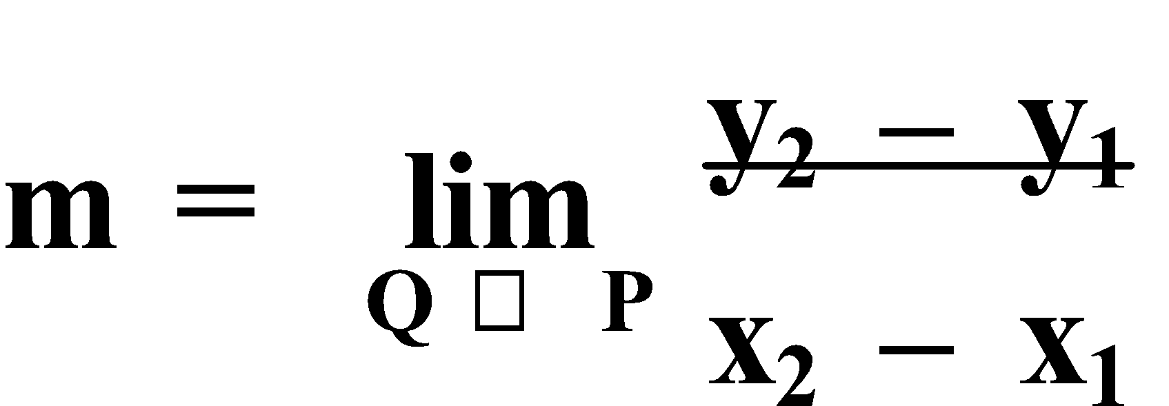 .

E.g.1. Determine the slope of y = x2 at (3,9).

| **Point P** | **Point Q** | **Gradient of chord PQ** |
| --- | --- | --- |
| (3,9) | (4,16) |  |
| (3,9) | (3.5,12.25) |  |
| (3,9) | (3.1,9.61) |  |
| (3,9) | (3.01,9.0601) |  |
| (3,9) | (3.001,9.006001) |  |

∴ As y → (3,9), m → 6.

Ref: *Ex.2A Q.1-3*

*LIMITING CHORD*

**2. GRADIENT FUNCTION:** The procedure used in Example 1 is called the **limiting chord process**. In general, to determine the **gradient** of the tangent at a point P on a curve y = f(x) – we choose some other point on the curve, Q, whose x co-ordinate is a little more than that of P, i.e. at **x + h**.

Thus the gradient of PQ is 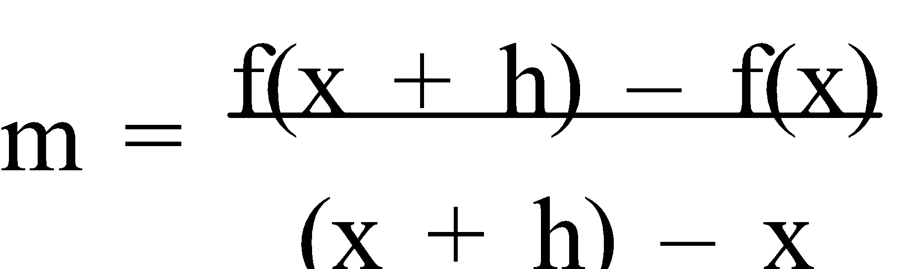 , i.e. 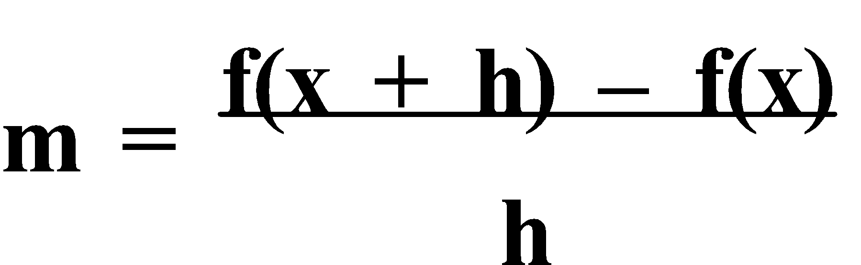 , and hence the gradient (of the tangent) at P(x,f(x)) is 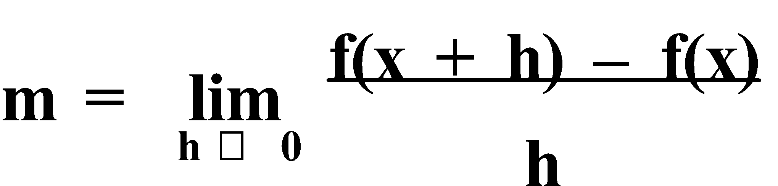 . This gives the **instantaneous rate of change** of the function at P, and **differentiation** is the process of determining the **gradient function**.

E.g.2. Find a rule for the (instantaneous) gradient of the function f(x) = 3x2. Hence calculate the gradient at the point (3,27).

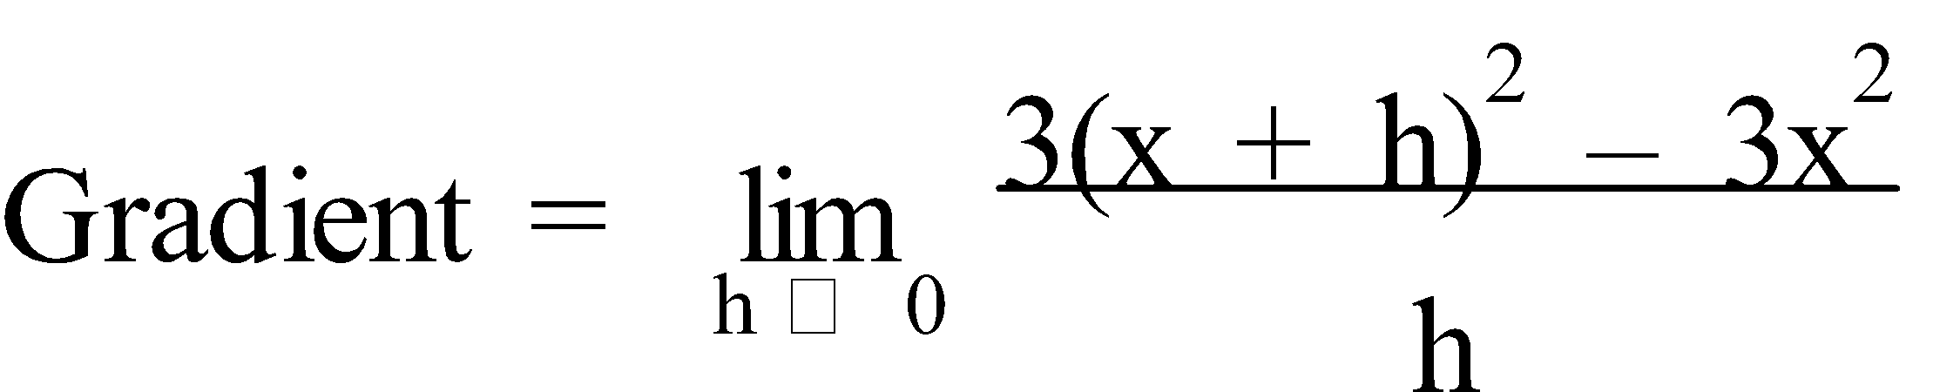

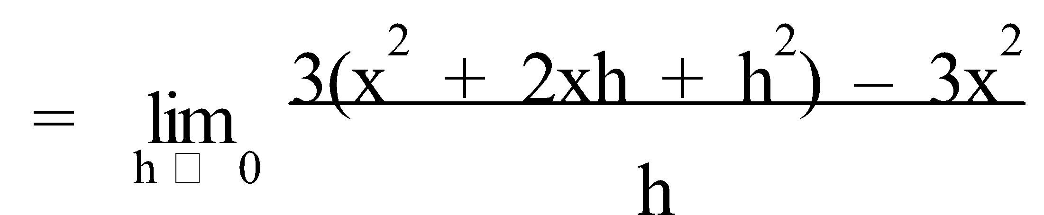

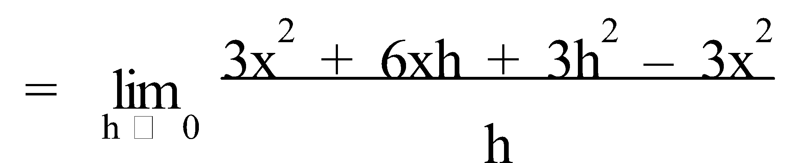

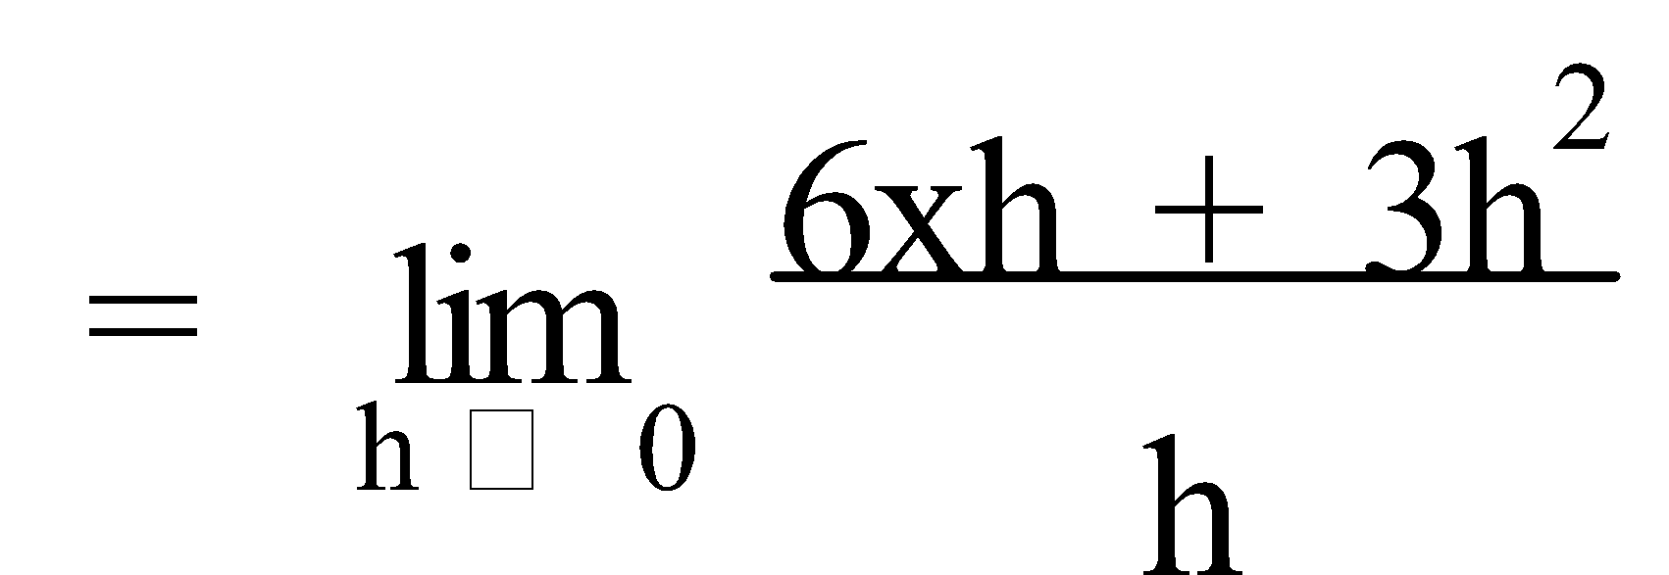

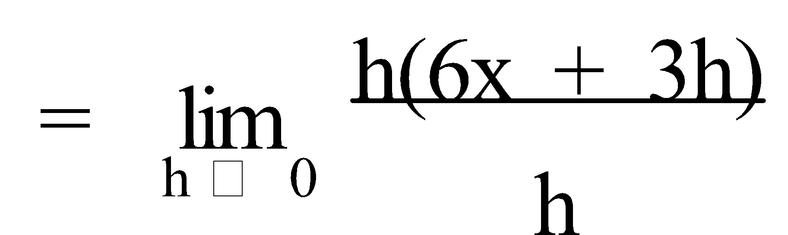

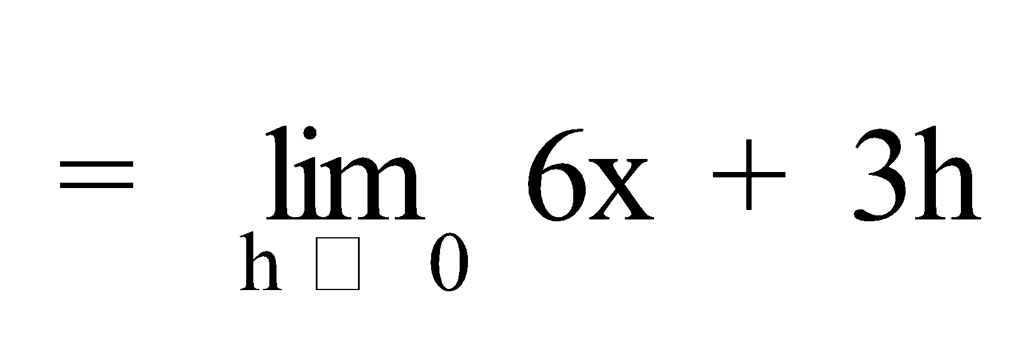

= 6x

∴ At (3,27), Gradient = 6(3)

= 18

Ref: *Ex.2B Q.1-3*

**3. DIFFERENTIATION:** Thus, when we **differentiated** 3x2 (in Example 2) with respect to (the variable) x, we obtained the **gradient function** 6x. Hence 6x is called the **derivative** of 3x2. The **derivative** or the derived function of f(x) **with respect to x** is usually denoted by one of these symbols 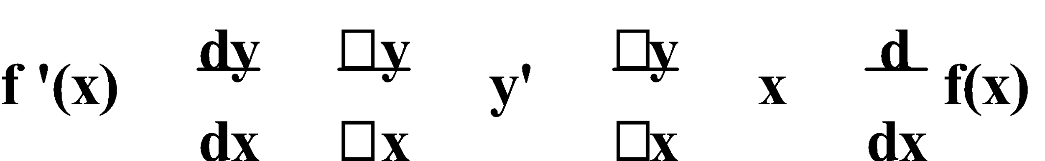. 

There are certain short-cuts to the process of differentiating **polynomial function**, **axn**.

**CONSTANT RULE:** If **f(x) = c**, then **f '(x) = 0**.

e.g. If f(x) = 7, then f '(x) = 0.

**POWER RULE:** If **f(x) = xn**, then **f '(x) = n.xn-1**.

e.g. If f(x) = x5, then f '(x) = 5x4.

**CONSTANT MULTIPLE RULE:** If **f(x) = k.g(x)**, then **f'(x) = k.g'(x)**.

e.g. If f(x) = 3x5, then f '(x) = 3 × 5x4 = 15x4

Thus, in general, to differentiate a **polynomial function** of the type –  where **n** is a non-negative integer and **an**, **an-1**, **an-2**, … are **coefficients** of **xn**, **xn-1**, **xn-2**, …, we “**multiply by the power and decrease the power by one**”. The highest power of x in any polynomial is called the **order** of the polynomial.

E.g.3. Find the derivative of:

a) y = 4x3

b) y = -3x2

c) 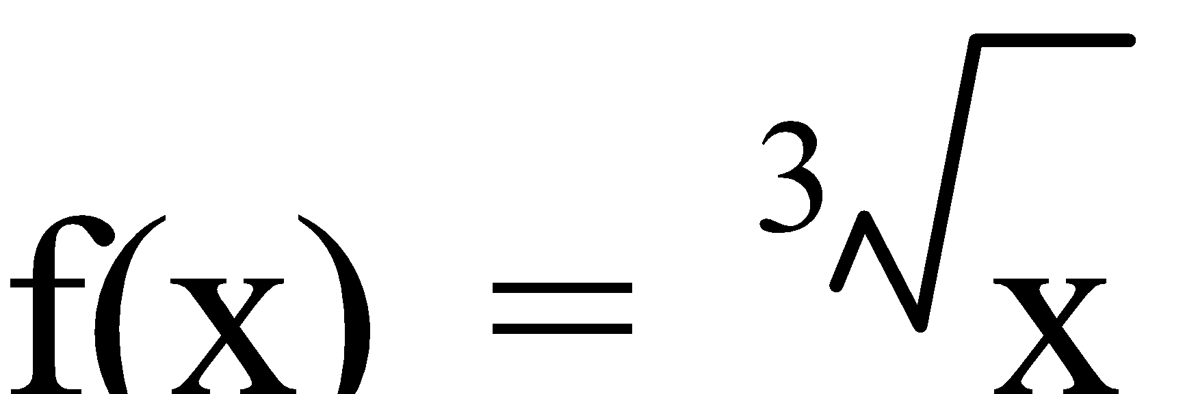

d) g(x) = 2πx4

a) y = 4x3

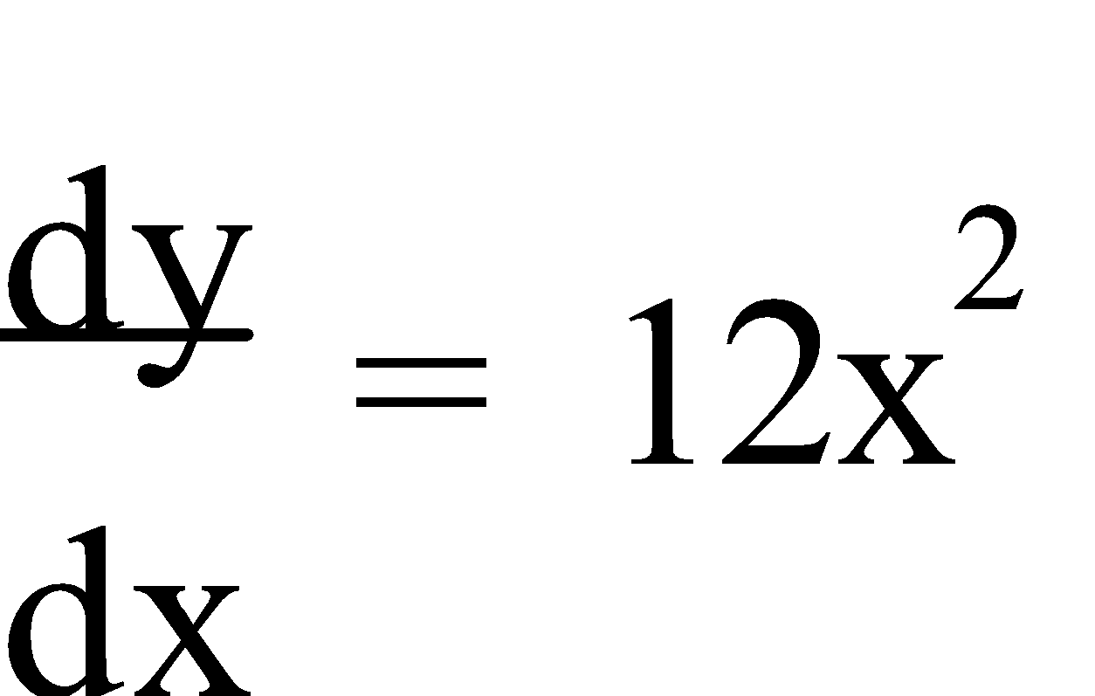

b) y = -3x2

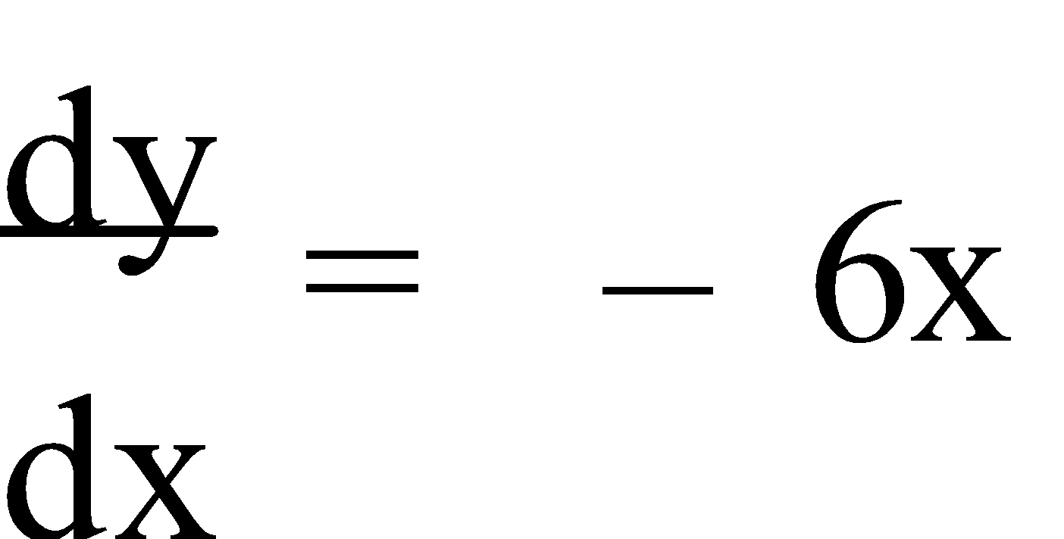

c)  = x⅓

f '(x) = ⅓ × x-⅔

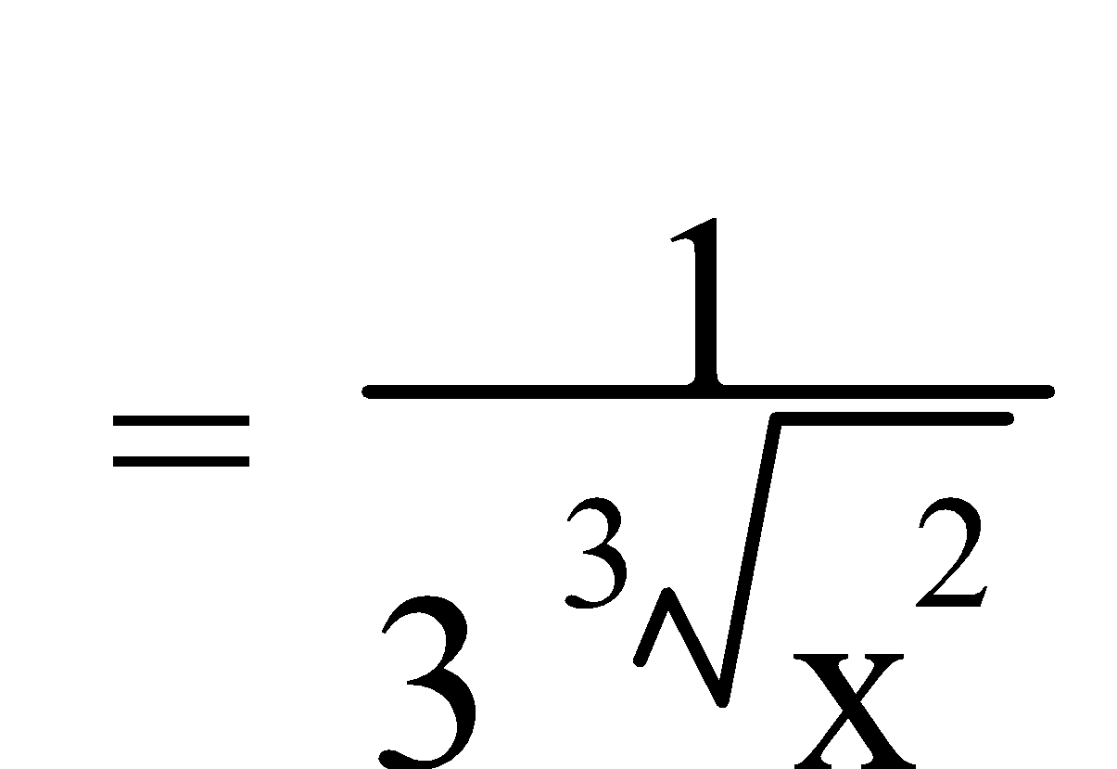

d) g(x) = 2πx4

g'(x) = 4 × 2πx3

= 8πx3

Ref: *Ex.2C Q.1-52 (R.H.S.); 53-59 (odd)*

When differentiating polynomials of the type **y = f(x) ± g(x)**, there is also a short-cut.

**SUM RULE:** If **f(x) = g(x) + h(x)**, then **f'(x) = g'(x) + h'(x)**.

e.g. If f(x) = 2x7 + 3x, then f '(x) = 14x6 + 3.

E.g.4. Find the derivative of:

a) 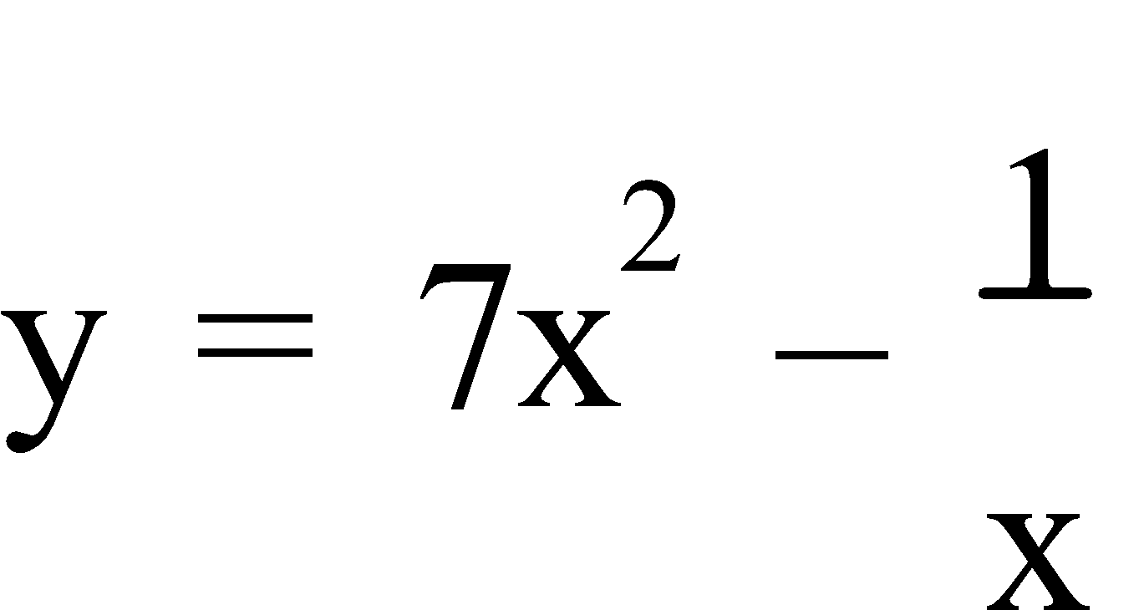

b) y = (x – 3)(x – 2)

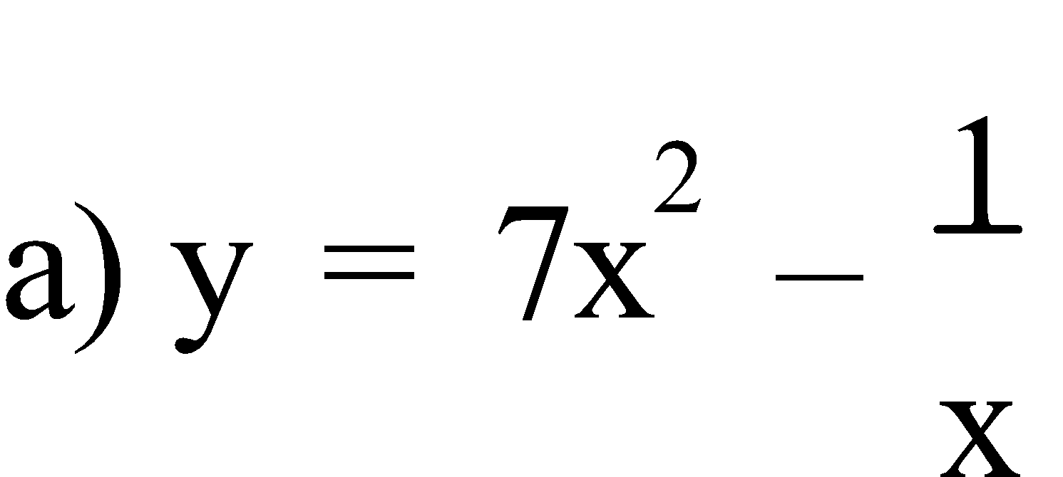

= 7x² – x-1

y' = 14x – (-1)x-2

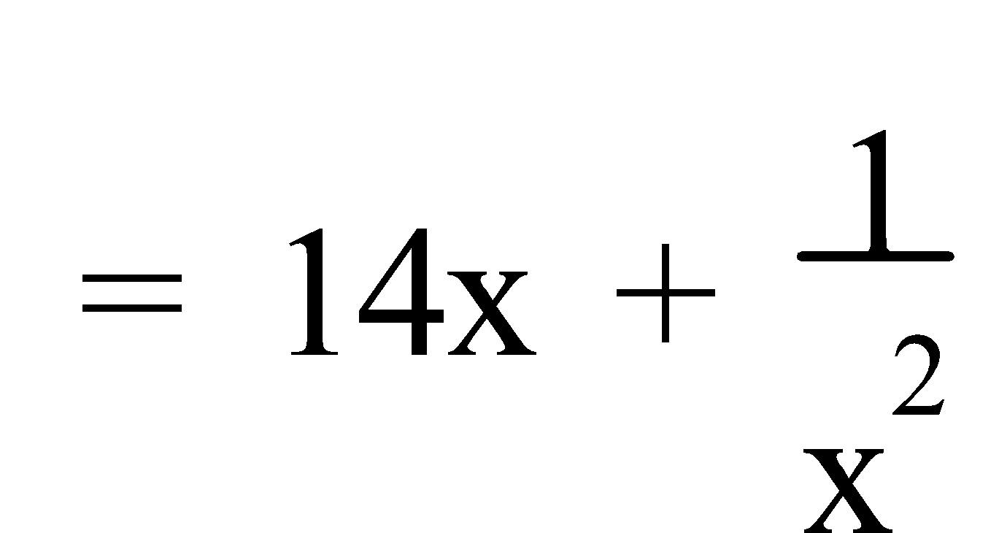

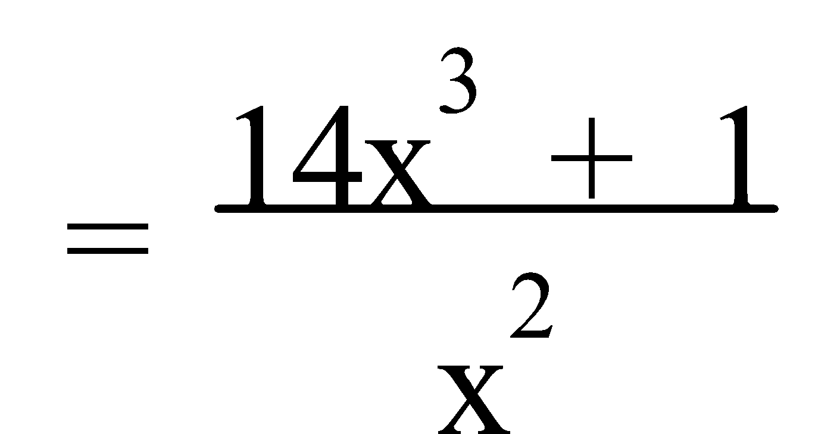

b) y = (x – 3)(x – 2)

= x² – 5x + 6

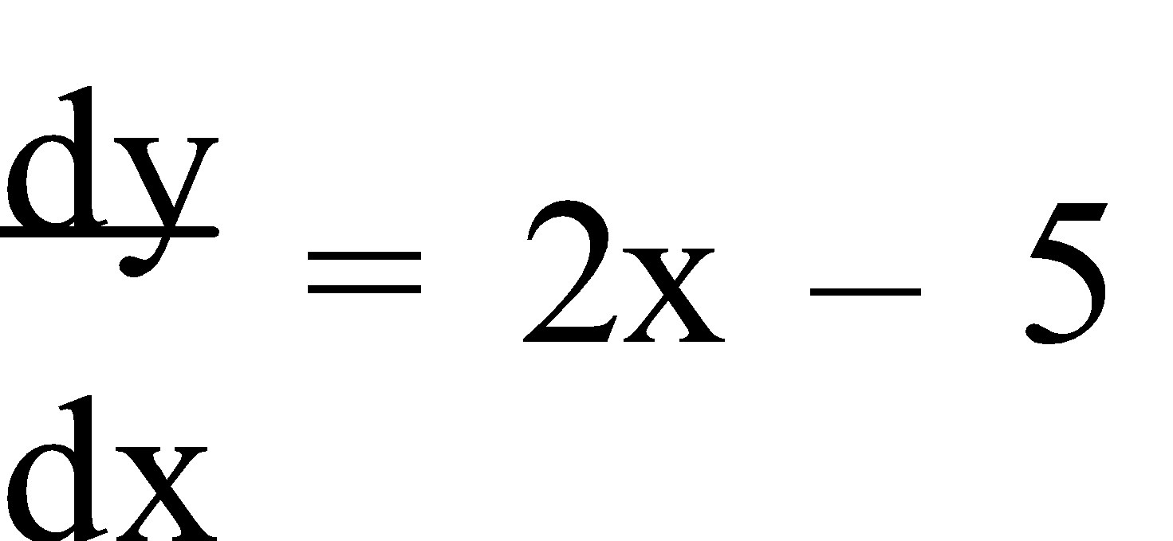

Ref: *Ex.2D Q.1-25 (odd)*

In the previous example, we multiplied out the brackets before differentiating. If we are required to differentiate a function such as **y = (1 – 2x2)5**, then to **expand** the bracket and differentiate would be **lengthy** and **liable to error**. A method which would simplify the process is required. The **Chain Rule** states if **y =** **[f(x)]n**, then 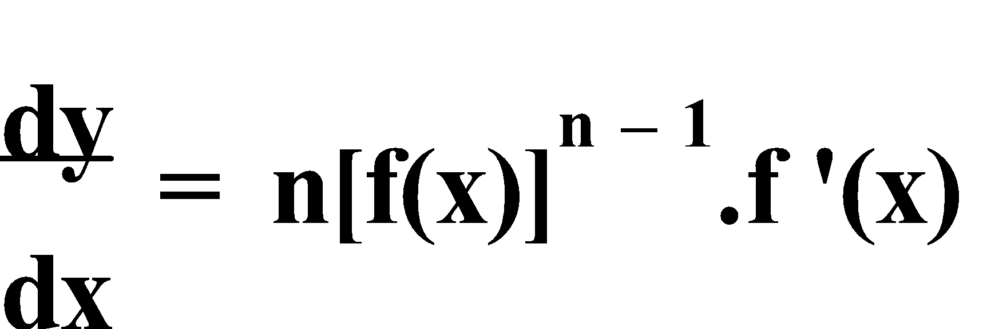.

For products, it is often ‘easier’ to **differentiate** first, then perform the **product(s)**, and

finally, **simplify** the answer, where appropriate. The **Product Rule** states that if **y = u(x).v(x)**, then 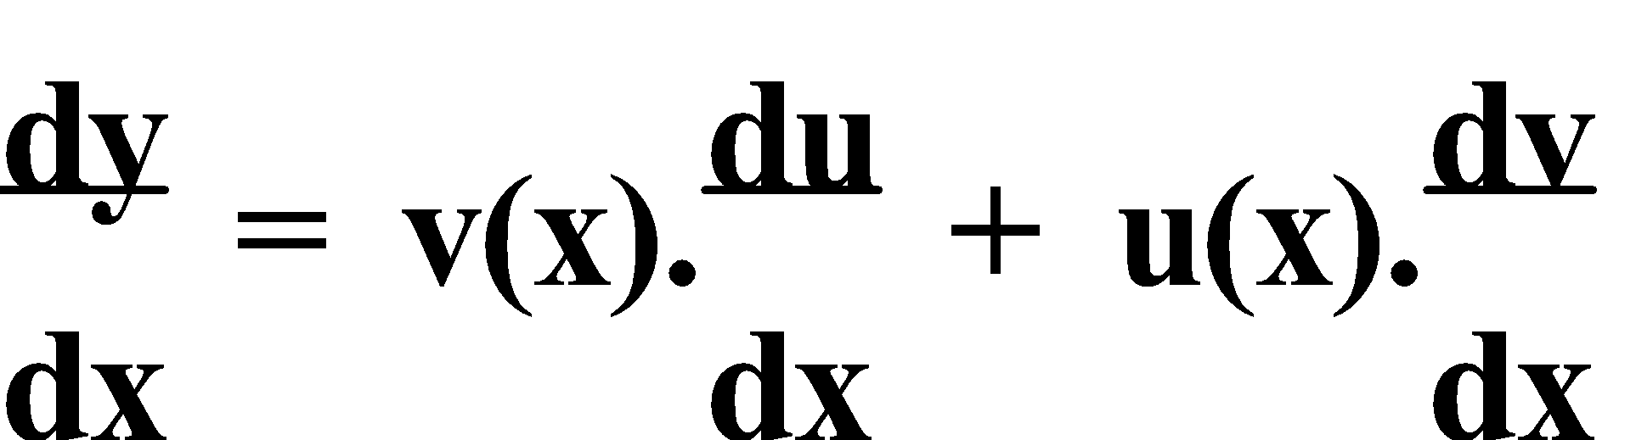 . Similarly, if **y = u(x).v(x).w(x)**, then 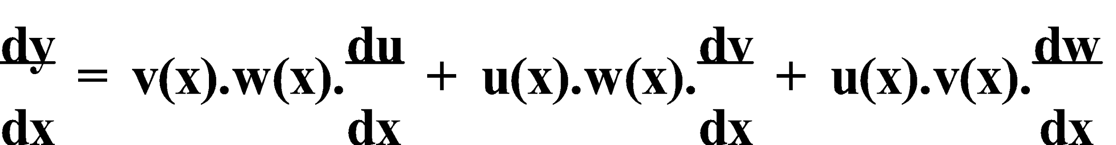.

Likewise, the **Quotient Rule** states that if 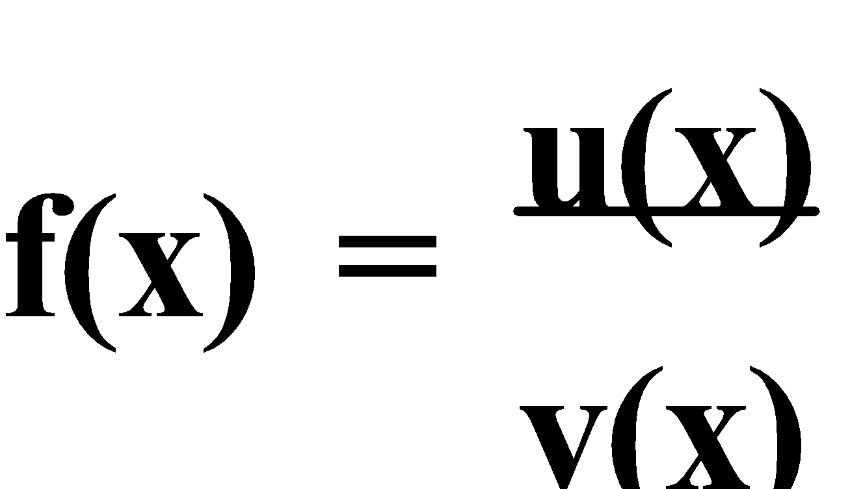 , then 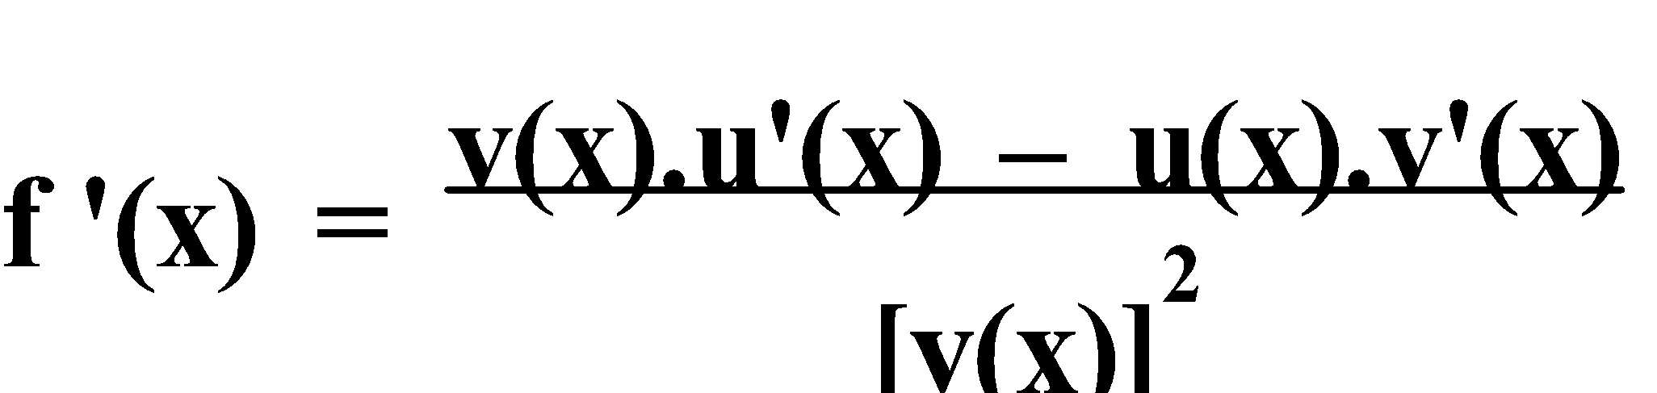.

E.g.5. Differentiate each of the following:

a) y = (5x – 3)(4x + 7)

b) 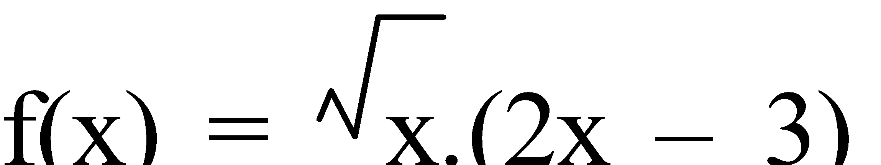

c) g(x) = (3x – 1)(2x3 – x)7

d) y = 2x(x3 – 5)(1 + x3)

e) 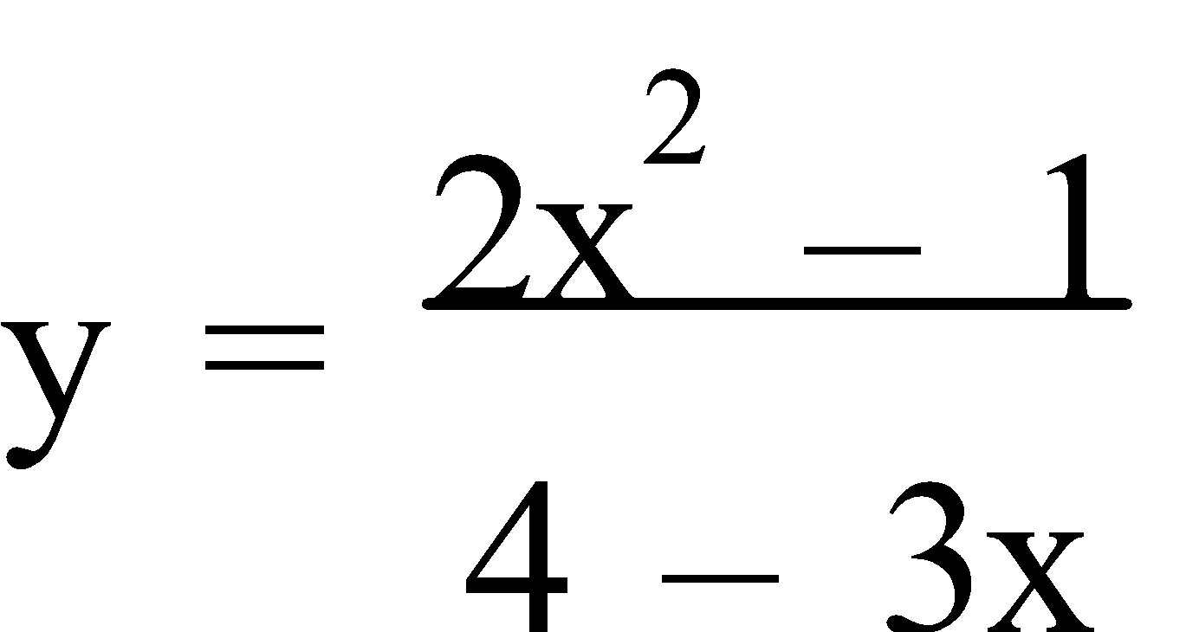

f) 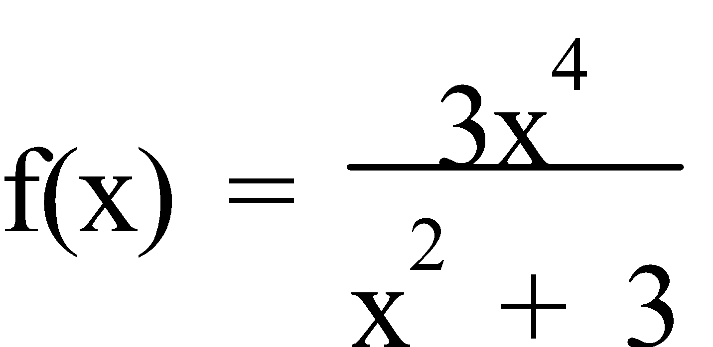

g) 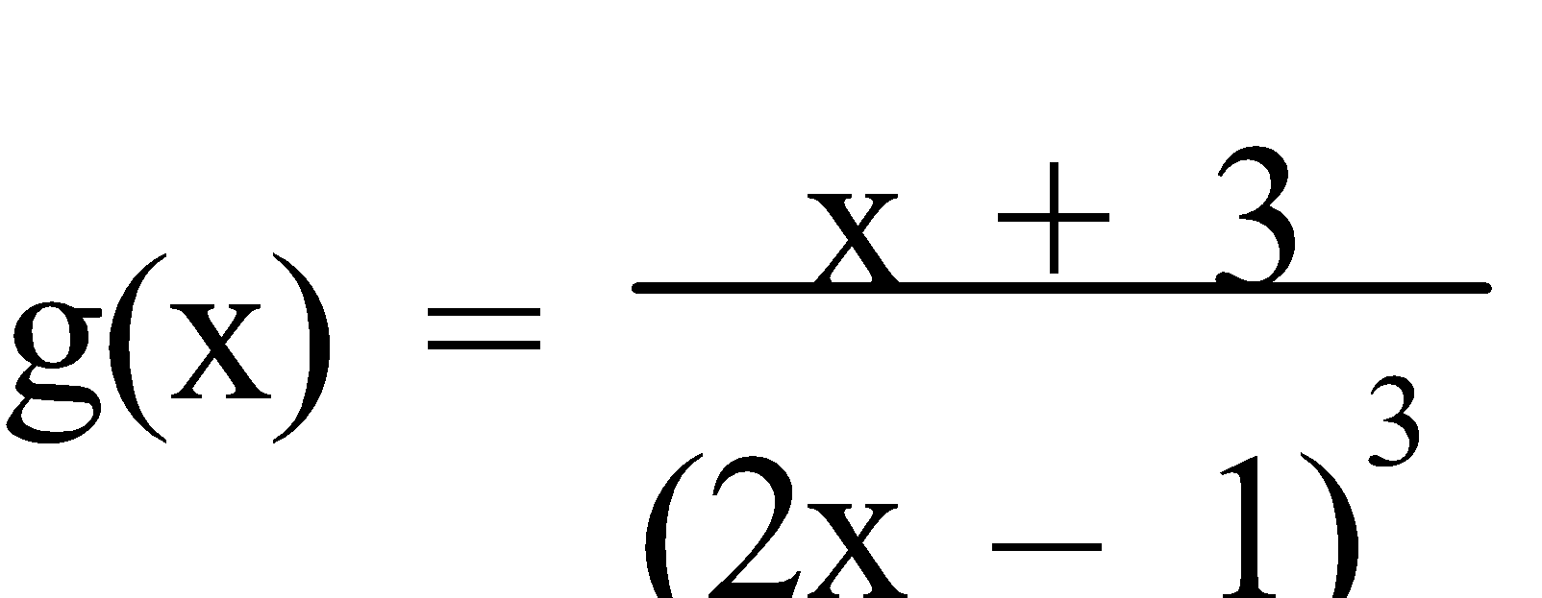

a) y = (5x – 3)(4x + 7)

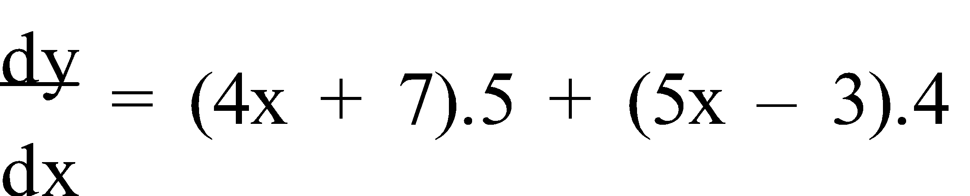

= 20x + 35 + 20x – 12

= 40x + 23

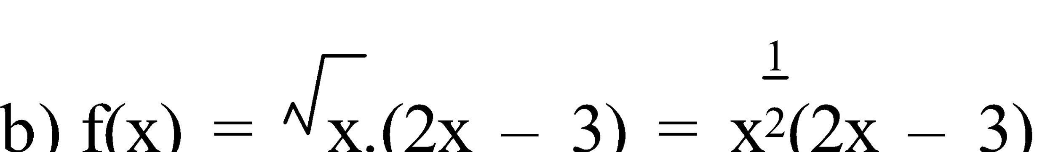

f '(x) = (2x – 3).½x-½ + x½.2

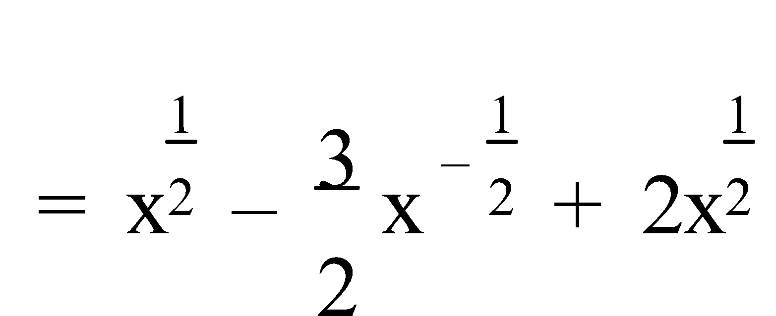

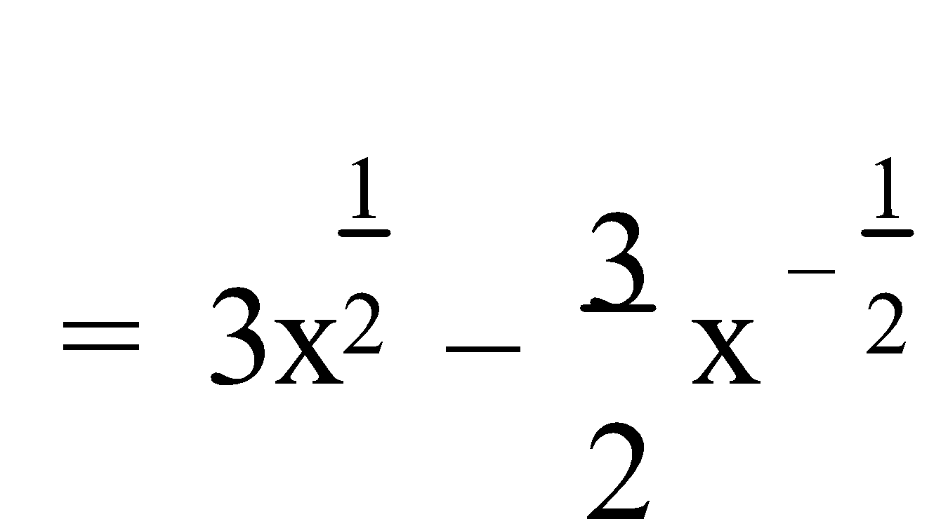

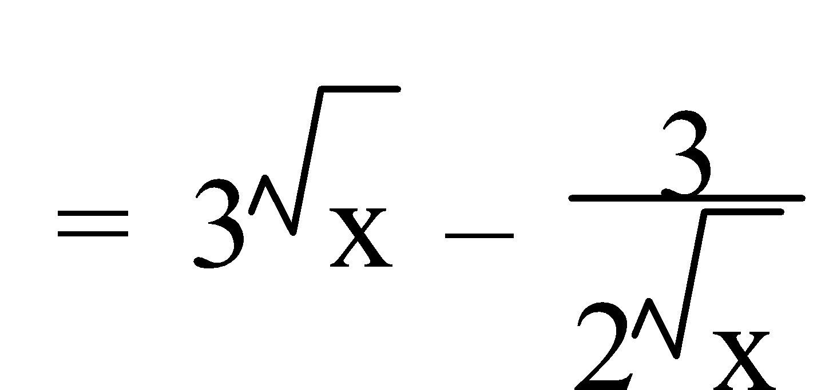

c) g(x) = (3x – 1)(2x3 – x)7

g'(x) = (2x3 – x)7.3 + (3x – 1)7(2x3 – x)6(6x2 – 1)

= 3(2x3 – x)7 + 7(3x – 1)(6x2 – 1)(2x3 – x)6

d) y = 2x(x3 – 5)(1 + x3)

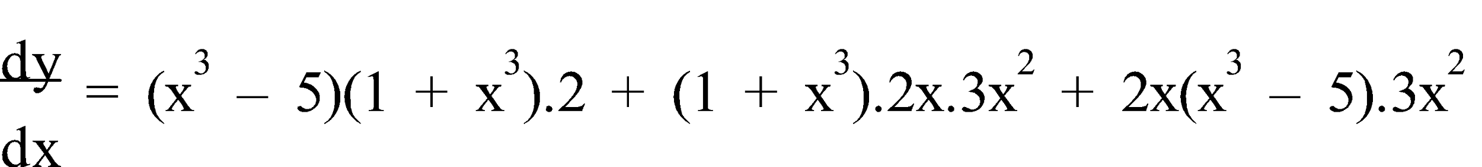

= 2(x3 – 5)(1 + x3) + 6x3(1 + x3) + 6x3(x3 – 5)

= 2(x6 – 4x3 – 5) + 6x3 + 6x6 + 6x6 – 30x3

= 2x6 – 8x3 – 10 + 6x3 + 6x6 + 6x6 – 30x3

= 14x6 – 32x3 – 10

e) 

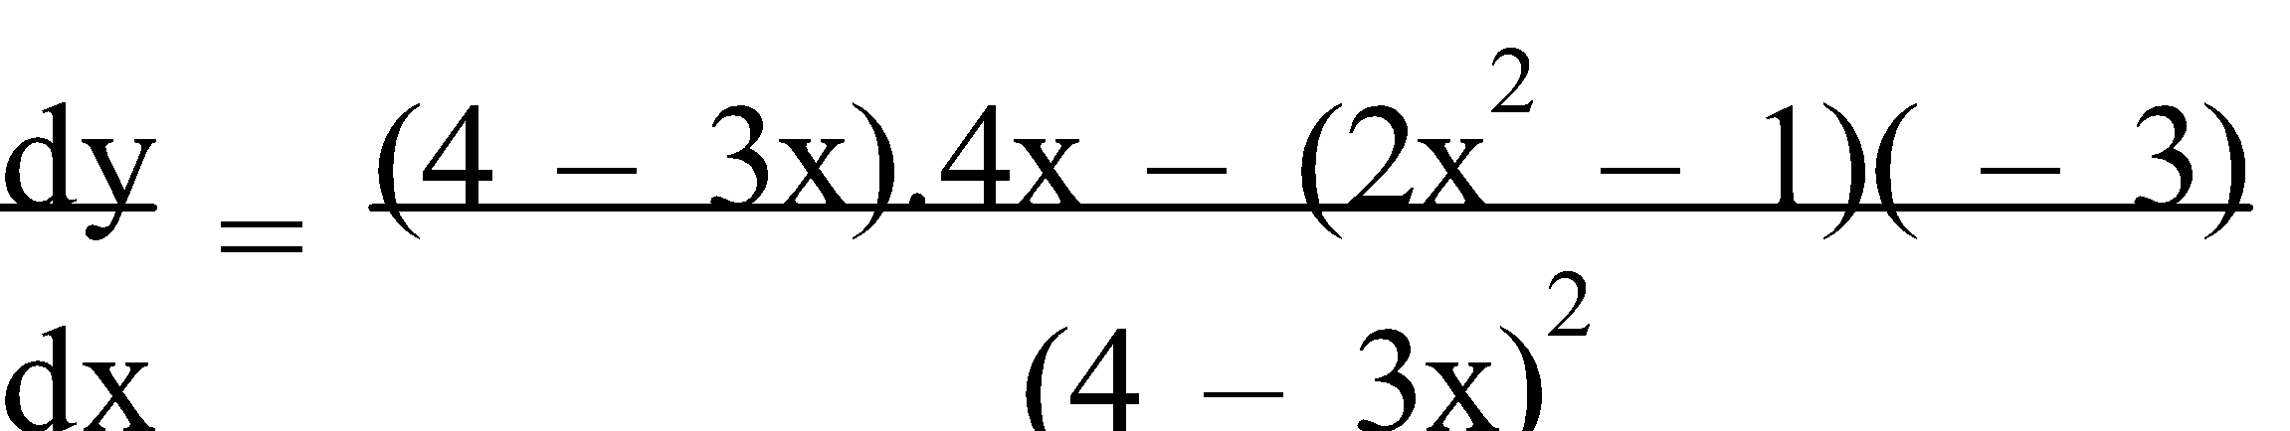

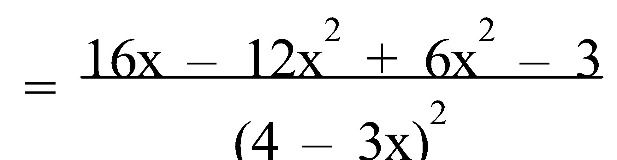

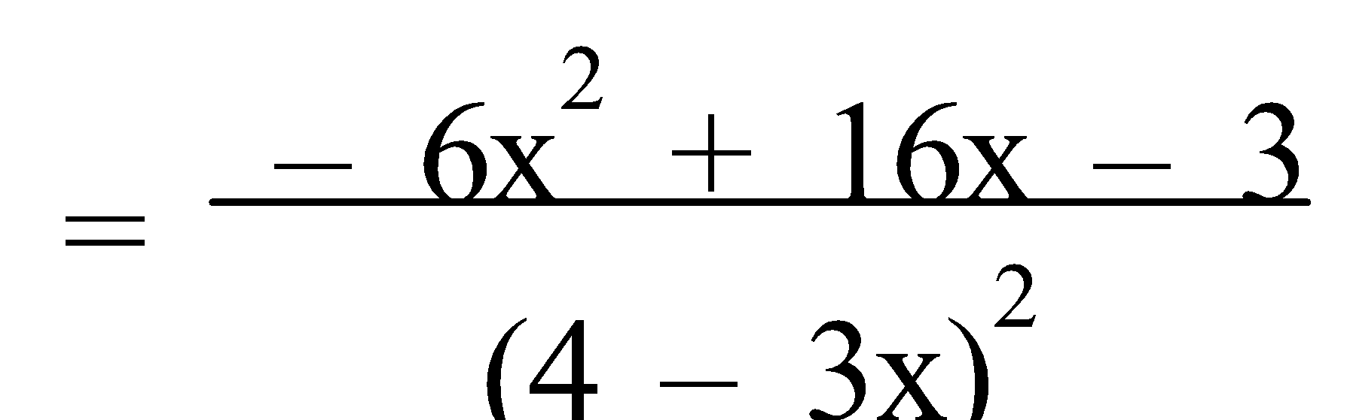

f) 

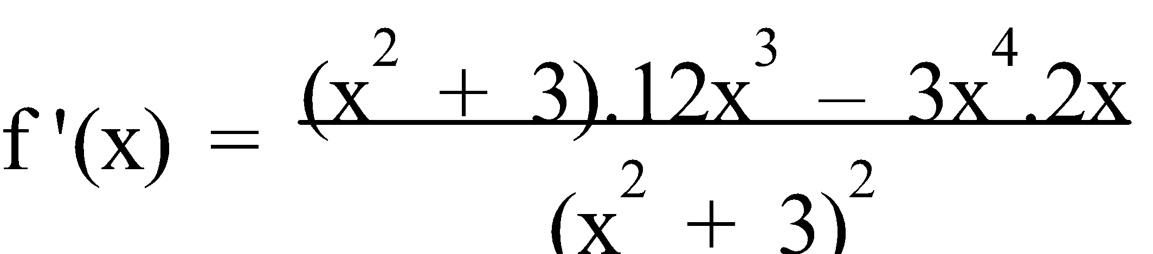

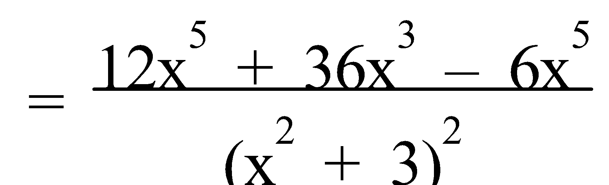

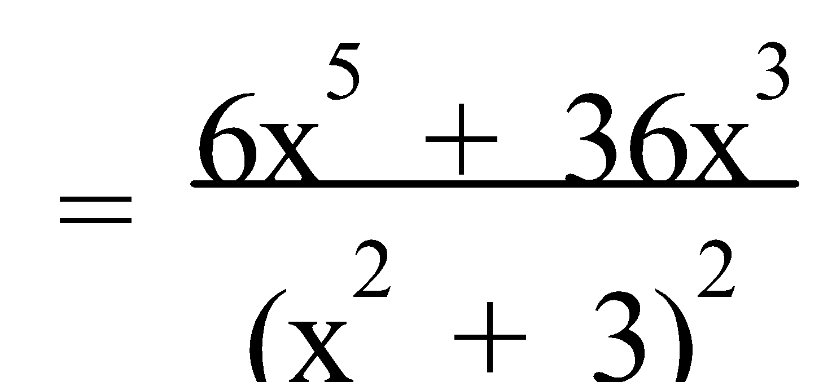

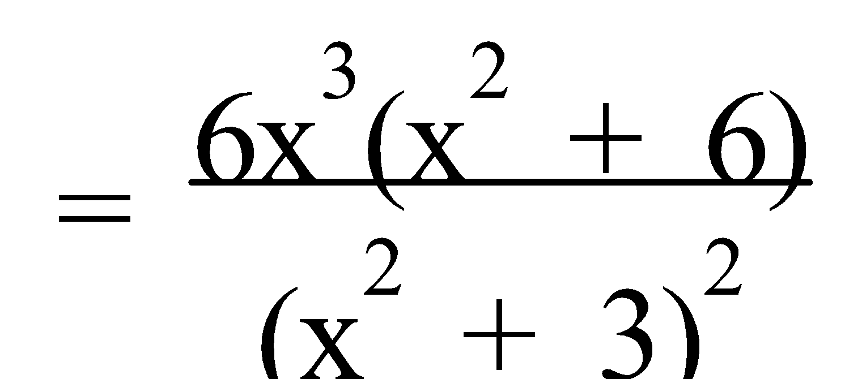

g) 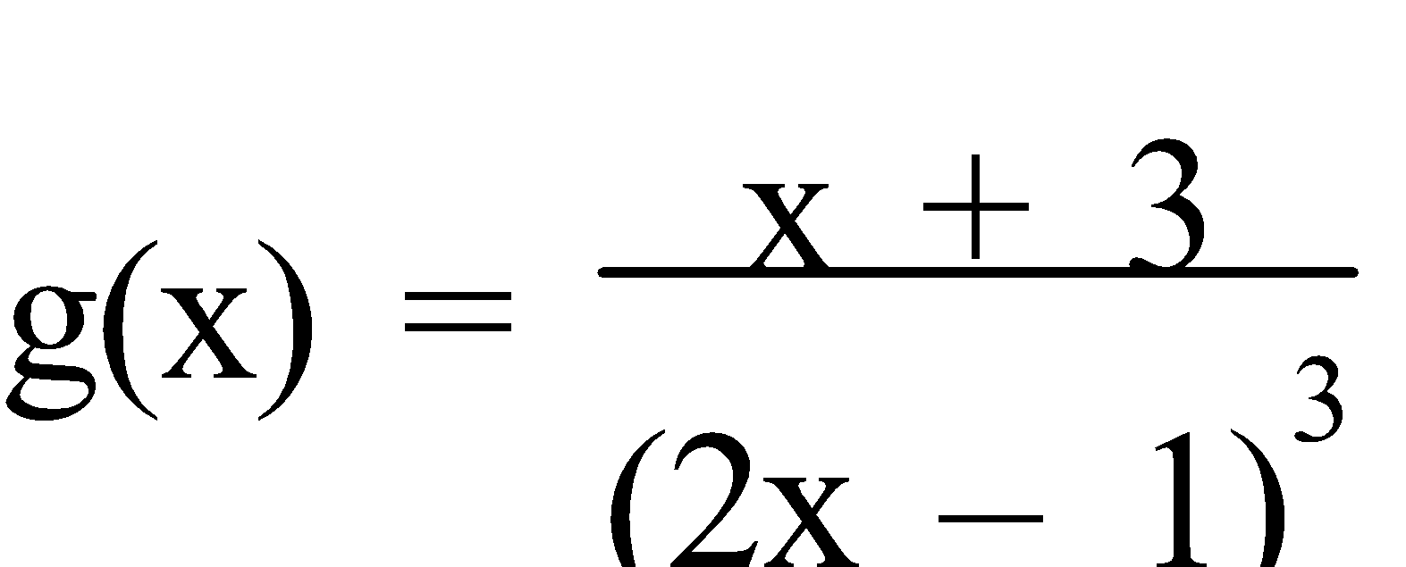

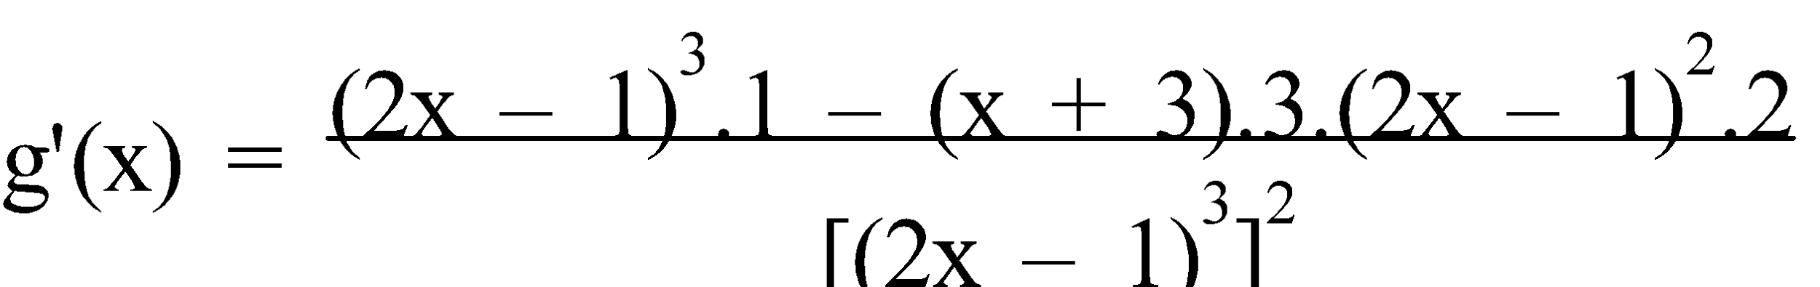

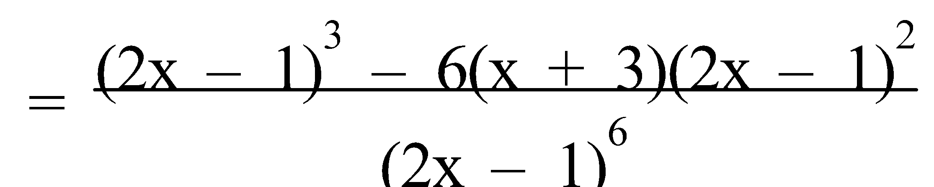

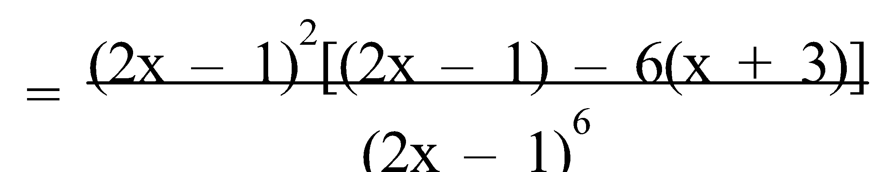

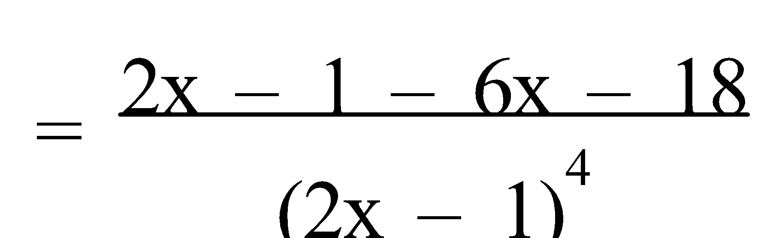

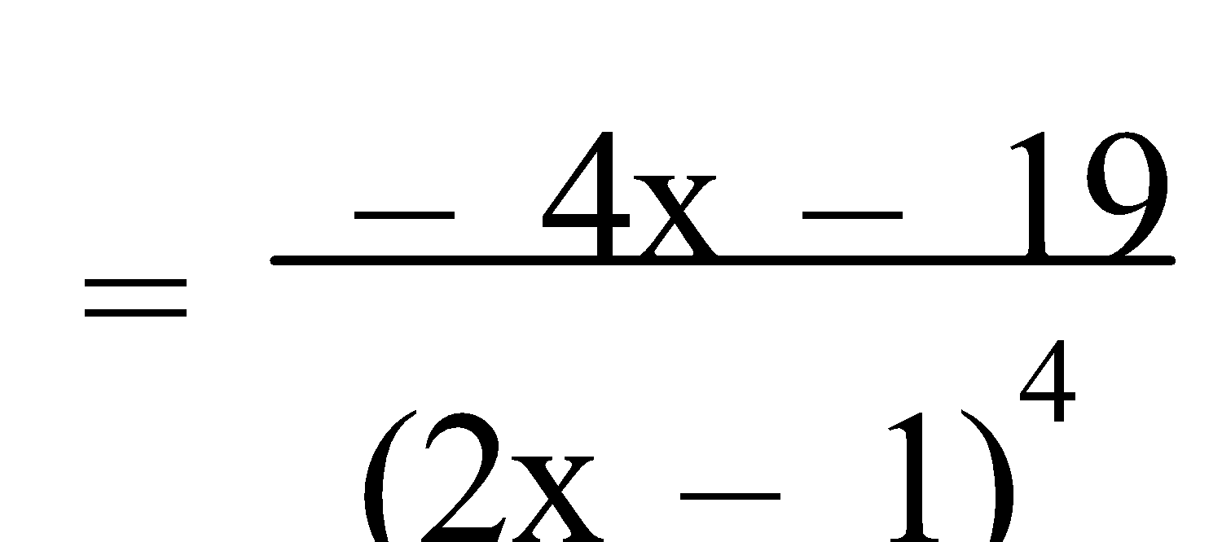

Ref: *Ex.2E Q.1-19 (odd); 20-23*

**APPLICATIONS OF DIFFERENTIATION**

**1. RATES OF CHANGE:** Remember – the **derivative** measures the **rate** at which any **dependent variable changes** as the **independent variable changes**.

E.g.1. Scientists have found a crystal which “grows” in the shape of a sphere when placed in a special solution. The volume, V cm³, of the sphere is increasing in such a way that at time t seconds it is given by **V = 7500 + 3600t – 150t2** for 0 ≤ t ≤ 12.

a) Calculate the volume when t = 12.

b) Find an expression for the rate of change of the volume with respect to time.

c) Calculate the rate at which the volume is increasing (in cm3/s) when t = 2 and when t = 10.

d) Comment on the rate of change of the volume from t = 2 to t = 10.

a) V = 7500 + 3600t – 150t2

V(12) = 7500 + 3600(12) – 150(12)2

= 29 100 cm³

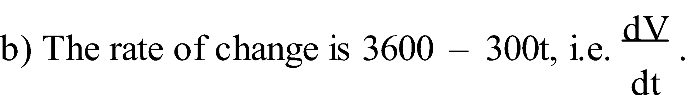

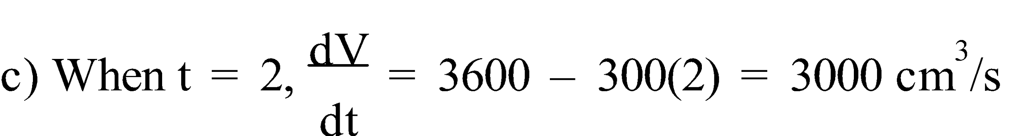

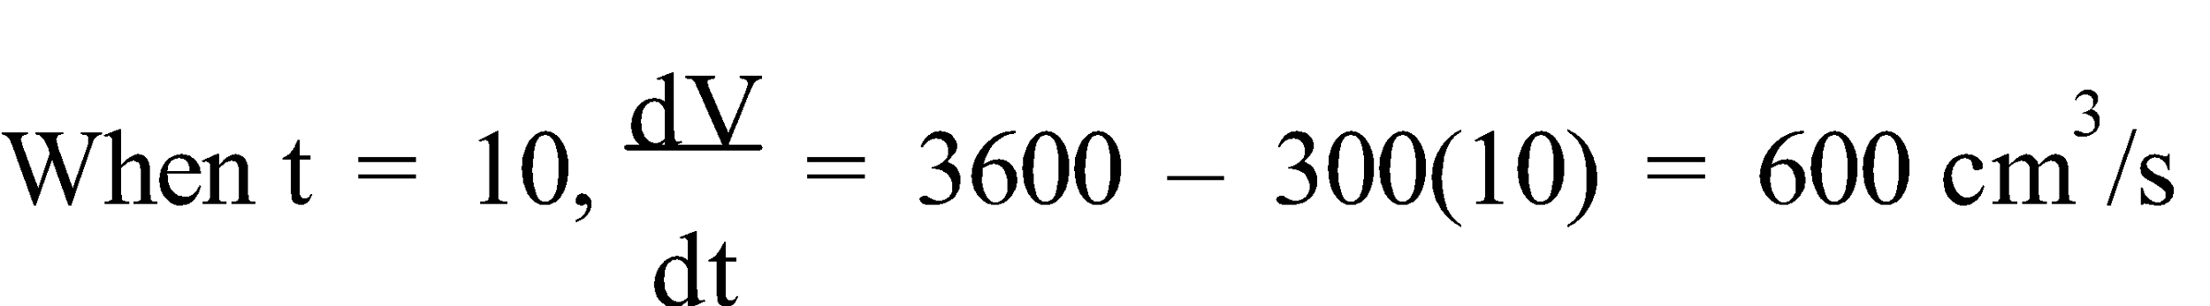

d) The rate at which the volume is changing (increasing) is slowing as time increases from t = 2 to t = 10.

Ref: *Ex.3A Q.1-10 (even), 11-17 (odd)*

**2. LOCATING STATIONARY POINTS:** As we pass through a **maximum point** the gradient changes from **positive to negative**. Likewise, as we pass through a **minimum point** the gradient changes from **negative to positive**. Hence, the **gradient** is **zero** at both **maxima and minima**. For **points of horizontal inflection**, whilst the **gradient is momentarily zero**, no change of sign is involved.

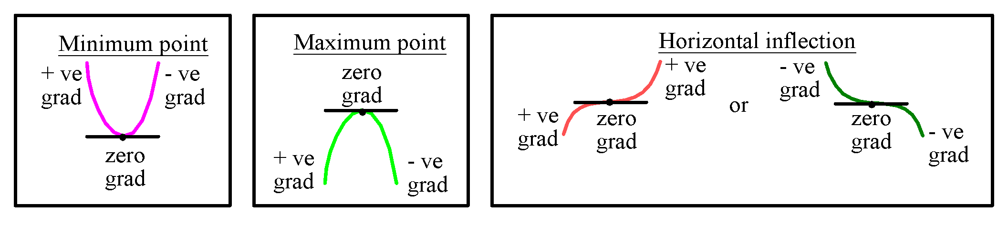

Thus, a **stationary point** can be determined by **f '(x) = 0**, and hence the point is a **maxima** if **f "(x) < 0**, a **minima** if **f "(x) > 0**, or a **point of horizontal inflection** if **f "(x) = 0**, but **not all** points of inflection are **stationary points**. **Non-stationary points of inflection** are (usually) found between a pair of turning points.

A **graphics calculator** will give the location, or a good approximation of the exact location, of almost all of the noteworthy features of a graph – the **x-** and **y-intercepts**, the **local/global maxima** and **minima**, the **extreme values** (i.e. as **x → ± ∞**). The only noteworthy feature not available on the graphics calculator is any **points of inflection** – horizontal or not.

This can be overcome by considering the **graph of f "(x)** and the points for which **f "(x) = 0**, or the **stationary points** of the graph of **f '(x)**. Alternatively this can be overcome by **solving f "(x) = 0**.

As the **display** on a graphics calculator is **limited**, we **cannot always be sure** that we are seeing the “whole picture”. We need to be able to **check** the information **by calculus methods**. This is especially true when the **calculator indicates** that there are **no roots or fewer roots** than anticipated. For example:

one root is expected, or three roots are expected.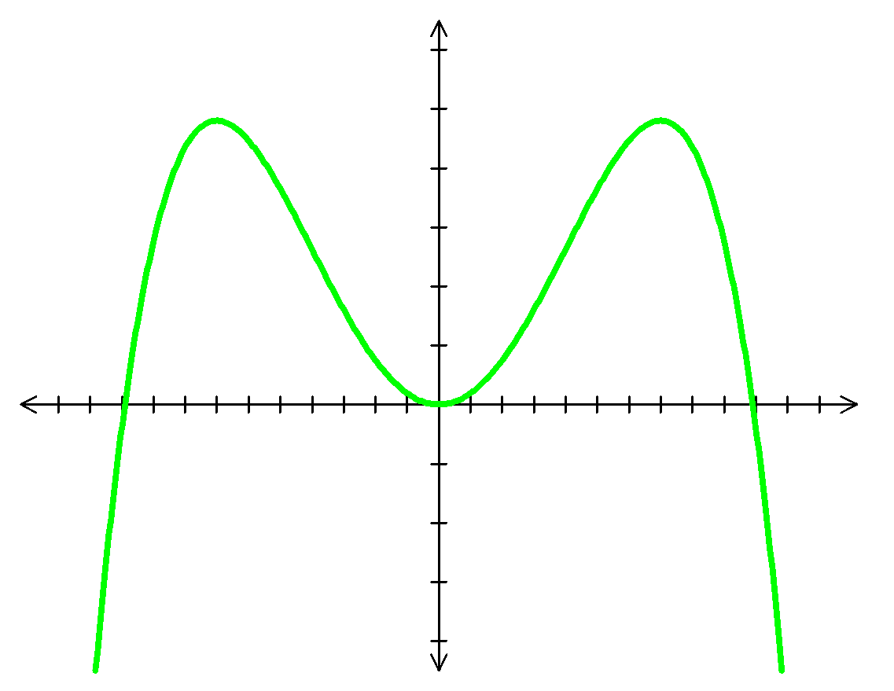

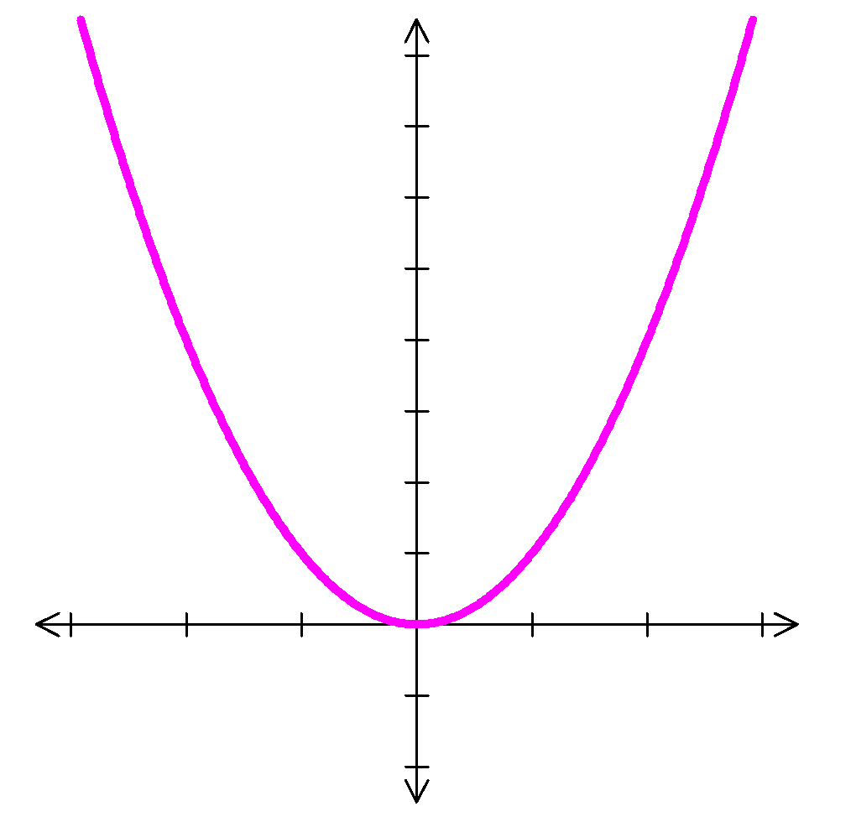

E.g.2. For **y = x3 – 9x2 + 15x + 2**, use differentiation to determine the nature and location of any stationary points.

y = x3 – 9x2 + 15x + 2 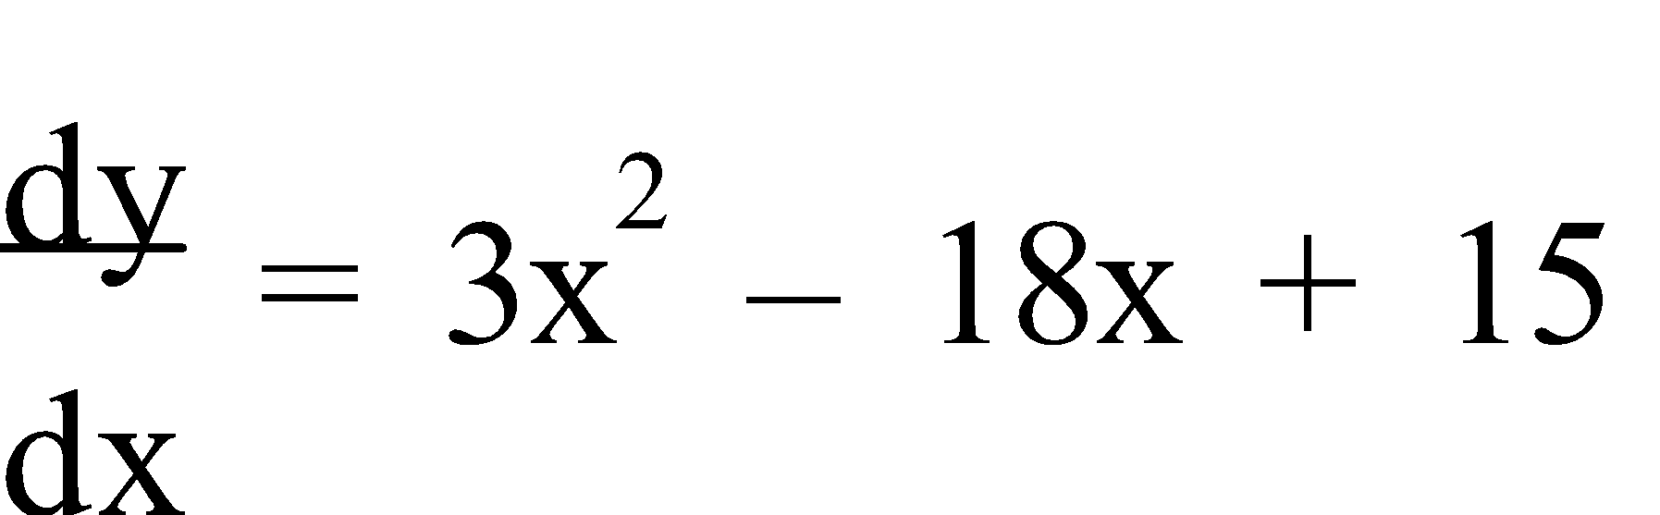 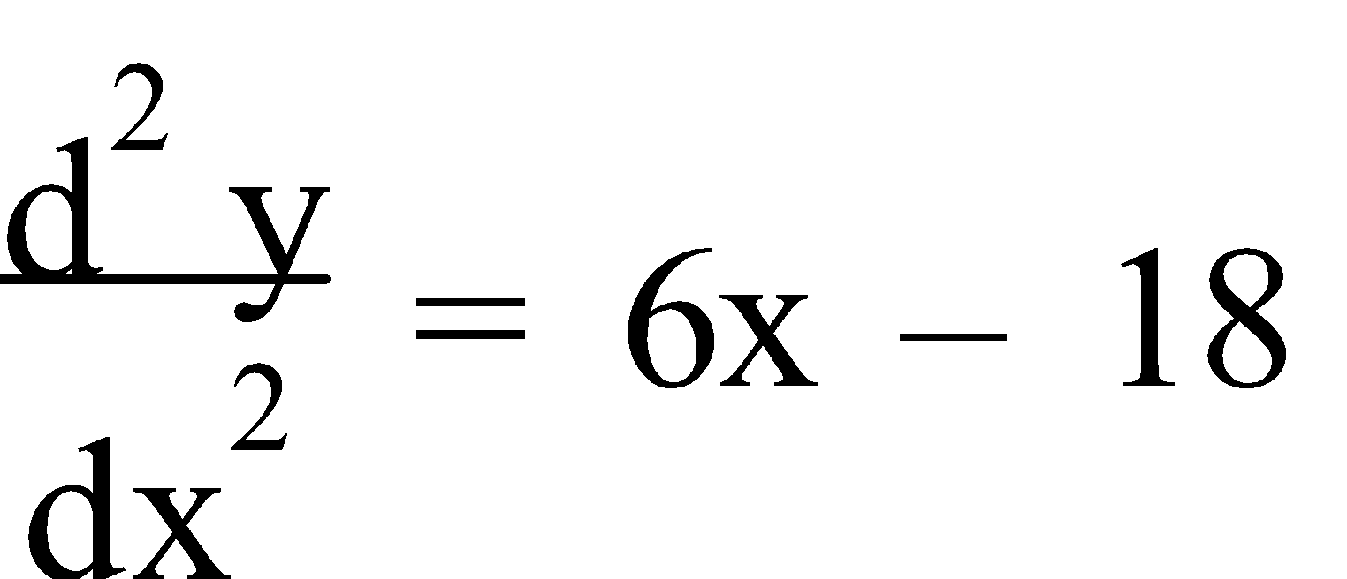

Stationary Points occur when 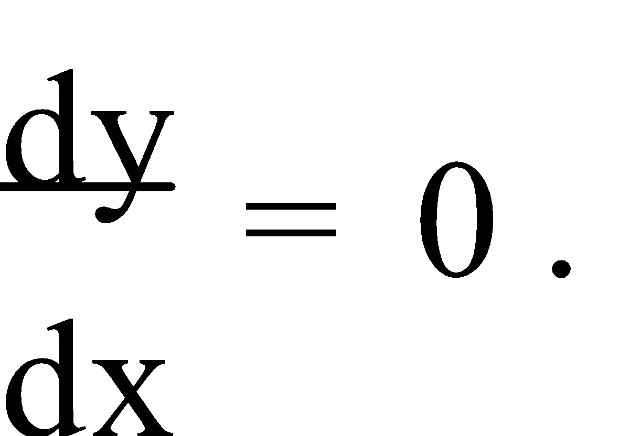

3x2 – 18x + 15 = 0

x2 – 6x + 5 = 0

(x – 1)(x – 5) = 0

x = 1 or x = 5

f(1) = 13 – 9(1)2 + 15(1) + 2 = 9 ⇒ (1,9)

f(5) = 53 – 9(5)2 + 15(5) + 2 = -23 ⇒ (5,-23)

[To determine the nature of the stationary points we could either use the second derivative or consider the gradient on either side of the stationary points.]

 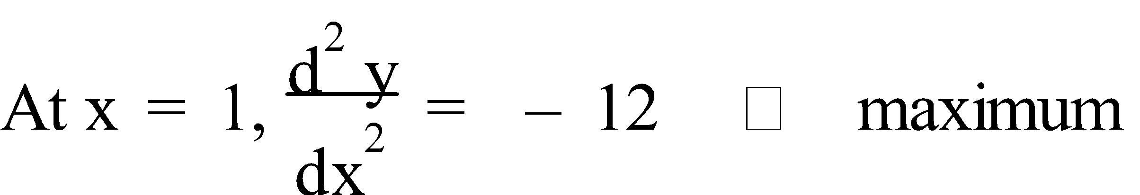 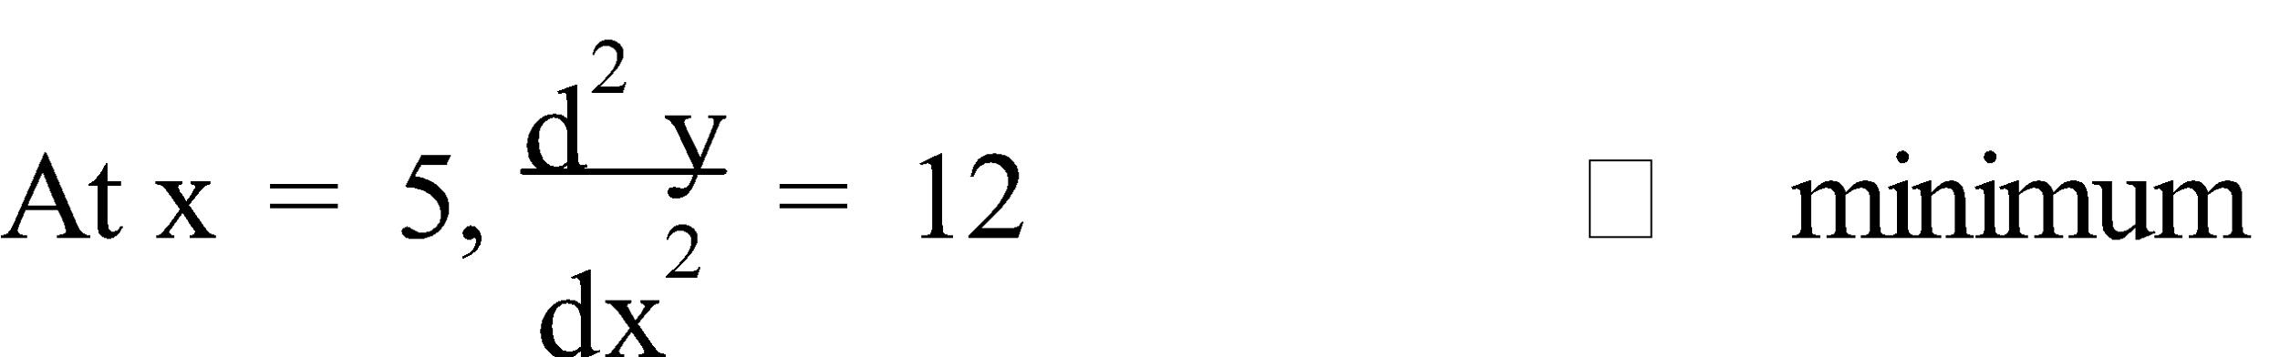

OR

Consider the gradient on either side of x = 1 and x = 5:

x = 0.9 x = 1 x = 1.1 x = 4.9 x = 5 x = 5.1

+ve 0 -ve -ve 0 +ve 

∴ (1,9) is a maximum and (5,-23) is a minimum.

Ref: *Ex.3B Q.1-10 (even); 11, 12*

**3. APPLICATIONS:** Thus, **optimum values** can be determined by **calculus methods**, i.e. **maximum/minimum** value when 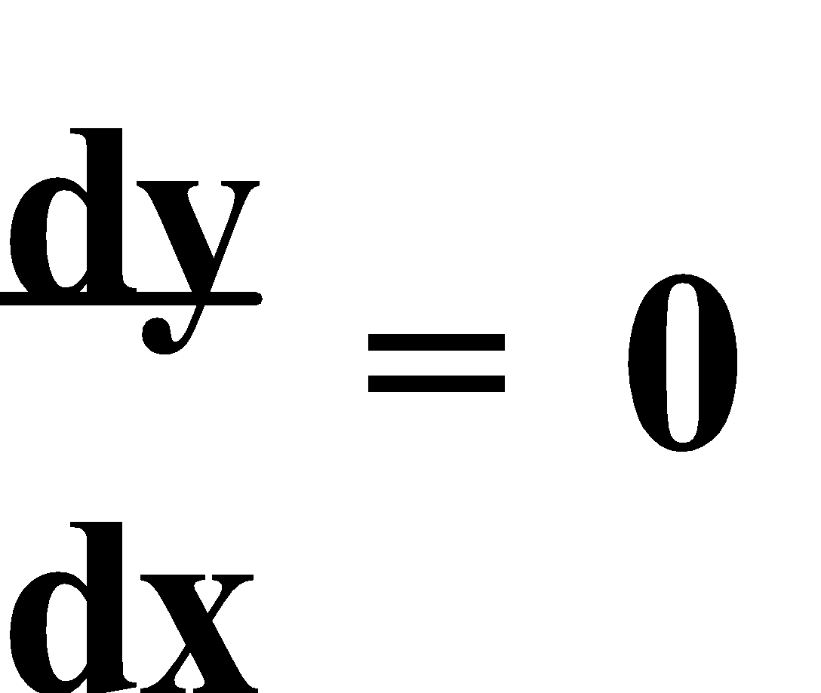, or **graphing** the function to be **optimized**, or **refining** the solution using a **table of values**.

E.g.3. An engineer finds that her profit from manufacturing a certain machine is given by **P(x) = 500 – 324x + 36x2 – x3**, where x is the number of machines manufactured per hour. Using calculus methods, find the number of machines that should be produced for maximum profit.

Graphical Method:

P(x) = 500 – 324x + 36x2 – x3

From the CAS calculator, the maximum occurs at 18

& from the graphics calculator, the maximum occurs at 18.000000814...

Calculus Method:

P(x) = 500 – 324x + 36x2 – x3

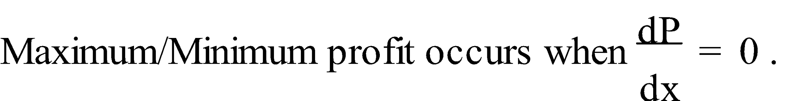

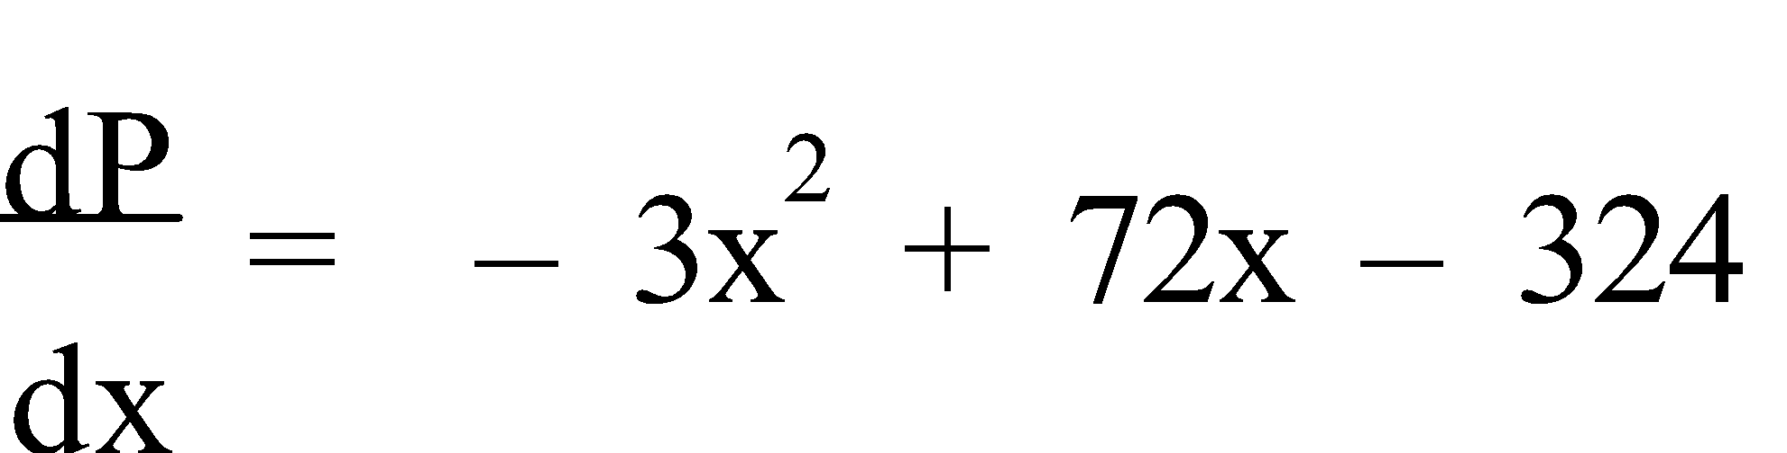

-3x2 + 72x – 324 = 0

x2 – 24x + 108 = 0

(x – 6)(x – 18) = 0

x = 6 or x = 18

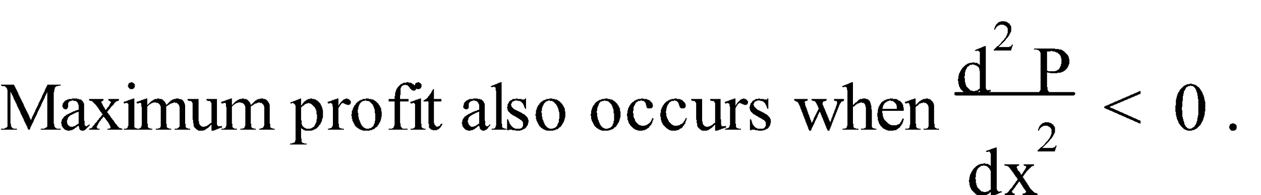

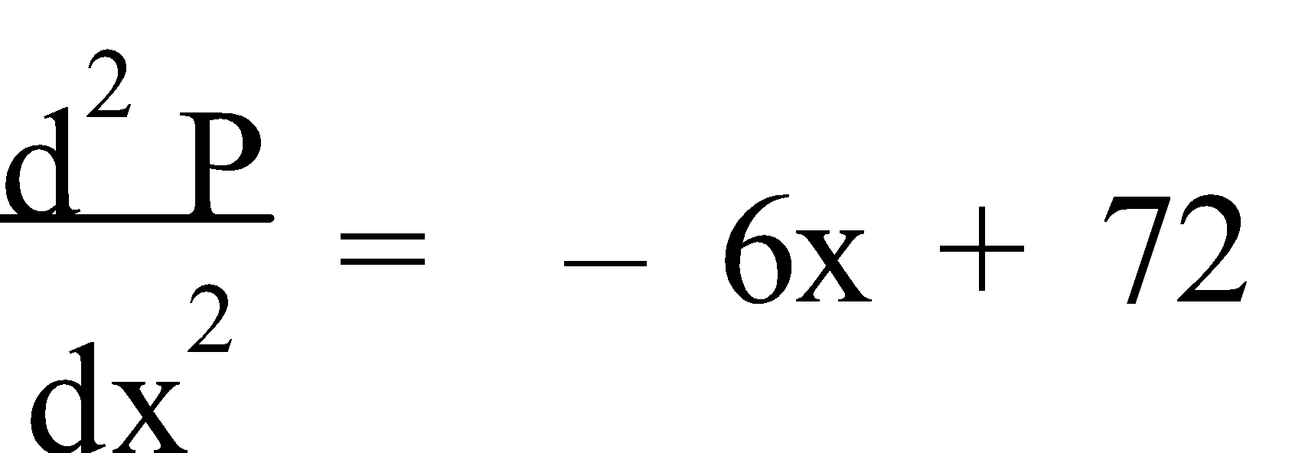

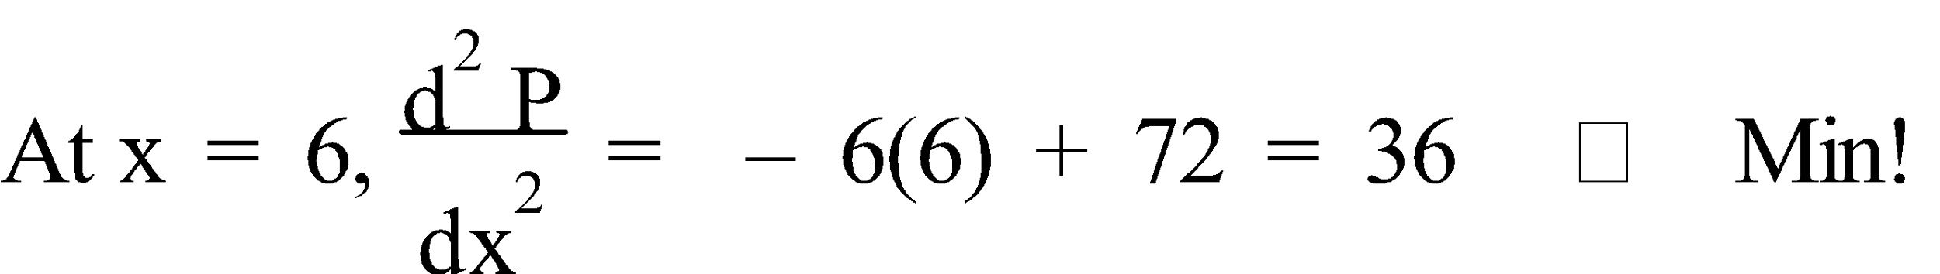

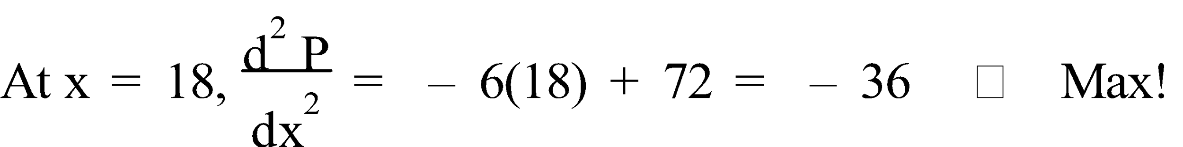

∴ The company should manufacture 18 machines per hour for a maximum profit of $500.

Ref: *Ex.3C Q.1-12 (even)*

**ANTIDIFFERENTIATION**

**1. ANTIDIFFERENTIATION:** **Antidifferentiation**, as the name implies, is the reverse of differentiation, e.g. If **f '(x) = 2x**, then **f(x) = x2** or **f(x) = x2 + 1** or **f(x) = x2 – 3**, etc. All of these, and more, have **f '(x) = 2x**. These are known as a **Family of Curves**. Thus, we say that the **antiderivative** (or **primitive**) of **2x** is **x2 + c**, where c is a constant. Hence any function has an **infinite** number of **antiderivatives** which differ from each other by a **constant** only. Additional information may make it possible to determine the value of **c**.

Previously, to differentiate **axn** we “**multiplied by the power and decreased the power by one**”, e.g. If **y = axn**, then 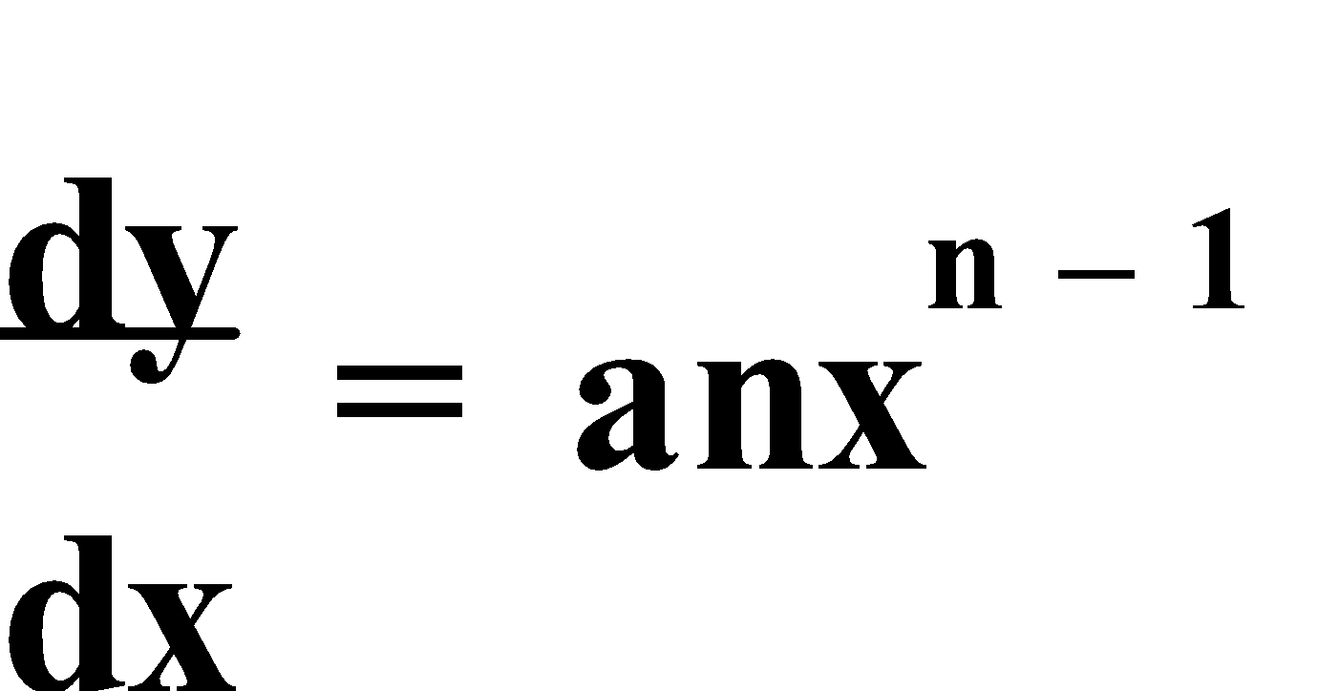. So, to reverse the process we “**increase the power by one and divide by the (new) power**”, e.g. If , then 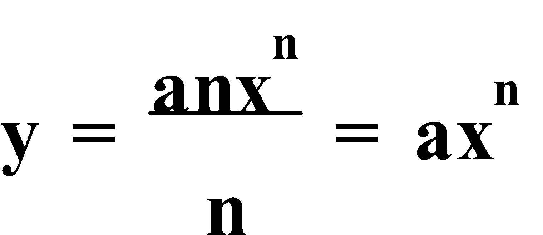. Thus, in general, if 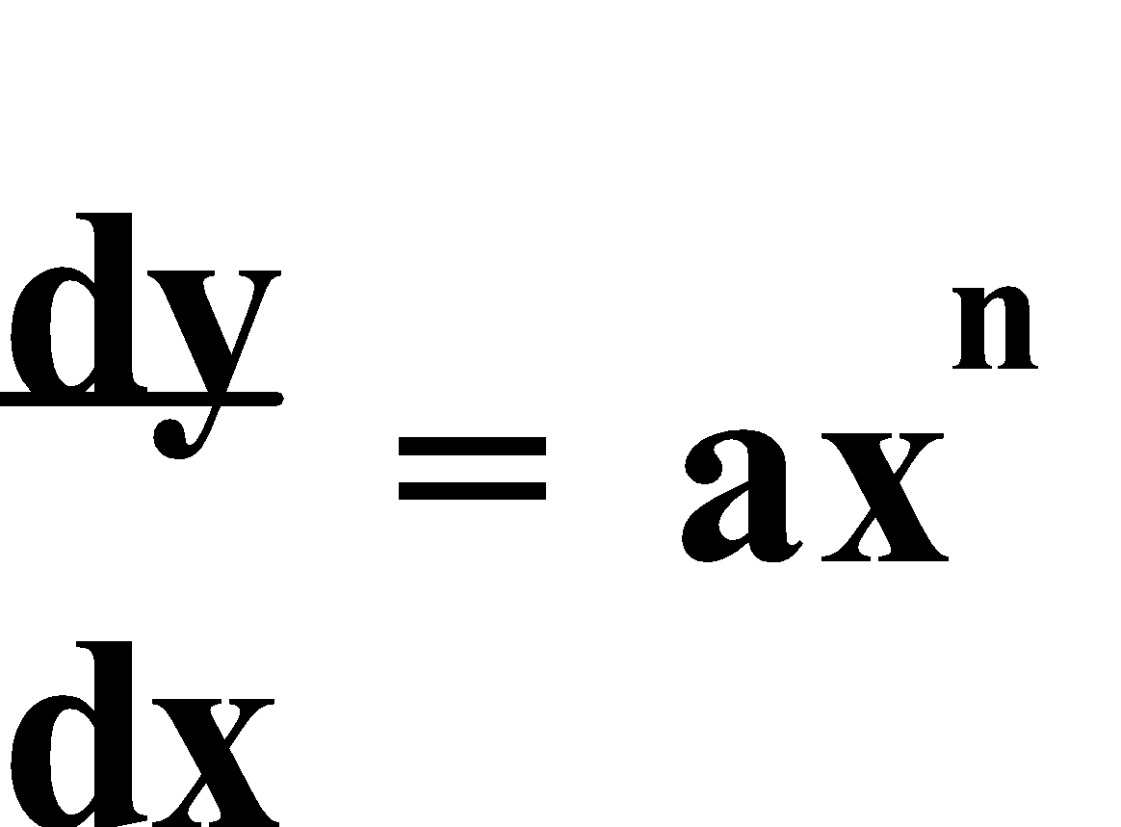, then 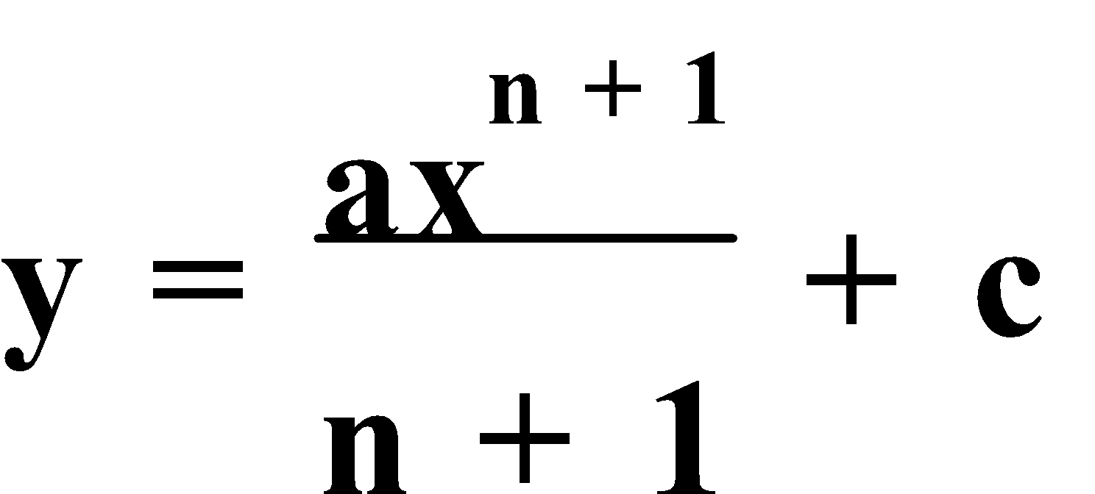 for **n ≠ -1**.

**NOTE:** The restriction placed on n for the above rule is because, so far, we do not know any polynomial, y, for which 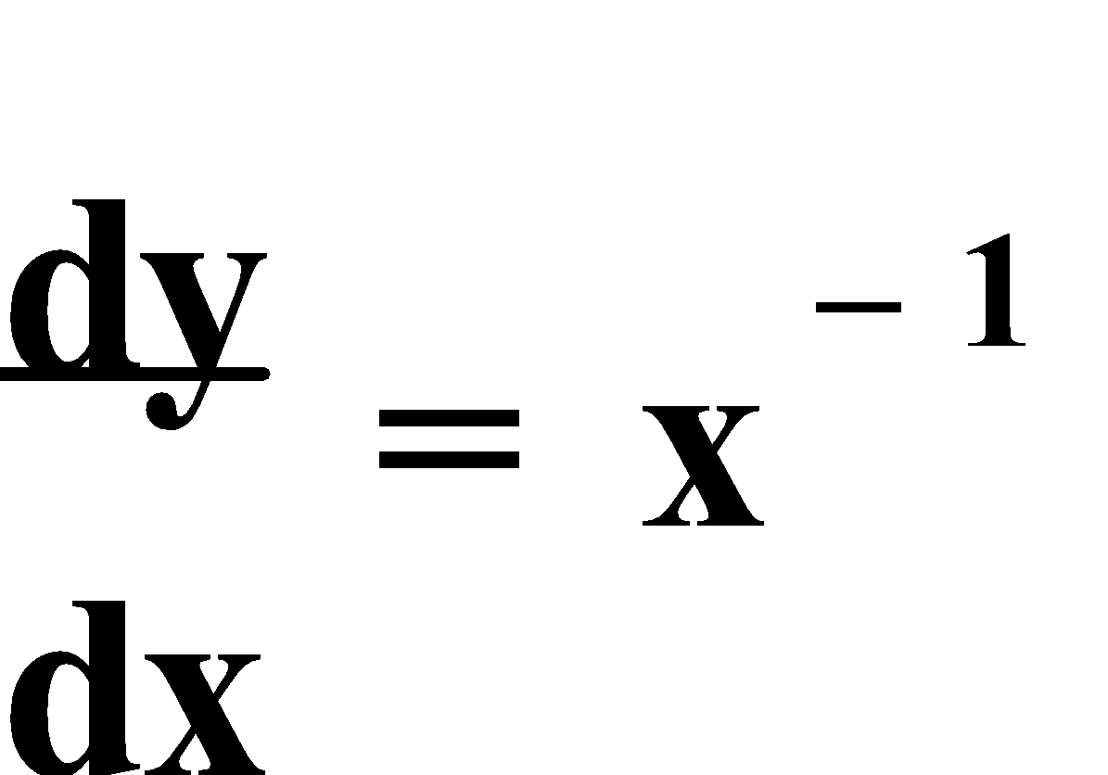.

E.g.1. Find the antiderivative of:

a) 2x2

b) x2 + 1

c) (x + 2)(x – 1)

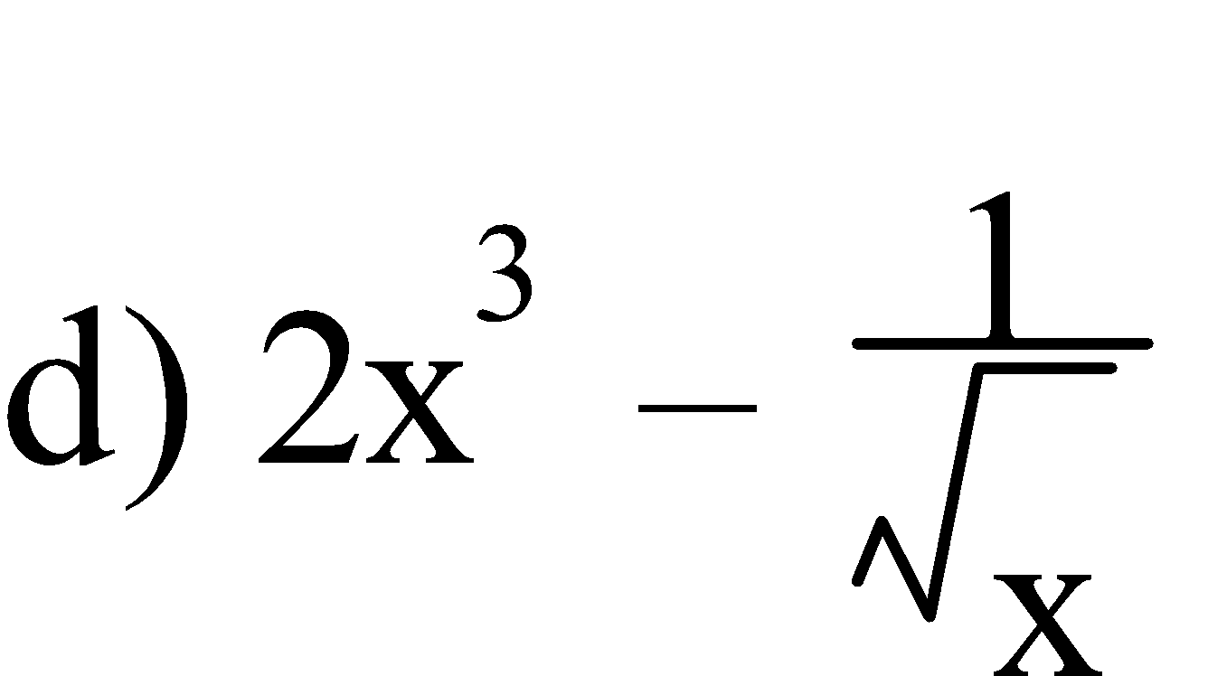

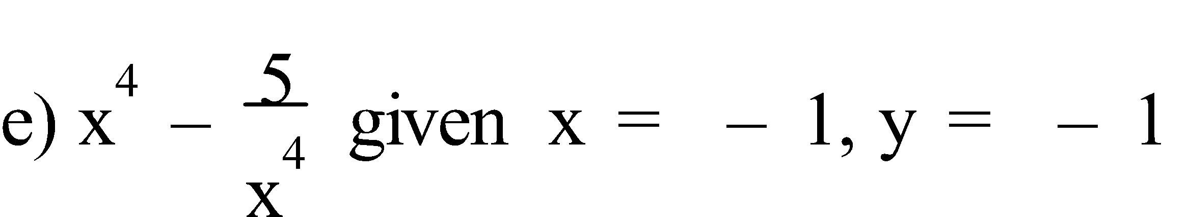

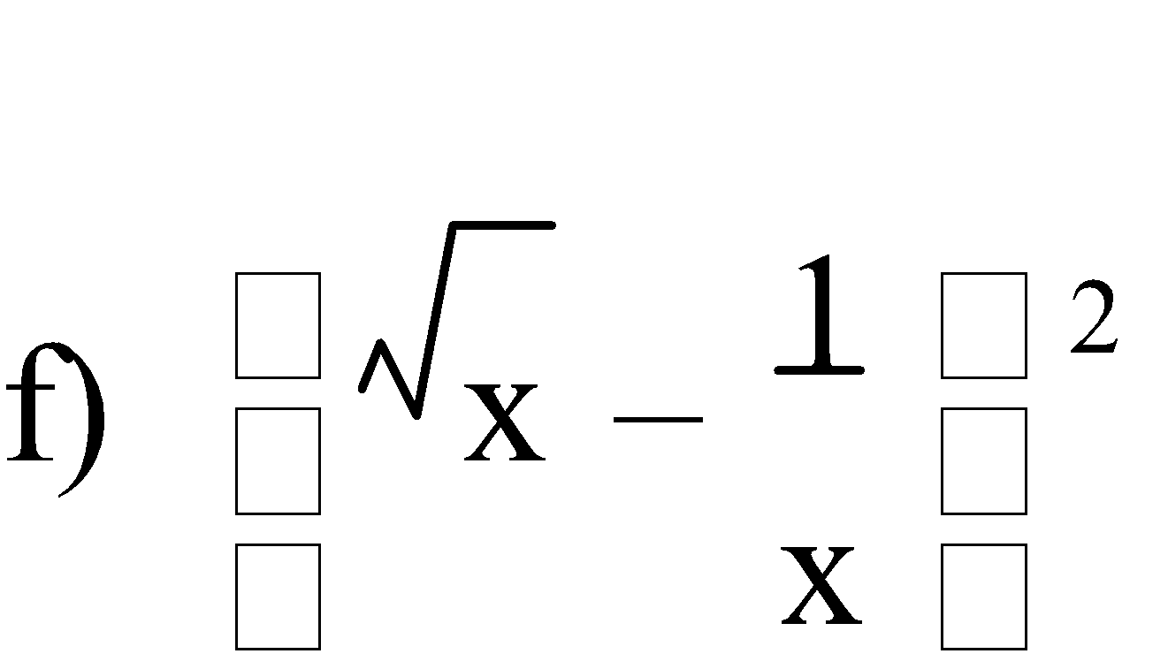

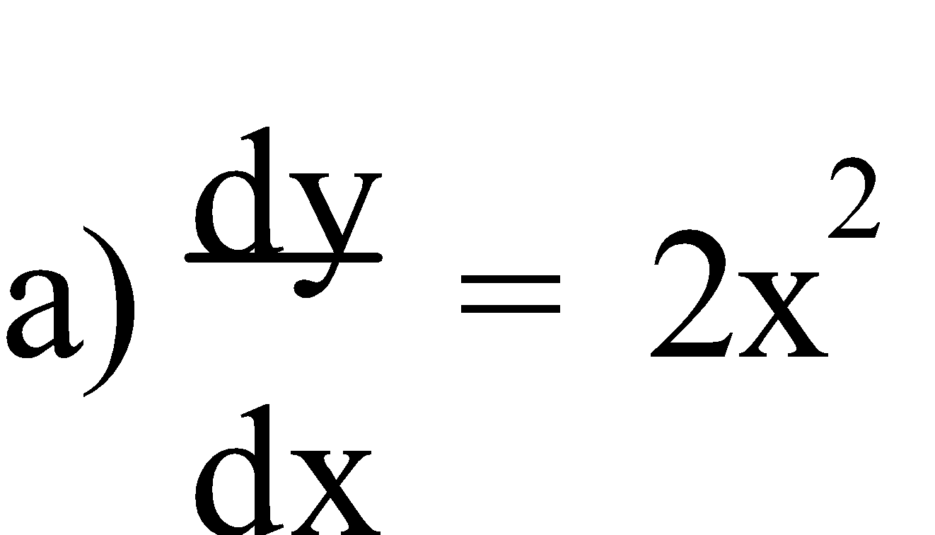

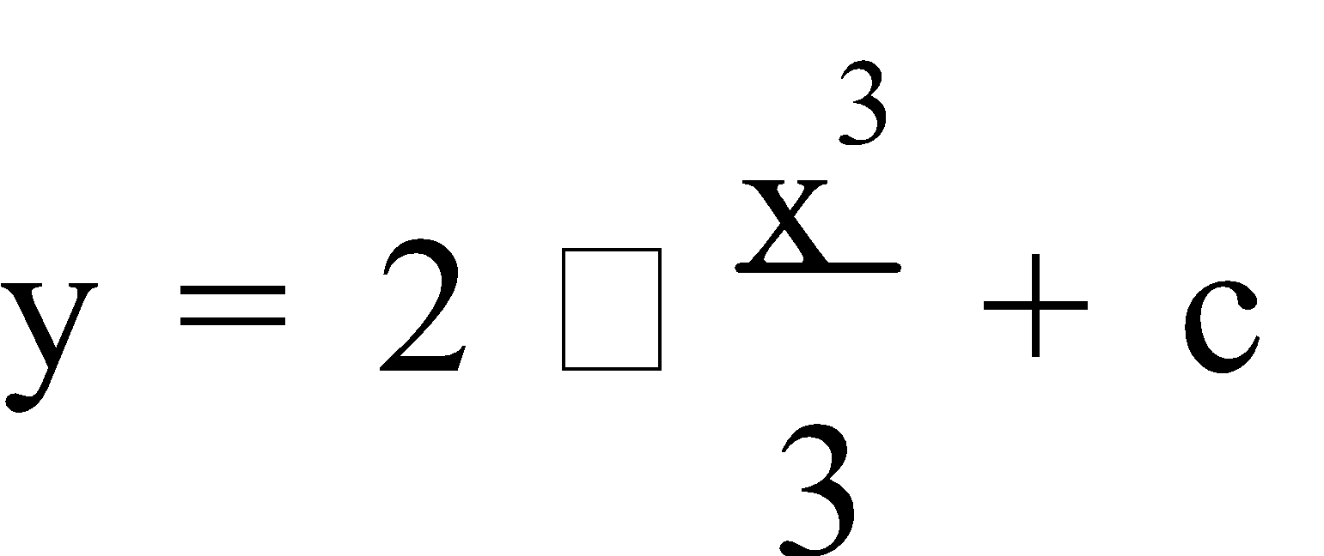

= ⅔x3 + c

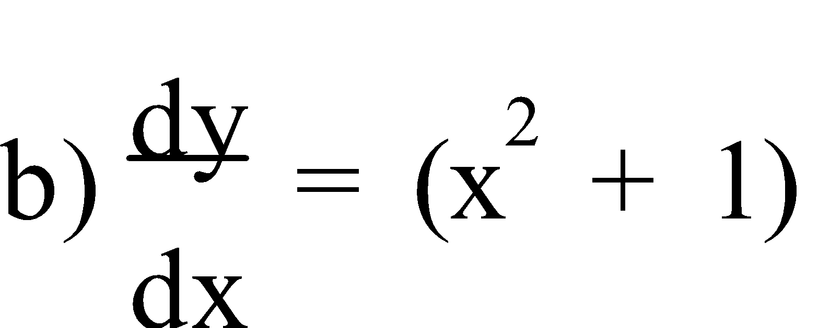

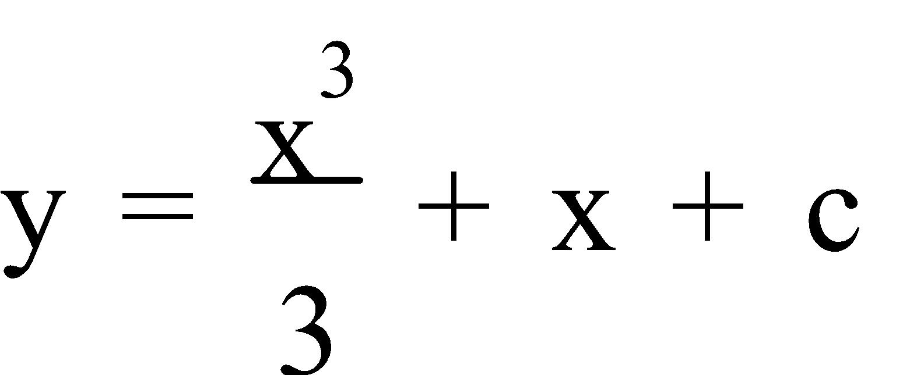

= ⅓x3 + x + c

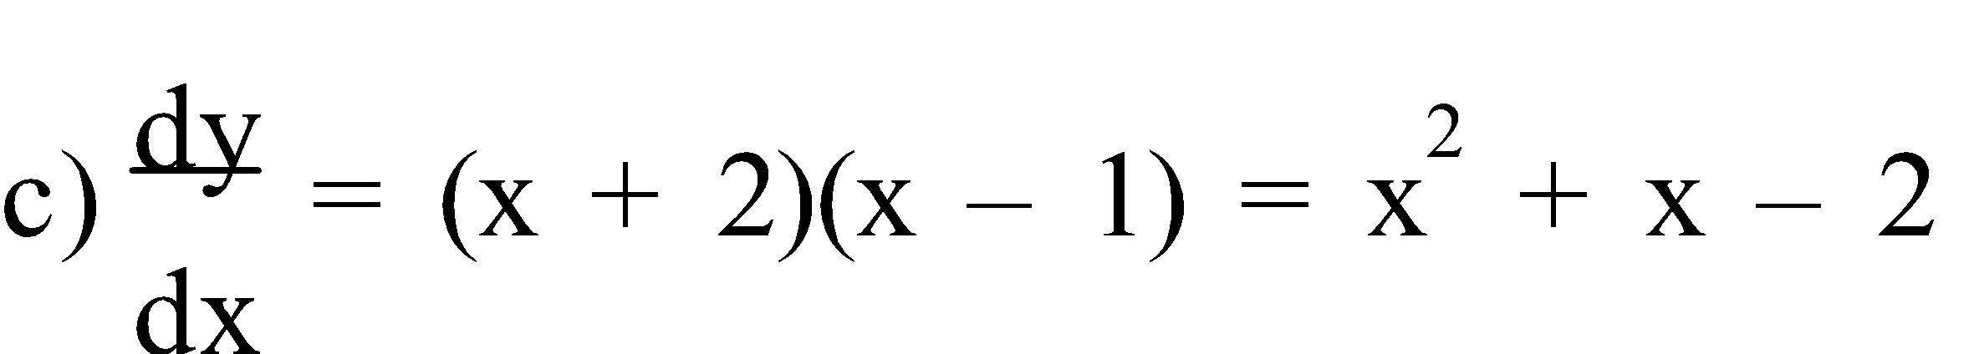

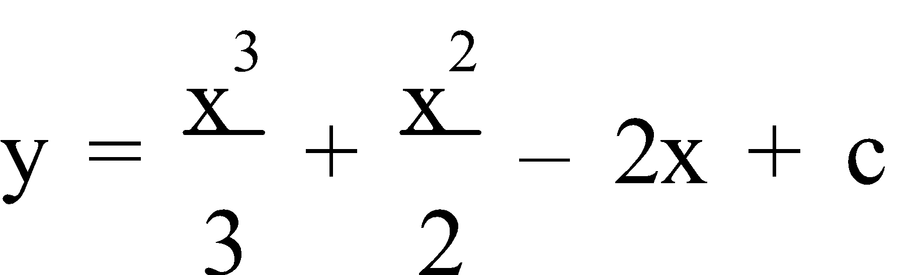

= ⅓x3 + ½x2 – 2x + c

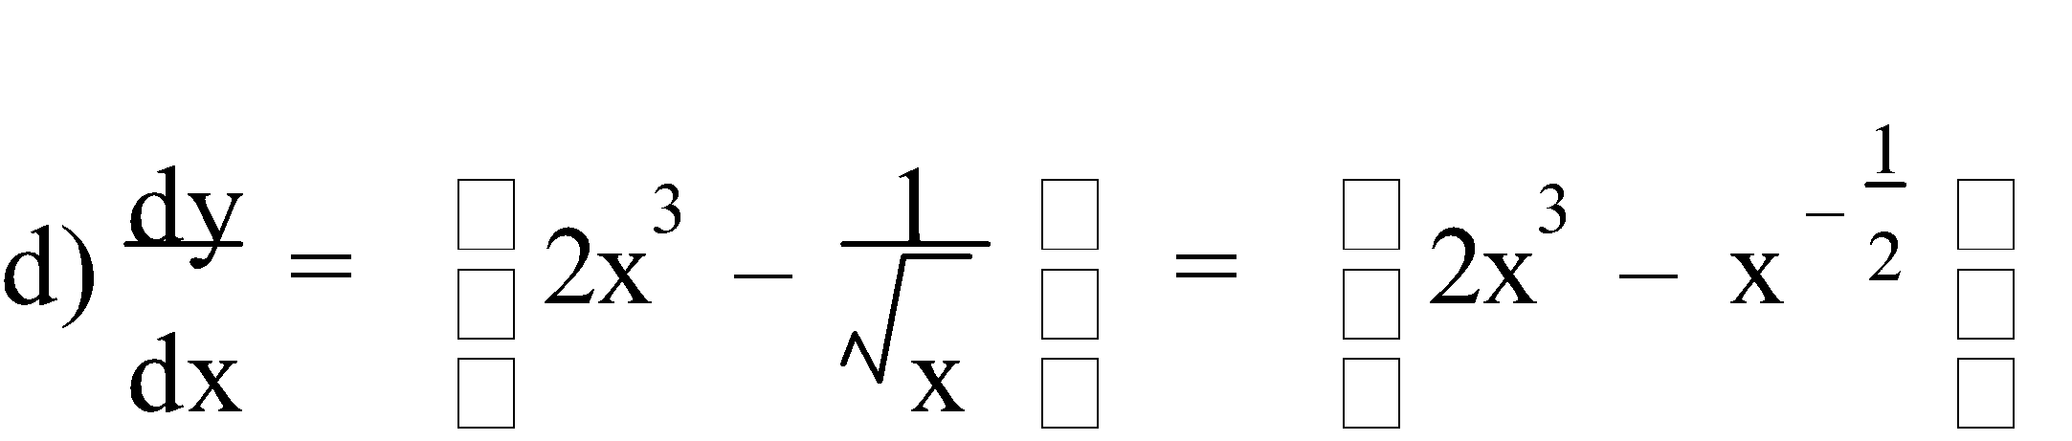

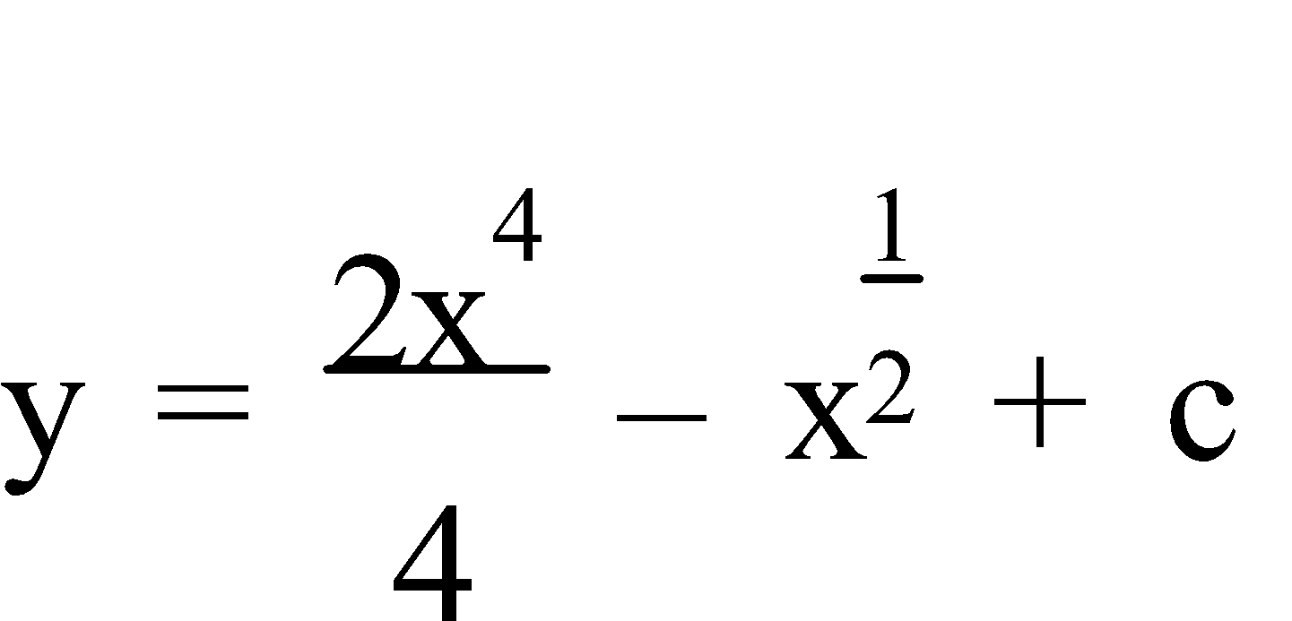 

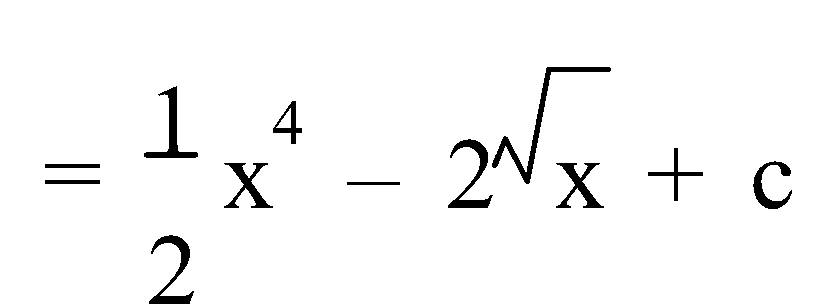

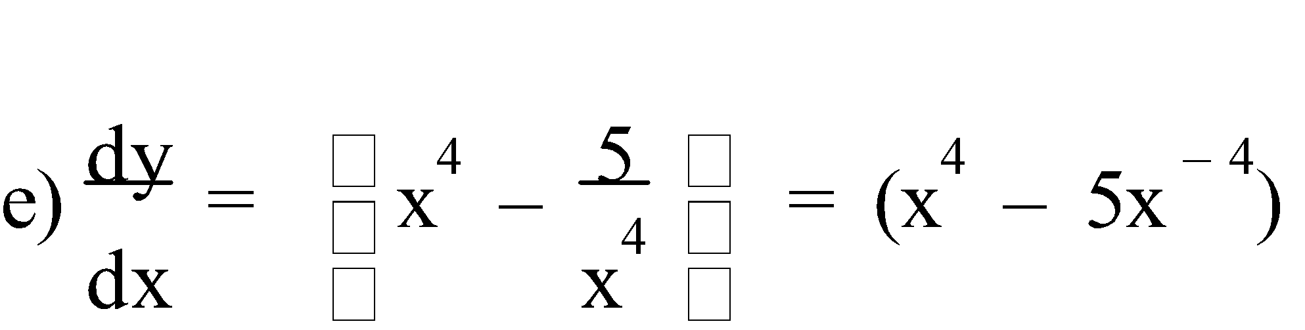

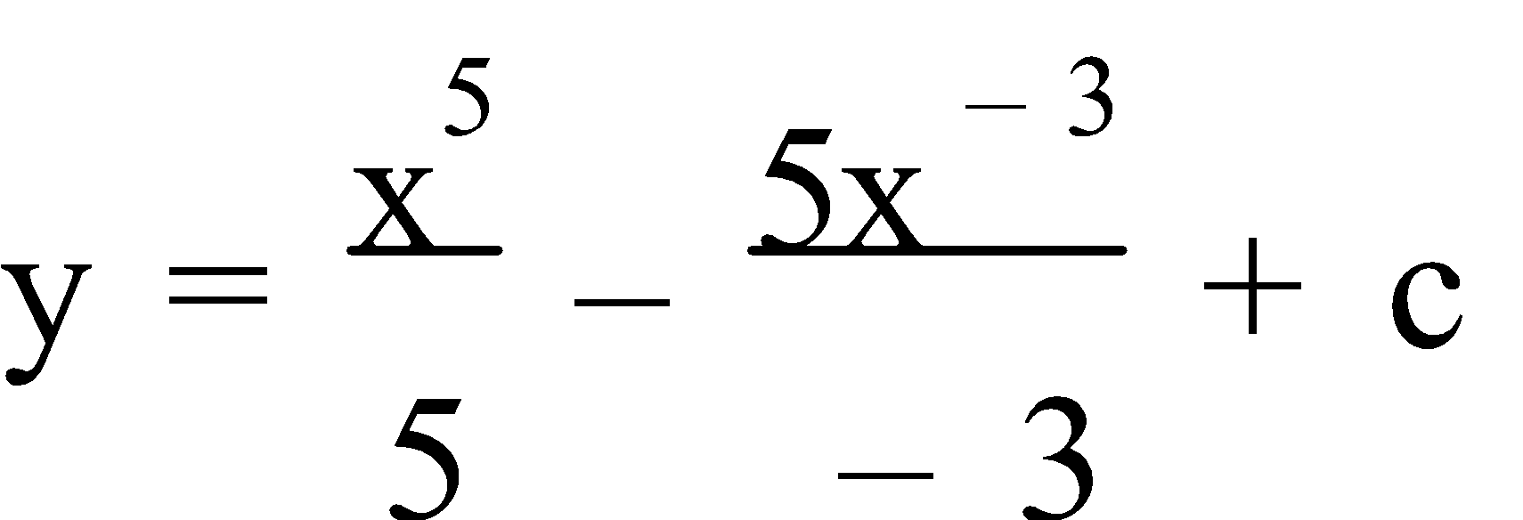

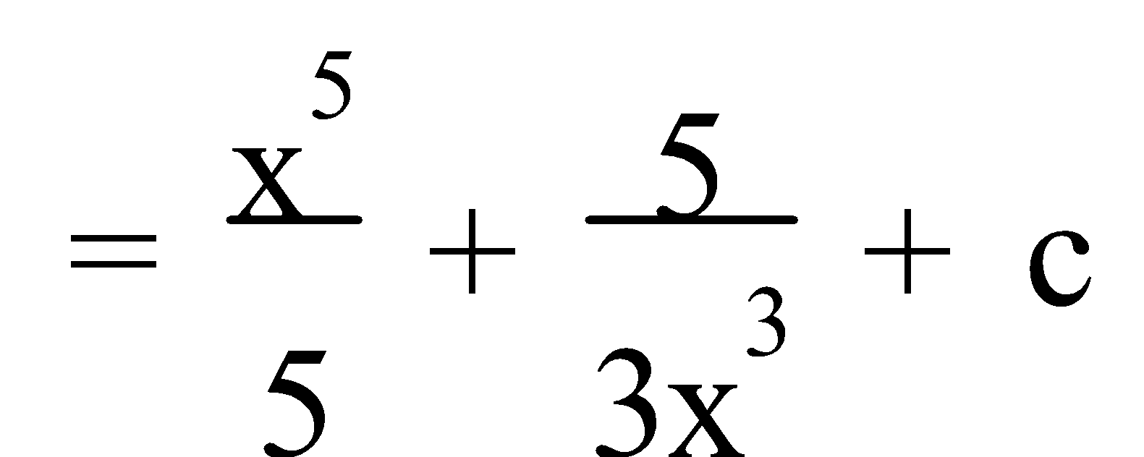

Given x = -1, y = -1

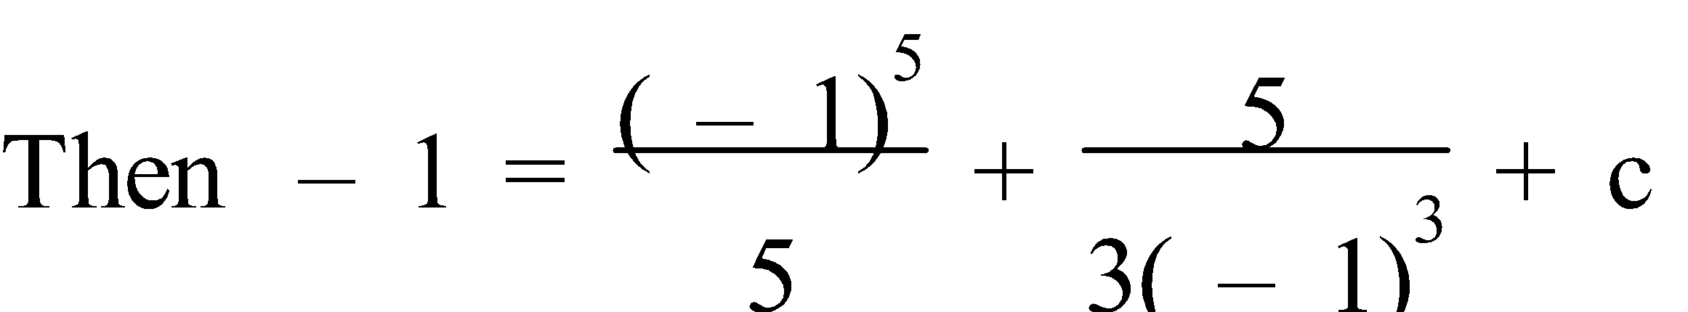

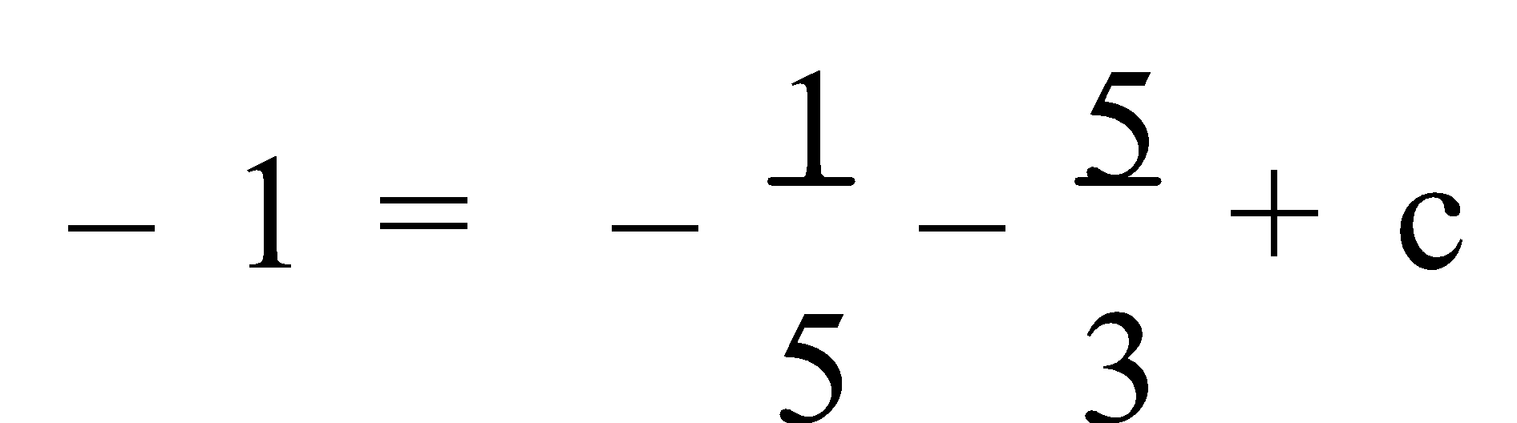

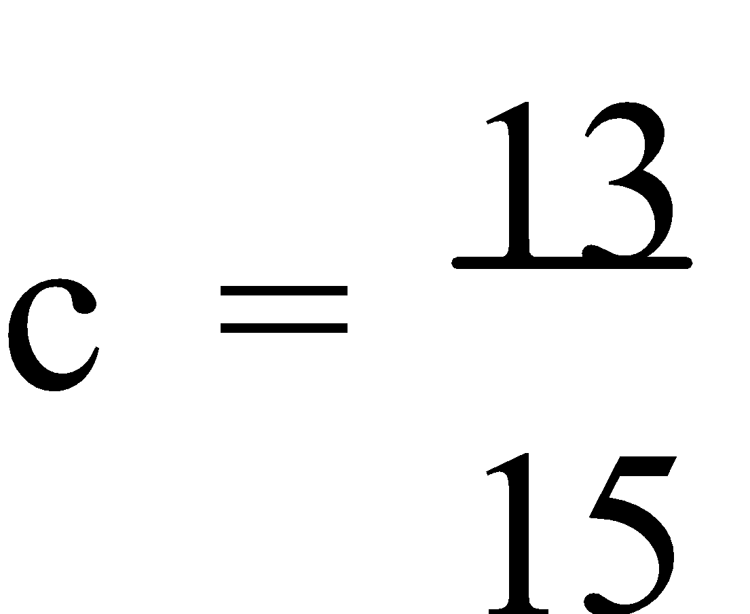

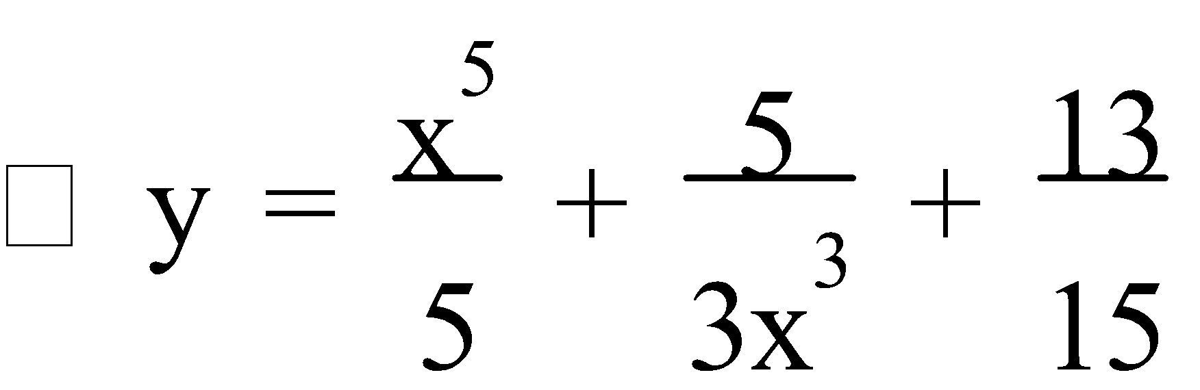

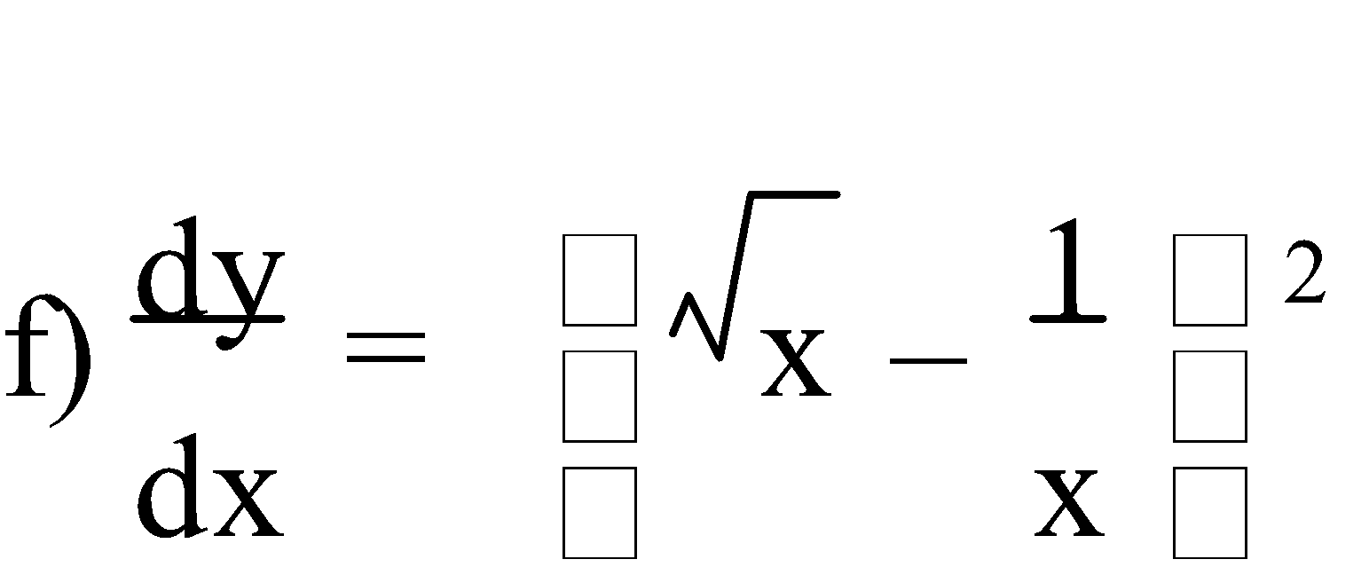

= (x½ – x-1)2

= (x – 2x-½ + x-2)

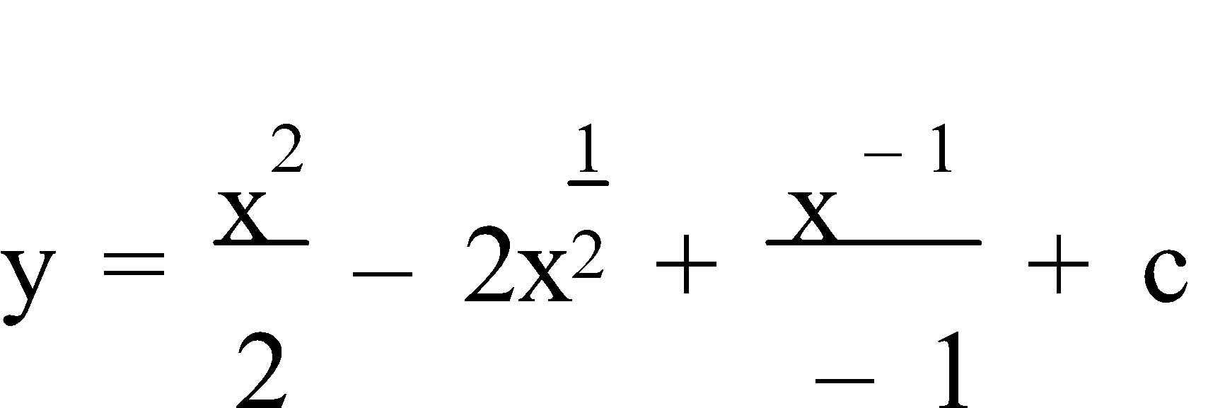 

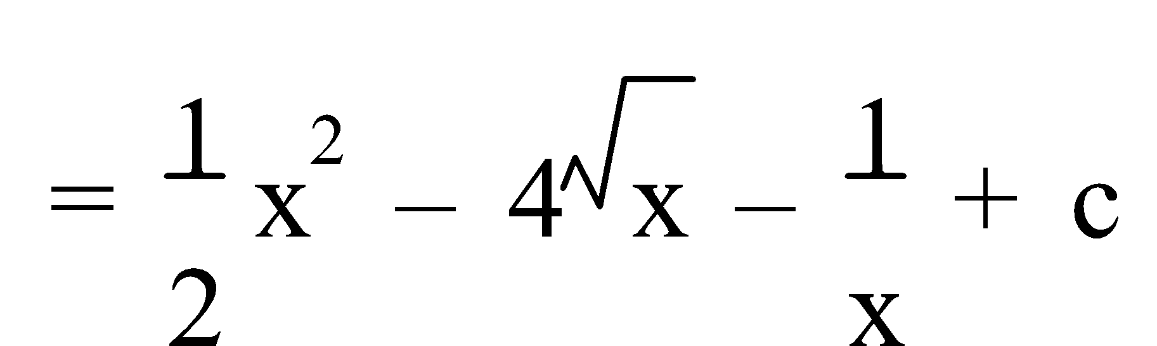

Ref: *Ex.4A Q.1-37 (odd)*

**2. FUNCTION FROM RATE OF CHANGE:** Previously we looked at real life situations where the **rate of change** (of a function) was required, e.g. rate of change of revenue, rate of change of volume, etc. Thus **antidifferentiation**, with some **additional information** to determine the **particular** function, can be used to find the function given the rate of change.

E.g.2. The rate of change of the volume of a certain spherical crystal was found to be such that 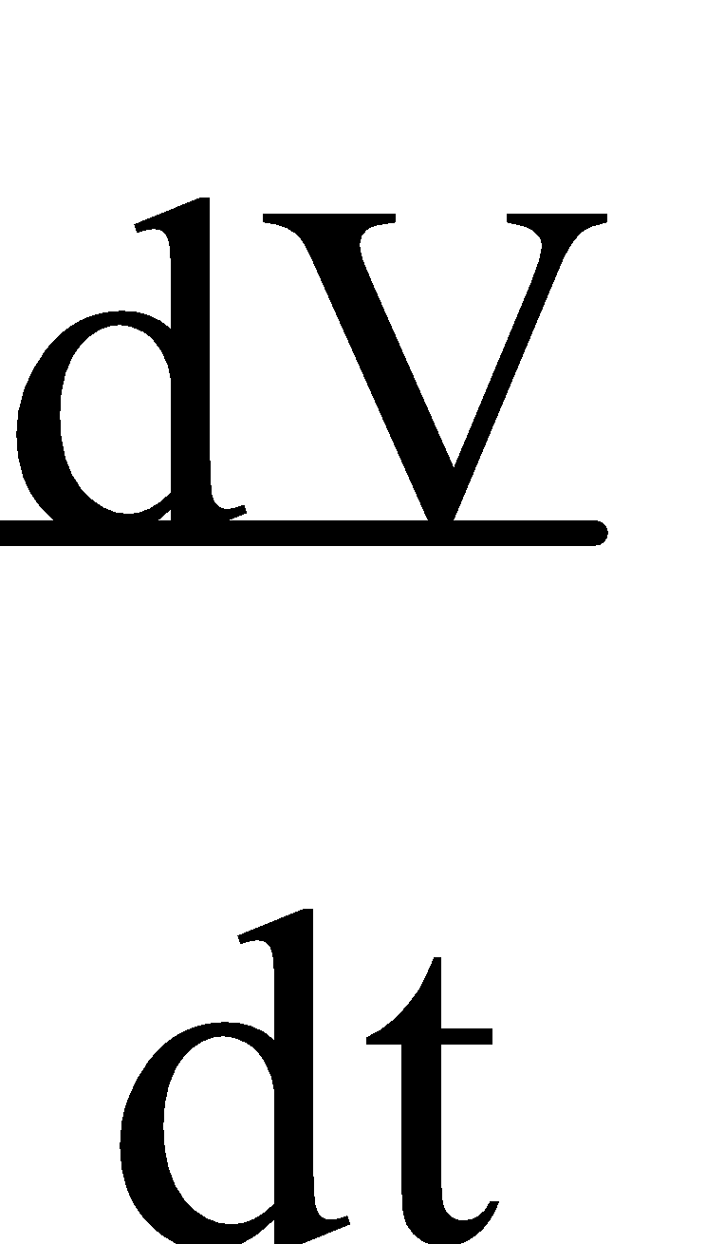 = 36 – 3t mm3/s, t seconds after it was placed in a special “growing” solution. Find the volume function V(t) and determine the volume 12 seconds after immersion if the crystal had an initial volume of 25 mm3.

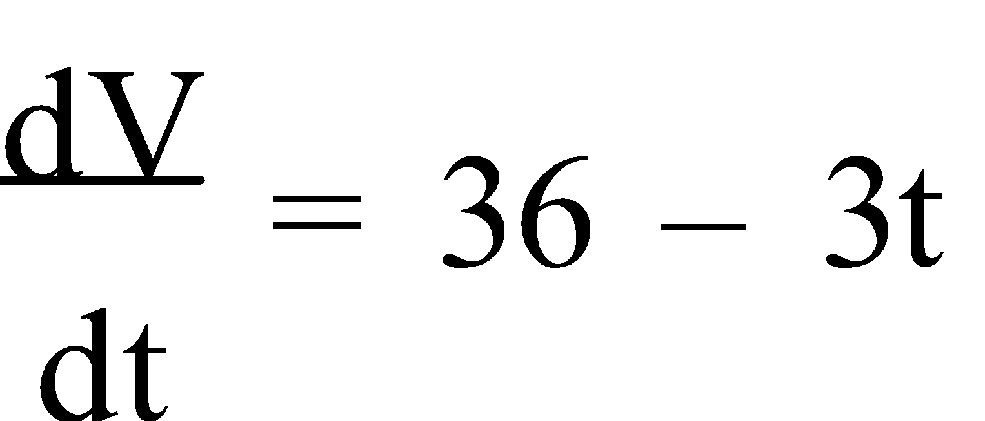

∴ V = ∫ (36 – 3t) dt

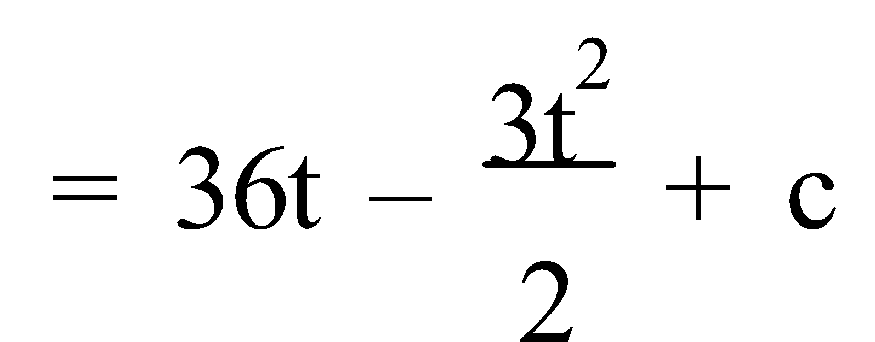

= 36t – 1.5t2 + c

But when t = 0, V = 25

36(0) – 1.5(0)2 + c = 25

c = 25

∴ V = 36t – 1.5t2 + 25

So, when t = 12,

V(12) = 36(12) – 1.5(12)2 + 25

= 241 mm3

∴ 12 seconds after immersion the crystal has a volume of 241 mm3.

Ref: *Ex.4B Q.1-1 (odd)*

**3. INDEFINITE INTEGRAL:** **Antidifferentiation** is also known as **integration** and is denoted by the **integral sign ∫**. Hence,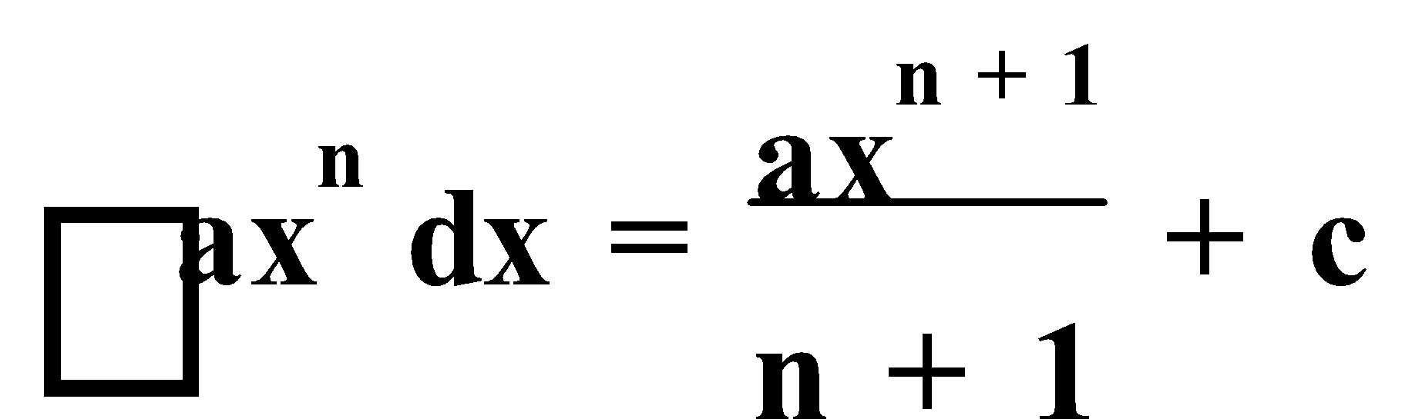. So, the antiderivative is also referred to as the **Indefinite Integral** or the **Primitive Integral** as it involves the **constant of integration**, **+ c**.

E.g.3. Integrate:

a) 4x3

b) 5 + 3x – 2x2

c) (4x – 3)2

a) 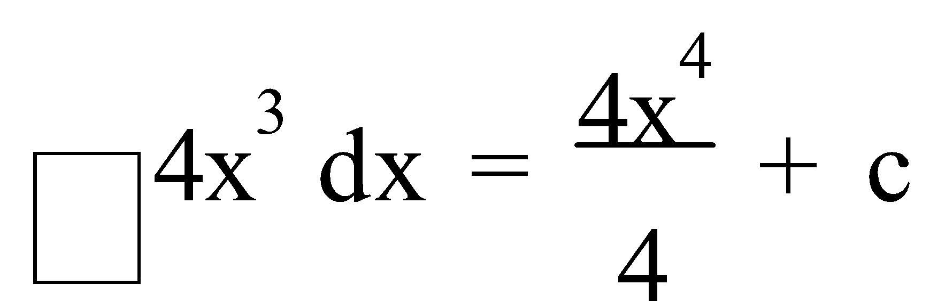

= x4 + c

b) 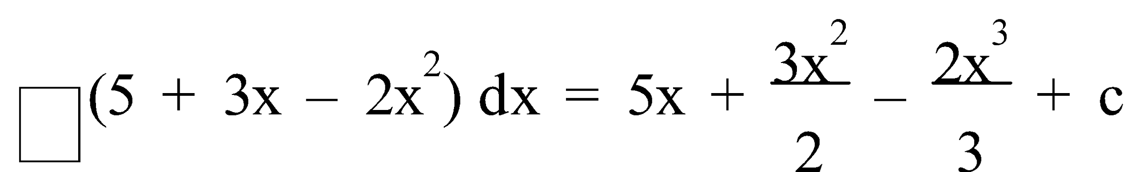

c) ∫ (4x – 3)2 dx = ∫ (16x2 – 24x + 9 ) dx

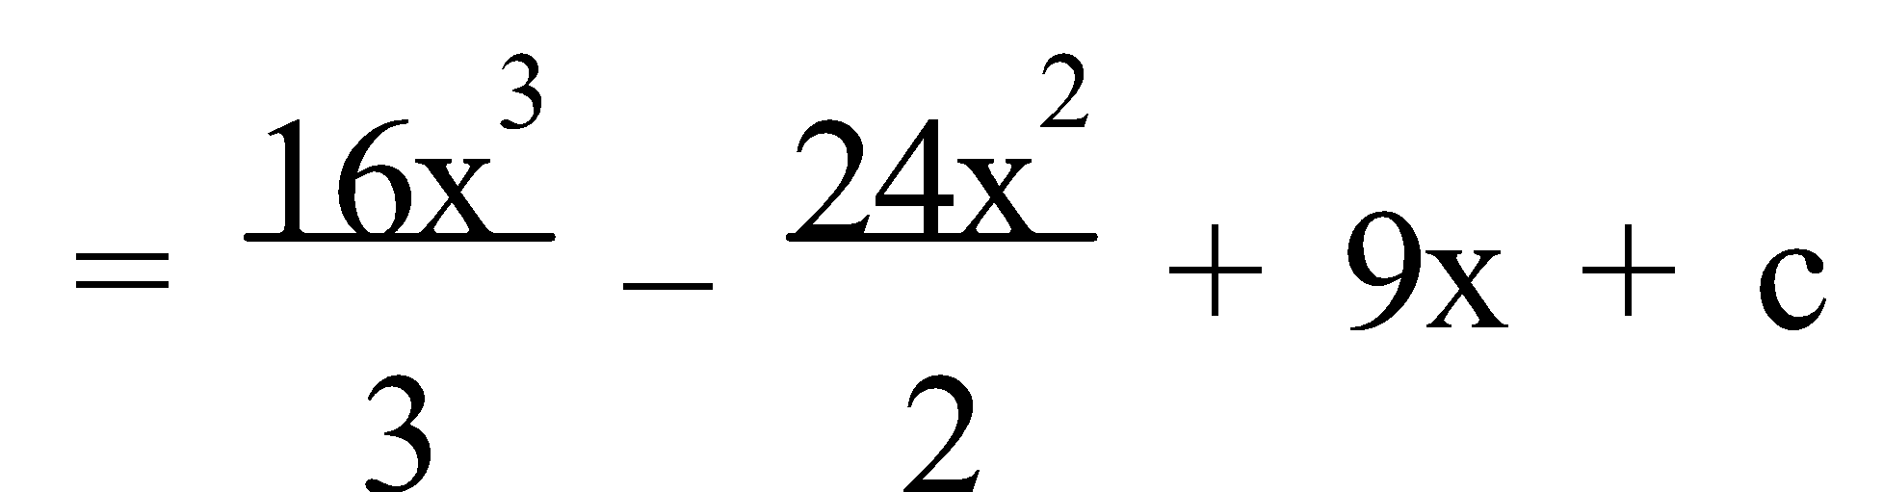

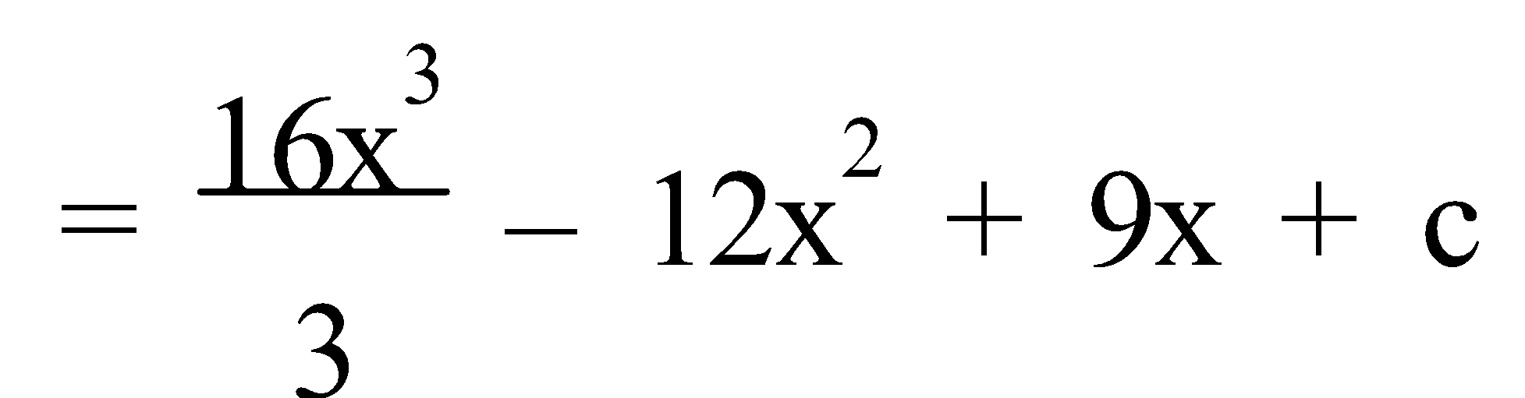

Ref: *Ex.4C Q.1-15 (odd)*

**PATTERNS**

**1. TESTING CONJECTURES:** **Mathematical statements** can be **always true**, e.g. if you multiply two odd numbers you get an odd number; **always false**, e.g. if you add 1 to an odd number you get an odd number; or **sometimes true** and **sometimes false**, e.g. if you double a number you get an even number. **Statements** that are **always true** are considered to be **fundamental truths**.

To test the **validity** of a generalised **conjecture** – **systematically** check specific examples to see if the statement holds true; the **more cases tested**, the **more** **confident** we are in the **validity of the statement**; however, only **one counter example** is required to **disprove a statement**, or produce a **formal proof**.

A **framework** for a **formal proof** involves **defining** all the **conditions**, making **statements** with **reasons**, if appropriate, **logically sequencing** an argument, and making a **concluding statement**.

**Algebraically**, for **n** being an integer – **odd** numbers are **2n + 1** or **2n – 1**, **even** numbers are **2n**, **consecutive even** numbers are **2n – 2**, **2n**, **2n + 2**, **2n + 4**, etc., **consecutive odd** numbers are **2n – 1**, **2n + 1**, **2n + 3**, etc., **integers differing by two** are **n** and **n + 2** or **n – 1** and **n + 1**, and **two digit** numbers are **10a + b** where **a** is the tens digit and **b** is the units digit.

E.g.1. Prove the validity of each of the following statements:

a) One less than the square of any counting number greater than 2 is always a multiple of 5.

b) The product of two even numbers is always even.

1. If the number is 3, then 32 – 1 = 8; this is not a multiple of 5.

∴ One less than the square of any counting number greater than 2 is not always a multiple of 5.

1. Let 2k and 2p be the two even numbers.

⇒ 2k × 2p = 4kp

= 2(2kp) ← Any integer multiple of 2 is even.

∴ The product of two even numbers is always even.

Ref: *PROVING GENERALISATIONS Q.1-10 (even)*

**2. GEOMETRIC REASONING:** A **geometric deductive proof** consists of a list of **statements**, and the **reasons** why these statements are true. **Writing** a **proof** consists of **drawing** a **diagram**, if appropriate, of the given situation, any **extensions** made/necessary **to the diagram**, stating any **given** information, and what is **required to prove**, **statements with reasons** and **concludes** with the statement that has been proved, often finishing with **Q.E.D.** if no reason required.

E.g.2. Using this diagram, prove ΔXOL ≅ ΔYOL.

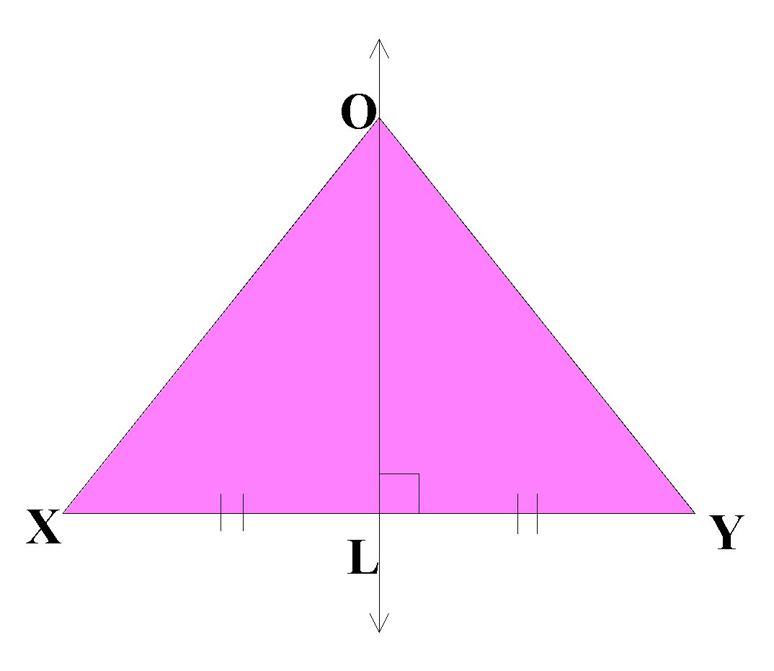

GIVEN: XL = YL; s∠XLO = s∠YLO = 90°

REQUIRED TO PROVE: ΔXOL ≅ ΔYOL

PROOF:

| **STATEMENTS** | **REASONS** |
| --- | --- |
| In ΔXOL and ΔYOL,  XL = YL  OL = OL  s∠XLO = s∠YLO = 90°  ∴ ΔXOL ≅ ΔYOL | Given  Same line segment  Given  S.A.S. |

Ref: *GEOMETRIC PROOFS Q.1-8 (even)*

**BIVARIATE DATA**

**1. CORRELATION:** **Bivariate data** is data collected concerning two variables, resulting in pairs of **variates**. Bivariate data may be represented graphically by a **scattergraph**, **scatter plot** or a **scatter diagram**. The **independent variable** is graphed on the horizontal axis and the **dependent variable** on the vertical axis.

A scattergraph will indicate both the **strength** and the **direction** of the **linear relationship** or **correlation** between the variates. [See scatter plots on p.67.] If a linear relationship appears to be appropriate then a **line of best fit** can be drawn on the scattergraph. The equation of the line **ŷ = ax + b** andcan be determined from a calculator with a **linear regression** mode. This is used to make **predictions** provided the linear relationship is reasonably strong.

The **correlation coefficient** (or Pearson’s correlation coefficient) (**r** or **rxy**) measures of how closely the relationship between two variables approximates a linear relationship, and **-1 ≤ r ≤ +1**, where **-1** is a **perfect** linear relationship with a gradient of -1, and **+1** is a **perfect** linear relationship with a gradient of +1. As a general guide:

| **r** | **STRENGTH OF LINEAR RELATIONSHIP** |
| --- | --- |
| 1 to 0.9  0.8 to 0.6  0.5 to 0.3  0.2 to -0.2  -0.3 to -0.5  -0.6 to -0.8  -0.9 to -1 | Strong  Medium Positive  Weak  No Significant linear relationship  Weak  Medium Negative  Strong |

**Predictions** can be either **interpolation** or **extrapolation**. **Interpolation** involves estimating or predicting within the range of the data. **Extrapolation** goes beyond known scores, is generally unreliable and can be quite misleading.

Either the **covariance** or the **correlation coefficient** may be used when determining if a relationship between two sets of variables exists. The **covariance** (**Sxy**) is the average of the product of the deviations of each x score from  and each y score from 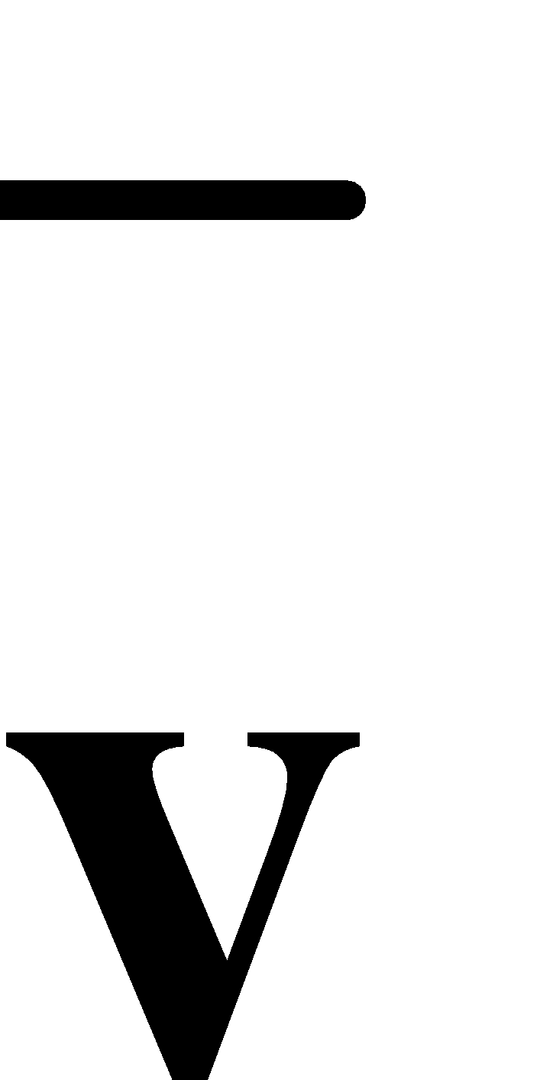 and is defined as 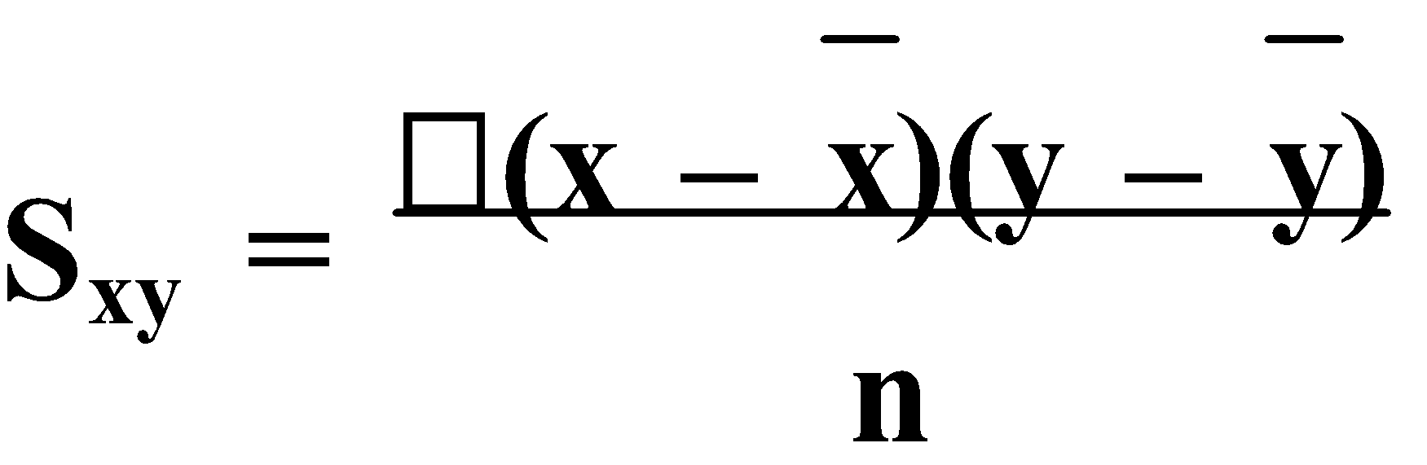 or 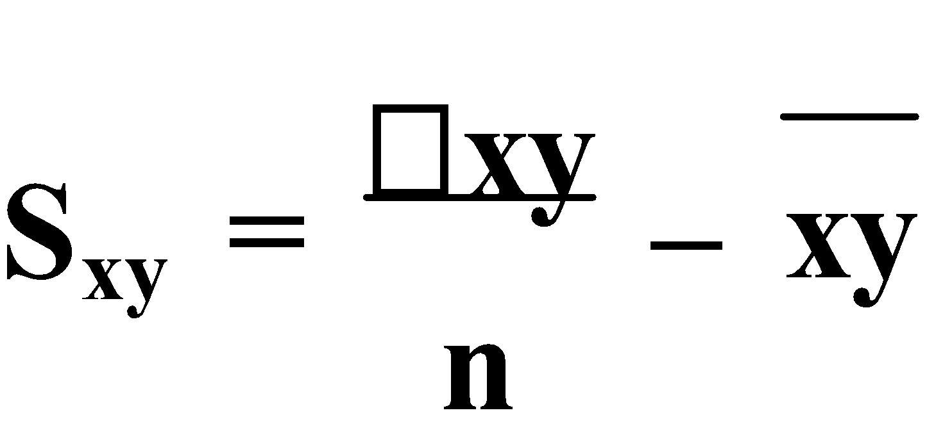 . The **correlation coefficient** is the standardized covariance and is defined as 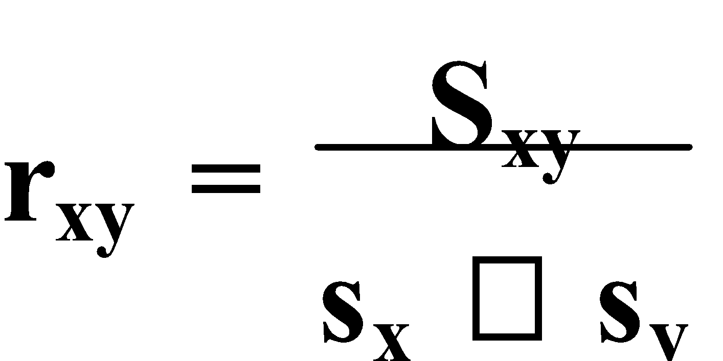 where **-1 ≤ r ≤ 1**. Hence, the covariance could also be defined as **Sxy = rxy × sx × sy**. The **covariance** (**Sxy**) is rarely used since the advent of calculators.

A **line of best fit** or the **least squares regression line** is a **predictor** of the y values in a scattergraph. A common notation for a prediction/regression line is **ŷ = ax + b**. The values for a and b can be determined by 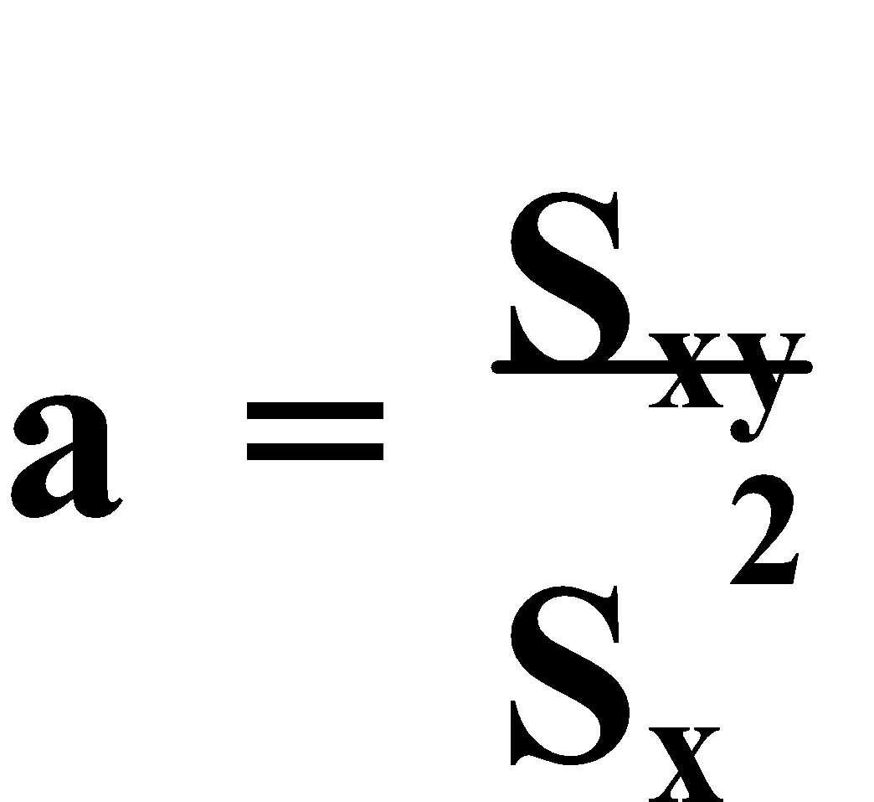 and 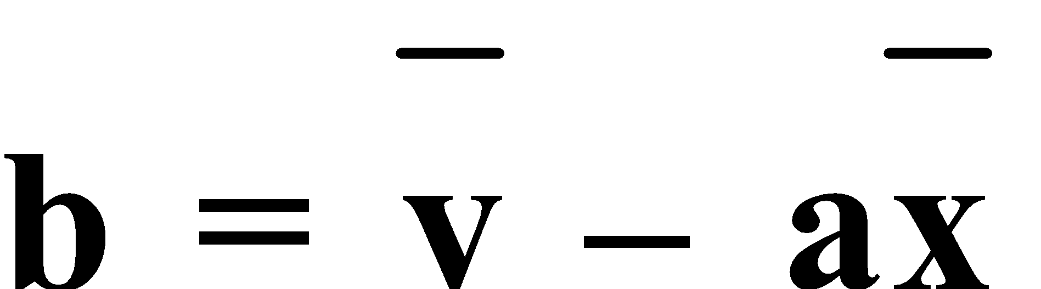. The **least squares regression line** passes through 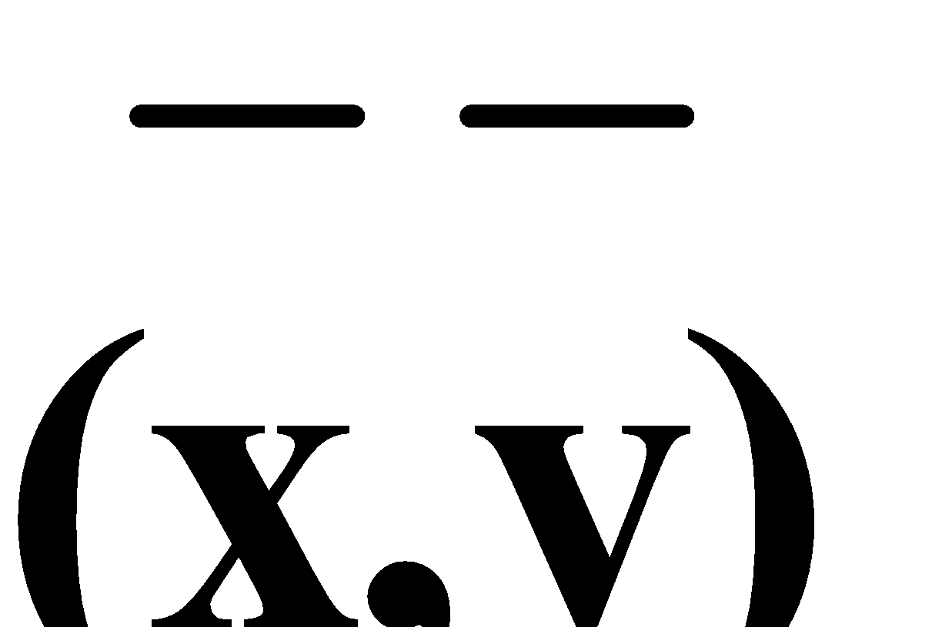.

The **residuals** are the errors of prediction or the deviations of the observations from the prediction line. **Each residual = actual plotted y value – predicted y value from the line drawn**, i.e. 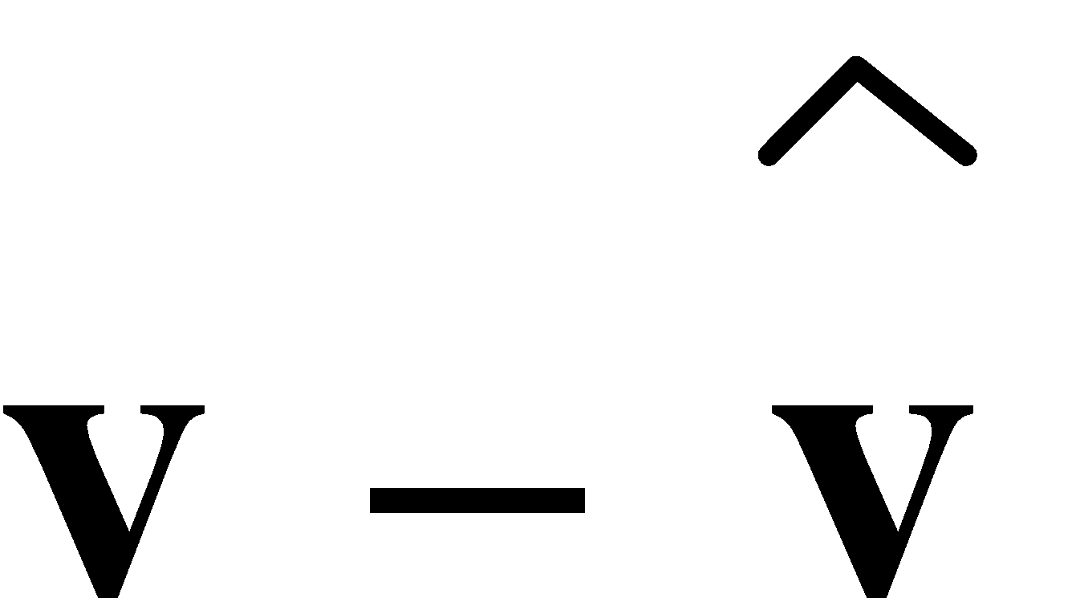.

**Time series data** is, literally, data collected over time. **Time** is always on the **horizontal axis**.

E.g.1. The following data gives the marks scored on 7 tests in Mathematics and Accounting by a student over the course of one year:

| **MATHEMATICS (m)** | 22 | 45 | 35 | 55 | 50 | 67 | 70 |
| --- | --- | --- | --- | --- | --- | --- | --- |
| **ACCOUNTING (a)** | 17 | 40 | 45 | 51 | 50 | 54 | 65 |

a) Draw a scattergraph for this data.

b) Give the equation of the line of best fit.

c) Use the line of best fit to predict the student’s next test result in Accounting if

the student scored 63 in the next Mathematics test.

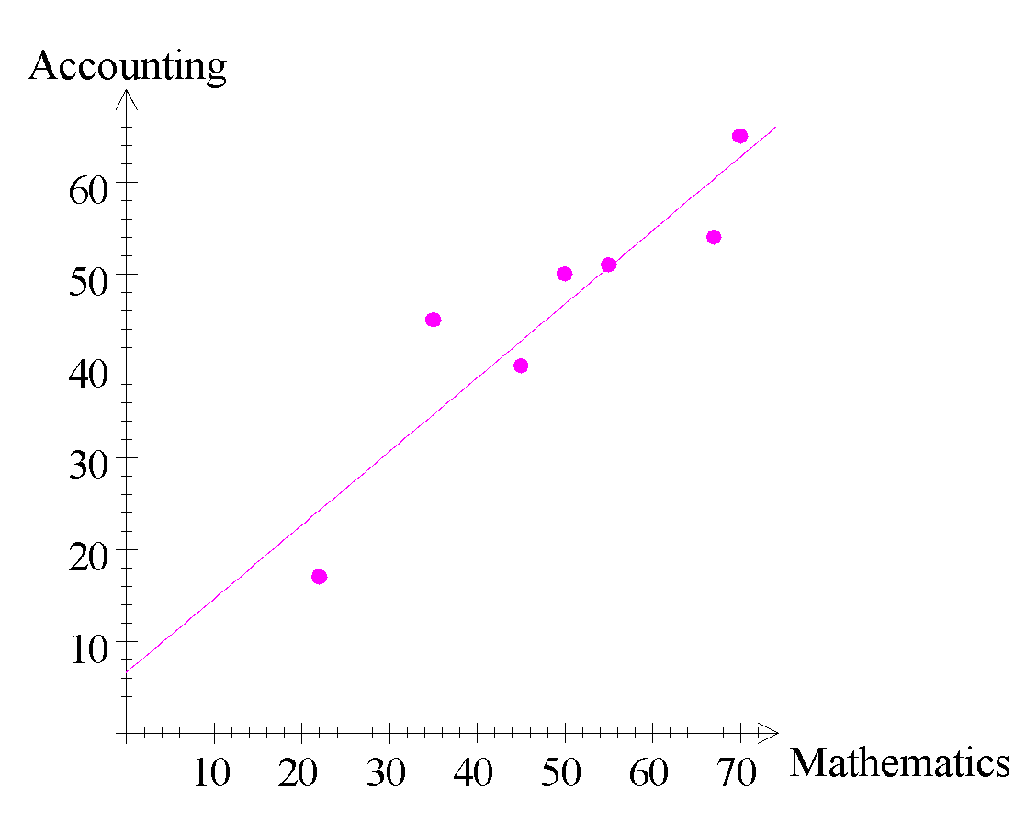

a)

b) â ≈ 0.80m + 6.58

c) From CAS calc., â(63) ≈ 57

∴ the expected Accounting mark is 57 for a Mathematics mark of 63.

Ref: *Ex.5A Q.1-18 (even)*

**2. OUTLIERS:** An **outlier** is a data point which is **anomalous** compared to the other data points. It stands **away from** the rest of the data. **Outliers** can significantly **alter** the position of the **line of best fit**. A **line of best fit** summarizes the **overall trend** of the data and, so it is usually **better to omit** any **outliers**. However, this should **not** be considered the **norm** for all statistical work. Removing an outlier or group of outliers is sometimes called **trimming** or **cropping** the data, and ‘**harvesting**’ the rest of the data.

**3. RESIDUALS:** A **scattergraph** will often indicate whether a linear relationship exists or if some **other type of relationship** would be better suited to the data. Either the **graph** of the data is clearly in a **shape other than a line** or the graph of the **residuals shows** an “**imbalance**” of data points on one side of the regression line. Your CAS calculator allows you to test, and use, a number of **different regression types**.

E.g.2. Draw a graph showing the residuals for the data from E.g. 1.

| **MATHEMATICS (m)** | 22 | 45 | 35 | 55 | 50 | 67 | 70 |
| --- | --- | --- | --- | --- | --- | --- | --- |
| **ACCOUNTING (a)** | 17 | 40 | 45 | 51 | 50 | 54 | 65 |

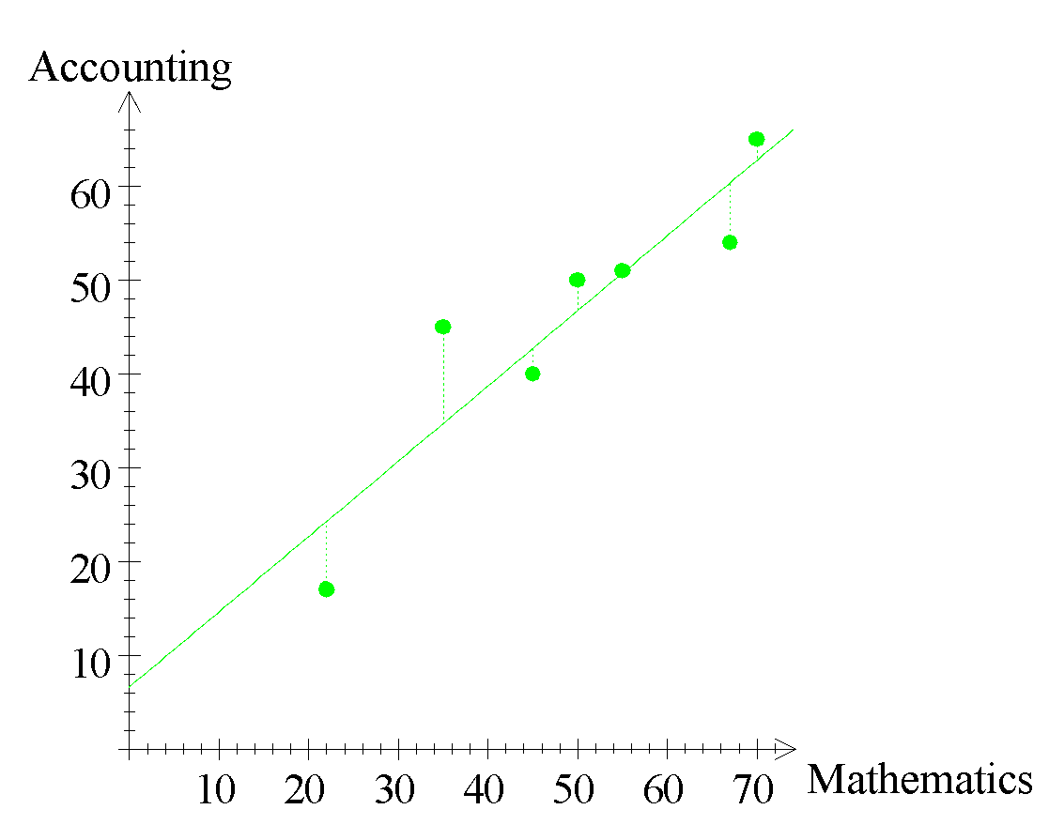

Ref: *Ex.5B Q.1-7 (odd); 6*

**MOVING AVERAGES AND SEASONAL EFFECTS**

**1. MOVING AVERAGES:** The line graph of a time series is usually characterized by fluctuations and irregularities. These fluctuations generally indicate **seasonal** variations within a **cycle**. One method to “smooth out” the graph of the original time series data is to find and graph the appropriate **moving average**. The number of cycles or seasons per year usually determines the “size” of the moving average. If there are no cycles/seasons then a 3-point moving average is commonly used. A **3-point average** is when 3 successive data points are taken, at a time, and the average for each group of 3 is calculated.

When working with data with a **cycle** of **4, 6, ...**, the **moving average** is **not** ‘**level**’ with any **score**. The **average** is calculated similarly to a 3-point average.

E.g.1. Nursing staff in a hospital are rostered on three shifts: morning (from 7 a.m. to 3:30 p.m.), evening (from 3 p.m. to 11:30 p.m.) and night (from 11 p.m. to 7:30 a.m.).

a) Calculate the 3-point moving average.

b) Graph the pattern of staff numbers and the 3-point moving averages.

The numbers of staff rostered over a 5 day period were:

| **DAY** | **SHIFT** | **NUMBER** |
| --- | --- | --- |
| **MONDAY** | MORNING  EVENING  NIGHT | 7  5  3 |
| **TUESDAY** | MORNING  EVENING  NIGHT | 11  9  4 |
| **WEDNESDAY** | MORNING  EVENING  NIGHT | 13  10  5 |
| **THURSDAY** | MORNING  EVENING  NIGHT | 12  8  4 |
| **FRIDAY** | MORNING  EVENING  NIGHT | 8  4  2 |

| **DAY** | **SHIFT** | **NUMBER** | **3-P.M.A.** |
| --- | --- | --- | --- |
| **MONDAY** | MORNING  EVENING  NIGHT | 7  5  3 | ---  5  6⅓ |
| **TUESDAY** | MORNING  EVENING  NIGHT | 11  9  4 | 7⅔  8  8⅔ |
| **WEDNESDAY** | MORNING  EVENING  NIGHT | 13  10  5 | 9  9⅓  9 |
| **THURSDAY** | MORNING  EVENING  NIGHT | 12  8  4 | 8⅓  8  6⅔ |
| **FRIDAY** | MORNING  EVENING  NIGHT | 8  4  2 | 5⅓  4⅔  --- |

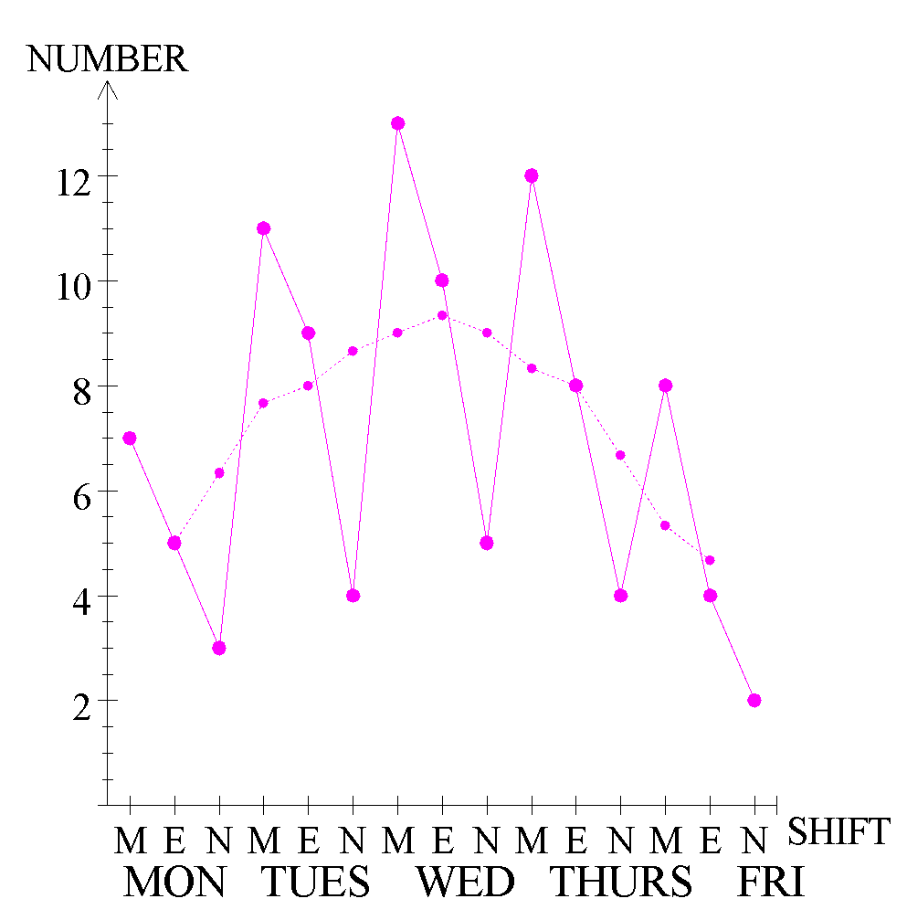

Ref: *Ex.6A Q.1-9*

**2. MAKING PREDICTIONS:** Many sequences of observations (time series) show a consistent, long term pattern or trend combined with shorter periodic or **cyclic variations**. These cyclic variations could be daily or seasonal. In general, **a time series combines the trend with cyclic or seasonal factors and possible random variations**.

The **seasonal or cyclic component** in a time series can be identified by using the **residuals**. In regression calculations, the residual R = actual value – predicted value. In time series, the **residual R = actual value – the moving average or expected value**. In both cases, the residual is the **difference** between the actual and expected values.

E.g.2. Calculate the residuals, R, for the nursing staff numbers in E.g.1.

| **DAY** | **SHIFT** | **NUMBER** | **3-P.M.A.** | **RESIDUAL** |
| --- | --- | --- | --- | --- |
| **MONDAY** | MORNING  EVENING  NIGHT | 7  5  3 | ---  5  6⅓ | ---  0  -3⅓ |
| **TUESDAY** | MORNING  EVENING  NIGHT | 11  9  4 | 7⅔  8  8⅔ | 3⅓  1  -4⅔ |
| **WEDNESDAY** | MORNING  EVENING  NIGHT | 13  10  5 | 9  9⅓  9 | 4  ⅔  -4 |
| **THURSDAY** | MORNING  EVENING  NIGHT | 12  8  4 | 8⅓  8  6⅔ | 3⅔  0  -2⅔ |
| **FRIDAY** | MORNING  EVENING  NIGHT | 8  4  2 | 5⅓  4⅔  --- | 2⅔  -⅔  --- |

To “**seasonally adjust**” (or **deseasonalize**) data, **subtract** the **seasonal residuals** from the original numbers to remove the seasonal or cyclic variations. When a moving average is used for identifying a cycle, the length of the cycle should be the same as the length of the moving average. For example, the nursing staff roster the cyclic variations result from always having most staff on morning shift and least staff on night shift.

E.g.3. Calculate the seasonally adjusted figures for the nursing staff numbers from E.g.1.



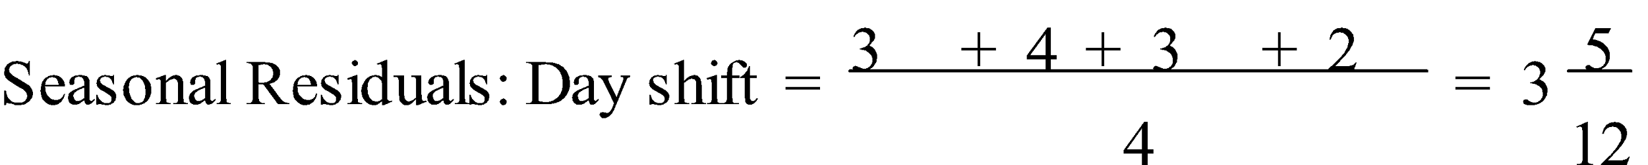 

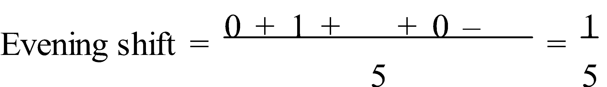 

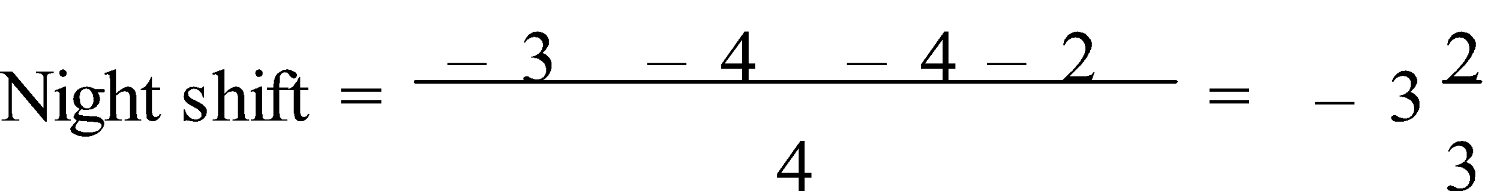

| **DAY** | **SHIFT** | **NUMBER** | **3-P.M.A.** | **RESIDUAL** | **ADJUSTED** |
| --- | --- | --- | --- | --- | --- |
| **MONDAY** | MORNING  EVENING  NIGHT | 7  5  3 | ---  5  6⅓ | ---  0  -3⅓ | 37/12  4.8  6⅔ |
| **TUESDAY** | MORNING  EVENING  NIGHT | 11  9  4 | 7⅔  8  8⅔ | 3⅓  1  -4⅔ | 77/12  8.8  7⅔ |
| **WEDNESDAY** | MORNING  EVENING  NIGHT | 13  10  5 | 9  9⅓  9 | 4  ⅔  -4 | 97/12  9.8  8⅔ |
| **THURSDAY** | MORNING  EVENING  NIGHT | 12  8  4 | 8⅓  8  6⅔ | 3⅔  0  -2⅔ | 87/12  7.8  7⅔ |
| **FRIDAY** | MORNING  EVENING  NIGHT | 8  4  2 | 5⅓  4⅔  --- | 2⅔  -⅔  --- | 47/12  3.8  5⅔ |

To **predict** a future value, the **trend line** is used to find the **predicted value** and then the appropriate **seasonal residual** is **added** to this.

E.g.4. Give the equation of the regression line for the nursing staff numbers from E.g.1. Use this equation, together with the seasonal component for the Morning shift calculated in E.g.3, to predict the number of nursing staff that should be rostered for Saturday morning.

The trend line equation is ŷ ≈ -0.064x + 7.897

For Saturday Morning shift, x = 16

ŷ(16) ≈ 6.872

∴ Predicted staff numbers ≈ 6.87 + 3.4

≈ 10

When working with data with a cycle of 4, 6, ..., it is better to use the centred moving average. This is calculated by **averaging**, a pair at a time, the **4-point averages**. This is known as a **centred 4-point moving average**.

E.g.5. Shown below are the number of service calls received by an air-conditioning firm.

a) Calculate the centred 4-point moving averages, the seasonal residuals and the seasonally adjusted series.

b) Graph, on the same axes, the raw data, the centred 4-point moving averages and the seasonally adjusted numbers.

c) Use the trend line formed by the moving averages and the seasonal residuals to predict the service calls for 1992.

|  | **1989** | **1990** | **1991** |
| --- | --- | --- | --- |
| **FIRST QUARTER** **SECOND QUARTER**  **THIRD QUARTER**  **FOURTH QUARTER** | 19  3  5  13 | 23  5  5  19 | 28  7  9  21 |

a)

| **QUARTER** | **PERIOD**  **(x)** | **CALLS** | **C.4.P.M.A.**  **(y)** | **RESID.** | **SEASONALLY ADJUSTED CALLS** |
| --- | --- | --- | --- | --- | --- |
| **1989: 1**  **2**  **3**  **4** | 1  2  3  4 | 19  3  5  13 | ----  ----  10.5  11.25 | ---  ---  -5.5  1.75 | 6.875  11.125  12.0625  9.875 |
| **1990: 1**  **2**  **3**  **4** | 5  6  7  8 | 23  5  5  19 | 11.5  12.25  13.625  14.5 | 11.5  -7.25  -8.625  4.5 | 10.875  13.125  12.0625  15.875 |
| **1991: 1**  **2**  **3**  **4** | 9  10  11  12 | 28  7  9  21 | 15.25  16  ----  ---- | 12.75  -9  ---  --- | 15.875  15.125  16.0625  17.875 |



| **CALLS** | **4.P.M.A.** |
| --- | --- |
| 19  3  5  13  23  5  5  19  28  7  9  21 | ---  10  11  11.5  11.5  13  14.25  14.75  15.75  16.25  --- |

Seasonal Residuals: 1st Quarter is 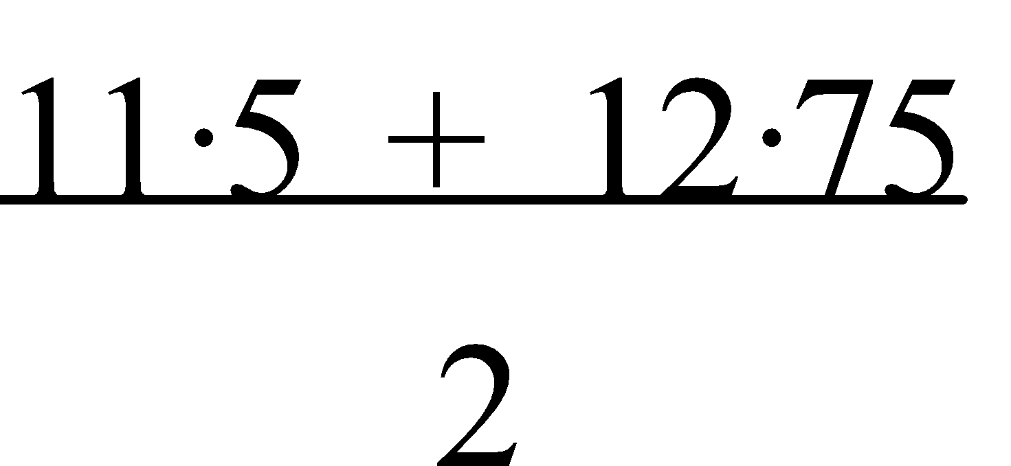 = 12.125

2nd Quarter is 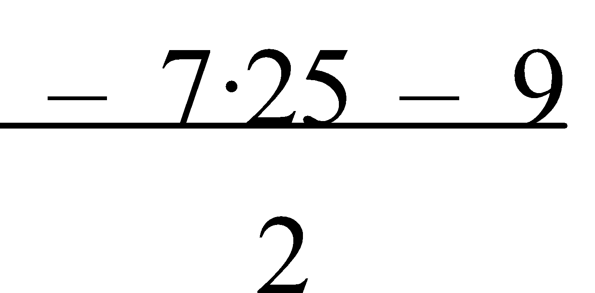 = -8.125

3rd Quarter is 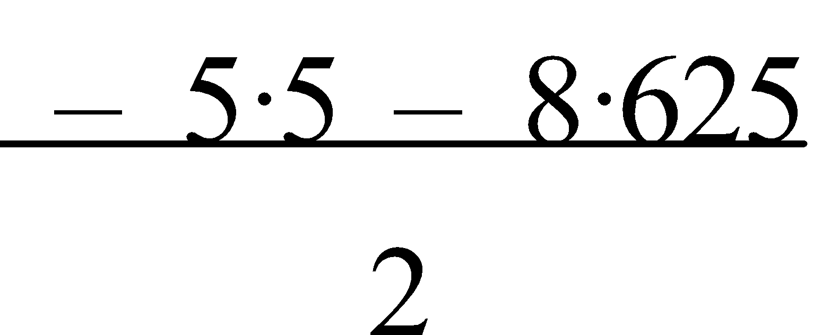 = -7.0625

4th Quarter is 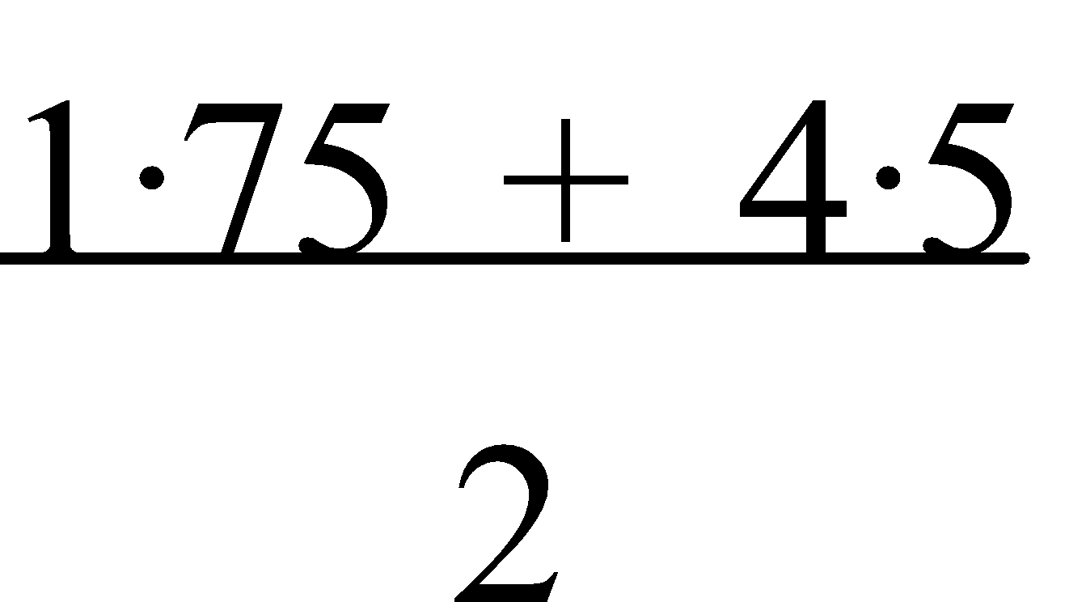 = 3.125



b)







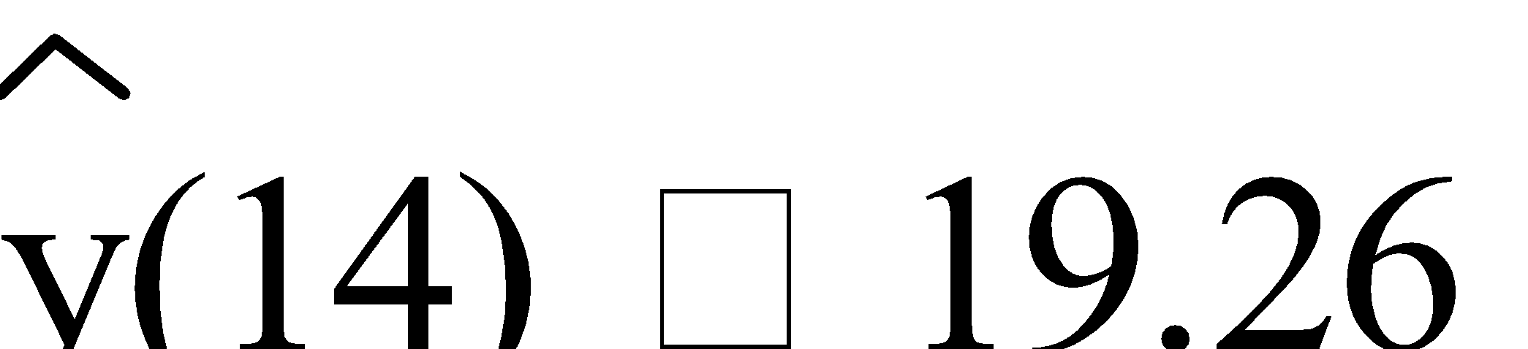

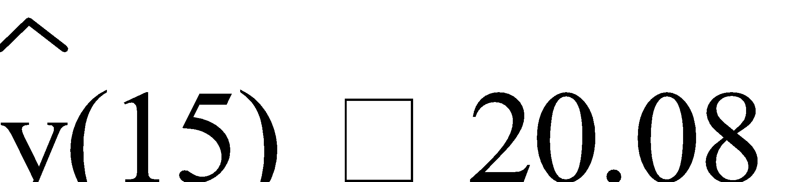

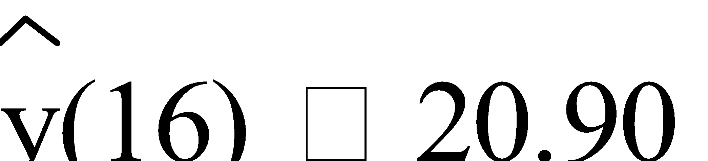

∴ Seasonally Adjusted Predictions for 1992 are:

1st Quarter: 18.44 + 12.125 ≈ 31

2nd Quarter: 19.26 - 8.125 ≈ 11

3rd Quarter: 20.08 - 7.0625 ≈ 13

4th Quarter: 20.90 + 3.125 ≈ 24

**NOTE:** Each centred 4-point moving average is actually based on 5 scores and can be found directly.

It is the average of half the first score, all of the next three scores and half of the fifth score, i.e. **C.4-P.M.A. = ½x1 + x2 + x3 + x4 + ½x5**

**4**

Ref: *Ex.6B Q.1-8 (even)*

**LINEAR PROGRAMMING**

**1. WRITING RESTRICTIONS:** Many industrial and economic decisions are based on the need to optimize some input/output (such as maximize profits by keeping costs down and revenue up). **Linear programming** is a technique developed to solve these problems of planning and management by using linear inequalities.

Solving such problems involves a number of steps –

* Define variables to represent each item.
* Write restrictions in terms of the variables.
* Graph the restrictions and determine the feasible region.
* Define the objective function to be optimized.
* Determine which point(s) in the feasible region give the optimum situation.

Defining the variables and writing the restrictions are the two most important steps towards solving the problem. Writing the restrictions involves translating the (English) words/sentences into algebraic symbols/inequalities.

E.g.1. A lolly maker is preparing for the Christmas market. Holly has 1800 kg of jubes, 1500 kg of licorice allsorts and 750 kg of fruit drops. She makes these into two mixtures: *Holiday* (h), which sells for $1.50 per kilogram and *Santa* (s), which sells for $4.00 per kilogram.

*Holiday* mixture contains 60% jubes, 30% licorice allsorts and 10% fruit drops. *Santa* mixture contains 20% jubes, 50% licorice allsorts and 30% fruit drops.

Write each of the following statements in terms of *h* and *s*:

1. the weight of jubes possible,
2. the weight of licorice allsorts possible,
3. the weight of fruit drops possible, and
4. the total cost of the *Holiday* and *Santa* mixtures.

a) Jubes: 0.6*h* + 0.2*s* ≤ 1800

b) Licorice allsorts: 0.3*h* + 0.5*s* ≤ 1500

c) Fruit drops: 0.1*h* + 0.3*s* ≤ 750

d) Cost = $(1.5*h* + 4*s*)

Ref: *Ex.7A Q.1-6, 12-18, 24-27, 32-36, 41-45*

**2. GRAPHING INEQUALITIES:** To graph an inequality, graph the appropriate equation, test a point not on the line, usually (0,0), and shade the "correct" section. When graphing inequalities, remember that a graph of **<** or **>** has a **broken line** to indicate that this is the boundary but is not included in the region whereas **≤** or **≥** are bounded by a **solid line**.

E.g.2. Graph each of the following inequalities

a) x ≤ 2,

b) y ≤ 2x – 1, and

c) y > -x – 2.

a) Graph: x = 2 ← a solid.

Shading: x ≤ 2 is to the left of x = 2.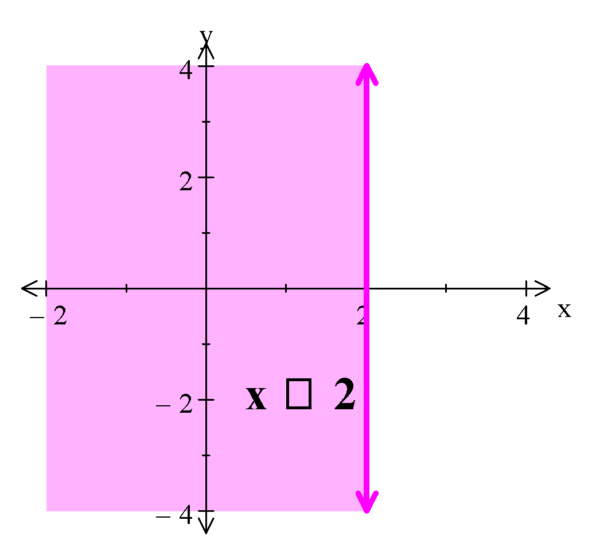

b) Graph: y = 2x – 1 ← a solid line.

Shading: y ≤ 2x – 1 does not contain (0,0).

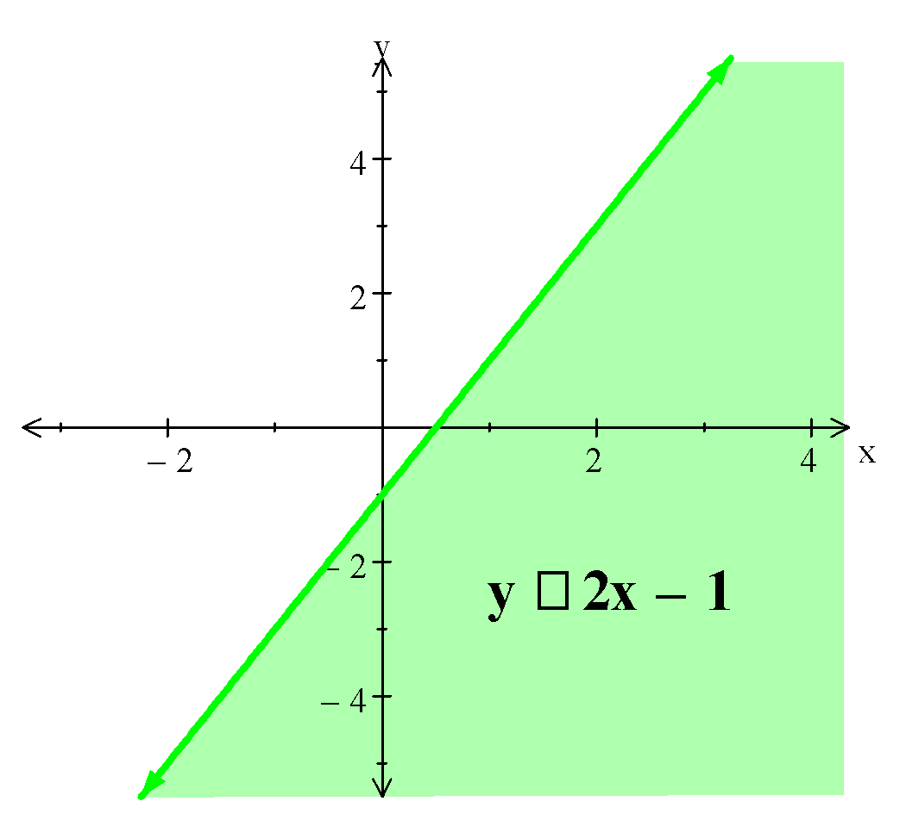

c) Graph: y = -x – 2 ← a broken line.

Shading: y > -x – 2 does contain (0,0).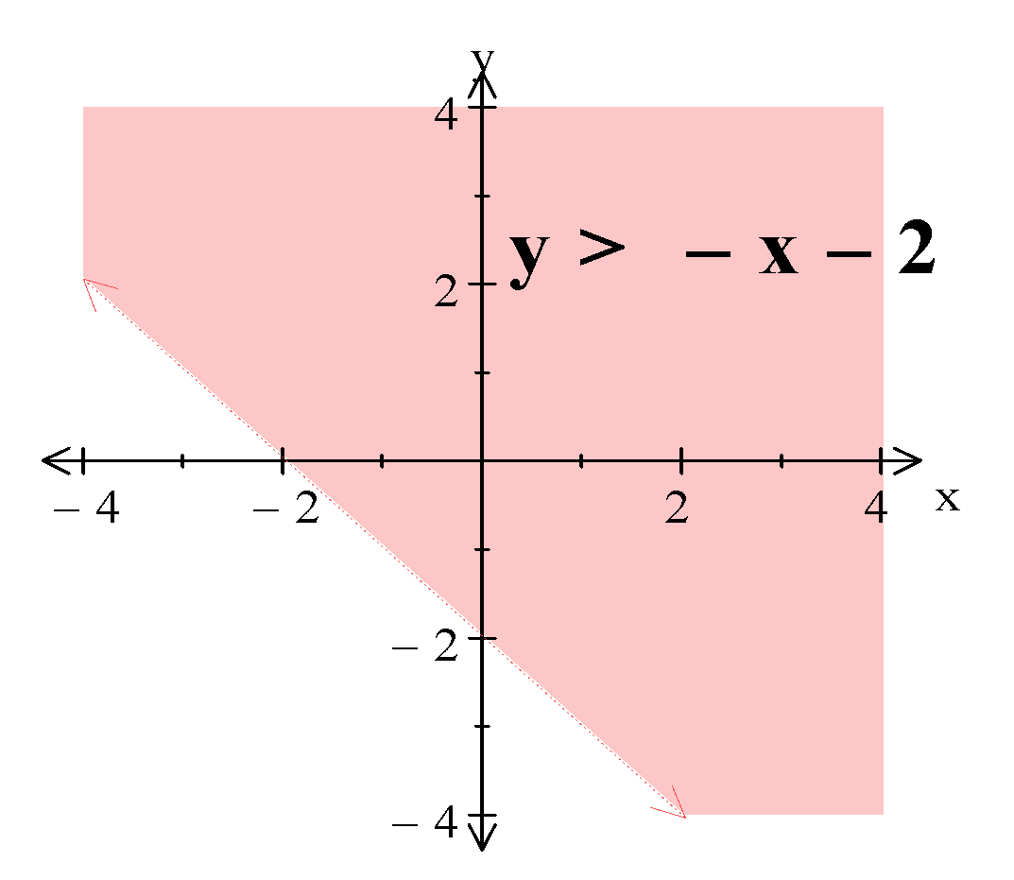

E.g.3. The graph the restrictions d ≥ 0, s ≥ 0, s ≤ d + 3, s ≥ 3 – d and d ≤ 4.

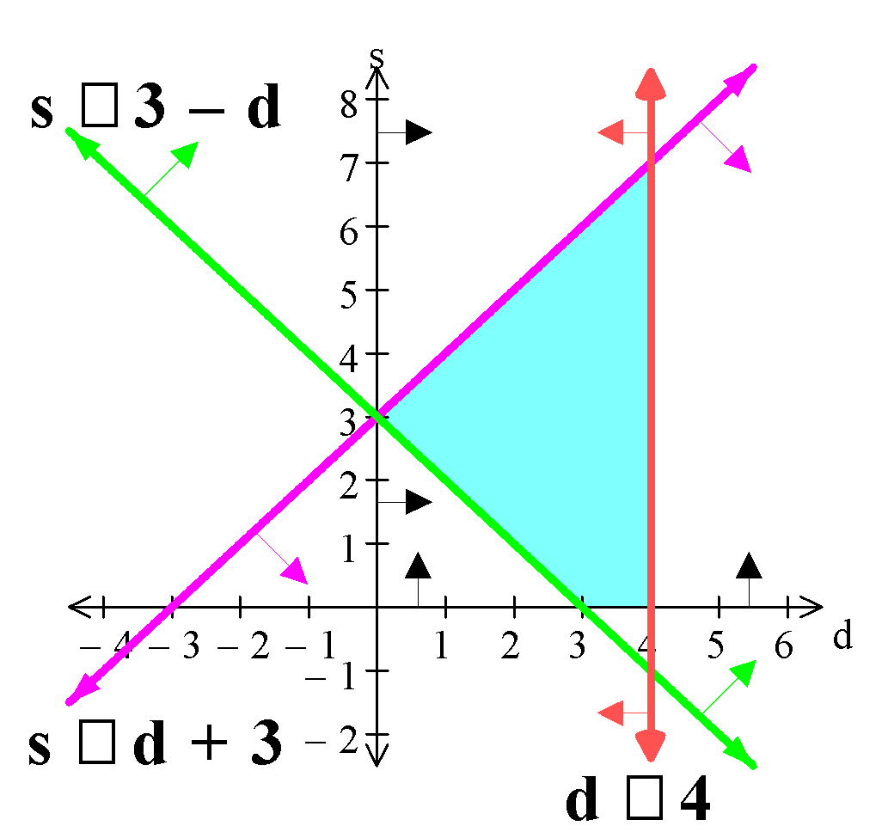

Ref: *Ex.7B Q.1-23 (odd)*

**3. DETERMINING THE OPTIMUM SOLUTION:** When two or more inequalities are graphed on the same set of axes, the resulting shaded area is called the **feasible region** or **solution space** because it satisfies all the inequalities (**constraints**). One of the vertices of the feasible region is (usually) the optimum solution. For real life situations, the constraints **x ≥ 0** and **y ≥ 0** are assumed to apply. The input/output to be optimized is sometimes referred to as the **objective function**.

E.g.4. For the graph in E.g.3, locate the points which:

a) maximize s,

b) minimize d,

c) maximize 2d + s, or

d) minimize 2d – s.

The points of the feasible region are (0,3), (3,0), (4,0) and (4,7).

|  | **(0,3)** | **(3,0)** | **(4,0)** | **(4,7)** | **SOLUTION** |
| --- | --- | --- | --- | --- | --- |
| **Max s** | 3 | 0 | 0 | 7 | (4,7) |
| **Min d** | 0 | 3 | 4 | 4 | (0,3) |
| **Max 2d + s** | 3 | 6 | 8 | 15 | (4,7) |
| **Min 2d – s** | -3 | 6 | 8 | 1 | (0,3) |

**NOTE:** In real life situations a solution of -3 may not be practical and so the next best solution would be used, i.e. 2d – s is minimized at (4,7). This solution would satisfy a question such as maximum income for minimum costs.

Ref: *Ex.7C Q.1-10 (even)*

E.g.5. Vivian wishes to make two models of a can-opener, a standard model and a deluxe model. He can make no more than 50 can-openers per hour. He can make no more than 20 deluxe models and no more than 40 standard models per hour. He makes 50 cents profit on a deluxe model and 40 cents profit on a standard model. What would you recommend the company to produce each hour in order to gain a maximum profit?

Let d be the number of deluxe model

and s be the number of standard model can-openers produced.

**Constraints:**

d + s ≤ 50 (Total production ≤ 50)

d ≤ 20

s ≤ 40

d ≥ 0 and s ≥ 0

**Graph:**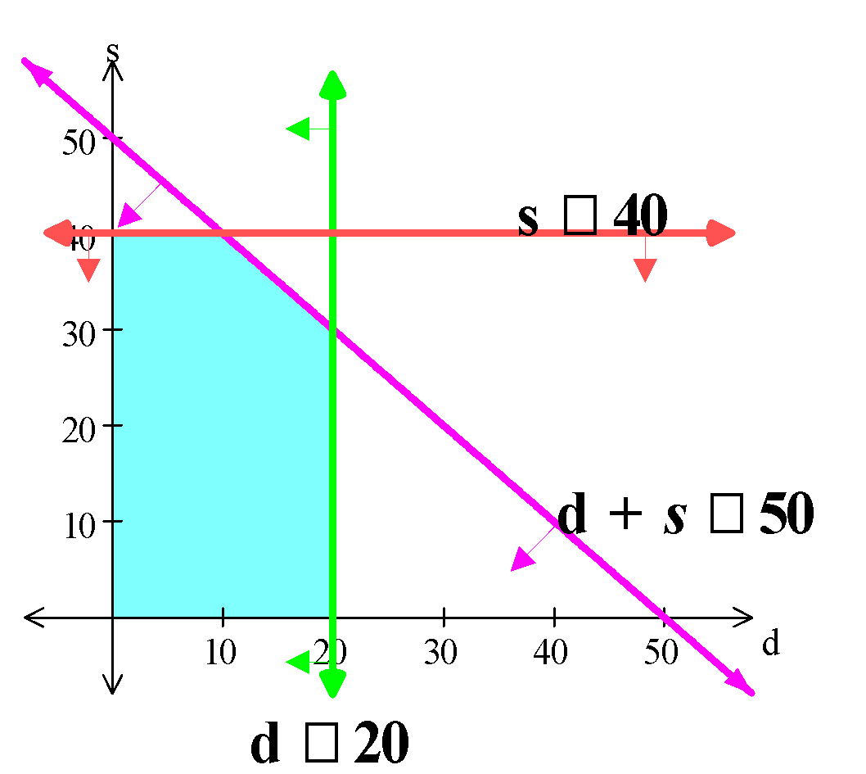

**Objective Function:** Profit = $0.50d + $0.40s

**Feasible Region:**

| **VERTEX** | **PROFIT** |
| --- | --- |
| **(0,0)** | $0 |
| **(0,40)** | $16 |
| **(10,40)** | $21 |
| **(20,30)** | $22 |
| **(20,0)** | $10 |

∴ Maximum profit of $22 occurs when 20 deluxe and 30 standard can-openers are made per hour.

Ref: *Ex.7D Q.1-14 (even)*

**AREA UNDER A CURVE**

**1. AREA UNDER A CURVE:** Areas of regular figures such as squares, circles, etc. can be readily found by common formulae. However, the area of non-regular figures such as the curve y = f(x) are not so readily found. Some “boundaries” for the area being considered need to be set. The **area under the curve** is usually bounded by the curve, the X-axis and the lines x = a and x = b for an interval [a;b].

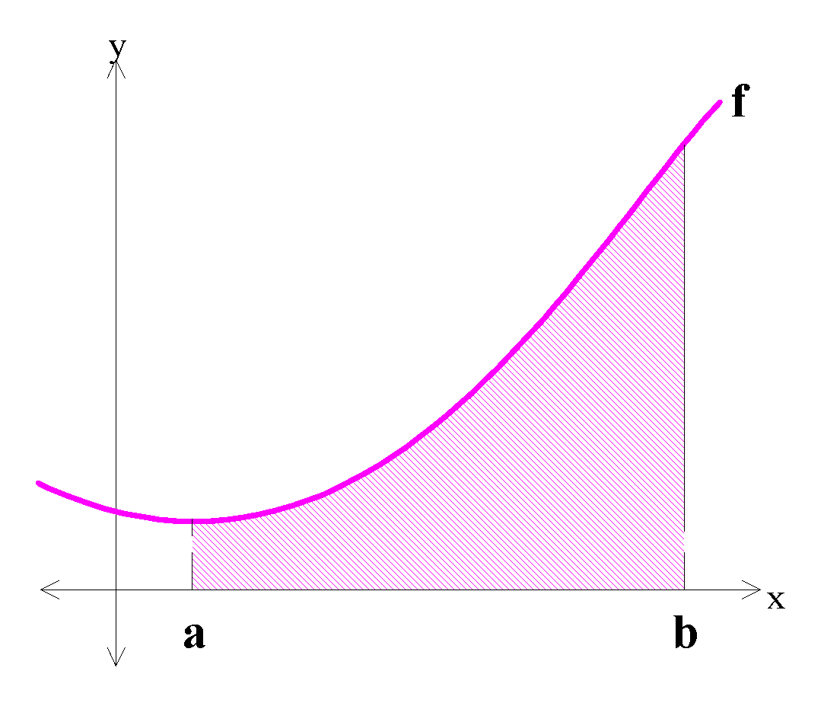



One method of approximating the area is to draw an **accurate graph** on grid paper, determine the area of one “**square**”, then simply **count the** “**squares**”, and **multiply** by the area of one square.

E.g.1. Use the graph of y = x3 to estimate the area under the curve from x = 1 to x = 2.



Area 1 square = 0.1 × 1 = 0.1 units2

There are approximately 37 little blocks in the required region.

∴ Area ≈ 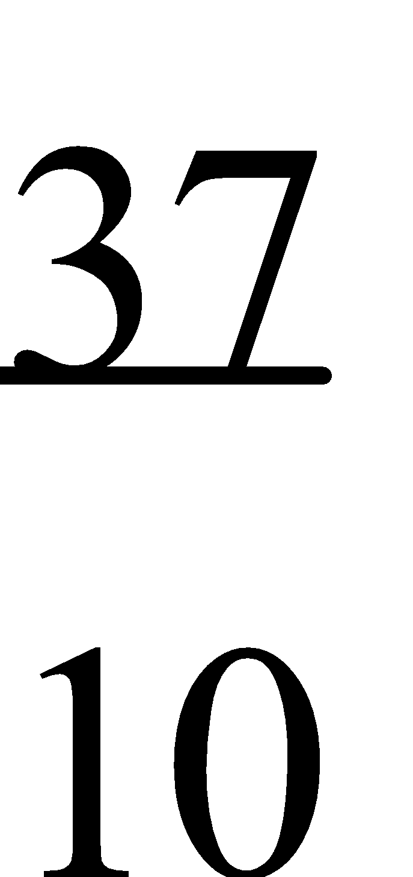 = 3.7 units2

Another method is to divide the interval [a;b] into a number of equal parts and construct rectangles, both upper and lower, and then sum the areas of these rectangles (**SU** and **SL**).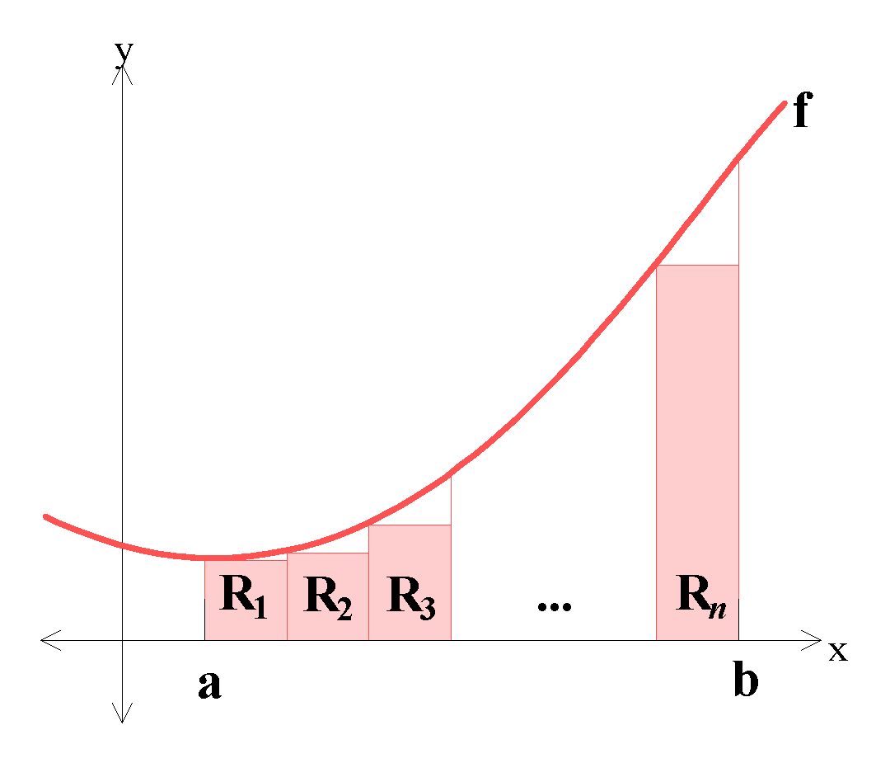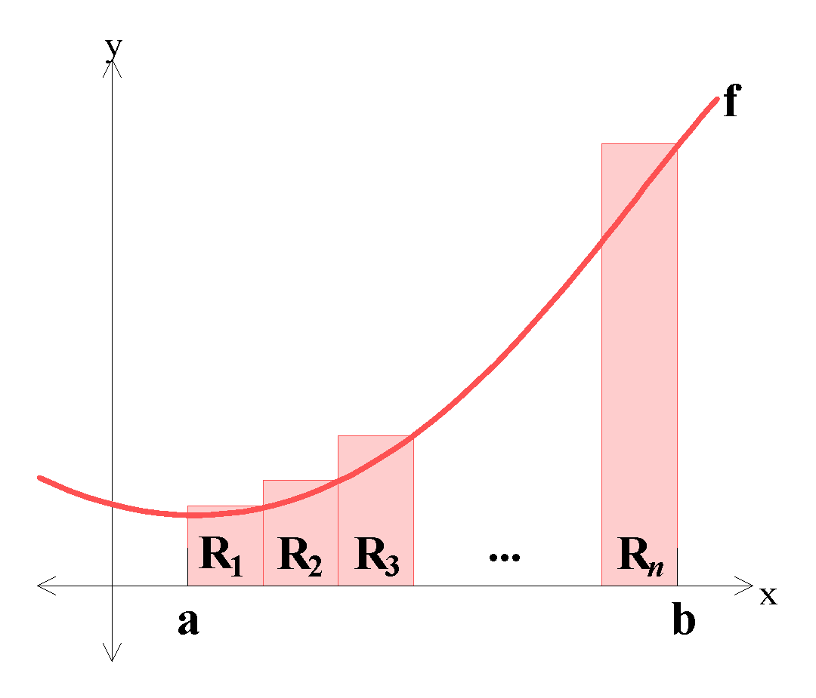

The sum of the (upper) rectangular areas (**SU**) is an **overestimate** of the required area and the sum of the (lower) rectangular areas (**SL**) is an **underestimate** of the required area, so the “**true**” **value** lies somewhere between the two. Thus, **A ≈** 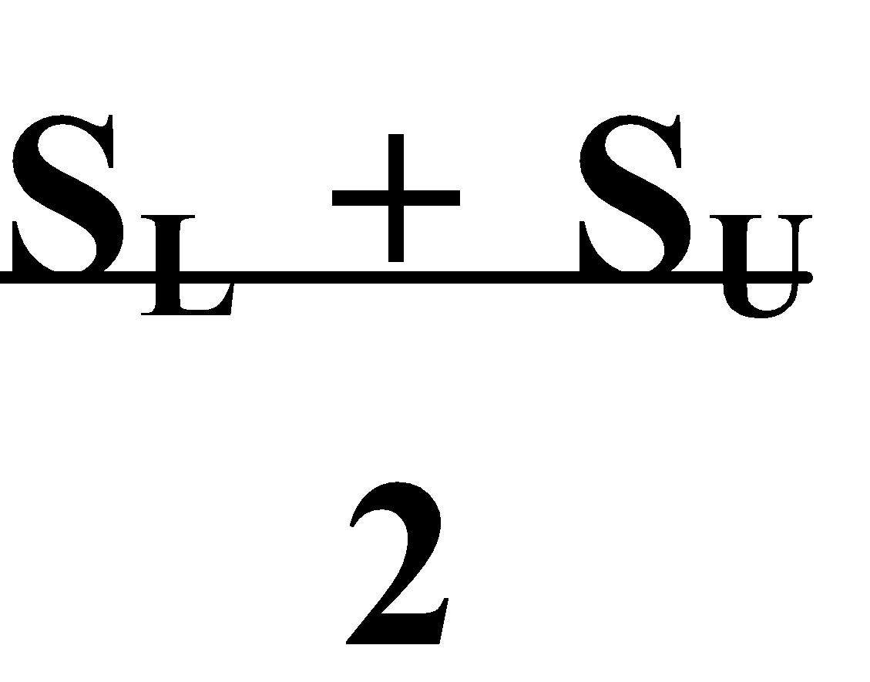. The **more sub-intervals** taken, the smaller the difference between SU and SL and

the **better the approximation** to the true area.

E.g.2. Given the curve y = x2 + 3, divide the interval [1;4] into three sub-intervals and construct both the upper and lower rectangles on them. Hence approximate the area bounded by the X-axis and the ordinates x = 1 and x = 4.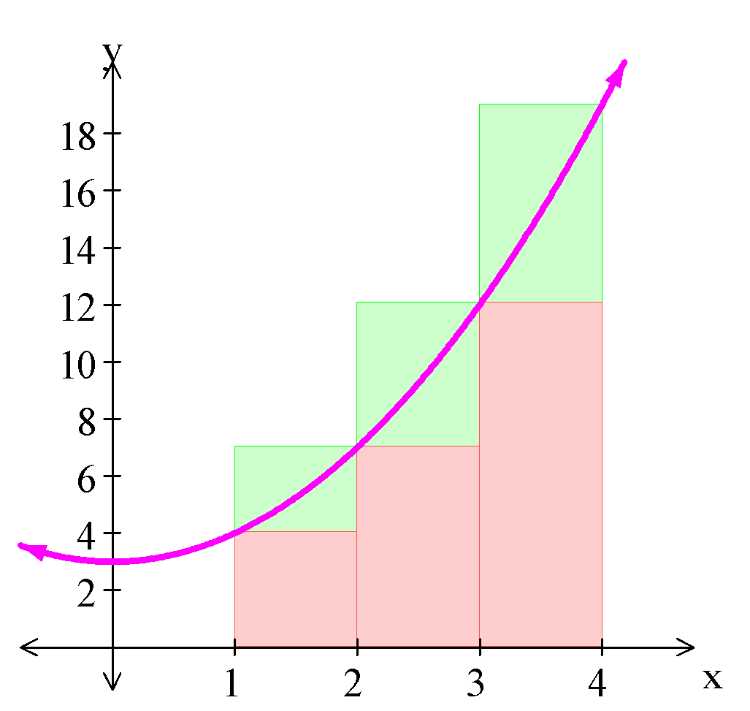

Overestimate: Underestimate:

R1 = 1 × 7 = 7 R1 = 1 × 4 = 4

R2 = 1 × 12 = 12 R2 = 1 × 7 = 7

R3 = 1 × 19 = 19 R3 = 1 × 12 = 12

SU = 38 SL = 23

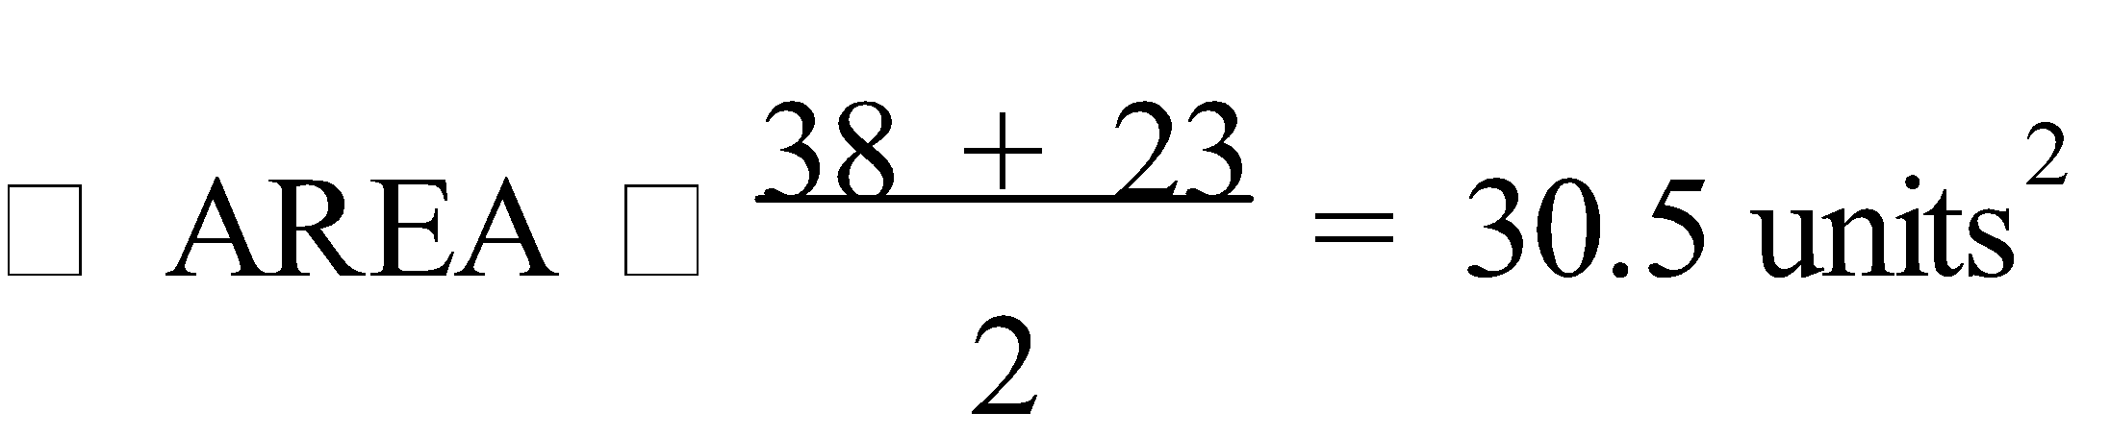

Ref: *Ex.8A Q.1-3*

**PROJECT NETWORKS**

**1. CRITICAL PATH:** Networks can be concerned with timing and tasks which must be completed in order. The tasks are shown on a **digraph** (directed graph) which gives a possible allocation of tasks. The arcs show the order in which the tasks are completed. Each node, called an **event**, represents a stage of completion of all the tasks on the paths which finish at that node. Since completing the “project” requires that all the tasks are done, the shortest time for completion is the time taken on the longest path. The path with the longest time is called the **critical path**, and any “spare” time is called **slack** or **float** time.

E.g.1. The digraph below shows the times, in minutes, needed to complete various tasks which make up a project.

a) What is the minimum time required for the completion of all tasks?

b) What is the critical path?

c) Identify slack areas.



a) The minimum time for the whole project is 79 minutes.

b) The critical path is DEGJK.

c) Delays in starting A, B, C, F, H or L could occur without affecting the finishing time.

Ref: *Ex.9A Q.1-10 (even)*

**2.** **PROJECT NETWORKS:** A **project network** represents a timing/task situation in a network where any task with no prerequisites gets a line from the start and its time is written along the line. Tasks with prerequisites are then added, each task drawn as a line from its prerequisites.

E.g.2. Three friends are working on a combined assignment made up of 10 activities (see the table below).

| **ACTIVITIES** | **A** | **B** | **C** | **D** | **E** | **F** | **G** | **H** | **I** | **J** |
| --- | --- | --- | --- | --- | --- | --- | --- | --- | --- | --- |
| **TIME (hrs)** | 3 | 2 | 3 | 6 | 4 | 8 | 6 | 7 | 3 | 4 |
| **PREREQUISITES** | - | - | - | A | C | B | B | D, F | E, G | H, I |

a) Draw a project network for the given activities.

b) What is the shortest time needed to complete the assignment?

c) Which activities are critical, in that extra time taken on them would result in delaying the completion of the assignment?

d) Mark the critical path on your diagram.

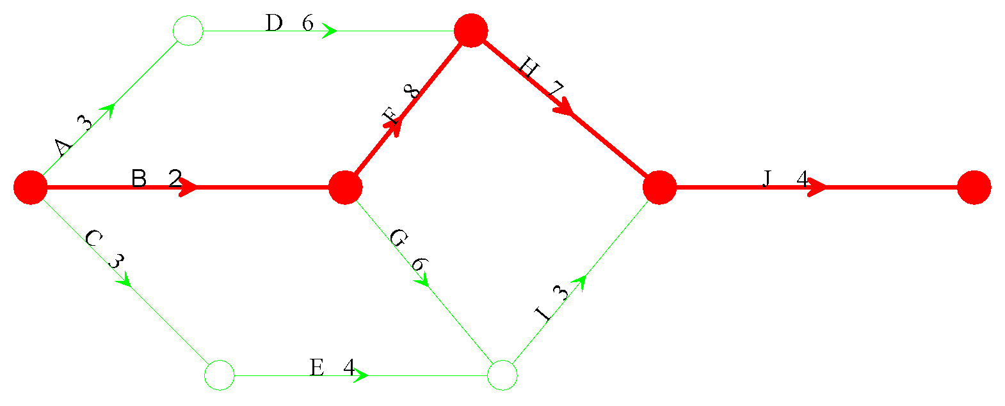

a) & d)

b) The shortest time is 21 hours.

c) The critical activities are B, F, H and J.

Ref: *Ex.9B Q.1-12 (even)*